Fall 2011
Unit 2 – An Introduction to Macroeconomics
Chapter 12 - AS/AD
- Reading Assignments:
  - Chapter 12 - Aggregate Supply and Aggregate Demand: ALL (not the appendix)
  - PLUS:
    - Ch. 9: The Business Cycle: pp. 171-173
    - Ch. 13: Fiscal Policy and the AD-AS Model: pp. 258-261
    - Ch. 18: Taxation and AS (Supply -Side Economics): pp. 374-378
    - Ch. 18: From Short Run to Long Run / Applying the Extended AS-AS Model - pp. 362-368
    - Ch. 9: Types of Inflation: pp. 179-180
- Study Guide
  - Chapter 12: Multiple Choice # 1, 3-9, 14-20, 22-25; Problems: # 1, 2, 4
  - Chapter 13: Multiple Choice #1, 3; Problems #1
  - Chapter 18: Multiple Choice 3 2, 3, 5, 6, 8, 10; Problems # 2, 5
- Web Quiz
  - Chapter 12 # 1-6, 8-10 at http://highered.mcgraw-hill.com/sites/0077337727/student_view0/chapter12/quiz.html
  - Chapter 13 # 7, 9 at http://highered.mcgraw-hill.com/sites/0077337727/student_view0/chapter13/quiz.html
  - Chapter 18 # 5, 7, 8, 10 at http://highered.mcgraw-hill.com/sites/0077337727/student_view0/chapter18/quiz.html
- End-of-Chapter Questions and Problems:
  - Chapter 12: Questions # 2, 3, 4, 5, 8, 9, 10; Problem 3, 5
  - Chapter 18: Questions # 1, 4, 9, 10; Problem #1
Chapter 6 - An Introduction to Macroeconomics
- Reading Assignments:
  - Chapter 6 ALL
  - PLUS:
    - Review Ch. 9: The Business Cycle: pp. 171-173
    - Review Ch. 1: "Present Choices, Future Possibilities": pp. 16-18
- Study Guide – Chapter 6
  - Multiple Choice: 1-5, 7-10, 13-15, 22, 25
  - Problems: 2, 3
- Web Quiz: Chapter 6 # 2-10 at http://highered.mcgraw-hill.com/sites/0077337727/student_view0/chapter6/quiz.html
- End-of-Chapter Questions and Problems:
  - Questions # 1, 4, 5, 6
  - Problems # 3, 5
Chapter 9 - Unemployment and Inflation
- Reading Assignments:
  - Chapter 9: ALL
  - Ch. 7: "GDP Price Index," pp. 141-142
- Study Guide – Chapter 9
  - Multiple Choice: # 1, 2, 4-11, 14-17, 19-23, 25
  - Problems: # 1, 3, 4
- Worked Problems 9.1 and 9.3 at http://highered.mcgraw-hill.com/sites/0077337727/student_view0/chapter9/worked_problems.html
- Web Quiz: Chapter 9 # 1-6, 8, 10 at http://highered.mcgraw-hill.com/sites/0077337727/student_view0/chapter9/quiz.html
- End-of-Chapter Questions and Problems:
  - Questions # 1, 3, 5-10; Problems #3 1, 2, 4, 5, 6
Chapter 7 - Measuring the Economy
- Reading Assignments:
  - Chapter 7 - ALL
- Study Guide – Chapter 7
  - Multiple Choice: # 1, 2, 4-7, 9-13, 15-19, 24-30
  - Problems:
    - Chapter 7: # 4, 5
    - Chapter 6: #1
- Worked Problem 7.2 at http://highered.mcgraw-hill.com/sites/0077337727/student_view0/chapter7/worked_problems.html
- Web Quiz # 1, 2, 4-9 at http://highered.mcgraw-hill.com/sites/0077337727/student_view0/chapter7/quiz.html
- End-of-Chapter Questions and Problems:
  - Question 7-4, Problem 7-7
Chapters 8 and Web Chapter 22W - Economic Growth and the Less Developed Countries
- Reading Assignments
  - Chapter 8 - ALL
  - Ch. 1 "A Growing Economy" pp. 15-16
  - Web Chapter 22W - ALL
    - at: http://highered.mcgraw-hill.com/sites/0077337727/student_view0/web_chapters_and_supplements.html
  - Also read: http://www.harpercollege.edu/~mhealy/g101ilec/intro/eco/ecomea/ecomeafr.htm
- Study Guide
  - Chapter 8:
    - Multiple Choice: # 1-3, 6-10, 13-22, 25
    - Problems: # 1, 2, 4
  - Chapter 22W:
    - Multiple Choice: # 1-8, 10-13, 17-21
    - Problems: # 1, 2
  - Chapter 6: Multiple Choice # 11
- Web Quizzes
  - Chapter 8: 1-7, 10 at http://highered.mcgraw-hill.com/sites/0077337727/student_view0/chapter8/quiz.html
  - Chapter 22W: 1-9 at http://highered.mcgraw-hill.com/sites/0077337727/student_view0/chapter_22w/quiz.html
- End-of-Chapter Questions and Problems
  - Chapter 8: Questions # 1-4, 6, 7, 10; Problems # 1-3
  - Chapter 22W: Questions # 1, 2, 4, 7, 10; Problems # 1, 2

Determinants of AD

AD | AD
C AD | C AD
I AD | I AD
G AD | G AD
Xn AD | Xn AD
MS Interest Rates I AD | MS Interest Rates I AD
T C AD | T C AD
S C AD | S C AD
But what causes these things to change? Well, economists have identified some determinants of the main components of spending: C, I, G, and Xn.
Determinants of C, I, G, and Xn:
C = consumer spending (and saving)
  - consumer wealth
Wealth C AD
Wealth C AD
  - consumer expectations
Expected future Income C today AD today
Expected future Income C today AD today
  - consumer indebtedness
Consumer Debt C AD
Consumer Debt C AD
  - taxes
T C AD
T C AD
I = investment spending
  - interest rates (money supply)
MS Interest Rates I AD (memorize this, it will help in future chapters)
MS Interest Rates I AD
  - profit expectations on investment projects
profit expectations I AD
profit expectations I AD
  - business taxes
Business Taxes I AD
Business Taxes I AD
  - technology
technology I AD
  - degree of excess capacity
excess (unused) plant capacity I AD
excess (unused) plant capacity I AD
G = government purchases
Xn = net export spending
  - net income abroad
Income in Foreign Countries Xn AD
Income in Foreign Countries Xn AD
  - exchange rates
value of the US dollar Xn AD
value of the US dollar Xn AD

Determinants of AS
AS | AS
price of resources AS | price of resources AS
productivity AS | productivity AS
business taxes and gov't red tape AS | business taxes and gov't red tape AS

Kitchen sink economics
http://money.cnn.com/2003/06/27/news/economy/secondhalf_economy/index.htm
Policy makers have thrown all but the kitchen sink at the economy. Will it help in the second half?
July 3, 2003: 10:23 AM EDT
By Mark Gongloff, CNN/Money Staff Writer
NEW YORK (CNN/Money) - Will the "kitchen sink" approach really fix the economy?
Policy makers in the federal government and the Federal Reserve have thrown everything but the kitchen sink at the ailing economy, and most economists are saying their efforts will spur relatively robust economic growth in the second half.
After growing at a paltry 1.4 percent rate in the first quarter and probably not much better in the second, gross domestic product (GDP) is expected to grow at a rate of 3.4 percent in both the third and fourth quarters, according to the Philadelphia Fed's latest survey of professional forecasters.
Of course, economic forecasters have often been overly optimistic since early 2001, when a recession/jobless recovery cycle began, and have been forced many times to ratchet down their expectations.
"All the good growth is in the forecasts, in the idea that financial conditions have eased," said Rory Robertson, interest-rate strategist at Macquarie Equities (USA). "But we've seen that doesn't always turn into actual good growth."
Still, Robertson and other economists have a little more reason to hope that this time might be different, thanks to a combination of:
- the recently-signed tax-cut plan, which will give rebate checks to families with children in late summer, right in time for back-to-school spending;
- improving consumer confidence -- critical, since consumer spending makes up more than two-thirds of the economy;
- the Fed's 13th rate cut of the cycle, taking the fed funds rate to 45-year lows;
- a weakened dollar, which should help make U.S. exports more competitive overseas; and a healthier stock market, making consumers feel wealthier.

German economy stalls
http://money.cnn.com/2001/08/23/europe/germany/index.htm
August 23, 2001: 10:37 a.m. ET

Europe's biggest economy grinds to a halt in Q2; ECB may cut rates

LONDON (CNN) - Confirmation that German economic growth has stalled could give euro-zone monetary chiefs the excuse to cut interest rates next week.
Growth in Europe's biggest economy ground to a halt in the second quarter, official figures from Germany's Federal Statistics Office showed on Thursday, as most economists had predicted.
The numbers reflect output and investment cutbacks by companies suffering from excess stock amid a global economic slowdown. The construction industry came under pressure as building work on factories and offices dwindled.
German Finance Minister Hans Eichel refused to be downcast, however, telling ZDF television there was "no reason for pessimism." Referring to tax cuts that came into force in January, Eichel forecast an upturn in demand later in 2001.
"We see that the inflation rate is going down, so that there is a chance that tax reform with its enormous relief in the second half of the year will begin to work," Eichel said.
But that isn't likely to deliver a revival in the economy until the end of the year, economists warned
The economy's big surprise
Some analysts think 3Q GDP grew at the strongest pace in four years -- but jobs may stay scarce.
October 16, 2003: 5:42 PM EDT
By Mark Gongloff, CNN/Money Staff Writer
http://money.cnn.com/2003/10/16/news/economy/gdp/index.htm
NEW YORK (CNN/Money) - Economists have been jacking up their forecasts for third-quarter economic growth, and many now say it may be the strongest number in nearly four years.
The problem is that might not translate into strong jobs growth anytime soon.
Economists, on average, think gross domestic product (GDP) grew at a 5 percent rate in the quarter, according to the latest surveys by Blue Chip Economic Indicators and the Wall Street Journal. Such a rate would be pretty decent -- the fastest pace since the first quarter of 2002, in fact.
But recent reports on international trade and consumer spending have many economists looking for something even faster -- say 6 percent, or maybe even 7 percent, strength not seen since GDP grew at a 7.1 percent pace in the fourth quarter of 1999. GDP is the broadest measure of the nation's economy.
"We are looking at a growth rate somewhere in between 6.5 percent and 7 percent at this point," said Oscar Gonzalez, economist at John Hancock Financial Services in Boston. "I think it's really going to be up there."
The Commerce Department's report last week of a surprising August improvement in the international trade balance was the first report to send economists scrambling for their calculators. Since the trade gap subtracts from overall GDP, the surprise narrowing of that gap in August should help third-quarter GDP.
The department helped out again this week, when it revised upward retail sales figures for July and August. Since consumer spending makes up more than two-thirds of total GDP, the revised data had many economists more firmly convinced third-quarter GDP could be big.
"Seven percent is not an unreasonable estimate for GDP growth," said Kevin Logan, chief market economist at Dresdner Kleinwort Wasserstein. "Retail sales were strong, especially with the revisions. Consumer spending possibly grew 12 percent at an annual rate. That's really charging right along."

Macroeconomics: AD / AS REVIEW
Use the graphs and the other information provided to answer the questions. BEFORE answering the questions DRAW the appropriate shifts on the graphs and use the graphs to FIND the answers. Click HERE for answers, BUT only after you have done the problems yourself!
1. Assume that there is an increase in government spending  Which determinant? ____________  Δ AD or Δ AS?  or ?  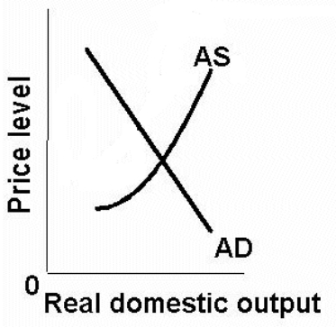  What happens to:  Real GDP _______________  Unemployment _______________  Price Level _______________  Inflation _______________  Type of Economic Growth:  Achieving the potential  or  Increasing the potential ? | 2. Assume that there is an increase in taxes  Which determinant? ____________  Δ AD or Δ AS?  or ?  What happens to:  Real GDP _______________  Unemployment _______________  Price Level _______________  Inflation _______________  Type of Economic Growth:  Achieving the potential  or  Increasing the potential ?

3. Assume that there is reduced gov’t red tape  Which determinant? ____________  Δ AD or Δ AS?  or ?  What happens to:  Real GDP _______________  Unemployment _______________  Price Level _______________  Inflation _______________  Type of Economic Growth:  Achieving the potential  or  Increasing the potential ? | 4. Assume that there is an increase in business investment  Which determinant? ____________  Δ AD or Δ AS?  or ?  What happens to:  Real GDP _______________  Unemployment _______________  Price Level _______________  Inflation _______________  Type of Economic Growth:  Achieving the potential  or  Increasing the potential ?

5. Assume that there is an increase in oil prices due to war  Which determinant? ____________  Δ AD or Δ AS?  or ?  What happens to:  Real GDP _______________  Unemployment _______________  Price Level _______________  Inflation _______________  Type of Economic Growth:  Achieving the potential  or  Increasing the potential ? | 6. Assume that the Fed decreases the money supply  Which determinant? ____________  Δ AD or Δ AS?  or ?  What happens to:  Real GDP _______________  Unemployment _______________  Price Level _______________  Inflation _______________  Type of Economic Growth:  Achieving the potential  or  Increasing the potential ?

7. Assume that there is new technology that reduces electricity costs  Which determinant? ____________  Δ AD or Δ AS?  or ?  What happens to:  Real GDP _______________  Unemployment _______________  Price Level _______________  Inflation _______________  Type of Economic Growth:  Achieving the potential  or  Increasing the potential ? | 8. Assume that exports increase  Which determinant? ____________  Δ AD or Δ AS?  or ?  What happens to:  Real GDP _______________  Unemployment _______________  Price Level _______________  Inflation _______________  Type of Economic Growth:  Achieving the potential  or  Increasing the potential ?

9. Assume that there is a decrease in marginal tax rates which increases labor productivity  Which determinant? ____________  Δ AD or Δ AS?  or ?  What happens to:  Real GDP _______________  Unemployment _______________  Price Level _______________  Inflation _______________  Type of Economic Growth:  Achieving the potential  or  Increasing the potential ? | 10. Assume that there is an poor harvests world wide which increases resource prices  Which determinant? ____________  Δ AD or Δ AS?  or ?  What happens to:  Real GDP _______________  Unemployment _______________  Price Level _______________  Inflation _______________  Type of Economic Growth:  Achieving the potential  or  Increasing the potential ?

11. Assume that there is a rise in the foreign exchange value of the dollar  Which determinant? ____________  Δ AD or Δ AS?  or ?  What happens to:  Real GDP _______________  Unemployment _______________  Price Level _______________  Inflation _______________  Type of Economic Growth:  Achieving the potential  or  Increasing the potential ? | 12. Assume that there is an increase in labor training and education  Which determinant? ____________  Δ AD or Δ AS?  or ?  What happens to:  Real GDP _______________  Unemployment _______________  Price Level _______________  Inflation _______________  Type of Economic Growth:  Achieving the potential  or  Increasing the potential ?

13. Assume that there is an increase in consumer debt  Which determinant? ____________  Δ AD or Δ AS?  or ?  What happens to:  Real GDP _______________  Unemployment _______________  Price Level _______________  Inflation _______________  Type of Economic Growth:  Achieving the potential  or  Increasing the potential ? | 14. Assume that there is a decrease in consumer confidence  Which determinant? ____________  Δ AD or Δ AS?  or ?  What happens to:  Real GDP _______________  Unemployment _______________  Price Level _______________  Inflation _______________  Type of Economic Growth:  Achieving the potential  or  Increasing the potential ?

15. Assume that there is an recessions in Europe, Japan, and Canada  Which determinant? ____________  Δ AD or Δ AS?  or ?  What happens to:  Real GDP _______________  Unemployment _______________  Price Level _______________  Inflation _______________  Type of Economic Growth:  Achieving the potential  or  Increasing the potential ? | 16. Assume that there are discoveries of new oil fields  Which determinant? ____________  Δ AD or Δ AS?  or ?  What happens to:  Real GDP _______________  Unemployment _______________  Price Level _______________  Inflation _______________  Type of Economic Growth:  Achieving the potential  or  Increasing the potential ?

17. Assume that there is an increase in interest rates not caused by price level changes  Which determinant? ____________  Δ AD or Δ AS?  or ?  What happens to:  Real GDP _______________  Unemployment _______________  Price Level _______________  Inflation _______________  Type of Economic Growth:  Achieving the potential  or  Increasing the potential ? | 18. Assume that there is a decrease in the amount of money in circulation  Which determinant? ____________  Δ AD or Δ AS?  or ?  What happens to:  Real GDP _______________  Unemployment _______________  Price Level _______________  Inflation _______________  Type of Economic Growth:  Achieving the potential  or  Increasing the potential ?

19. Assume that there is an international agreement to make businesses reduce pollution  Which determinant? ____________  Δ AD or Δ AS?  or ?  What happens to:  Real GDP _______________  Unemployment _______________  Price Level _______________  Inflation _______________  Type of Economic Growth:  Achieving the potential  or  Increasing the potential ? | 20. Assume that there is an more competition due to fewer trade restrictions  Which determinant? ____________  Δ AD or Δ AS?  or ?  What happens to:  Real GDP _______________  Unemployment _______________  Price Level _______________  Inflation _______________  Type of Economic Growth:  Achieving the potential  or  Increasing the potential ?

Chapter 6 –Introduction to Macroeconomics – Quick Quiz
1. The term "recession" describes a situation where:
A. inflation rates exceed normal levels.
B. output and living standards decline.
C. an economy's ability to produce is destroyed.
D. government takes a less active role in economic matters.
2. Why are economists concerned about inflation?
A. Inflation generally causes unemployment rates to rise.
B. Real GDP is necessarily falling when there is inflation.
C. Inflation lowers the standard of living for people whose income does not increase as fast as the price level.
D. Inflation increases the value of peoples' saving and encourages overspending on goods and services.
3. Which of the following is an example of economic investment?
A. Volvo buys an old factory building from General Motors.
B. Nike buys a new machine that increases shoe production.
C. Bill Gates buys shares of stock in IBM.
D. Warren Buffet buys U.S. savings bonds.
4. If an economy wants to increase its current level of investment, it must:
A. sacrifice future consumption.
B. print more money.
C. offer more stocks and bonds to financial investors.
D. sacrifice current consumption.
Chapter 12 – Aggregate Demand and Aggregate Supply – Quick Quiz
AGGREGATE DEMAND
1. Other things equal, a decrease in the real interest rate will:
A. expand investment and shift the AD curve to the left.
B. expand investment and shift the AD curve to the right.
C. reduce investment and shift the AD curve to the left.
D. reduce investment and shift the AD curve to the right.
2. Which of the following would most likely shift the aggregate demand curve to the right?
A. An increase in stock prices that increases consumer wealth.
B. Increased fear that a recession will cause workers to lose their jobs.
C. An increase in personal income tax rates.
D. A reduction in household borrowing because of tighter lending practices.
3. Which of the following would most likely reduce aggregate demand (shift the AD curve to the left)?
A. A reduced amount of excess capacity.
B. Increased government spending on military equipment.
C. An appreciation of the U.S. dollar.
D. Increased consumer optimism regarding future economic conditions.
4. In an effort to avoid recession, the government implements a tax rebate program, effectively cutting taxes for households. We would expect this to:
A. affect neither aggregate supply nor aggregate demand.
B. increase aggregate demand.
C. reduce aggregate demand.
D. reduce aggregate supply.

Chapter 12 – Aggregate Demand and Aggregate Supply – Quick Quiz
AGGREGATE SUPPLY
1. The aggregate supply curve (short-run):
A. graphs as a horizontal line.
B. is steeper above the full-employment output than below it.
C. slopes downward and to the right.
D. presumes that changes in wages and other resource prices match changes in the price level.
2. The aggregate supply curve (short-run) is upsloping because:
A. wages and other resource prices match changes in the price level.
B. the price level is flexible upward but inflexible downward.
C. per-unit production costs rise as the economy moves toward and beyond its full-employment real output.
D. wages and other resource prices are flexible upward but inflexible downward.
3. Other things equal, appreciation of the dollar:
A. increases aggregate demand in the United States and may increase aggregate supply by reducing the prices of imported resources.
B. increases aggregate demand in the United States and may decrease aggregate supply by reducing the prices of imported resources.
C. decreases aggregate demand in the United States and may increase aggregate supply by reducing the prices of imported resources.
D. decreases aggregate demand in the United States and may reduce aggregate supply by increasing the prices of imported resources.
4. The economy's long-run aggregate supply curve:
A. slopes upward and to the right.
B. is vertical.
C. is horizontal.
D. slopes downward and to the right.
5. Graphically, cost-push inflation is shown as a:
A. leftward shift of the AD curve.
B. rightward shift of the AS curve.
C. leftward shift of AS curve.
D. rightward shift of the AD curve.

Chapter 12 – Aggregate Demand and Aggregate Supply – Quick Quiz
EQUILIBRIUM and CHANGES in AD and AS
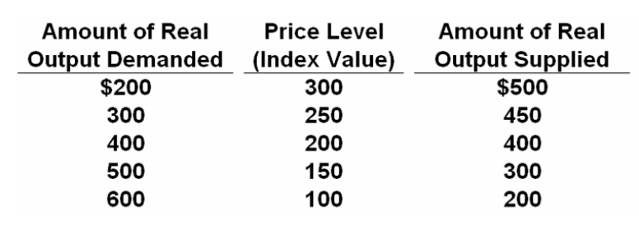
1. Refer to the above data. The equilibrium price level will be:
A. 150.
B. 200.
C. 250.
D. 300.
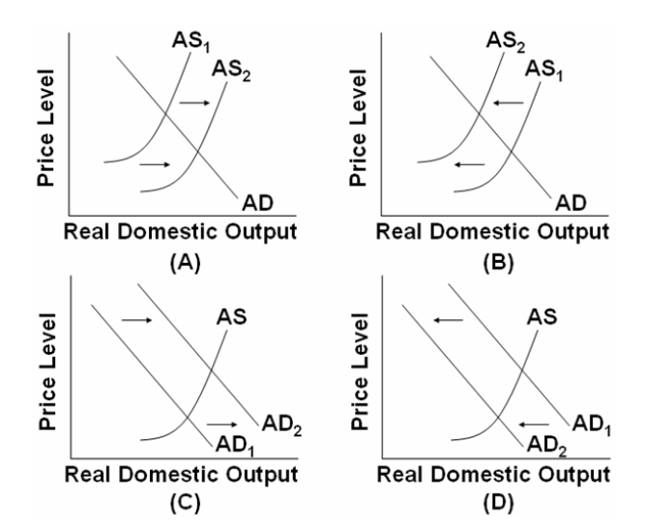
2. Which of the above diagrams best portrays the effects of an increase in resource productivity?
A. A
B. B
C. C
D. D

3. Which of the above diagrams best portrays the effects of a decrease in the availability of key natural resources?
A. A
B. B
C. C
D. D

4. Which of the above diagrams best portrays the effects of an increase in foreign spending on U.S. products?
A. A
B. B
C. C
D. D
5. Which of the above diagrams best portrays the effects of an increase in consumer spending?
A. A
B. B
C. C
D. D
6. Which of the above diagrams best portrays an improvement in expected rates of return on investment?
A. A
B. B
C. C
D. D
7. Which of the above diagrams best portrays the effects of a substantial reduction in government spending?
A. A
B. B
C. C
D. D
8. Which of the above diagrams best portrays the effects of a dramatic increase in energy prices?
A. A
B. B
C. C
D. D

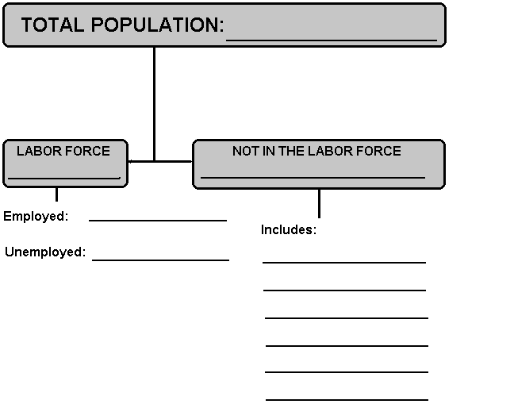

Use the data above to calculate the Unemployment Rate

THE UNEMPLOYMENT RATE

1. In the table below are statistics showing the labor force and total employment during year 1 and year 5. Make the computations necessary to complete the table. (Number of persons is in thousands.)

Year 1 Year 5

Labor force 95,450 108,250

Employed 90,325 100,830

Unemployed ______ ______

Unemployment rate ______ ______

(a) How is it possible that both employment and unemployment increased?

(b) Would you say that year 5 was a year of full employment?

(c) Why is the task of maintaining full employment over the years more than just a problem of finding jobs for those who happen to be unemployed at any given time?

2. Use the following data to calculate:
(a) the size of the labor force and
(b) the official unemployment rate.

Total population 1,500;
population under age 16 and institutionalized, 360;
not in labor force, 450;
unemployed, 69;
workers with part-time jobs who are looking for full-time jobs, 30.

3. What are two criticisms of the unemployment rate? How do these criticisms relate to the overstating or understating of the unemployment rate?
QUICK QUIZ - What Is Full Employment?
1. | Kevin has lost his job in an automobile plant because of the use of robots for welding on the assembly line. Kevin plans to go to technical school to learn how to repair microcomputers. The type of unemployment Kevin is faced with is:
  A. | cyclical.
  B. | frictional.
  C. | structural.
  D. | natural.
2. | At the full-employment unemployment rate there is only:
  A. | cyclical and frictional unemployment.
  B. | frictional and structural unemployment.
  C. | demand-deficient unemployment.
  D. | "discouraged workers" unemployment.
3. | The full-employment rate of unemployment is also called the:
  A. | potential rate of unemployment.
  B. | cyclical rate of unemployment.
  C. | frictional rate of unemployment.
  D. | natural rate of unemployment.
4. | One reason why economists argue that the full-employment unemployment rate was higher in the 1980s than in the 1960s is that:
  A. | smaller numbers of women and young workers entered the labor force in the 1980s.
  B. | larger numbers of white male workers have entered the labor force in the 1980s.
  C. | unemployment compensation was increased in terms of the number of workers covered and the size of benefits over this time period.
  D. | substantial decreases occurred in the minimum wage over this time period.

QUICK QUIZ - What Is Unemployment?
1. | A nation has a population of 260 million people. Of these, 50 million are retired, in the military, or in institutions. There are 188 million who are employed and 12 million who are unemployed. What is the unemployment rate?
  A. | 4 percent
  B. | 6 percent
  C. | 9 percent
  D. | 27 percent
2. | In calculating the unemployment rate, "discouraged" workers who are not actively seeking employment are:
  A. | excluded.
  B. | included.
  C. | treated the same as part-time workers.
  D. | used to determine the size of the labor force.
3. | In calculating the unemployment rate, part-time workers are:
  A. | counted as unemployed.
  B. | counted as employed.
  C. | used to determine the size of the labor force, but not the unemployment rate.
  D. | treated the same as "discouraged" workers who are not actively seeking employment.
4. | Official unemployment rate statistics may:
  A. | overstate the amount of unemployment by including part-time workers in the calculations.
  B. | understate the amount of unemployment by excluding part-time workers in the calculations.
  C. | overstate the amount of unemployment because of the presence of "discouraged" workers who are not actively seeking employment.
  D. | understate the amount of unemployment because of the presence of "discouraged" workers who are not actively seeking employment.

Chapter 9 – Unemployment and Inflation – Quick Quiz
TYPES OF UNEMPLOYMENT
1. When the U.S. economy has achieved full employment, the unemployment rate is between:
A. 5 and 6 percent.
B. 4 and 5 percent.
C. 3 and 4 percent.
D. 2 and 3 percent.
2. Which of the following constitute the types of unemployment occur at the natural rate of unemployment?
A. frictional and cyclical unemployment.
B. structural and frictional unemployment.
C. cyclical and structural unemployment.
D. frictional, structural, and cyclical unemployment.
3. Assume that Kyle is temporarily unemployed because he has voluntarily quit his job with company A and will begin a better job next week with company B. Kyle will be considered as:
A. cyclically unemployed.
B. frictionally unemployed.
C. secularly unemployed.
D. employed.
4. Susie has lost her job in a Vermont textile plant because of import competition. She intends to take a short course in electronics and move to Oregon where she anticipates that a new job will be available. We can say that Susie is faced with:
A. secular unemployment.
B. cyclical unemployment.
C. structural unemployment.
D. frictional unemployment.
5. The type of unemployment associated with recessions is called:
A. frictional unemployment.
B. structural unemployment.
C. cyclical unemployment.
D. seasonal unemployment.

Chapter 9 – Unemployment and Inflation – Quick Quiz
INFLATION
1. If the Consumer Price Index rises from 300 to 333 in a particular year, the rate of inflation in that year is:
A. 11 percent.
B. 33 percent.
C. 91 percent.
D. 10 percent.
2. Demand-pull inflation:
A. occurs when prices of resources rise, pushing up costs and the price level.
B. occurs when total spending exceeds the economy's ability to provide output at the existing price level.
C. occurs only when the economy has reached its absolute production capacity.
D. is also called cost-push inflation.
3. Inflation initiated by increases in wages or other resource prices is labeled:
A. demand-pull inflation.
B. demand-push inflation.
C. cost-push inflation.
D. cost-pull inflation.
4. Cost-of-living adjustment clauses (COLAs):
A. invalidate the "rule of 70."
B. apply only to demand-pull inflation.
C. increase the gap between nominal and real income.
D. tie wage increases to changes in the price level.
5. Which of the following statements is correct? Unanticipated inflation:
A. arbitrarily "taxes" fixed-income groups.
B. increases the real value of savings.
C. increases the purchasing power of the dollar.
D. benefits creditors at the expense of debtors.

Chapter 7 – Measuring the Economy – Quick Quiz
DEFINING GDP
1. GDP is:
A. the monetary value of all goods and services (final, intermediate, and non-market) produced in a given year.
B. total resource income less taxes, saving, and spending on exports.
C. the economic value of all economic resources used in the production of a year's output.
D. the monetary value of all final goods and services produced within a nation in a specific year.
2. Final goods and services refer to:
A. goods and services that are unsold and therefore added to inventories.
B. goods and services whose value has been adjusted for changes in the price level.
C. goods and services purchased by ultimate users, rather than for resale or further processing.
D. the excess of U.S. exports over U.S. imports.
3. Tom Smith grows tomatoes for home consumption. This activity is:
A. excluded from GDP in order to avoid double counting.
B. excluded from GDP because an intermediate good is involved.
C. excluded from GDP because no market transaction occurs.
D. included in GDP because it reflects production.
4. Which of the following transactions would be included in GDP?
A. Mary buys a used book for $5 at a garage sale.
B. Nick buys $5000 worth of stock in Microsoft.
C. Olivia receives a tax refund of $500.
D. Peter buys a newly constructed house.
5. Gross investment refers to:
A. private investment minus public investment.
B. net investment plus investment in replacement capital.
C. net investment after it has been "inflated" for changes in the price level.
D. net investment plus net exports.
6. Which of the following is not economic investment?
A. the purchase of a drill press by the Ajax Manufacturing Company
B. the purchase of 100 shares of AT&T by a retired business executive
C. construction of a suburban housing project
D. the piling up of inventories on a grocer's shelf
Chapter 7 REVIEW
1. DEFINITION OF GDP

Which of the following are included and which are excluded in calculating this year’s GDP?
(a) A monthly scholarship check received by an economics student
[included or excluded? (circle one)]

(b) The purchase of a new truck by a trucking company
[included or excluded? (circle one)]

(c) Government purchase of missiles from a private business
[included or excluded? (circle one)]

(d) The purchase of a used tractor by a farmer
[included or excluded? (circle one)]

(e) The value of the purchase of shares of Microsoft by an individual
[included or excluded? (circle one)]

(f) Social Security checks received by a retired person
[included or excluded? (circle one)]

(g) An increase in business inventories
[included or excluded? (circle one)]

(h) The income of a tax accountant working for a business
[included or excluded? (circle one)]

(i) Income received from interest on a corporate bond
[included or excluded? (circle one)]

- The cashing in of a U.S. savings bond
[included or excluded? (circle one)]

2. GDP AND SOCIAL WELFARE

GDP is often used as a measure of Economic Well-Being in a country, but there are problems.

For each problem below state whether actual GDP figures UNDERSTATE or OVERSTATE actual economic well-being. “Understate” means that the GDP figures are too low compared to society’s actual economic well-being. “Overstate” means that the GDP figures are too large compared to society’s actual well-being.

a. non-market transactions are not included in GDP
Therefore does GDP UNDERSTATE or OVERSTATE society’s actual economic well-being?
b. leisure increases the standard of living but it isn't counted
Therefore does GDP UNDERSTATE or OVERSTATE society’s actual economic well-being?
c. improved product quality often isn't accounted for in GDP
Therefore does GDP UNDERSTATE or OVERSTATE society’s actual economic well-being?
d. GDP does not account for the composition of output
Therefore does GDP UNDERSTATE or OVERSTATE society’s actual economic well-being?
e.GDP does not account for the distribution of output
Therefore does GDP UNDERSTATE or OVERSTATE society’s actual economic well-being?
f. increases in GDP may harm the environment
Therefore does GDP UNDERSTATE or OVERSTATE society’s actual economic well-being?
g. the underground economy produces goods and services but they are not included in GDP
Therefore does GDP UNDERSTATE or OVERSTATE society’s actual economic well-being?
h. GDP does not account for a possible future decline in output due to resource depletion.
Therefore does GDP UNDERSTATE or OVERSTATE society’s actual economic well-being?
i. Noneconomic Sources of Well-Being like courtesy, crime reduction, etc., are not covered in GDP.
Therefore does GDP UNDERSTATE or OVERSTATE society’s actual economic well-being?
j. We must use per capita GDP to compare the living standards of different countries.
Therefore does GDP UNDERSTATE or OVERSTATE society’s actual economic well-being?

3. GDP PER CAPITA

Which country has a higher GDP, Switzerland or India? Which has a higher level of economic well-being?

Switzerland:
GDP: $239.3 billion (2003)
Population: 7,450,867 (2003)
India:
GDP: $3.033 trillion (2003)
Population: 1,065,070,607 (2003)

4. CALCULATING GDP

Below is a list of domestic output and national income figures for a given year. All figures are in billions. The ensuing questions ask you to determine the major national income measures by both the expenditure and income methods. Answers derived by each approach should be the same.

a. Using the data below, determine GDP and NDP by the expenditure method.

b. Calculate National Income (NI).

Personal consumption expenditures 245
Net foreign factor income earned 4
Transfer payments 12
Rents 14
Consumption of fixed capital =depreciation 27
Social security contributions 20
Interest 13
Proprietors’ income 33
Net exports 11
Dividends (part of corporate profits) 16
Compensation of employees 223
Indirect business taxes 18
Undistributed corporate profits (part of profits 21
Personal taxes 26
Corporate income taxes (part of corporate profits) 19
Corporate profits 56
Government purchases 72
Net private domestic investment 33
Personal saving 20
5. NOMINAL AND REAL GDP

The following data show nominal GDP and the appropriate price index for several years.

Compute real GDP for each year. In which year(s) was there a recession (decline in real GDP)? (All GDP figures are in billions.)

Nominal Price level
Year GDP index Real GDP

1 $117 120 ________

2 124 104 ________

3 143 85 ________

4 149 96 ________

5 178 112 ________

6 220 143 ________

Chapter 7 – Measuring the Economy – Quick Quiz
GDP and SOCIAL WELFARE

1. Which of the following activities is excluded from GDP, causing GDP to understate a nation's well-being?
A. the services of health care workers
B. the services of military personnel
C. the construction of new buildings
D. goods and services produced in the underground economy

2. The GDP tends to:
A. overstate economic welfare because it does not include certain nonmarket activities such as the productive work of housewives.
B. understate economic welfare because it includes expenditures undertaken to offset or correct pollution.
C. understate economic welfare because it does not take into account increases in leisure.
D. overstate economic welfare because it does not reflect improvements in product quality.

3. The growth of GDP may understate changes in the economy's economic well-being over time if the:
A. distribution of income becomes increasingly unequal.
B. quality of products and services improves.
C. environment deteriorates because of pollution.
D. amount of leisure decreases.

4. GDP data are criticized as being inaccurate measures of economic welfare because:
A. they do not take into account changes in the amount of leisure.
B. they do not take into account all changes in product quality.
C. they do not take into account the adverse effects of economic activity on the environment.
D. of all of these considerations.

Chapter 7 – Measuring the Economy – Quick Quiz
CALCULATING GDP
Answer the next question(s) on the basis of the following data. All figures are in billions of dollars:
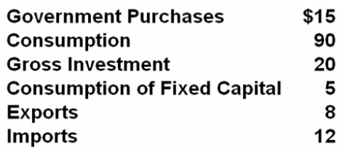
1. Refer to the above data. GDP is:
A. $116.
B. $121.
C. $125.
D. $150.
2. Refer to the above data. NDP is:
A. $116.
B. $121.
C. $125.
D. $150.
3. Real GDP and nominal GDP differ because the real GDP:
A. is adjusted for changes in the volume of intermediate transactions.
B. includes the economic effects of international trade.
C. has been adjusted for changes in the price level.
D. excludes depreciation charges.
4. If nominal GDP rises:
A. real GDP may either rise or fall.
B. we can be certain that the price level has risen.
C. real GDP must fall.
D. real GDP must also rise.

5. Using the table below, in which year was there a recession?

Year | Nominal  GDP | Price  Index | Real  GDP
1 | $ 550 | 140 | $ 393
2 | 560 | 145 | 389
3 | 590 | 150 | 393
4 | 600 | 152 | 395
5 | 620 | 155 | 400

A. year 2
B. year 3
C. year 4
D. year 5
ECONOMIC GROWTH - REVIEW

1. Use the diagram below to answer this question.

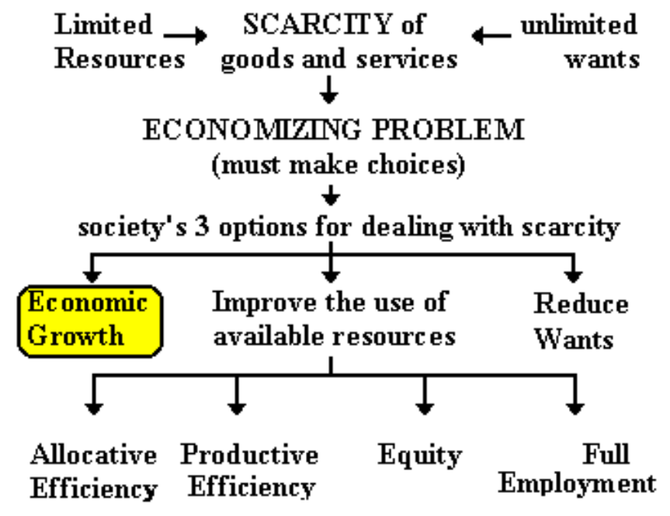

a. Define ECONOMIC GROWTH as shown in the diagram:

b. What CAUSES this type of economic growth?

c. Is this type of economic growth an increase in POTENTIAL GDP or ACHIEVING the potential?

2. Use the diagram below to answer the questions.

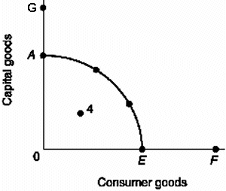

a. If the economy’s production possibilities curve is shown by curve AE, then draw in a new curve which indicates positive economic growth according to the 5 Es model.

b. Is this type of economic growth (1) an INCREASING the potential GDP or (2) achieving the POTENTIAL?

3. Use the diagram below to answer this question.

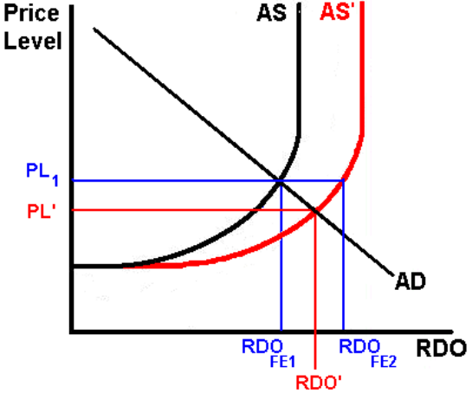
a. What would cause the AS curve to shift to the right?

b. Is this type of economic growth an INCREASE in potential GDP or ACHIEVING the potential?
4. Use the diagram below to answer this question.

a. If the economy illustrated by production possibilities curve AE is producing at point 4, what economic problem does this represent for this economy?

b. Assume that the economy moves from point 4 to a point on the curve. Draw an arrow to show the change.

c. Is this type of economic growth an INCREASE in potential GDP or ACHIEVING the potential?

5. Use the diagram below to answer this question.

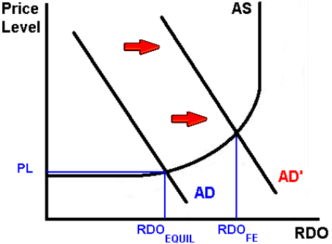

a. What would cause the AD curve to increase from AD to AD’ as shown in the graph above?

b. Is this type of economic growth an INCREASE in potential GDP or ACHIEVING the potential?

6. What are the two (three) definitions of economic growth used in class? State which definition is an INCREASE in potential GDP and which is ACHIEVING the potential?

7. Suppose an economy’s real GDP is $125 billion in year one and $130 billion in year two. What is the growth rate of its GDP?

Chapter 8 – Economic Growth – Quick Quiz

1. Growth is advantageous to a nation because it:
A. promotes faster population growth.
B. lessens the burden of scarcity.
C. eliminates the economizing problem.
D. slows the growth of wants.

2. Strong property rights are important for modern economic growth because:
A. they allow governments to extract the gains from private citizens' investments.
B. people are less likely to invest if they are fearful that others can take their returns on investment without compensation.
C. they ensure an equitable distribution of income.
D. business cycle fluctuations will be smaller and less likely to disrupt investment patterns.

3. Which of the following institutional arrangements is most likely to promote growth?
A. Patents and copyrights that expire quickly and are loosely enforced.
B. Strong government control over resource allocation decisions.
C. Unrestricted trade between nations.
D. All of these.

4. Free trade:
A. discourages growth by increasing competitive pressures on domestic firms.
B. encourages growth by effectively eliminating all patent and copyright barriers to growth.
C. discourages growth compared to circumstances where the government strongly controls foreign trade.
D. encourages growth by promoting the rapid spread of new inventions and innovations.

5. An outward shift of a nation's production possibilities curve:
A. ensures the nation of an increase in real GDP per capita.
B. ensures the nation of an increase in real GDP, but not of real GDP per capita.
C. neither ensures a nation of an increase in real GDP nor of an increase in real GDP per capita.
D. ensures a nation of an increase in both real GDP and real GDP per capita.

Use the list below to answer the following questions:
1. Improvements in technology
2. Increases in the supply (stock) of capital goods
3. Purchases of expanding output
4. Obtaining the optimal combination of goods, each at least-cost production
5. Increases in the quantity and quality of natural resources
6. Increases in the quantity and quality of human resources
6. Refer to the above list. As distinct from the demand and efficiency factors of economic growth, the supply factors of economic growth are:
A. 2, 5, and 6 only.
B. 2, 4, 5, and 6 only.
C. 1, 2, 5, and 6 only.
D. 1, 3, 4 only.
7. Refer to the above list. As distinct from the supply factors and efficiency factor of economic growth, the demand factor of economic growth is:
A. 1 only.
B. 4 only.
C. 1 and 3 only.
D. 3 only.
8. Refer to the above list. As distinct from the supply factors and demand factor of economic growth, the efficiency factor of economic growth is:
A. 1 only.
B. 4 only.
C. 1 and 3 only.
D. 3 only.
9. Which set of items in the above list would shift an economy's production possibilities curve outward?
A. 2, 5, and 6 only
B. 2, 4, 5, and 6 only
C. 1, 2, 5, and 6 only
D. 1, 3, 4 only
10. Which set of items in the above list would move an economy from a point inside its production possibilities curve to a point on its production possibilities curve?
A. 1, 2, 5, and 6 only
B. 3 and 4 only
C. 3 only
D. 1, 3, 4 only
ECONOMIC GROWTH – THE LESS DEVELOPED COUNTRIES -
Indicators of Economic Development

From the textbook: Characteristics of Developing countries (DVCs):

Role of agriculture:

Literacy rates:

Unemployment:

Population growth rate:

Type of exports:

Amount of capital equipment:

Production technologies:

Productivity:

Mark’s List: Characteristics of Less Developed Countries (LDCs):

1. GDP per capita:

2. Population Growth rates:

3. Occupational Structure of the Labor Force:

4. Urbanization:

5. Consumption per capita:

6. Infrastructure:

7. Social Conditions

literacy rates:

life expectancy:

health care:

caloric intake:

infant mortality:
ECONOMIC GROWTH – THE LESS DEVELOPED COUNTRIES -
The absolute income gap between rich and poor nations has been widening.

For example,

LDC: if per capita income is $400 per year and there is a 2% growth rate, by how much will income increase?

IAC: Where per capita income is $20,000 per and there is a 2% growth rate, by how much will income increase?

ECONOMIC GROWTH – THE LESS DEVELOPED COUNTRIES - AID QUIZ
What fraction of the U. S. federal government's budget is spent on FOREIGN AID?

1% | 5% | 10% | 15% | 20% | 25%
HOW MUCH AID DO WE GIVE as a % of our GDP (income)?
0.2% | 0.5% | 1% | 5% | 20% | 15%

REVIEW: Indicators of the Level of Economic Development
NOTE: Do not confuse “indicator” with “cause”

INDICATOR IAC / MDC DVC /LDC

Role of agriculture _______________ _______________

Level of industrialization: _______________ _______________

Literacy rates: _______________ _______________

Unemployment: _______________ _______________

Population growth rate: _______________ _______________

Type of exports: _______________ _______________

Amount of capital equipment: _______________ _______________

Production technologies: _______________ _______________

Productivity: _______________ _______________

GDP (income) per capita: _______________ _______________

Structure of the Labor Force: _______________ _______________

Urbanization: _______________ _______________

Consumption per capita: _______________ _______________

Infrastructure: _______________ _______________

literacy rates: _______________ _______________

life expectancy: _______________ _______________

caloric intake: _______________ _______________

infant mortality: _______________ _______________

birth rates: _______________ _______________

Chapter 22W – Less Developed Countries – Quick Quiz

1. Approximately what percentage of the world's income is received by the richest one-fifth of the world's population?
A. 20 percent
B. 30 percent
C. 60 percent
D. 80 percent
2. Most of the world's population lives in:
A. North America.
B. the DVCs.
C. Western Europe.
D. the IACs.
3. The DVCs are:
A. located primarily in Northern Europe.
B. located primarily in Western Europe.
C. located primarily in Africa, Asia, and Latin America.
D. more-or-less evenly distributed over the various continents.
4. Increases in the total real output of many DVCs do not increase the nation's standard of living because:
A. diminishing returns may be encountered in increasing total output.
B. population increases may dissipate the increase in real output.
C. disguised unemployment in agriculture will persist.
D. surplus farm labor may move from rural areas to industrial areas, causing unemployment.
5. In recent years the industrially advanced nations as a group have provided foreign aid amounting to about what percentage of their aggregate outputs?
A. .25 percent
B. .7 percent
C. 1 percent
D. 2 percent
6. Economic growth in the DVCs might increase if IACs:
A. reduce their tariffs and import quotas.
B. encourage more immigration of high-skilled DVC workers.
C. outlaw direct private investment abroad by IAC corporations.
D. discourage capital flight to the DVCs.
7. Large agricultural subsidies for food and fiber in IACs hurt the economies of the DVCs by:
A. causing higher prices for imported food products.
B. lowering saving rates in the DVCs.
C. encouraging "brain drains" from the DVCs.
D. reducing world agricultural prices and thus export income of the DVCs.

