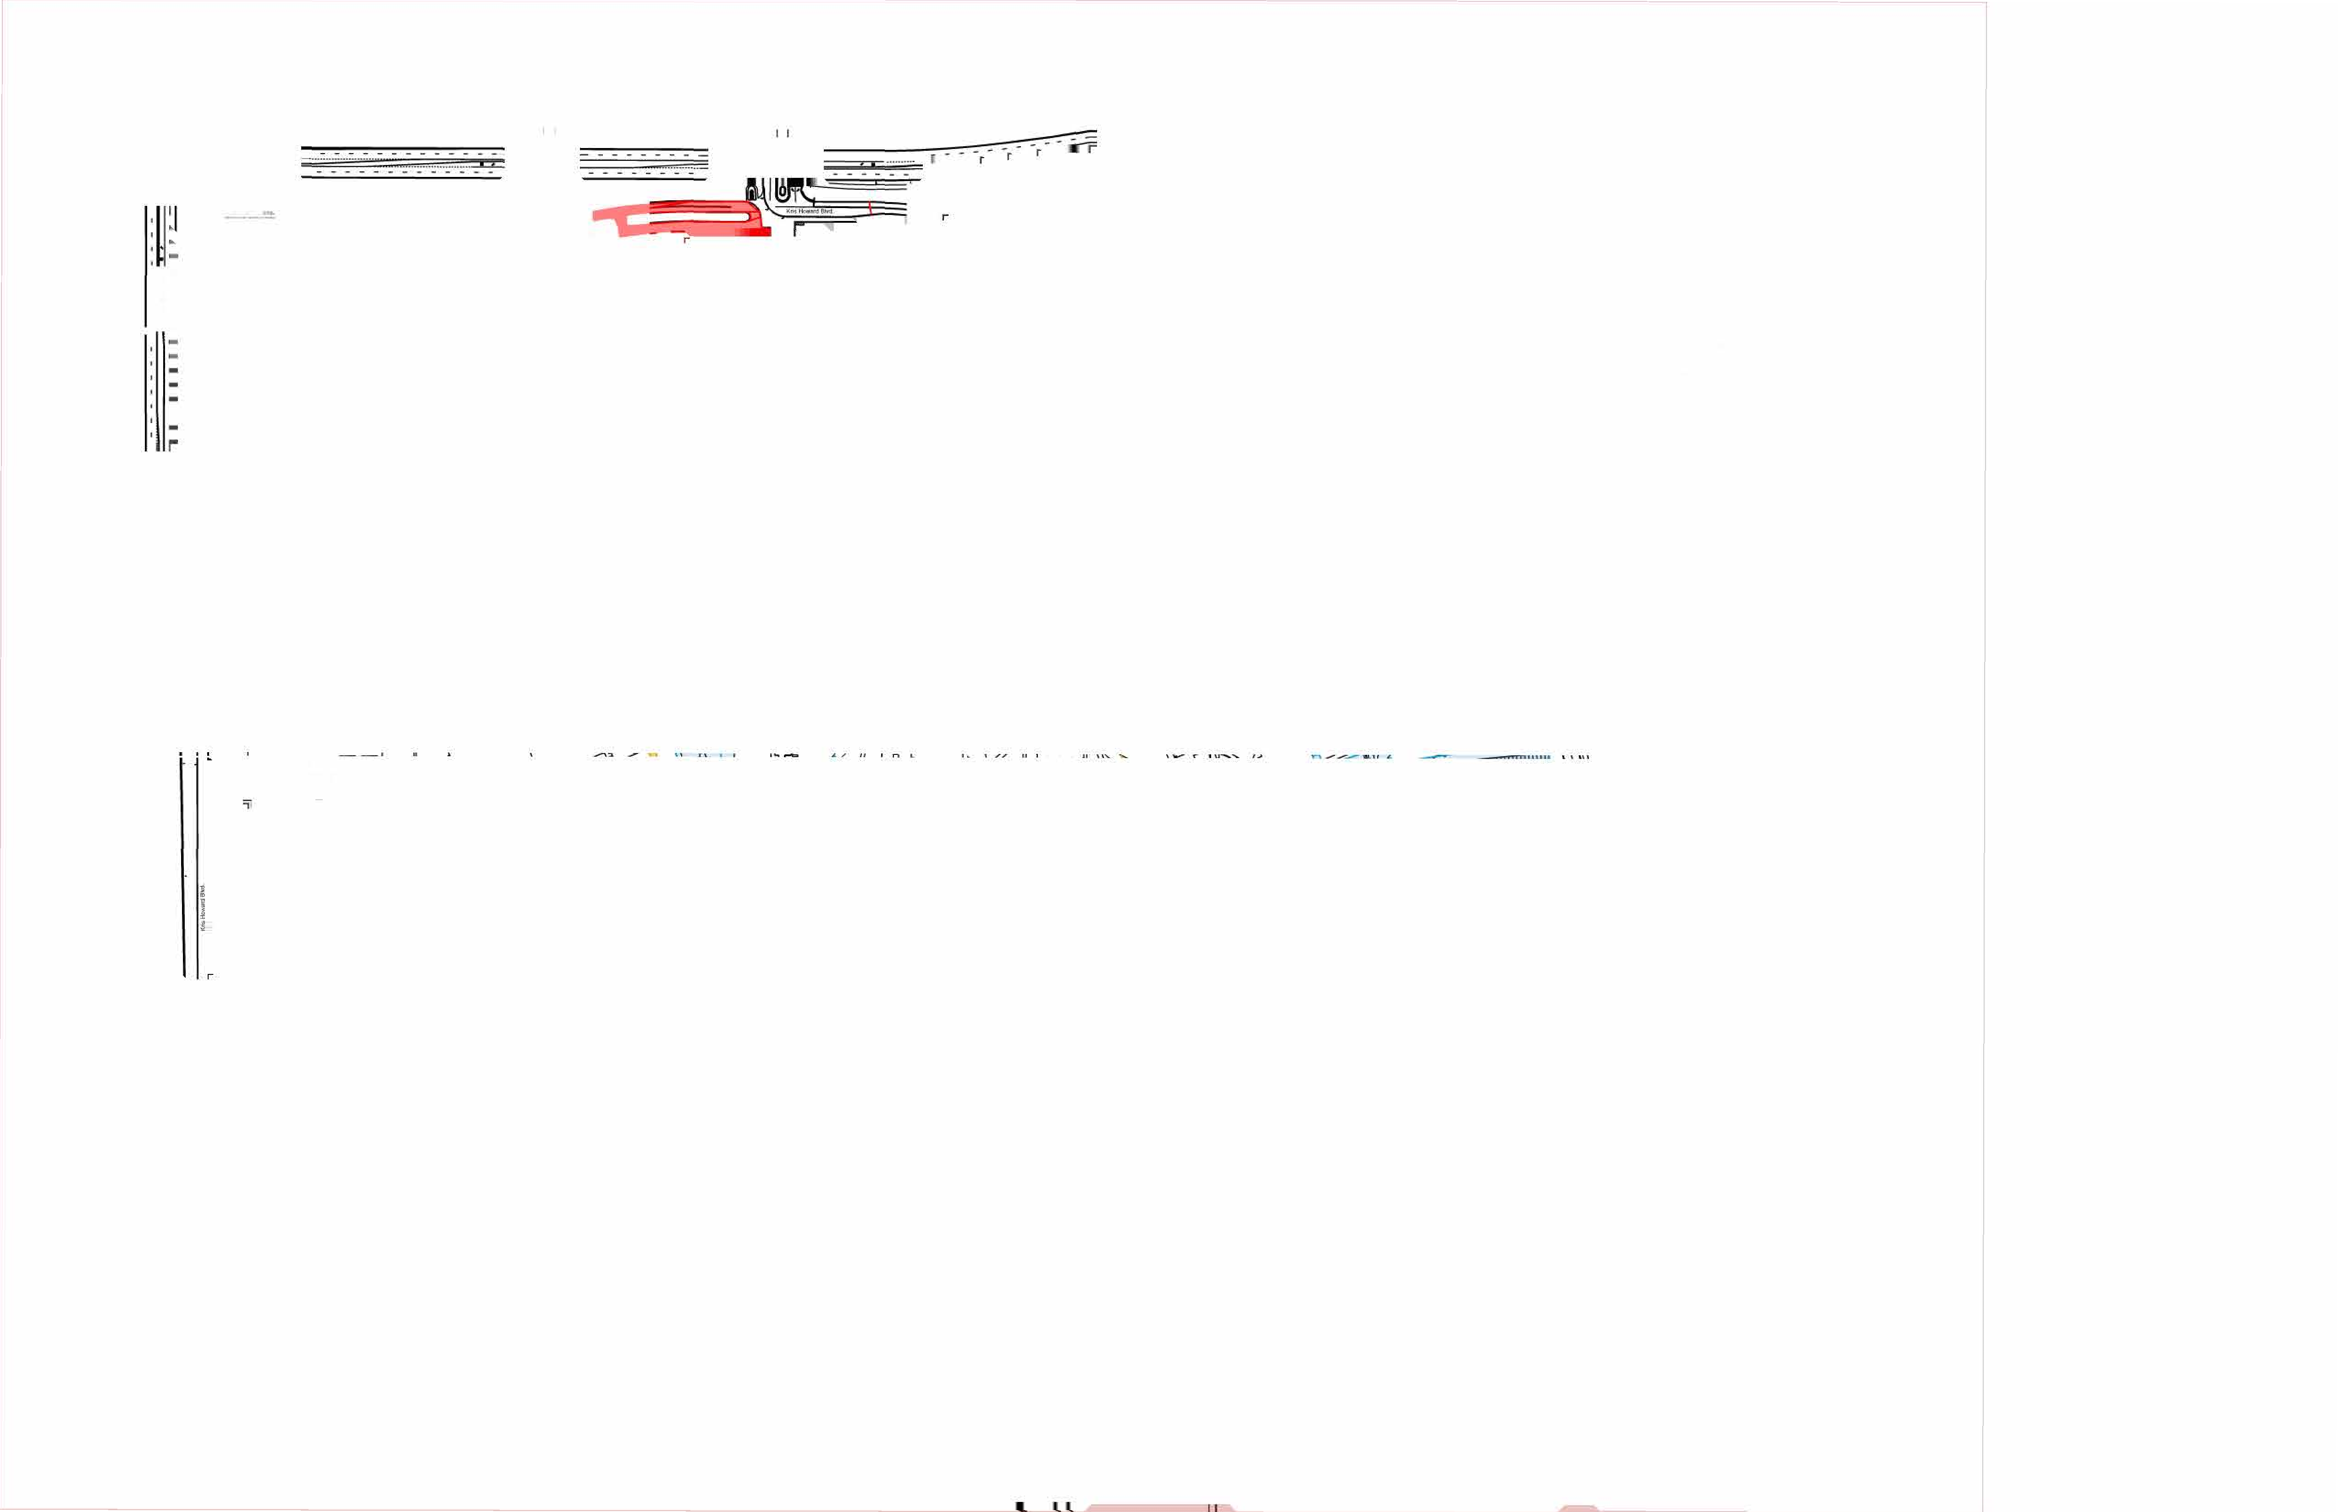
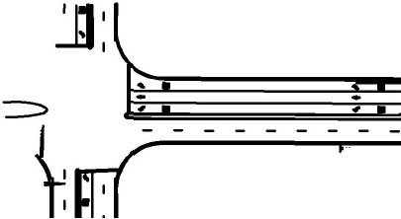
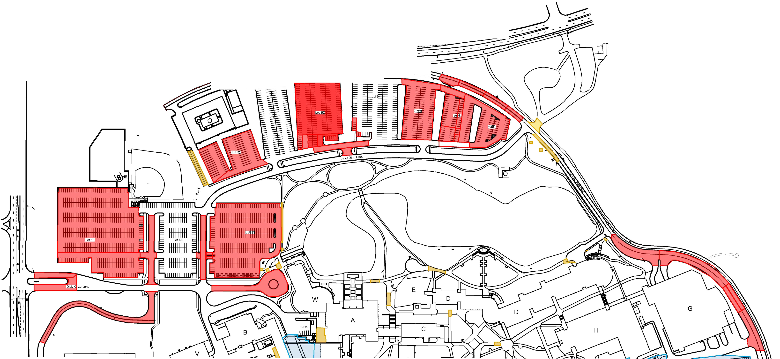
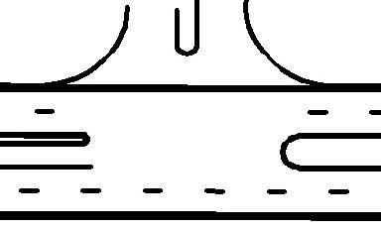
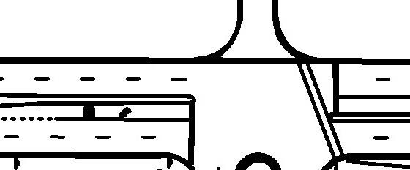
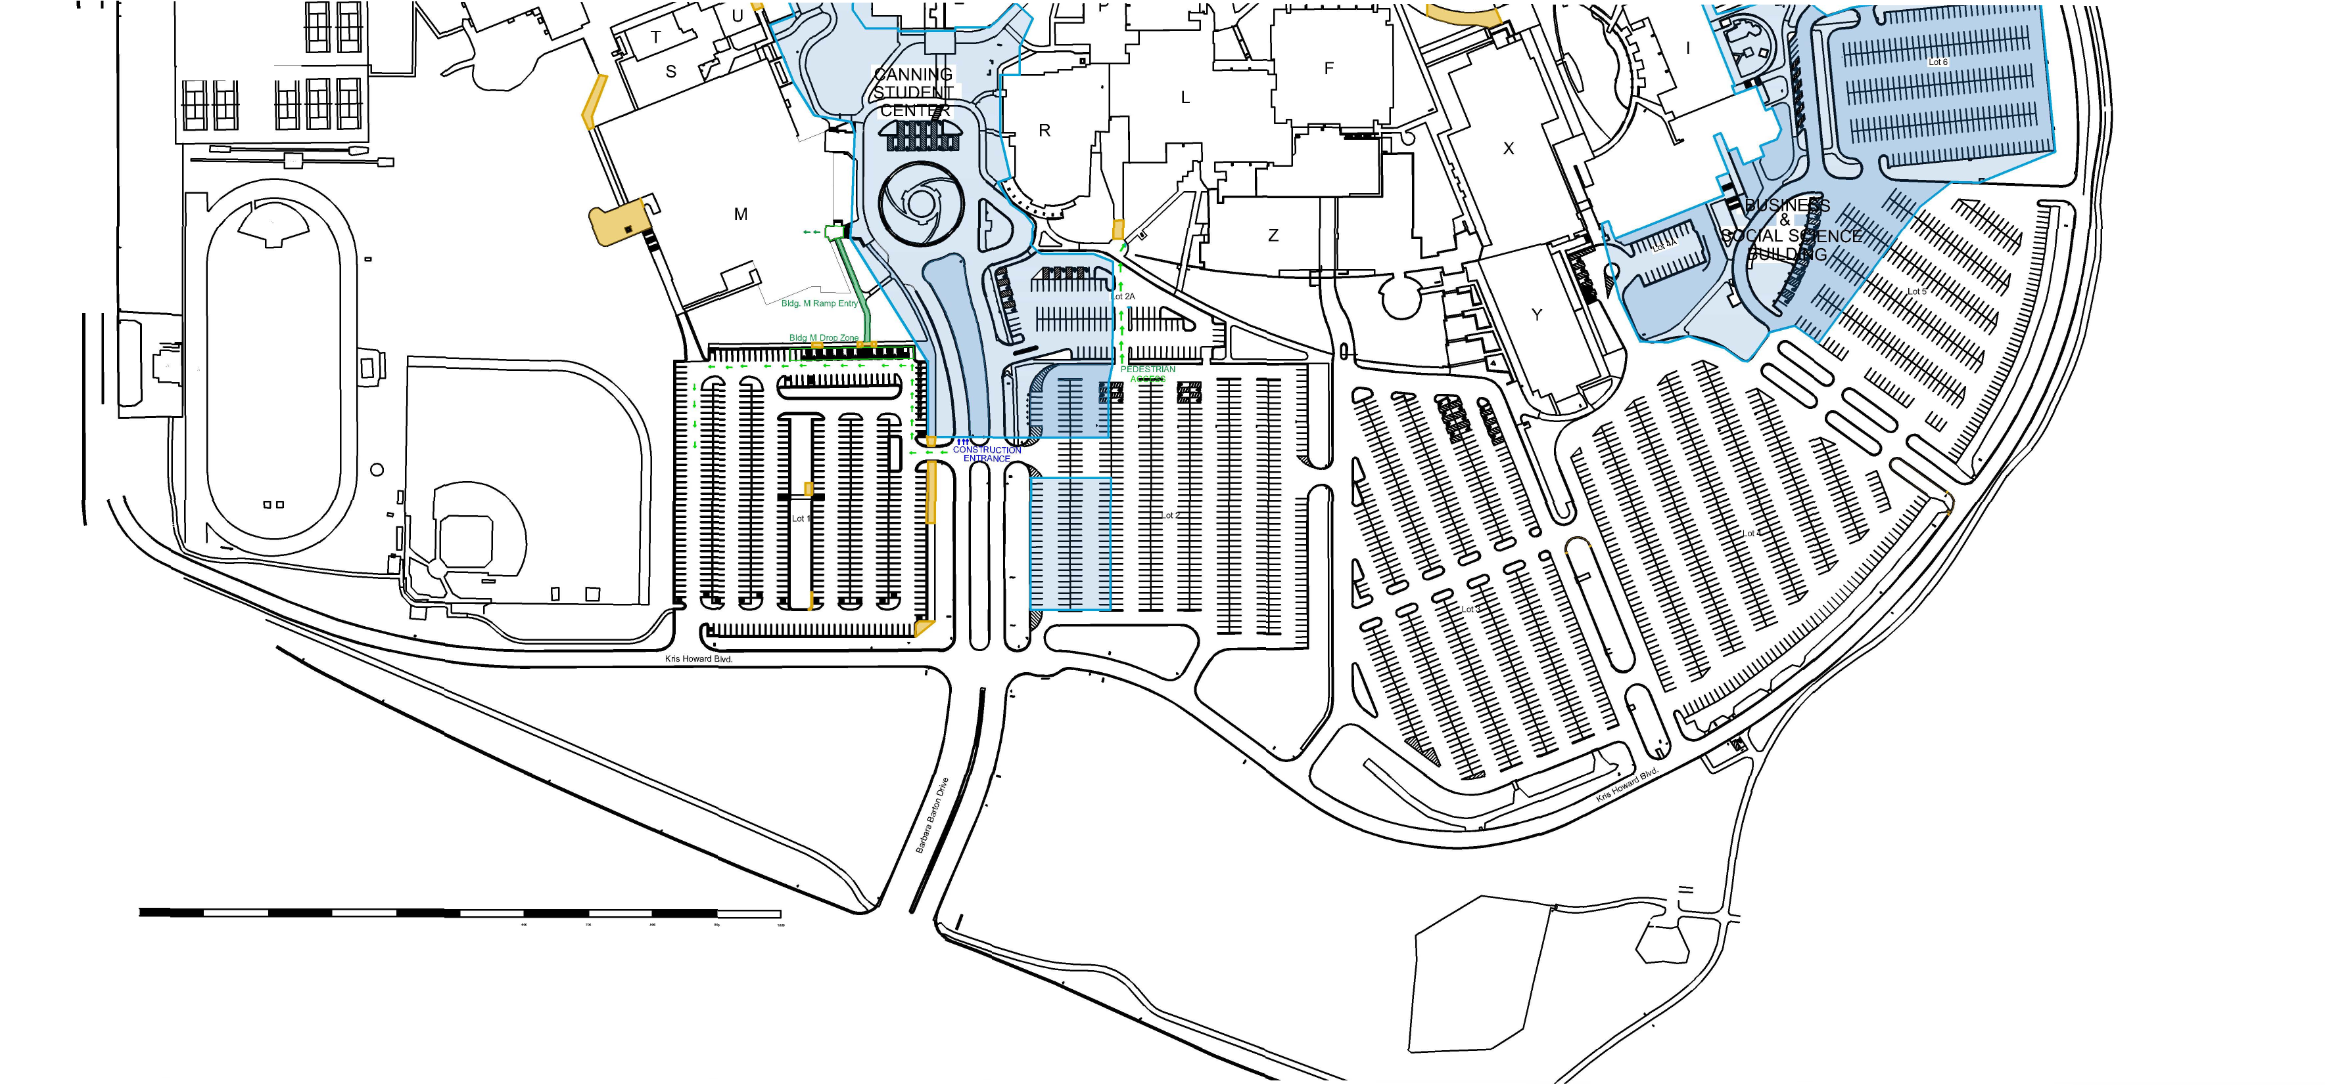
,

!
•
:
.
' '
I
\1
.
:
'
'
-
I
I
I
.,,,
:::.-:-
_-::..-.=..'7..:._
fflfflfflffl

ffl
---
----

3

LEGEND
•
Fencing
•
Pedestrian
Access
•
Concrete
Work
•
Asphalt
Work

