I
F
L

X

ENTRANCE OPEN LOBBY CEILING WORK
J

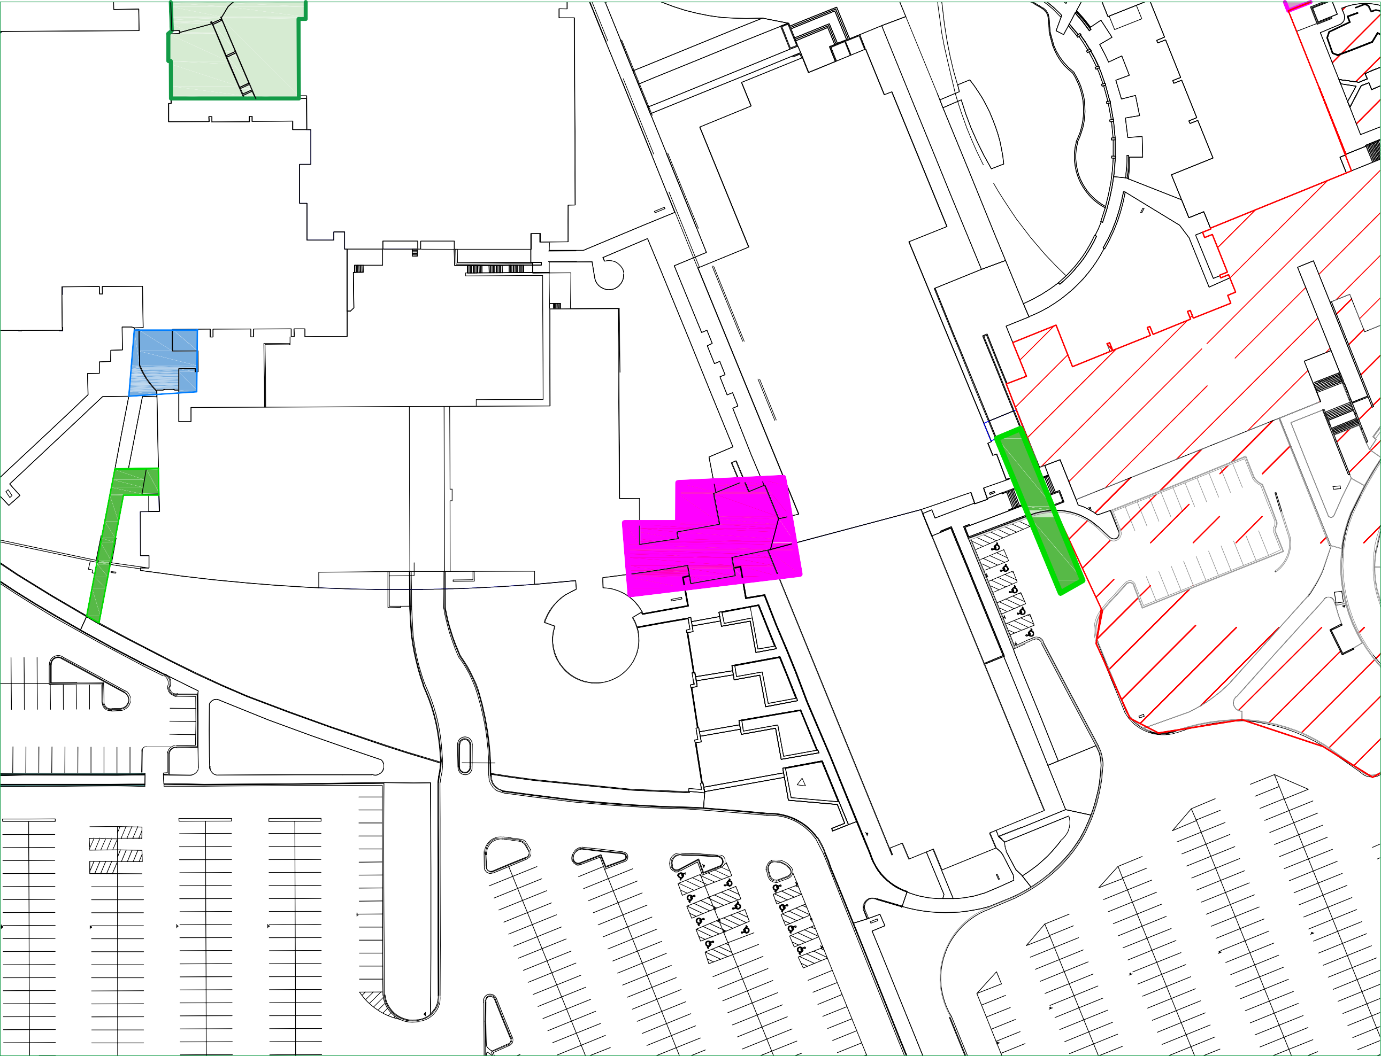

ot 2A

DESTRIAN CESS
Z

Alt. Entrance during construction

LOBBY CLOSED- NO ACCESS

12/15/25-1/9/26
BUSINES
& SOCIAL SCI
BUILDIN
Alt. Entrance during construction

Y

