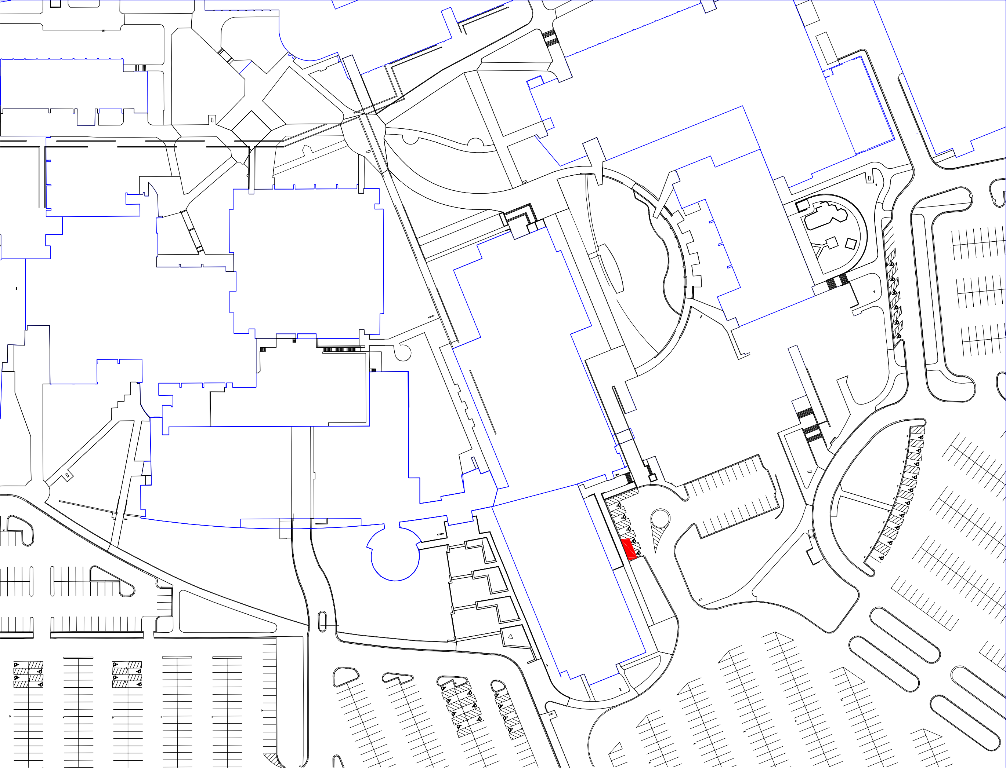
D G
RAC
EQUIPMENT
ENCLOSURE
DUST

C H
. TUNNEL

. TUNNEL
. TUNNEL

P

I
F
L

X

Z
Lot 4A

Lot 2A
Y

