Request for Proposal Q01219
Insurance Brokerage Project RFP
Addendum #1
January 23, 2026

All changes to the Request for Proposal (RFP) are valid only if they are issued by written addendum. Each proposer must acknowledge receipt of any addenda in their submission. Each proposer, by acknowledging receipt of any addenda, is responsible for the contents of the addenda and any changes to the proposal therein. Failure to acknowledge receipt of any addenda may cause rejection. If any language or figures in this addendum conflict with the original document, this addendum shall prevail.

This addendum consists of the following clarifications and amendments:
- Please reserve February 23rd for interviews. Several One hour timeslots have been reserved on that date for interviews. You will be notified if you have been shortlisted for the interview phase of this RFP.

This addendum consists of questions received to date and their Responses:
- Can you please provide historical increases for the Medical + Rx program over the last three years?
Answer: Attached

- Can you provide any items on the current plan designs and EE rates in place today?
Answer: Attached

- Is the medical program fully insured or self-insured today? If not, has it been considered recently and if so, how long has the program been in place?
Answer: Our plan has been fully insured since October of 1998. We have looked at self-insuring relentlessly and have never received savings from Blue Cross Blue Shield in their renewal proposals. However, the College would like to have the successful respondent review and help to College to determine appropriate self-insurance levels if it is in the best interest of the college.

- What are the top 3 priorities for the Board and senior leadership as it pertains to the employer healthcare program?
Answer: Cost Containment – Holistic & Flexible Benefits – Data Transparency to use in evaluating cost effectiveness and quality of care.

- Can you provide commentary on any restrictions in terms of the benefits (i.e., Collective Bargaining Agreements, etc.)
Answer: Collective Bargaining Agreement language summary below:
Medical Benefits
Effective January 1, 2018, the Board shall contribute the following percentages towards the named plans:
1) PPO Legacy Plan = 75%
2) PPO Wellness = 82%
3) HMO Illinois = 82%
4) HMO Blue Advantage = 84%
5) BC/BS HDHC = 80%
Effective for the 2018 plan year, should the annual premium increase by fifteen percent (15%) or more for either the HMO or the PPO over the previous year’s premium for either the HMO or the PPO respectively, the Insurance Committee shall recommend plan design changes to reduce the premium increase to fifteen percent (15%) or less for the plan that the premium is fifteen percent (15%) or more.

- Has the College experienced any performance issues with the current carriers/vendors?
Answer: No

- What are the top three priorities to be addressed immediately?
Answer: Cost Containment, education of our insurance committee in preparation for necessary cost containment changes, and data collection.

- Please confirm our understanding from the pre-bid call that we are able to use suppliers to meet the 5% BEP participation goal, at a dollar-for-dollar arrangement.
Answer: Correct. The dollars can be achieved by subcontracting with suppliers or other firms to perform work or for buying supplies. All firms utilized should be certified by the Commission on Equity and Inclusion.

- Please describe the current wellness program/initiatives and any that are being considered.
Answer: We promote the Blue Cross Tools, we have an EAP and we have an internal Harper Wellness program. I have pasted the screen snip of our internal wellness page below.

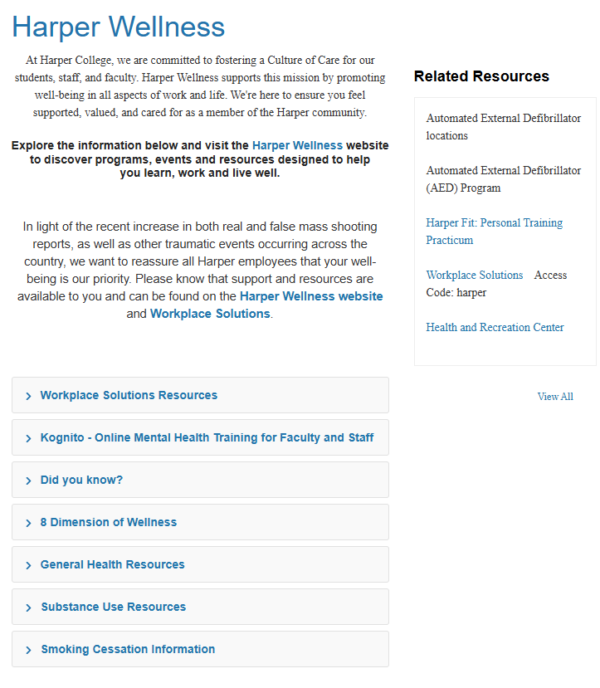
- Do the different union and non-union groups all have the same plan designs and the same insured rates?
Answer: Yes, all employees regardless of union group have the same insurance choices and pay the same premiums.

- A census file that includes coverage tiers and elections
Answer: Attached

- The latest Open Enrollment materials
Answer: Attached

- Whether Harper College currently has a stated 1–3-year strategy in place; if so, please share
Answer: No Formally stated strategy in place.

- A breakdown of union representation, including the number of employees in each union.
Answer: Same Attachment as Question #12

- A list of current vendor partners and the services they provide.
Answer: This is answered in the Power Point attachment for Question #2

- “The following benefit programs will be considered for this scope of work: Medical; Dental; Vision; Life; Accidental Death/Disability; Long Term Disability; Short Term Disability; Enrollment Assistance; Identity Protection; Home/Auto Discounts; Pet Insurance; Flexible Spending Accounts; Health Savings Accounts; Employee Assistance Program; Section 125 plan document maintenance.” Could you please confirm the intended scope for Employee Assistance?
Answer: We use Oracle Fusion for our benefits and enrollment is completely online. We do not need help with the actual enrollments. We are talking more about employee education.

- Facilitate open enrollment in collaboration with the College” – What specific activities does this entail?
“Assist the College when needed with the development of communications and implementation for new plans or changes to current plans” – Could you elaborate on what support is expected?
Answer: Please see the answer to question #16 and to build upon that, we are talking about all of the data needed to back up change with the Board and the unions. This would include descriptive reports, predictive modeling, prescriptive analytics, talking points, and help with communicating change.

- Is Harper College Fully Insured today? The statement “Review and make recommendations and help the College establish self-funded insurance structures” leads me to believe this to be the case.
Answer: Yes, please see question #3

- As discussed, at the Pre-Bid meeting yesterday, it seemed like proposals are to be delivered virtually. On page 11 of the RFP document it notes “Proposals (RFP Response) may be submitted in a sealed envelope, addressed as follows:” Could you please clarify which method of submission will be utilized?
Answer: Please use the link in the proposal to submit responses virtually. https://www.dropbox.com/request/kDV0hFrbWSV1yHmaLQnd

The Following documents are attached.
Q1 – Health Insurance Premium Increase History
Q2 – New Employee Benefits Overview 2026
Q2 – 2026 Insurance Premiums
Q12 – Census Report
Q13 – Open Enrollment

Sincerely,

Jewell M. Jackson
Purchasing Manager
Purchasing@harpercollege.edu.

