�;'"� GRUMMANIBUTKUS

------ ENERGY EFFICIENCY CONSULTANTS AND SUSTAINABLE DESIGN ENGINEERS

ADDENDUM 1

Date: | July 16, 2026
To: | Elvia Fernandez Harper College  1200 West Algonquin Road Palatine, IL 60067 | Re: | Harper College  Tunnel Repairs Phase IV GBA #P24-0105-00  Harper College #Q01249
Cc: | Christina Snitko Harper College  1200 West Algonquin Road  Palatine, IL 60067

This Addendum forms a part of the Bidding Documents and amends the original documents dated July 2, 2026.
Acknowledge receipt of this addendum in the space provided on Bid Form. Failure to do so may subject bidder to disqualification.

GENERAL

- There was a discrepancy between the WebEx Link for submission of bids in the newspaper advertisement for bids and the project manual. The project manual indicates the correct link. The link has been tested to ensure it is functional.

Correct info:
Bids will be opened publicly directly following the deadline for receipt of bids via
Webex https://harpercollege.webex.com/ha rpercollege/j.php?MTID=m845573a47744c71 b8608c57daf875 157

QUESTIONS
- Would it be possible to obtain the pre-bid meeting attendance sheet for the subject solicitation?

See attached.

- Can you please provide the PSI for the steam and pumped steam condensate?

Steam operates at 100psig. The pumped condensate pressure is variable. All condensate piping in Specification 23 2213 is the same material. fittings, joints, and joining methods.

- Can you please provide clarification on Pipe Support Scope of Work? The pipe support schedules on M1.00, M1.01, and M1.02 seem to be incomplete. There are supports and notes that are cut off. Can you please provide a scope for the support work along with notes 1-7 that are missing?

Refer to the updated drawings issued with Addendum 1.

1 of 2

DRAWINGS

M1.00 (issued)
1. Revised "Main Utility Tunnel Pipe and Pipe Supports Scope of Work" schedule as indicated.

M1.01 (issued)
1. Revised "Main Utility Tunnel Pipe and Pipe Supports Scope of Work" schedule as indicated.

M1.02 (issued)
1. Revised "Main Utility Tunnel Pipe and Pipe Supports Scope of Work" schedule as indicated.

END ADDENDUM

p:124 projectslp24-0105-00harp\03 issued\26 07 16 addendum 1126 07 16 addendum 1.docx

2 of 2


SIGN IN & Please Print & Attach your Business Card
7/9/2026
Pre-Bid Meeting
Q01249 Tunnel Repairs - Phase IV
NAME COMPANY Phone EMAIL

Af/fru� C!..uwr./rq- Harper College 847 925-6622 purchasing@harpercollege.edu
:::11�r�1"�'n:��ff.v;l ;e;J�... �\ 1::r:o:::t:+::::::i�t��l,�rc�ri\s:J:/:V:\l�ech:Jc:uI1:�1cr�t( ::::::1G�1;o::1�;.7�·2�0:i-9-C:i;i:t:i::'S:::5.�/1i,,@rM;�e.\o;�tf;1�co{+Jk.J�.�l,l�(}f�/Si�ii:f��f�)o,:l�'lt(�p.1�-�::"::
...�. ..St.cUJJ.tLVl;c).�t -·..........\���.Cih.'�....................(� q.J...Y?Y.?.-7:.51�......0 .1:.?.Y.�9.h�.o/.�(.�.�C!�!'.���?/...<;./!'
.UIJ.vs.\nnu...�v.1.-i.t1:-e.9..........� ..co.,ft:.&jR........C.rf?)..9.?:-��.(t?.�r7 .......?. ;>.(1..1.S5?..@..���(�
1).o_v� lif.c1.....................fuv..�1'11:\•'.\M¥.".'.�....--�).\� �-\�.?.S:.........Jh�Jg-°-:}f\J�dd�s,...

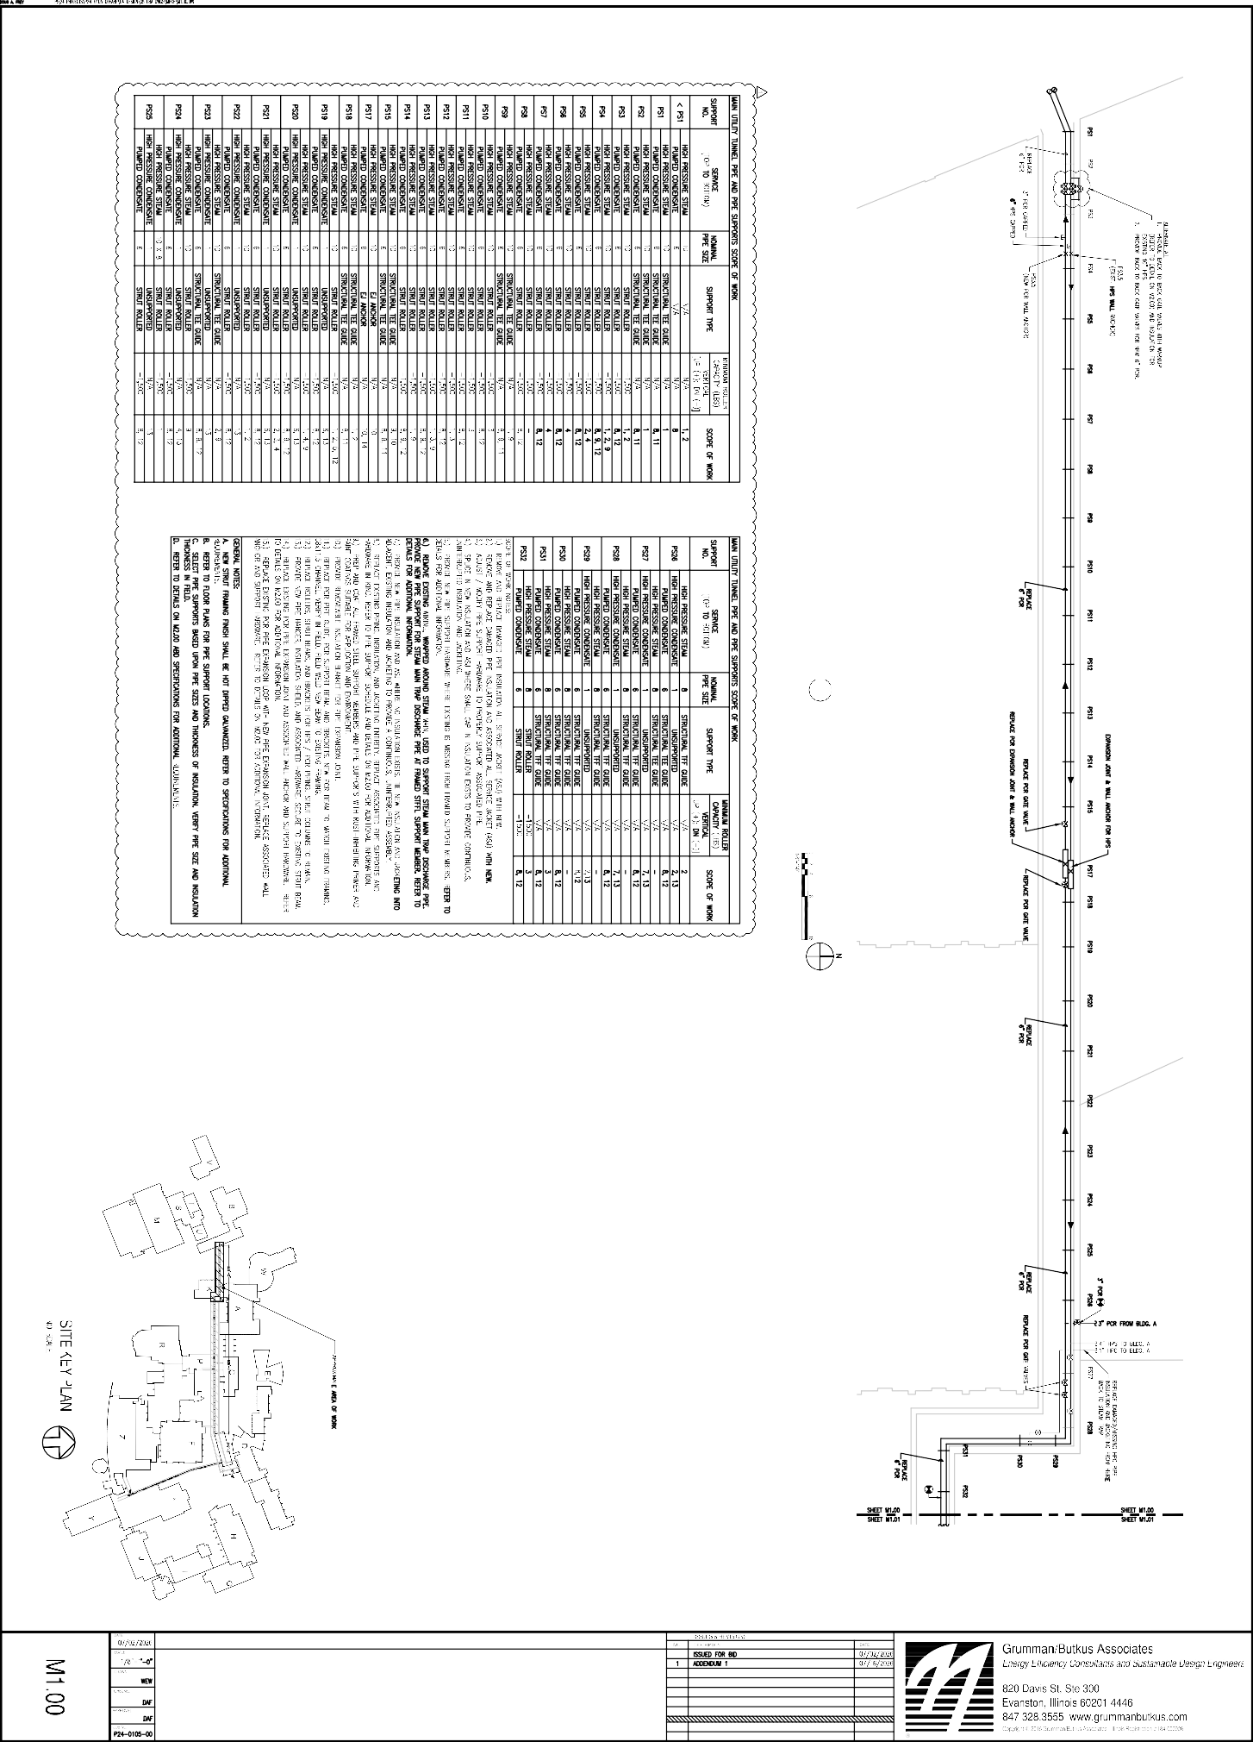
UTILITY TUNNEL MECHANICAL PLAN - AREA 1
1
N

UTILITY TUNNEL MECHANICAL PLAN - AREA 1 TUNNEL REPAIRS PHASE IV
HARPER COLLEGE
1200 WEST ALGONQUIN ROAD PALATINE, ILLINOIS 60067-7398

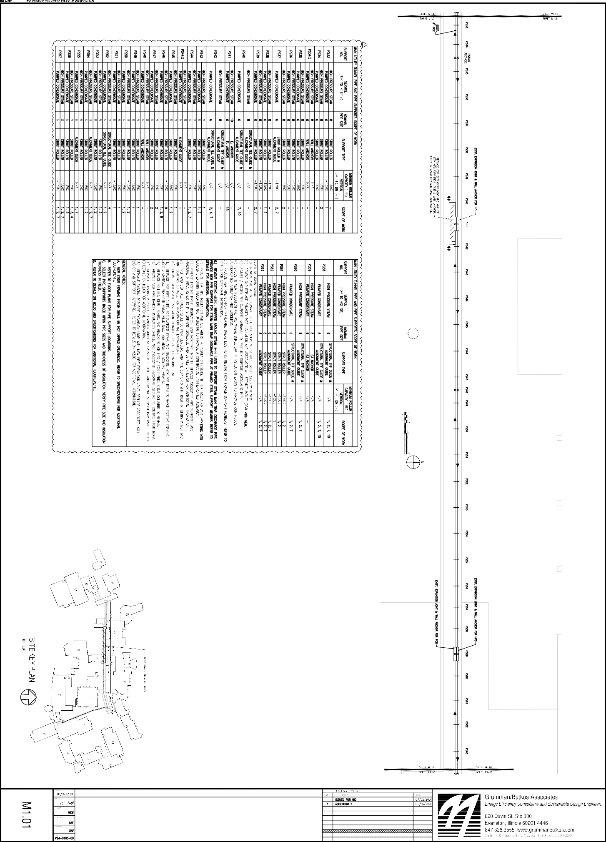
UTILITY TUNNEL MECHANICAL PLAN - AREA 2
1
N

UTILITY TUNNEL MECHANICAL PLAN - AREA 2 TUNNEL REPAIRS PHASE IV
HARPER COLLEGE
1200 WEST ALGONQUIN ROAD PALATINE, ILLINOIS 60067-7398

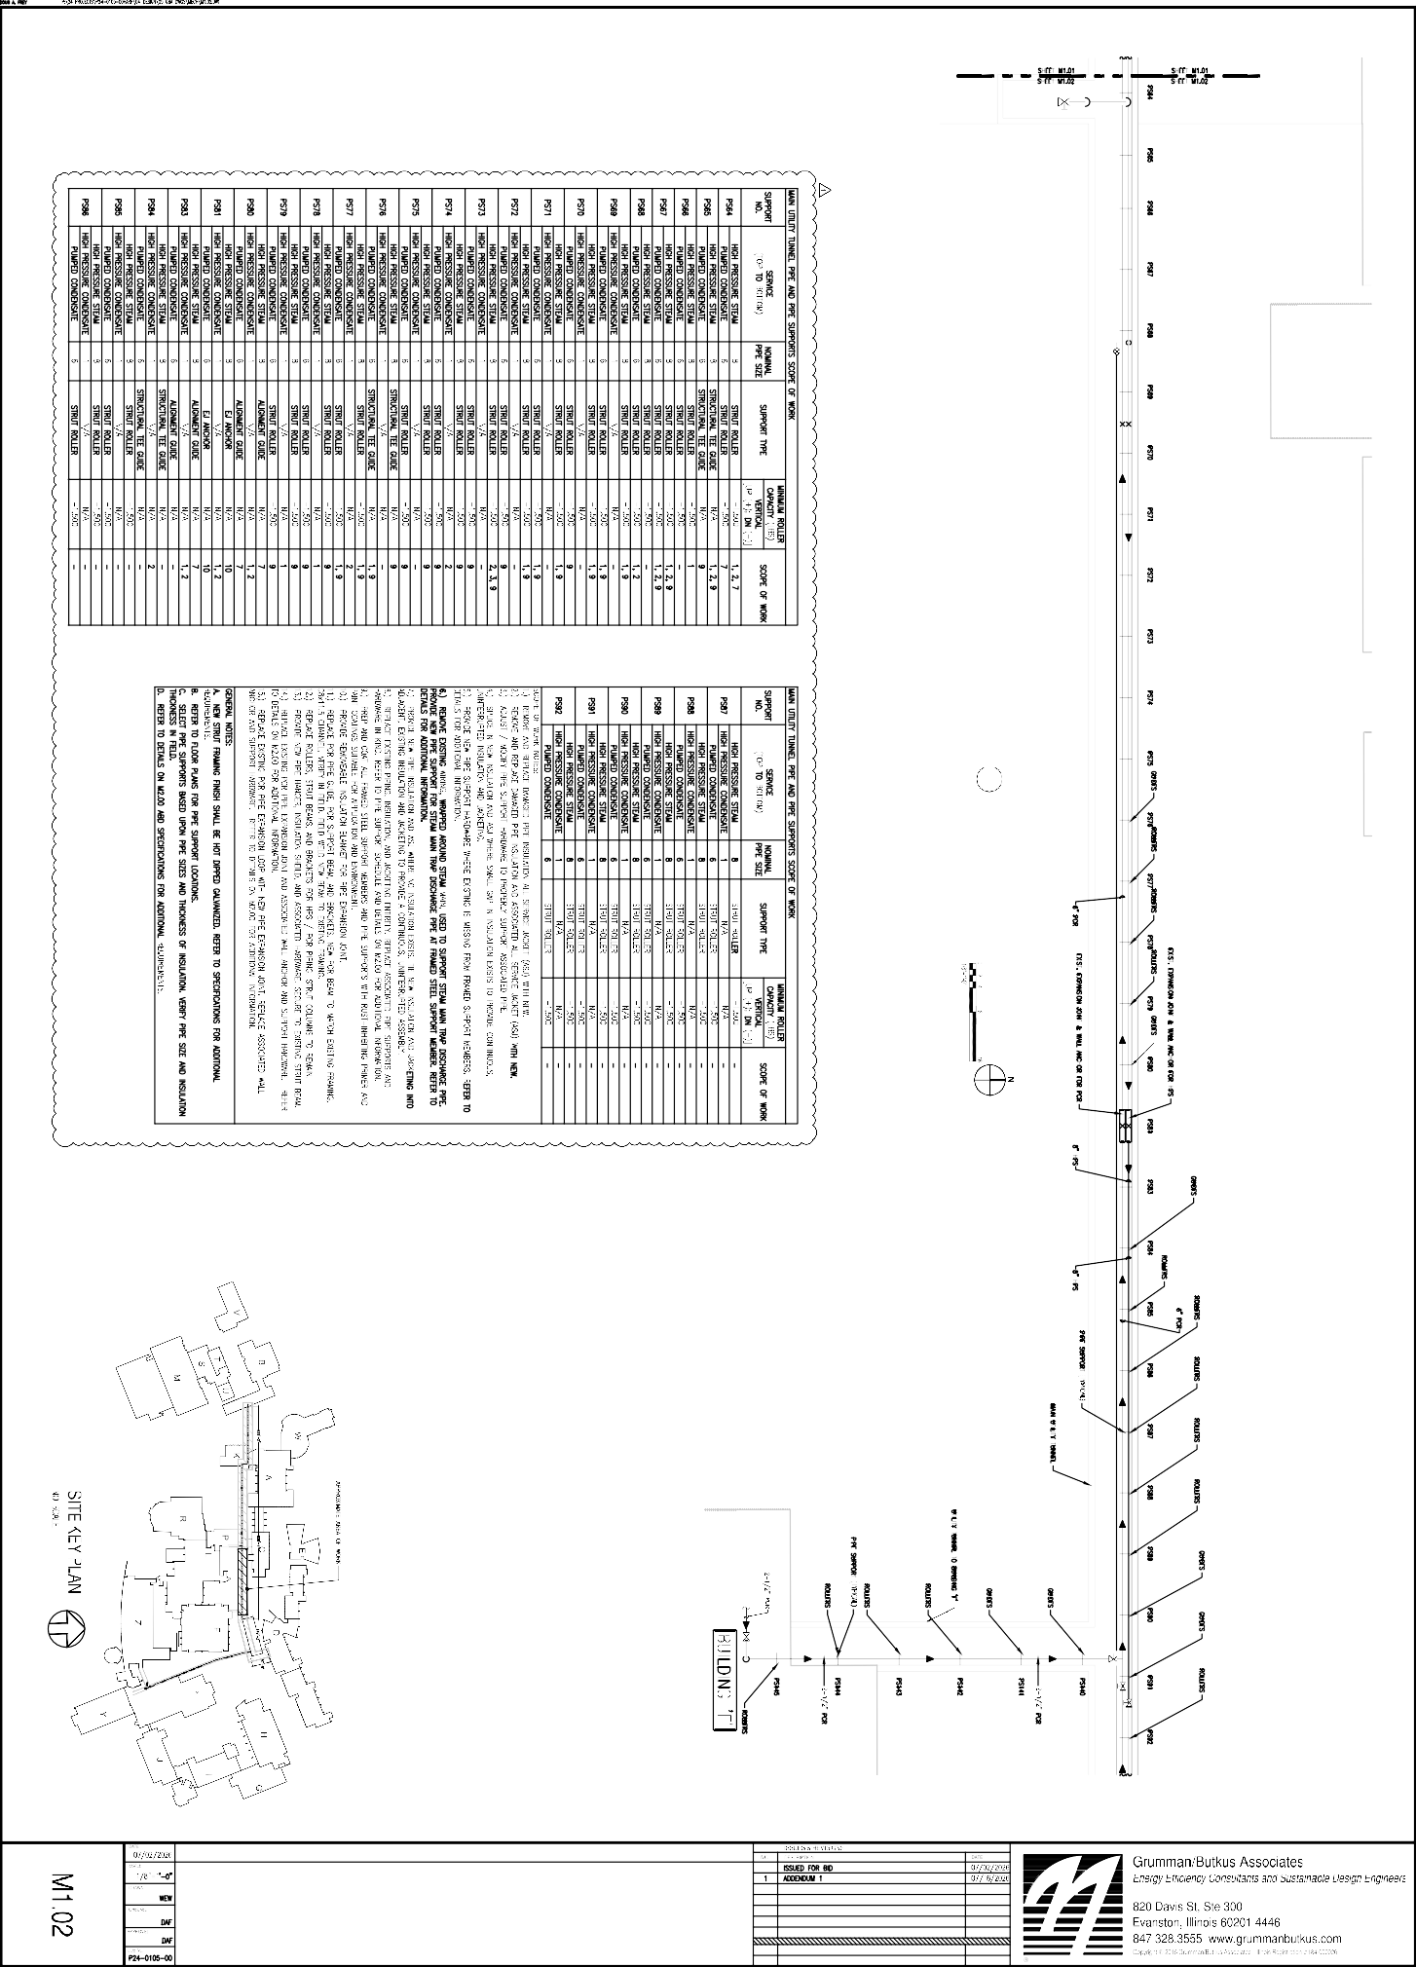
UTILITY TUNNEL MECHANICAL PLAN - AREA 3
1
N

UTILITY TUNNEL MECHANICAL PLAN - AREA 3 TUNNEL REPAIRS PHASE IV
HARPER COLLEGE
1200 WEST ALGONQUIN ROAD PALATINE, ILLINOIS 60067-7398

