AGREEMENT BETWEEN WILLIAM RAINEY HARPER COLLEGE
AND

HARPER 512 ASSOCIATION, IEA-NEA FY2026-2028

August 2026

CORE VALUES

RESPECT

We demonstrate Respect by interacting with and caring for others in a way that adds dignity to ourselves, our relationships and our organization by:
- valuing and celebrating the uniqueness of individuals and their strengths;
- expressing appreciation for our colleagues’ time, efforts and contributions;
- encouraging multiple perspectives.

INTEGRITY

We demonstrate Integrity by supporting an honest and ethical environment by:

- respecting confidentiality and acting in a trustworthy manner;
- being accountable for our actions and adhering to policies and procedures;
- making decisions that are fiscally and socially responsible.

COLLABORATION

We demonstrate Collaboration by working internally and externally toward shared goals to create a more positive outcome by:
- actively listening, responding to others with empathy;
- practicing open and honest communication and sharing information that is essential for success;
- using positive humor to foster a healthy and enjoyable environment.

EXCELLENCE

We demonstrate Excellence by setting and pursuing high standards of professionalism and competency by:
- providing exceptional service to all while demonstrating pride in our work;
- welcoming new challenges and seeking opportunities for growth and development;
- encouraging and empowering each of us to achieve our best.

2

TABLE OF CONTENTS
Agreement . . . . . . . . . . 4
Article I. Recognition . . . . . . . . 4
Article II. Dues Deduction . . . . . . . 4
Article III. Non-Discrimination . . . . . . . 5
Article IV. Board Rights. . . . . . . . 5
Article V. No Strikes . . . . . . . . 7
Article VI. Grievances . . . . . . . . 7
Article VII. Hours of Work, Overtime, and Call-Back Pay . . . 8
Article VIII. Seniority . . . . . . . . 11
Article IX. Leaves of Absence . . . . . . . 13
Article X. Vacations . . . . . . . . 14
Article XI. Sick Leave . . . . . . . . 16
Article XII. Holidays . . . . . . . . 18
Article XIII. Insurance . . . . . . . . 19
Article XIV. Other Leave With Pay . . . . . . 21
Article XV. Military Leave . . . . . . . 22
Article XVI. Wages . . . . . . . . 22
Article XVII. Retirement . . . . . . . . 24
Article XVIII. Safety and Health . . . . . . . 24
Article XIX. General . . . . . . . . 25
Article XX. Waiver and Entire Agreement . . . . . 27
Article XXI. Savings . . . . . . . . 28
Article XXII. Term of Agreement . . . . . . . 29
APPENDIX “A” Wage Rate Ranges . . . . . . 30

AGREEMENT

This Agreement is entered into by and between the BOARD OF COMMUNITY COLLEGE DISTRICT NO. 512, COUNTY OF COOK, LAKE, KANE AND MCHENRY AND STATE OF
ILLINOIS (hereinafter referred to as the "Board") and HARPER 512 ASSOCIATION, IEA-NEA, (hereinafter referred to as the "Union").

Article I. Recognition

  - The Board recognizes the Harper 512 Association, IEA-NEA as the exclusive collective bargaining representative for the full-time and part-time employees in the following classifications: Painter, Custodian, Maintenance Helper, Equipment Mechanic, Groundskeeper, Maintenance Mechanic, HVAC Mechanic Operator, Warehouse/Driver, and Utilities Mechanic. These classifications shall not be arbitrarily altered during the term of the Agreement. This Agreement shall apply to other classifications which may be established within the scope of duties now and historically included within the list of the classifications.

Supervisors, managerial, confidential, professional employees, guards, and all other employees shall be excluded from the bargaining unit. As used herein, "part-time" shall mean an employee who shall be regularly employed less than forty (40) hours per week and "temporary" shall mean an employee who shall be regularly employed less than ninety (90) continuous workdays. The definition of the term "supervisor" shall be as defined in the Illinois Educational Labor Relations Act. As used hereinafter the term "employee" shall be limited to the employees in this bargaining unit. Nothing herein shall be construed as to preclude membership in the Union by any person employed by the Board.

  - This Agreement shall not be construed to prevent the Board or any administrator from meeting with and coaching any employee for the purpose of hearing the views and proposals of such employee. However, it is understood that the Union is the exclusive bargaining agent of the employees in the bargaining unit described in Section 1.1. No employee, either orally or in writing, shall enter into any agreement or arrangement that is contrary to, or conflicting with the terms and conditions of this Agreement.

  - Recognition of the Union as bargaining agent is not intended as a guarantee, implicit or implied, that any work currently or subsequently performed by employees covered by this Agreement shall continue to be performed by these employees or as a guarantee of employment to any employee.

Article II. Dues Deduction

  - The Board shall deduct regular Union dues from the pay of each employee who has authorized the same in writing such to be effective no later than thirty (30) calendar days after receipt of such authorization. The Board shall transmit such dues no less often than monthly to the Secretary-Treasurer of the Union or designee. An

employee's authorization shall be deemed revoked upon the termination of employment, and any revocation of authorization consistent with the terms of the authorization shall be implemented no later than thirty (30) calendar days after its receipt by the Board. Upon revocation of authorization, the Board shall make a final deduction pursuant to the terms of the authorization.
  - Dues authorization forms shall be furnished by the Union.
  - The Union agrees to indemnify and hold the College, the Board of Trustees, its members, agents, and employees harmless against any and all claims, suits, orders, or judgments brought or issued against the College as a result of an action taken or not taken by the College under the provisions of this Section.
  - The Board agrees to notify the Union of the names of new employees no later than thirty (30) calendar days after employment of such employee shall commence.
  - A dues authorization may be revoked by the Union member’s written notice to the Union. The authorization shall be deemed automatically revoked with the issuance of the Union member's last paycheck.

The Union shall be responsible for immediately notifying the College Payroll department of any individual members who request revocation of dues. In doing so, they shall also indemnify, defend and hold the Board harmless against any claim, demand, suit, cost, expense, or any other form of liability, including reasonable attorney’s fees and costs arising from or incurred as a result of any act taken or not taken by the Board, its members, officers, agents, employees, or representatives in complying with or carrying out the provisions of Article II including any charge that the Board failed to discharge any duty owed to its employees arising out of any deduction.

Article III. Non-Discrimination

  - There shall be no discrimination against any employee for Union activity.

  - No non-introductory employee shall be discharged or otherwise disciplined without just cause.

Article IV. Board Rights

  - The Board, on behalf of the electors of the District, retains and reserves the ultimate responsibilities for proper management of the College District conferred upon and vested in it by the Statutes and Constitution of the State of Illinois and the United States, including the responsibility for maintaining executive management and administrative control of the College District and its properties and facilities and the activities of its employees as related to the conduct of College affairs.

  - The Board shall retain the sole right and authority to operate and direct the affairs of the College, including, but not limited to, all rights and authority exercised by the Board prior to the execution of this Agreement. Among the rights retained by the

Board are the rights, subject to the other provisions of this Agreement:

    - to select (hire, promote, demote, transfer, and terminate) the working forces in accordance with the requirements determined by the Board;

    - to direct, plan, and control operations;

    - to determine the operations to be conducted at the College and by the employees covered by this Agreement;

    - to introduce new equipment, machinery, or processes, and to change or eliminate existing equipment, machinery, or processes;

    - to subcontract any or all of the operations performed by the employees covered by this Agreement, subject to the grievance procedure;

    - to lay off, terminate, discharge, discipline, or otherwise relieve employees from duty for lack of work or other causes;

    - to direct and control the work force;

    - to establish rules governing employment and working conditions, if not inconsistent with the Agreement;

    - to determine the size of the work force, including the number of employees assigned to any particular operation;

    - to determine the work pace and work performance levels, subject to the provisions of this Agreement;

    - to establish, change, combine, or abolish job classifications and the job content of any classification;

    - to determine the length of the workweek, and when overtime shall be worked; to delegate authority to exercise these rights to the College administration.
All other rights of management are also expressly reserved, even though not enumerated above, unless they are limited by the specific and explicit terms of some other provision of this Agreement and then only to the extent that such specific and express terms are in conformance with the Constitution and laws of the State of Illinois and the Constitution and laws of the United States. Nothing contained herein shall be construed to deny or restrict the Board of it rights, responsibilities, and authority under the Illinois Community College Act or any other national, state, county, district or local laws or regulations as they pertain to education.

Article V. No Strikes
  - It is agreed that during the term of this Agreement the Union will not recommend, authorize, engage or assist in a strike against the Board, except as permitted in the Illinois Educational Labor Relations Act.

  - In the event of a labor dispute involving any other labor group, the College shall take appropriate action to ensure a safe working environment for employees.

Article VI. Grievances
  - For purposes of this Agreement, a grievance is defined as an allegation by an employee or the Union that there has been a violation, misrepresentation, or misapplication of the terms of this Agreement.
All time limits consist of work days – Monday through Friday with the exception of the posted Observed Campus Closure Schedule.

  - The Board and the Union hereto acknowledge that it is usually most desirable for an employee and the supervisor to resolve a problem through free and informal communication. Accordingly, the parties shall attempt to informally resolve any grievance herein defined. However, if the informal process fails to satisfy the grievant, a grievance may be processed as follows:
Step 1: The employee or the Union may present the grievance in writing clearly indicating all grievants, the article and section violated, summarizing all relevant facts and the remedy sought to the immediate supervisor within fifteen (15) days of the incident. The supervisor will arrange for a meeting to take place within ten (10) days after receipt of the grievance. The grievant, the Union's representative if desired by the employee, and the supervisor shall be present for the meeting. Within ten (10) days of the meeting, the grievant and the Union shall be provided with the supervisor's written response including the reasons for the decision. If the supervisor does not respond in a timely manner, the grievance may be advanced to the next step of the grievance procedure.

Step 2: If the grievance is not resolved at Step 1, then the grievant and/or the Union may refer the grievance to the Director of Physical Plant or his/her official designee within ten (10) days after receipt of the Step 1 response or within ten (10) days after the Step 1 meeting, whichever is later. The Director of Physical Plant shall arrange with the Union representative for a meeting to take place within ten (10) days of the appeal. Within ten (10) days of the meeting, the Union shall be provided with the Director of Physical Plant’s written response including the reasons for the decision. If the Director of Physical Plant does not respond in a timely manner, the grievance may be advanced to the next step of the grievance procedure.

Step 3: If the grievance is not resolved at Step 2, then the grievant and/or the Union may refer the grievance to the Executive Vice President of Finance and Administrative Services or his/her official designee within ten (10) days after receipt of the Step 2 response or within ten (10) days after the Step 2 meeting, whichever

is later. The Executive Vice President of Finance and Administrative Services or his/her official designee shall arrange with the Union representative for a meeting to take place within ten (10) days of the Executive Vice President of Finance and Administrative Services’ or his/her official designee's receipt of the appeal. Within ten (10) days of the meeting, the Union shall be provided with the Executive Vice President of Finance and Administrative Services’, or his/her official designee's, written response including the reasons for the decision. If the Executive Vice President of Finance and Administrative Services or his/her official designee does not respond in a timely manner, the grievance may be advanced to the next step of the grievance procedure.

Step 4 - Arbitration: If the grievance is not resolved at Step 3 to the satisfaction of the Union, the grievance may be referred by the Union to binding arbitration by notifying the President of the College within twenty (20) days of receipt of the Executive Vice President of Finance and Administrative Services’ or his/her official designee's written decision. The Union shall promptly request of the American Arbitration Association (AAA) a panel of qualified arbitrators who are members of the National Academy of Arbitrators from which the parties may make a selection pursuant to the practices of the American Arbitration Association. Selection and notification of an arbitrator and all arbitration proceedings shall conform to the rules and regulations outlined by the AAA. Such proceedings shall take place at the earliest possible date.

The authority of the arbitrator shall be strictly limited to whether there has been a violation, misinterpretation, or misapplication of this Agreement. In making his/her recommendation, the arbitrator shall not add to or enlarge upon this Agreement, and any suggested remedy, if appropriate, shall conform to Illinois law. An arbitrator shall have the authority to order the restoration of employment of a dismissed non-introductory employee only if accompanied by a finding of violation of the employee's substantive rights. The arbitrator in such cases shall reduce any back pay award by any amounts earned (or which reasonably might have been earned) by the employee during the period they were not working and by any unemployment compensation earned during such period. The fees and expenses of the arbitrator shall be shared equally by the Board and the Union.

  - The Board acknowledges the right of the Union's grievance representative to participate in the processing of a grievance at any step of the grievance procedure.
Should the attendance at a grievance meeting require that an employee or a Union representative be released from his or her regular duties, he or she shall be released without loss of pay or benefits.

Article VII. Hours of Work, Overtime, Call-Back and On-Call Pay

  - The standard workweek shall consist of forty (40) hours exclusive of lunch period. The Board shall meet and confer on an advising basis with the Union when it

contemplates alterations in the configuration of the daily work schedule during the summer months.

  - The workweek for payroll purposes will commence at the beginning of the first shift on Monday and terminate at the end of the last shift beginning on Sunday. The workday shall be a period of twenty-four (24) consecutive hours commencing with the starting time of the employee's shift. Full-time employees shall be required to work at the regular hourly rate for forty (40) hours per week. Assignments normally will be made Monday through Friday, but if it is necessary for school operation, employees may be assigned to work any other five (5) consecutive days. The work week for third shift custodial will be Sunday through Thursday from 11 p.m. to 7:30 a.m. A permanent change in the workweek assignment will occur through the posting process.

    - The College will provide an employee 48 hours advanced notice of any shift change that is temporary in nature and not an Emergency event, when possible. When there is to be a prolonged (more than 1 week) change to an employee’s hours. The college and Union will meet to discuss impact.

  - Second and Third Shifts for Utilities Employees

    - Shift Structure
      - Hours of the Second Shift: The second shift will be scheduled from 3:00 p.m. to 11:30 p.m. or as otherwise agreed upon by the Union and the College.
      - Hours of the Third Shift: The third shift will be scheduled from 11:00 p.m. to 7:30 a.m. or as otherwise agreed upon by the Union and the College.
      - Staffing: The second and third shift will be staffed by existing utilities Employees who are selected for the shift based on seniority or other mutually agreed upon criteria.
      - Compensation:
        - Employees assigned to the second shift will receive a shift differential payment of $1.00 per hour as per the terms of the collective bargaining agreement.
        - Employees assigned to the third shift will receive a shift differential payment of $2.50 per hour as per the terms of the collective bargaining agreement.
        - The pay rate for the second and third shift will be in accordance with Article 16.2 and 16.3 of the collective bargaining agreement.

    - Scheduling and Assignment
The second and third shifts will follow the standard workweek as defined in the collective bargaining agreement for payroll processing. Employees working second and third shift Utilities may be scheduled Monday through Sunday for operations continuity. Overtime rules and rates will be applied as necessary, in accordance with the agreement.

    - Health and Safety
      - Workplace Safety: The College will ensure that the second and third shifts are staffed with the appropriate tools and equipment, and safety measures to maintain a safe working environment.
      - Health and Wellness: The College will take into consideration the health and well-being of Employees working the second and third shifts.
      - Support: Employees will contact their immediate supervisor if there are any questions or need for additional support while working shifts.

    - Training and Support
      - Training: Employees will receive proper training and orientation to ensure they are equipped with the necessary skills and information for their duties. Training will be provided at no cost to the Employee.
      - Support Services: The College will ensure that all departments and services that require utilities maintenance are fully supported during the second and third shifts to maintain smooth operations.

    - Removal of On-Call
Consistent with the December 20, 2024, Memorandum of Agreement, on-call is eliminated for Employees working in utilities and maintenance.

  - Overtime premium shall be paid as follows:

    - For all hours worked in excess of forty (40) hours in a workweek, one and one-half (1½) times the employee's straight time hourly rate shall be paid.

    - For all hours worked on Sunday, twice the employee's straight time hourly rate shall be paid, provided this subparagraph shall not be applicable to any employee assigned to work on Sunday as part of their normal workweek. An employee not on a normal Monday through Friday workweek schedule shall be compensated at twice the employee's straight time hourly rate for all hours worked on the seventh (7th) day of the employee's established workweek.

    - For all hours worked on holidays, two and one-half (2½) times the employee's straight time hourly rate shall be paid.
    - Periods of paid sick leave, personal business leave or leave without pay shall not count as hours worked as regards the application of the overtime premium.
    - Emergency overtime, as authorized by the Executive Director of Facilities Management or designee, will be paid at the applicable overtime rate and will not be included in calculating hours for a forty (40) hour workweek. All emergency overtime will be taken as overtime or optional release as agreed to with the supervisor.

There shall be no pyramiding of overtime premiums. Overtime shall not be paid more than once for the same hours worked.

  - All employees who are assigned to work six (6) or more hours in any single day shall be entitled to a lunch period of not less than thirty (30) consecutive minutes. All employees assigned to work six (6) or more hours in a single day shall be entitled

to a fifteen (15) minute break at a time prescribed by the Board, and all employees assigned to work eight
(8) or more hours in a single day shall receive two (2) such fifteen (15) minute breaks.

  - If an employee who has completed his/her regular shift and left the College premises is called into work at a time other than his/her regular shift with less than eight (8) hours notice, they shall be guaranteed two (2) hours pay at regular overtime rates, provided this section shall not be applicable to an employee called into work immediately prior to his/her regular shift.

  - Without creating any work ownership, scheduled overtime events shall be equalized over the course of six (6) months within each department section, job classification and shift. The sole remedy for any inequalities in overtime assignment which may arise shall be preference for future overtime assignments. For equalization purposes, if an employee is excused from working overtime, they shall be recorded as having worked the overtime from which they were excused. Overtime worked on Monday morning by a day shift employee to clear snow shall not be charged as an overtime event to the overtime list. The appropriate supervisor for each section shall maintain and post by the main time clocks no less than monthly the record for overtime for all employees in that section.”

  - An employee working the shift during which clocks are set back or advanced, will receive pay for the total actual hours worked.

  - On-Call
    - Every Road and Grounds employee will be assigned a shift during the Monday-Friday workweek. Using a continuously rotating seniority-based schedule. Roads and Grounds employees will be assigned on-call status Monday through Sunday from November 1 through April 15 each calendar year.

    - On-call employees must be available, ready, and prepared to work 24/7 from November 1 through April 15.
    - On-call Road and Grounds employees must report to duty in their appropriate work uniform within one (1) hour of the phone call notifying them of the on-call event. Additional travel time may be allowed in rare cases involving delays caused by extreme weather or unforeseeable circumstances.
    - On-call Road and Grounds employees will be paid a weekly stipend of $140.00 per week.

    - On-call Road and Grounds employees will be paid in accordance with call-back pay as defined within Article VII of the contract. On non-holidays, this amount is time-and-a-half. On holidays, this amount is double time-and-a-half. (Refer to Article VII. Hours of Work, Overtime and Call-Back Pay)

Article VIII. Seniority

  - The term "seniority" shall be defined as an employee's length of continuous service with the College in years, months, and days dating from his/her most recent date of hire into the bargaining unit. The relative seniority of employees hired on the same day shall be determined by a flip of the coin.

  - Each new employee shall be considered as an introductory employee for his/her first ninety (90) days of continuous employment and will receive no seniority during such period. There shall be no seniority among introductory employees. Grievances may be presented by introductory employees except in connection with their discharge or layoff or discipline. Upon successful completion by an employee of his/her introductory period, his/her seniority date shall revert to his/her last date of hire. The introductory period shall not be extended except in individual instances for good reasons shown, and in no event shall such extension be for more than sixty (60) calendar days.

  - In the event of a reduction of work force in a job classification lasting more than five(5) consecutive workdays, all introductory employees in the affected department shall be laid off first. If a further reduction is required, the least senior employee(s) in the affected department shall be removed first from such classification provided that the more senior employee(s) shall have relatively equal skill, ability, experience and physical fitness to perform the work to be done.

  - In the event that a permanent job vacancy develops in a classification, notice of such vacancy shall be posted for a period of five (5) working days during which time non-introductory employees may apply on-line. Copies of the posting shall be sent to the president of the Union. As between such employees, where skill, ability and physical fitness are relatively equal, primary consideration shall be given to seniority.
Employees selected to fill vacancies under this Section shall receive an introductory period of up to sixty (60) days. If none of the applicants has the experience to perform satisfactorily the work involved, the College may offer the posted vacancy to a qualified employee who did not apply or hire a new qualified employee for the vacancy. Any employee accepting a promotion pursuant to this Section may not apply for any other posted job within six (6) months from the date of transfer to the new classification. The successful applicant will be transferred to the new classification as soon as practicable, consistent with efficient operations.

If for a period of one (1) calendar year following the lay-off of any employee the Board shall determine to employ any person on a regular basis in the department of the affected employee, all laid off employees shall first be re-employed in inverse order of their dismissal before any new persons are employed. Employees on lay off shall retain and accumulate seniority and continuous service during such lay off to the maximum period of one (1) calendar year. A recalled employee who fails to respond affirmatively to such recall within three (3) calendar days after receipt of such notice of recall, or within seven (7) calendar days of mailing of notice of recall to the employee's last known address shall be deemed to have abandoned all claim to such position or to any future right of recall, provided the recalled employee who responds affirmatively may defer his/her return to employment at the College for an additional five (5) calendar days if they are then otherwise employed.

  - Seniority and the employment relationship shall be terminated when an employee:
    - quits;

    - is discharged;

    - is absent for three (3) consecutive days without notifying the College and furnishing an excuse satisfactory to the College for his/her absence;
    - is absent from work for any reason for six (6) calendar months, except if such absence is due to a compensable disability incurred during the course of employment, provided such employee returns to work within thirty (30) days after final payment of statutory compensation for such disability;
    - is laid off and fails to report for work within three (3) days after having been
recalled by written notice, sent by certified mail, to the employee's last known address on file with the College;

    - does not report for work at the termination of an authorized leave of absence;

    - falsifies the reason for a leave of absence or a personal business leave or is found to be working during a leave of absence;

    - retires.
  - If an employee is promoted or transferred to a job outside of the bargaining unit for more than one (1) year and is later transferred back to a job within the bargaining unit, they shall be credited with all seniority prior to the promotion.

Article IX. Leaves of Absence

  - A regular full-time employee shall have the right to make application for a short-term leave of absence for justifiable reasons. The College will give consideration to the circumstances of each application and will determine whether or not the leave shall be granted. A short-term leave of absence shall not exceed an aggregate period of ten (10) working days for each twelve (12) months of continuous employment, up to a maximum of thirty (30) working days. Application for the leave of absence, and the granting of such leave, shall be in writing. A request for a short-term leave of absence without pay must be approved by the employee's immediate supervisor, the Chief Human Resources Officer and the appropriate Administrator. The leave of absence shall be without pay and may be renewed upon written request therefore. The College may require an employee to take a physical examination upon return from a leave of absence, as well as at other times.

The taking of a short-term leave of absence without pay shall not result in loss of seniority or accrued sick leave. Accrued vacation leave shall be paid prior to the commencement of the leave of absence. Upon return to employment from a short-term leave of absence, the employee shall, if possible, be assigned to the same shift as they were working prior to the onset of such leave.

  - A regular full-time employee shall have the right to make application for a long-term leave of absence for a period of up to one (1) calendar year without pay. A request for such leave must be in writing. The granting of such leave shall be at the sole discretion of the Board of Trustees. Good and sufficient reason for the request must be shown and individual cases will be decided on their own merit. Accrued vacation leave shall be paid prior to the commencement of the leave of absence.

While on such leave, an employee shall be allowed to participate in the college medical, dental and life insurance programs provided the employee shall make timely advance payments of the full cost due for such insurance to the designated college office. Upon indication that the employee wishes to return, the employee shall be reinstated to the same position and shift they were working prior to the onset of such leave should a position be available. If no position is available at the termination of the leave, the provisions of Article 8.5 concerning reinstatement shall apply.

  - Full-Time members who have been employed by the College for at least one (1) year and are eligible for FMLA shall also be eligible for paid parental leave connected to the birth or adoption of a child.

Employees should first initiate the FMLA paperwork directly with benefits@harpercollege.edu.

Parental leave consists of two types of leave: Birth Leave (to recover medically from childbirth) and Bonding Leave (to bond with a child). All applicable accrued leave must be used first and then the following paid parental leave applies:

- Using Paid Parental Leave for Birth:

  - Should accrued Sick, Vacation, and Personal Business time be exhausted before six (6) weeks for a vaginal delivery or the first eight (8) weeks for a C-Section, then Short-Term Disability benefits of 60% of salary will be paid for the balance of the disability period (six or eight weeks).

  - Should accrued Sick, Vacation, and Personal Business, and Short-Term Disability benefits be exhausted before the end of the twelve (12) week FMLA period, paid parental leave will be paid up to a maximum of four (4) weeks regular pay or until the end of the 12-week FMLA period, whichever happens first.

- Using Paid Parental Leave for Bonding:

  - First five (5) Sick days can be used without documentation.
  - Additional Sick days can be used with supporting documentation.
  - Accrued Vacation and Personal Business can always be used.
  - Should accrued leave be exhausted before the end of the twelve (12) week FMLA period, paid parental leave will be paid up to two (2) weeks regular pay or until the end of the 12-week FMLA period, whichever happens first.
  - Paid parental leave taken will run concurrently with leave under FMLA.

  - An employee may utilize up to three (3) work days without loss of pay or deduction of personal leave to observe recognized religious holidays of their faith if such observance is reasonably required by their faith. Written notice of intention to utilize such leave shall be given at least fifteen (15) calendar days in advance to the Executive Director of Facilities Management.

  - Any leave of absence herein which by its terms is not mandatory shall be within the sole discretion of the Board of Trustees. The granting or denial of such leave shall be non- precedential with respect to any other application for such leave, provided such granting or denial shall not be based upon any factor deemed discriminatory herein.

  - As a condition precedent to all leaves of absence, each employee agrees to waive any claim whatsoever for unemployment compensation during the period of such leave.

  - During the time period that an employee is eligible for benefits under the Family Medical Leave Act, group health, dental, life and accidental death and dismemberment insurance benefits shall be maintained under the same conditions as if the employee were actively employed.

  - Full-Time members who have been employed by the College for at least one (1) year and are eligible for FMLA shall also be eligible for paid elder care leave. Eligible members may receive up to four (4) weeks paid elder care leave to serious medical condition end-of-life care for parents and parent figures.

Employees should first initiate the FMLA paperwork directly with benefits@harpercollege.edu. All applicable accrued leave must be used first and then the following elder care leave applies:
- First five (5) Sick days can be used without documentation.
- Additional Sick days can be used with supporting documentation.
- Accrued Vacation and Personal Business can always be used.
- Should accrued leave be exhausted before the end of the twelve (12) week FMLA period, paid elder care leave will be paid up to two (2) weeks regular pay or until the end of the 12-week FMLA period, whichever happens first.
- Paid elder care leave taken will run concurrently with leave under FMLA.

9.9 Sick Leave (aka Catastrophic) Pool- The purpose of the Sick Leave Bank is to aid Harper 512 Association employees, who are experiencing serious medical hardship or an extended illness and who have exhausted all paid leave, by providing them with additional salary continuation. This applies to the prolonged illness of the employee and does not apply to the prolonged illness of family members. Leaves related to pregnancy are not covered by this benefit. The benefit can only be used for current needs and not to pay someone retroactively. The sick leave bank can only be accessed once in a two (2) year rolling period of time.

Eligibility begins after completion of one year of continuous service at the College. The recipient is a Harper 512 Association employee who is eligible to accrue leave and has exhausted all paid leave and has a serious medical hardship or extended illnesses or injury which severely impacts the health of the employee and requires absence from work. These conditions must also meet the eligibility conditions for the Family and Medical Leave Act (FMLA). Employees are ineligible to use leave from this bank if they are receiving or have applied for Workers’ Compensation Benefits or receiving payments through Harper’s short-term or long-term disability policy. No leave time will accrue during the period of time the employee is being paid from the sick leave bank.

The maximum number of days an employee may receive from the bank is 40 working days per year. The amount of pay received will be based on the receiving employee’s base salary. All monies received will incur appropriate taxes and other required deductions. If more than one eligible member is approved to receive days from the bank, a pro-rated amount of the total remaining days available in the bank will be given to each, not to exceed forty (40) days each. Human Resources will administer the donated time and pay the recipient based on the current payroll schedule.

IEA/NEA members may donate personal business days, sick leave and vacation hours that are not used through the end of the fiscal year. The processing of donations to the sick leave bank may take up to 60 days to ensure balances are adjusted accurately.

To obtain days from the Sick Leave Bank, the requesting employee must complete a written request form and send it to Human Resources at benefits@harpercollege.edu who will validate the individual’s FMLA and pay status. Paperwork for planned absences must be completed and submitted ten (10) days prior to the anticipated use of sick leave bank. In unforeseen circumstances or emergencies, the employee shall submit their request as soon as possible. The college will follow all HIPAA laws and regulations at all times.

Article X. Vacations
  - Regular employees, working 20 hours per week or more, will receive the following vacation leave allowance:

    - One (1) through five (5) years continuous service: ten (10) days a year.
    - Beginning with the sixth (6th) year of continuous service, through the tenth (10th) year of continuous service: fifteen (15) days a year.

    - For each additional year of continuous service there is one (1) additional day of vacation for each year to a maximum of twenty (20) working days a year as follows:

- years - 16 days
- years - 17 days
- years - 18 days
- years - 19 days
- years - 20 days
For each day of vacation leave, a full-time employee shall be entitled to eight
(8) hours pay at his/her straight time rate. For each day of vacation, a regular part-time employee working 20 hours or more shall be entitled to the number of hours regularly scheduled on the day the vacation leave is used at his/her straight time rate.
An employee not working a Monday through Friday schedule shall be entitled to a continuous vacation period no less in duration than that which would be available to them if they worked the regular Monday through Friday schedule of other employees.

  - Vacation leave for full-time, regular employees will be accumulated per pay period on the following basis:

During the first (1st) year through the fifth (5th) year anniversary date of continuous service:
3.08 hours per pay period.

Beginning with the sixth (6th) year anniversary date of continuous employment through the tenth (10th) year anniversary date of continuous service: 4.62 hours per pay period.

Beginning with the eleventh (11th) year anniversary date of continuous service as follows:
- years - 4.93 hours per pay period
- years - 5.24 hours per pay period
- years - 5.54 hours per pay period
- years - 5.85 hours per pay period
- years - 6.16 hours per pay period

Full-time employees who work less than their full-time, regular schedule due to leave without pay, and part-time employees working 20 hours per week or more, will accumulate vacation leave in the same proportion as their hours actually worked bears to the regular full-time schedule.

  - Total vacation accumulation cannot exceed five days in addition to the amount earned for the contract year. Any excess leave will be forfeited on July 1 of each year. For record keeping purposes, leave will be calculated from July 1 to June 30.

  - Introductory employees will accumulate vacation leave during the introductory period, but will not be paid for it if they fail to complete their introductory period.

  - Vacation leave can only be taken to the extent that it is actually earned.

  - A minimum of five (5) consecutive working days must be taken each year. Vacations will be staggered to insure a reasonable staff level.

  - Vacation leave must be taken in half-day increments or more. Vacation leave will be charged on a half-day or a full day basis.
  - Vacation leave must be recorded on the employee's payroll report.
  - Upon termination of employment, vacation time earned but not used will be paid at the employee's current straight-time rate.
  - Vacation leave must be approved by the immediate supervisor. The vacation leave schedule for the ensuing summer should be completed by April 1. Time preferences will be based on seniority if the vacation request is submitted before the schedule is established.

Article XI. Sick Leave

  - Regular full-time employees or regular part-time employees working half-time or more are entitled to sick leave earned at the rate of one (1) day per month or 3.69 hours per pay period.

Regular full-time employees who work less than their regular schedule due to leave without pay and regular part-time employees working half-time or more, are entitled to sick leave in the same proportion as their hours actually worked bears to the regular full-time schedule.

Sick leave shall be cumulative.

  - Sick leave cannot be used for any purpose other than personal illness, quarantine, or serious illness/medical emergency in the immediate family. Medical emergency would typically include an emergency hospital admission or critical care of an immediate family member or the serious illness of a young dependent child. These short-term situations are limited to five (5) working days. "Immediate family" shall be defined as: parents, spouse or domestic partner, children (or any child that the employee is acting in loco parentis), brother, sister, grandchildren, grandparents or parents-in-law.

Appointments with doctors or dentists should be scheduled on Saturdays or regular days off or during the first or last hour of the workday, if possible. An employee must make up all time lost from work as a result of medical appointments within the same workweek on a straight time basis.

  - An employee must call his/her supervisor or designee a minimum of one (1) hour prior to the start of his/her work shift on the first day of illness and every day thereafter unless they are in the hospital or convalescing at home from a period of sickness or accident. In the latter case, they must report to the appropriate supervisor either in person, by telephone, or by letter the first day of absence and every seventh (7th) calendar day thereafter during the absence.

  - A certificate from an employee's doctor may be requested to verify an illness or to ensure that the employee has sufficiently recovered to return to work.

  - The College reserves the right to seek the advice and consent of a physician of its choice in order to determine whether an individual may be entitled to benefits.

Should the employee take sick leave of five (5) working days or more for their own injury or illness, the employee must be cleared by the College designated health provider. It is the responsibility of the employee to contact the College designated health provider to obtain an appointment before returning to work and to provide the Human Resources Office with the medical documentation before reporting for the next scheduled shift.

The College shall endeavor to obtain an appointment for a return to work clearance on the next day after the employee calls for said appointment and has obtained the necessary medical records.

In the event that an employee is required to wait more than one day after the day on which they call the College for a return to work clearance evaluation, then the employee shall be paid for all time lost from work beginning with the fifth day after the day on which they called the College for a return to work clearance and continuing until they return to work with no reduction of accrued sick leave, provided, however, that if the employee is not cleared to return to work by the College physician, then all-time lost waiting to see the College designated health provider shall be paid out of accrued sick leave, if any, or treated as unexcused leave.

Note: The use of the term “College physician” is intentional to be specifically defined as a medical doctor.

  - Sick leave can be taken only to the extent it is actually earned.

  - In the case of extended illness, earned vacation time and unused personal business days must be taken before applying for short-term or long-term disability leave.

  - An employee arriving at work two (2) hours after his/her normal starting time or leaving work two (2) hours before his/her normal quitting time due to illness shall be charged for one-half (½) day of sick leave. One-half (½) day sick leave will not be allowed the day before or after a holiday or vacation.
  - During the time an employee is authorized to be absent from work and is on full pay status, all fringe benefits continue to accrue and are in full force.

  - Excessive absenteeism, defined as any pattern of occurrences of undocumented absences, may result in disciplinary action. Undocumented absence is defined as leave with or without pay other than medically documented absences.

  - Leave Accrual Cycle

During any pay period, employees accumulate vacation and sick time based on their length of service with Harper College. An employee’s pay stub (delivered two weeks in arrears of the pay period worked) reflects the balance of any time accrued prior to the pay period, time accrued during the pay period, and any time taken during the pay period. Should it be necessary, an employee may take sick or vacation time during the pay period within it is accrued.

Example: Assume prior vacation balance of 10 hours; accrue 6 hours per pay period

Pay period: September 27 – October 10 (2 weeks) Pay date: October 23
Hours worked: 72 hours
Vacation taken: 8 hours
Vacation balance: 8 hours (10 accrued + 6 earned – 8 taken)

Pay period: October 11 – October 25 Pay date: November 6
Hours worked: 68 hours Vacation taken: 12 hours
Vacation balance: 2 hours (8 accrued + 6 earned – 12 taken)

Pay period: October 26 – November 8 Pay date: November 20
Hours worked: 72 hours Vacation taken: 8 hours
Vacation balance: 0 hours (2 accrued + 6 earned – 8 taken)

Article XII. Holidays

  - The College's holiday schedule will be published no later than the fall of each year for the following calendar year. Each employee shall be granted the following holidays with pay.

    - New Year's Day (January 1)
    - Martin Luther King's Birthday (Third Monday in January)
    - Lincoln's Birthday (As observed in College calendar)
    - Reading Day (usually falls the Friday before Easter)
    - Memorial Day
    - Juneteenth National Freedom Day (as observed in College calendar)
    - Independence Day (July 4)
    - Labor Day (First Monday in September)
    - Columbus Day (To be used during winter break)
    - General Election Day
    - Veteran's Day (To be used during winter break)
    - Day Before Thanksgiving
    - Thanksgiving Day (Fourth Thursday in November)
    - Day After Thanksgiving
    - December 24
    - December 25
    - New Year's Eve Day (December 31)

  - A holiday falling on a Saturday will normally be observed on the preceding workday. Should it fall on a Sunday, the holiday will normally be celebrated on the following workday. The Board shall meet and confer on an advising basis with the Union when it contemplates alterations in this procedure for specific situations.

  - A paid holiday occurring during an employee's scheduled vacation will not be charged to vacation leave.

  - To be eligible for holiday pay, an employee, unless excused, must work all scheduled hours on the scheduled workday immediately prior to the holiday and the scheduled workday immediately following the holiday.

  - A paid holiday occurring on a day that an eligible full-time employee is not normally scheduled to work shall be allowed a compensatory day to be utilized no later than the end of the contract year following such holiday, at a time that is mutually agreeable to the employee and his/her supervisor.

  - All full time employees shall receive the same additional days off with pay between December 24 and New Year's Day, if any, as do the majority of Classified Employees.

  - Utilities Employees
    - Utilities Employees whose regularly scheduled shift falls on a holiday (as defined in Article 12.1) are required to work on that holiday.
    - Utilities Employees scheduled to work on a holiday may submit a request to take the day off without use of vacation leave. Such Employees will not be charged a vacation day and will receive regular holiday pay. Such requests should be submitted no fewer than twenty-one calendar days prior to the holiday.

Article XIII. Insurance

  - The Board shall provide group term life insurance equal to two (2) times the annual salary, rounded off to the next $1,000 for each eligible employee, but not to exceed
$100,000.

  - The Board shall provide Accidental Death and Dismemberment Insurance equal to two (2) times the annual salary, rounded off to the next $1,000 for each eligible employee, but not to exceed $100,000.

  - Effective January 1, 2018 through December 31, 2022, the Board shall contribute the following percentages towards the named plans:

    - PPO Wellness Plan = 75%
    - HMO Illinois = 82%
    - HMO Blue Advantage = 84%
    - BC/BS HDHC = 80%

Future increases in the Board contribution for either the PPO or the HMO medical insurance coverage shall be based on the premium increase to the HMO coverage. The Board shall assume eighty percent (80%) of the HMO premium increase and the employee shall assume the remainder of the premium increase, depending on the plan of their choice.

In the event the premium contribution required by an employee would exceed twenty percent (20%) of the premium cost for the medical insurance coverage selected by the employee, the premium contribution of the employee shall be limited to twenty percent (20%) of the premium cost.

Future changes over the term of this Agreement to the PPO or HMO insurance coverage shall be in accordance with Article 12.7 of this Agreement.

  - The Board shall pay the premium for dental insurance for each eligible employee.
  - The Board shall pay the premium necessary to provide a monthly disability benefit of sixty percent (60%) of salary, not to exceed $4,500 per month for short-term and long-term disability insurance for eligible employees.

  - The Board will continue to make a premium contribution for the employee for health/major medical insurance and dental insurance while the employee is receiving short-term disability insurance under this Article.
Employee and dependent coverage, while the employee is on short-term disability, will be paid by the Board in the same proportion as if the employee were actively at work. The employee will still be responsible for paying his/her share of the employee and dependent insurance to Harper College.
  - The health/major medical and dental insurance shall be no less comprehensive than that which prevailed during the 2006 plan year, provided that such coverage may be altered during the negotiations process and/or after an evaluation of the coverage by a committee composed of recognized or established employee groups at the College. The Union may appoint one employee to represent the Union as liaison to the committee. If rules or procedures of the insurance committee allow, the liaison shall be a voting member of the committee.

  - As used in this Article (Article XII) the term "Plan Year" shall mean the 12 calendar months commencing January 1.

  - Employees who are injured at the College during working hours must immediately report the accident to their supervisor.

Employees shall receive full pay for work absence arising from injury incurred while in the course of employment without deduction from accumulated sick leave, for the first thirty (30) days of such absence. The amount paid by the College shall be the difference between the sums paid to the employee under the College Income Protection Plan, State Universities Retirement System benefits, or Workers' Compensation disability payments and the employee's full wages.

  - The Board shall make available to eligible employees an IRS Section 125 salary reduction program for insurance premiums and eligible non-reimbursed medical and dependent care expenses. The maximum reimbursement for non-reimbursed medical expenses shall be Two Thousand Five Hundred Dollars ($2,500) and the maximum reimbursement for non- reimbursed dependent care shall be Five Thousand Dollars ($5,000).

Article XIV. Other Leave With Pay

  - Regular full-time employees will be eligible for three (3) non-cumulative days of personal business leave to be used each contract year for special occasions when they cannot attend to personal business on their own time.

Employees wishing to be excused for Personal Business leave will not be allowed the leave during the new hire introductory period or during the last two (2) weeks of employment, or the day before or after a holiday, vacation, or sick day except in an emergency, which emergency shall be fully explained and/or documented as soon as possible.
Any of the three (3) Personal Business days which are unused each year shall be added to the employee's accumulated sick leave.
  - A bereavement leave with pay up to five (5) consecutive days may be granted in the event of the death of:
    - Spouse or domestic partner
    - Child (or any child that the employee is acting in loco parentis)
    - Parent, step parent, adoptive parent, or foster parent
    - Sibling

A bereavement leave with pay up to three (3) consecutive days may be granted in the event of the death of:
    - Aunt and uncle
    - Nephew and niece
    - Grandchildren
    - Grand parents
    - Parents-in-law, son-in-law, daughter-in-law, brother-in-law, sister-in-law

This leave is for the purpose of attending the funeral, which includes such related events as the wake or visitation. Proof of death may be requested by the College. In the event that additional time beyond the allocated bereavement leave is needed, the employee may use personal days and/or vacation days (in that order) to extend the absence. Personal and vacation days may only be used to the extent they have been accrued.
  - An employee called for jury duty, or who has been subpoenaed as a witness, may be granted special leave to fulfill this duty. The College shall compensate the employee who is required to serve as a juror, or who has been subpoenaed as a witness in a proceeding in which the employee has no financial stake, the amount of pay they would have received from the College for all straight time hours missed from work during such a period of leave. Reimbursement received for out-of-pocket expenses during jury duty shall not be considered as pay. The employee shall present proof of such service.
  - Work Life Balance Leave
    - Employees will receive two (2) – eight (8) hour days added to a Work Life Balance Leave bank at the beginning of each fiscal year (July 1)
    - The following conditions of the leave time and usage apply:
      - Work Life Balance leave must be used in eight (8) hour increments (no ½ day or quarter hour use)
      - Work Life Balance Leave will not be carried over beyond the end of the fiscal year. Any unused time will be forfeited on June 30th.
      - Work Life Balance Leave must be requested and approved by the immediate supervisor following department leave request procedures.
      - Work Life Balance Leave use will count in the calculation of overtime hours.

Article XV. Military Leave

  - An employee who is a member of an Armed Service Reserve or National Guard unit, when mandatorily called for summer camp, will be granted leave up to fifteen calendar days to fulfill such duty. If the unit is called for special duty, up to thirty calendar days leave will be granted. The College shall compensate the employee for the difference between the payment they receive for such services and the amount of pay they would have received from the College for all hours missed from the employee's standard workweeks during such a period of leave.

Article XVI. Wages

  - Base wage rate increases for each year of the agreement are as follows:

Year 1: 2025 - 2026 = 3.0% with retroactive pay from July 1, 2025
Year 2: 2026 - 2027 = 3.4% with retroactive pay from July 1, 2026
Year 3: 2027 - 2028 = December 2026 CPIU + .4% (Ceiling 4.0% - Floor 2.0%)

16.2

  - Shift differential shall be:

2nd Shift $1.00 per hour
3rd Shift $2.50 per hour

The College will pay Shift Differential on Overtime starting July 1,2026. Shift
differential will not be paid on leave time. Shift differential is paid based on shift
hours worked.

  - At the College’s request, the College and Union may jointly approve a recommendation to provide additional financial compensation to an employee in recognition of outstanding service or for substantially advanced skills.

  - The College shall provide five (5) uniforms to Facilities staff at no cost, ensuring that uniforms are appropriate for the duties performed, well-maintained, and replaced as needed due to normal wear and tear. Staff members are expected to wear the designated uniform during all assigned work hours and comply with standards regarding safety. Any changes to uniform requirements or specifications will be communicated and discussed with the Union prior to implementation. The College will also accommodate reasonable requests for alternative uniform options based on medical, religious, or personal needs in accordance with applicable laws and college policies.

  - The Board shall provide a footwear allowance of $60.13 for custodians and $120.26 as of FY26 for all other union members. This allowance will increase annually by CPI-U for the duration of the contract (July to June cycle).
  - Cell Phone Stipend
    - Purpose
The cell phone stipend is for Employees who are required to use their personal cell phones for work-related purposes. This stipend compensates for the costs associated with such use.
    - Eligibility
The cell phone stipend is available to all Employees. Eligible Employees are those whose roles require them to be available for work related communication during normal working hours and who utilize their personal cell phones for such communication.
    - Stipend Amount
The College agrees to provide a per pay period stipend of $10.00 to eligible Employees. The stipend amount is intended to cover the costs associated with the use of their personal cell phones for work-related purposes.
    - Stipend Distribution
The stipend will be paid per pay period to eligible Employees, in the same manner as regular payroll disbursements, starting with the first pay period following the execution of this agreement.
    - Tax Implications
The stipend is considered taxable income and will be subject to all applicable federal, state, and local taxes. The College will withhold applicable taxes as required by law.
    - Use of Stipend
The stipend is intended to reimburse Employees for the work-related use of their personal cell phone. Employees are not required to submit detailed records of cell phone usage. However, Employees must maintain their availability for work-related communications as required by their job description.
  - An employee designated to serve as an acting foreman or temporarily assigned to a job classification which is normally paid at a higher rate of pay than the employee's regular position, for a period of no less than one (1) work day and no more than one hundred eighty (180) consecutive calendar days, shall be compensated for such service at one hundred nine percent (109%) of his/her straight time hourly wage. The one hundred eighty (180) day maximum may be extended after a discussion with the Union.

  - All wages shall be paid bi-weekly, that is once every two (2) weeks. The Board agrees to meet with the Union to discuss any alteration from the bi-weekly pay period schedule.

Article XVII. Retirement

  - An employee who retires from the College and is receiving retirement benefits from the State Universities Retirement System shall be eligible to enroll them, their spouse and dependent children twenty-four (24) years of age or younger in credit offerings and the INZONE program, subject to such reasonable rules and regulations concerning waiver of tuition. The amount of tuition waived per class for continuing education offerings for the retiree shall be at 100% waiver. Dependent child participation in any summer INZONE program shall be eligible for an eighty percent (80%) tuition waiver during this agreement.

  - An employee who retires under the State Universities Retirement System may change to the group health insurance program provided through Central Management Services.

Article XVIII. Safety and Health

  - The College shall continue to make reasonable provisions for the safety and health of its employees at the College during the hours of their employment.

  - In accordance with the Board of Trustees policy, new employees shall be required to have a physical examination before beginning work.
New employees shall be reimbursed for such examination in accordance with the then prevailing Board policy. The College may request a medical examination at any time during employment, at its expense.

  - In cases where employees are required to engage in emergency operations, the College will attempt to give adequate notice to the employees involved, consistent with the operation needs.

The President or designee reserves the right to close the campus for students or employees during an emergency event, but to have it remain open for purposes of carrying out required business. An employee who is required to continue working or report to work during the time period that the campus is officially closed due to the emergency event shall be paid an additional one-half (1/2) times his/her straight time hourly rate of pay (along with his/her regular straight time hourly rate of pay) for the first eight (8) hours worked during the closing up to a maximum of eight (8) hours. An employee on overtime status shall not be eligible for this additional rate of pay. Hours worked beyond eight (8) hours will be paid at the appropriate overtime rate.

If an employee is required to report for work during an emergency campus closure, and that employee is unable to report for work, then it may be necessary to charge the absence of the employee to leave without pay solely at the discretion of the College.

If the President or designee authorizes employees to be released from work early because of an existing or anticipated event, the time missed will not be charged to earned leave.

If the College remains open or re-opens for employees and an employee is unable to report for work at all because of the emergency event, the employee must promptly notify his supervisor and the employee will have the option of using a vacation day or be charged for leave without pay.

  - The Board acknowledges that it is appropriate that if custodians are assigned to shovel snow, typically, they will be correspondingly relieved from their regular duties.

  - At least two employees shall be appointed by the Union to any committee created by the Facilities Shared Governance safety work group to address Facilities Management safety issues.

  - The Board shall furnish each employee with appropriate safety equipment when performing tasks where such shall reasonably be required, including face masks, safety glasses and inhalation equipment.

  - Return to Work- Because work related injury or illness can create disruption and uncertainty for both the College and its Employees, the Parties affirm the importance of creating, implementing, and maintaining a Return-to-Work Program. The College and the Union agree to form a Return-to-Work committee to produce and implement clear and consistent guidelines for a Return-to-Work Program. No personal protected health information will be shared or discussed by the Return-to-Work committee.

Article XIX. General

  - The Union shall have access to a bulletin board, in appropriate fan rooms or near time clocks, conveniently located for posting of meeting notices and other information of interest to its members. Such materials shall be identified with the name of the Union and signed by an appropriate officer thereof. Such materials shall not be derogatory of any person associated with the College and shall not include items which are primarily endorsements of candidates for political office (other than for offices of the Union).
  - Each employee shall have access to inspect his/her personnel file and records pursuant to law and Board policies and regulations governing such inspection, provided such inspection shall occur during normal business hours in the presence of a Board-designated employee and that nothing shall be permanently removed from any record or file without the approval of the Chief Human Resources Officer.

  - Employees may be required to attend training sessions from time to time to learn more about their work or because of new federal, state or local regulations. Such training sessions shall be held on paid time or compensated for if after regular working hours. If a new license is required, the College shall reimburse the employee for the new license and any renewal expenses associated with continued required licensure. Required licensure shall be solely determined by the College.

  - Employees shall not initiate, supervise, or otherwise participate in, or have authority over a direct benefit, such as initial employment, termination, retention, promotion, transfer, salary adjustments, or leaves of absence of a member of the immediate
family, as defined in 13.2.

No person will be transferred or promoted if a relationship as mentioned above will result. This policy shall be applied in a non-discriminatory manner.

  - The Union will be allowed to hold one meeting per quarter. Reservations must be made with the Senior Event Planner, and the usual charges for facilities will be applicable. Special meetings may be held on campus with the prior agreement of the Executive Director of Facilities Management or designee.

In the event that the Association desires to send representatives to local, state or national conferences or on other business pertinent to Association affairs, these representatives shall be excused without pay for up to ten (10) working days.

The Board shall provide the Association with a file cabinet that locks.

  - The Board shall assign at least two (2) mechanics to work overtime when the supervisor determines this is required for safety.

Upon a written request from the employee, the Board shall provide for a review of the employee's job description and specification which review shall be requested no more frequently than once every twenty-four (24) calendar months. Such review shall be with an appropriate administrator conducted as promptly as feasible. The Board shall not be obligated to honor any such request.
  - For the purpose of maintaining communications between labor and management and to cooperatively discuss and seek to solve problems of mutual concern, the Board shall convene a committee which shall include employees of whom at least one-half (½) shall be designated by the Union President.
The committee shall meet at a time agreeable to all of its members, but no less frequently than semi-annually. The committee shall be alternatively chaired by someone designated by the Board and by the Union. Any committee member may place an item on the agenda by filing the same with the Chairperson at least five (5) workdays prior to the scheduled meeting. Recommendations of the committee shall be transmitted to the appropriate College administrator. The committee shall not have jurisdiction and shall not undertake to resolve or consider any pending grievance pursuant to this Agreement, nor any item being negotiated by the parties.
  - The Board shall waive tuition charges (but not including any other fees, expenses or charges) for each employee, employee's spouse or dependent children 24 years of age or younger who enroll in a credit course and INZONE at the College, all subject to such reasonable rules and regulations concerning waiver of tuition. The amount of tuition waived per class for continuing education offerings for the employee shall be at 100% waiver. Dependent child participation in any summer INZONE program shall be eligible for an eighty percent (80%) tuition waiver during this agreement.

  - To ensure equity, the College encourages and supports Association employees to participate in the Shared Governance process where Association employees are provided representation. Therefore, the Association and the College will work together so Association employees selected for such committee membership shall have the opportunity to attend, when operational requirements permit, without loss of pay or having to make up time. Prior supervisory notification for attendance is required two business days prior to the meeting. Notification will be accepted as calendar appointments added to employees’ calendars by committee chairs. These calendars are shared with Supervisors via Outlook.

  - Professional Development course work, other than that provided by Harper's tuition waiver program will be reimbursed to a maximum of one thousand dollars ($1,000) per fiscal year for job-connected or job-oriented courses only. In certain instances, this benefit may be used, with prior approval of the appropriate Supervisor, to pay for membership fees and incidental expenses related to professional organizations, subscriptions to professional journals, books or periodicals, course fees, and seminars, workshops or other non-traditional courses taken during normal paid working hours. If an employee is hired mid-year, the current maximum benefit amount will be pro-rated accordingly.

Association employees desiring to take coursework, workshops or seminars that would benefit the employee and the College in doing his/her job shall request approval for the activity from the immediate supervisor and the Executive Director of Facilities Management. Such requests shall be given serious consideration.

  - The Board shall distribute the workload as equitably as practicable among the employees so that no undue hardship shall be placed on any employee.
  - For safety and security purposes, the College employs the use of electronic video security monitoring in the public areas of the College.
Electronic Video security devices shall not be used in the following areas: locker rooms, changing areas, restrooms, designated break rooms, or other areas prohibited by law.

Surveillance through the use of concealed cameras may take place only if there is reasonable suspicion of an ongoing policy violation or criminal action and will executed by the College’s Police Department.

Article XX. Waiver and Entire Agreement

  - Article 20.1 The parties acknowledge that during the negotiations which resulted in this Agreement, each had the unlimited right and opportunity to make demands and proposals with respect to any subject or matter not removed by law from the area of collective bargaining, and that the understandings and agreements arrived at by the parties after the exercise of that right and opportunity are set forth in this Agreement. Provided, however, that the Board will negotiate with the Union over wages, hours and other terms and conditions of employment, which include but are not limited to those related to the possible future need of the College to establish a normal workweek which may include shifts on Saturday and/or Sunday.

Article XXI. Savings

  - If any provision of this Agreement is subsequently declared by the proper legislative or judicial authority to be unlawful, unenforceable, or not in accordance with applicable statutes or ordinances, all other provisions of this Agreement shall remain in full force and effect for the duration of this Agreement.

Article XXII. Term of Agreement

22.2 This Agreement shall be in effect July 1, 2025 or as otherwise identified in the specific articles and shall continue in effect through midnight of June 30, 2028.

Agreed to, signed, and entered into this 19th day of August, 2026.

Harper 512 Association IEA-NEA

Bargaining Unit Representative:

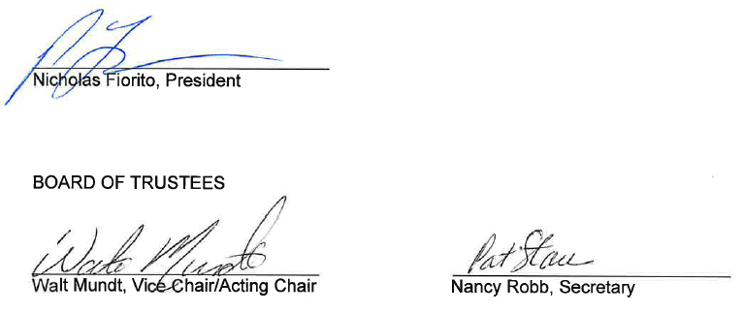

Appendix A

On a one-time non-precedential basis, employees with nine or more years of service as of June 30, 2021 will receive a $0.50 per hour increase to their base pay in year one only of the contract.

On a one-time, non-precedential basis, all HVAC mechanics with less than nine years of service will receive a one-time non-precedent setting, increase of $0.50 per hour to their base pay in year one only.

On a one-time, non-precedential basis, union members employed as of January 19, 2022 will receive a $1,000 stipend on the final paycheck in June 2022. This stipend does not increase the employees’ base salary and will not be paid if the employee separates from the College for any reason before the stipend payment.

On a one-time, non-precedential basis, Union members who begin employment from January 20, 2022 through December 31, 2022 are eligible to receive a sign-on stipend of $1,000 one year after the date of hire. This stipend does not increase the employees’ base salary and will not be paid if the employee separates from the College for any reason before the stipend payment.

30


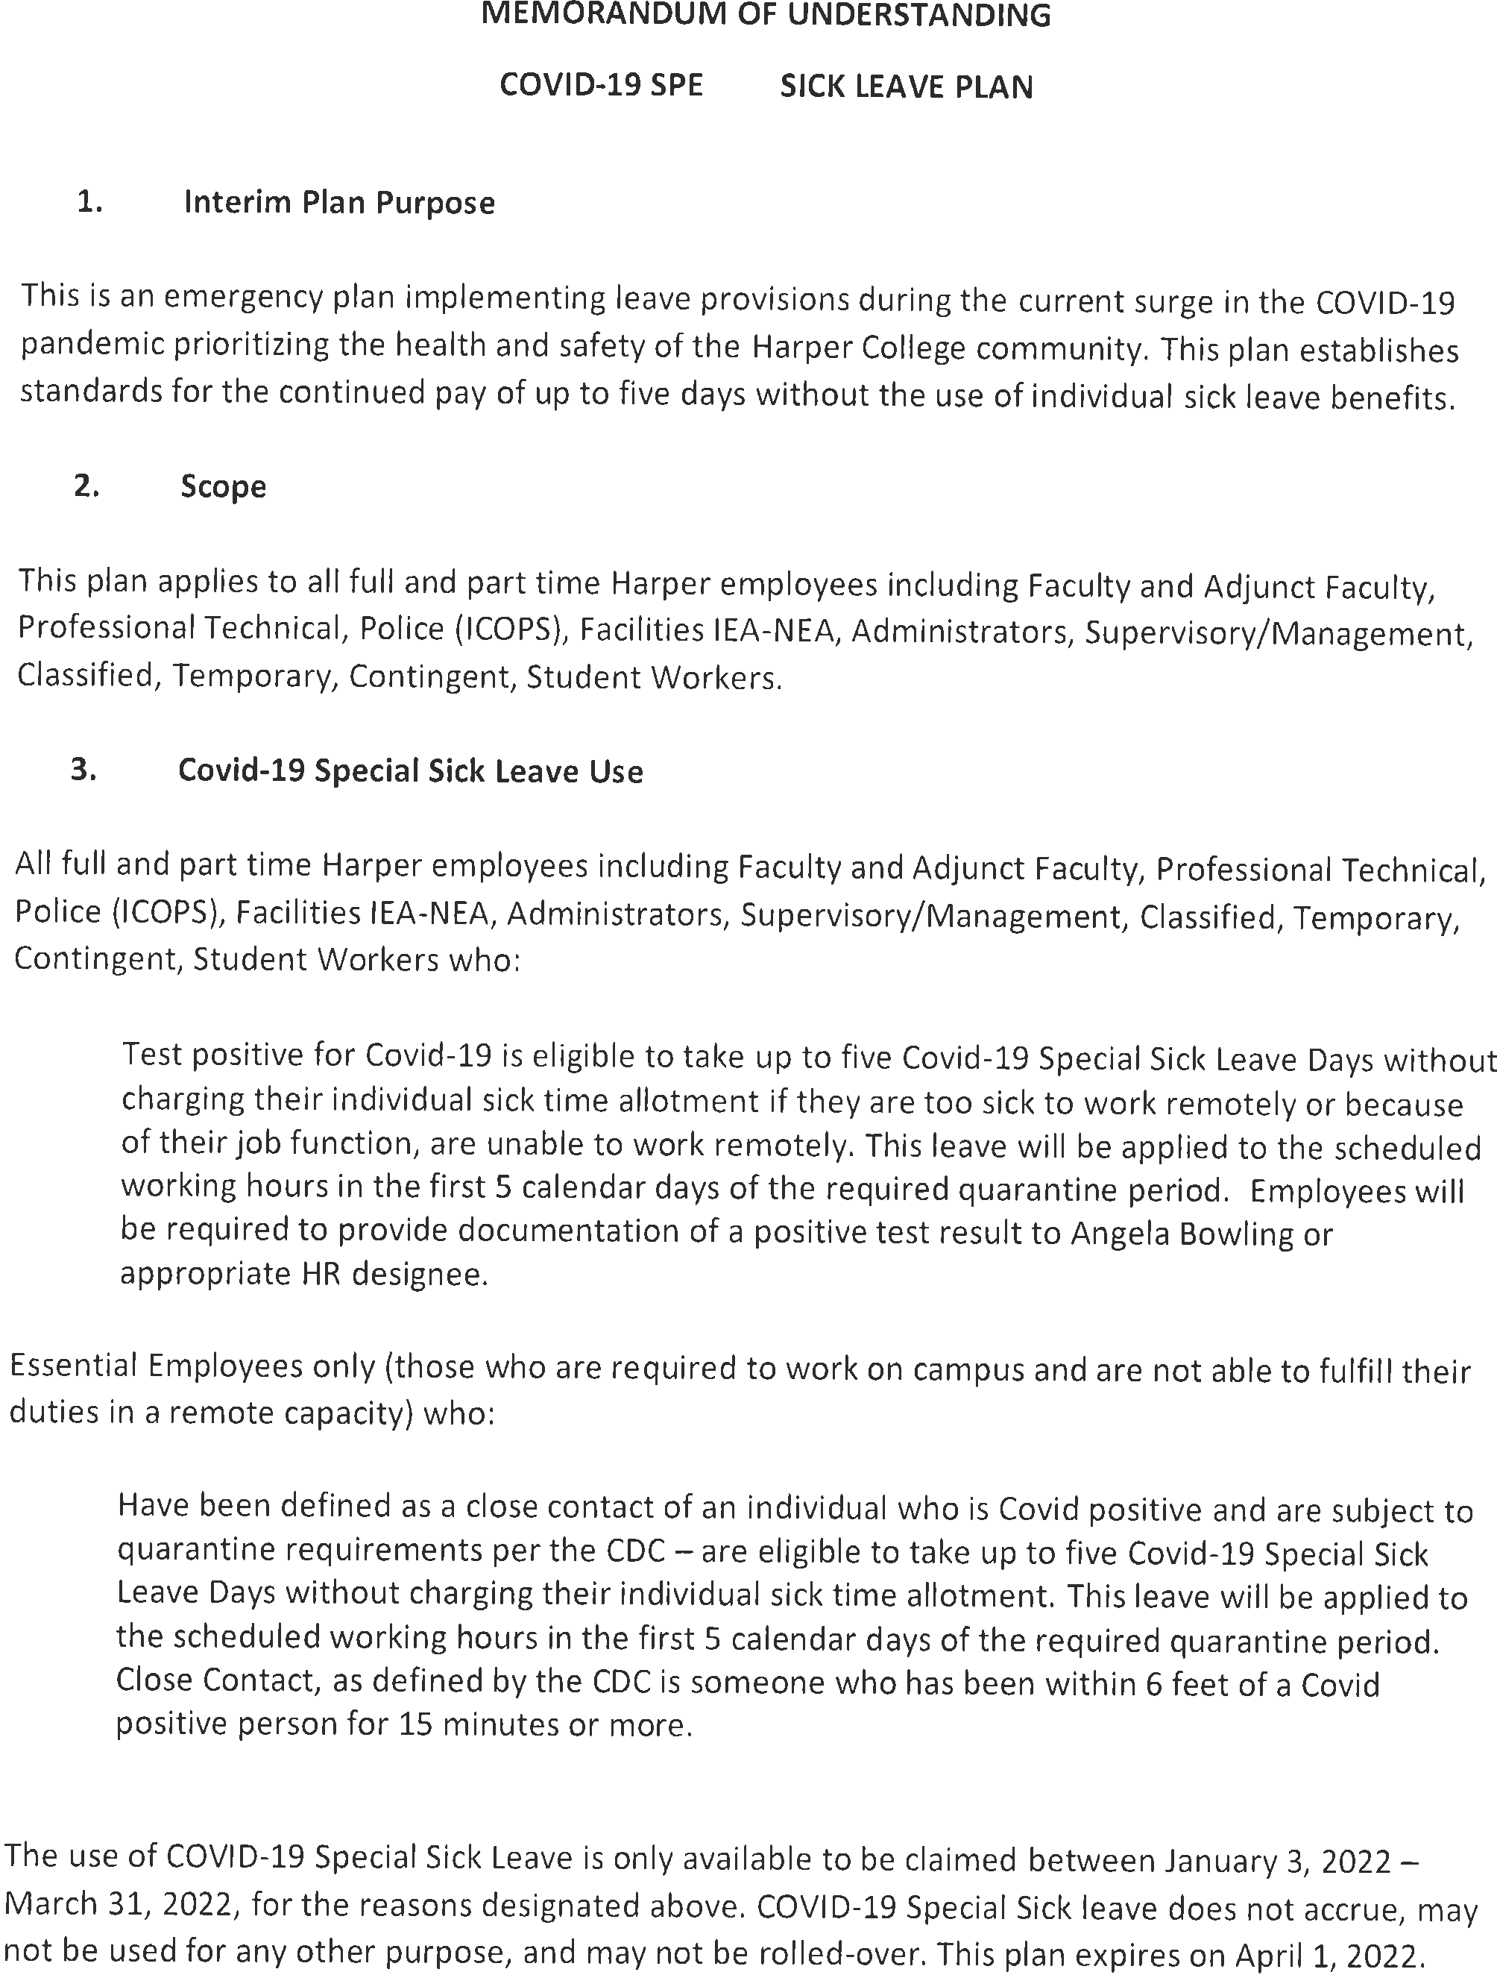

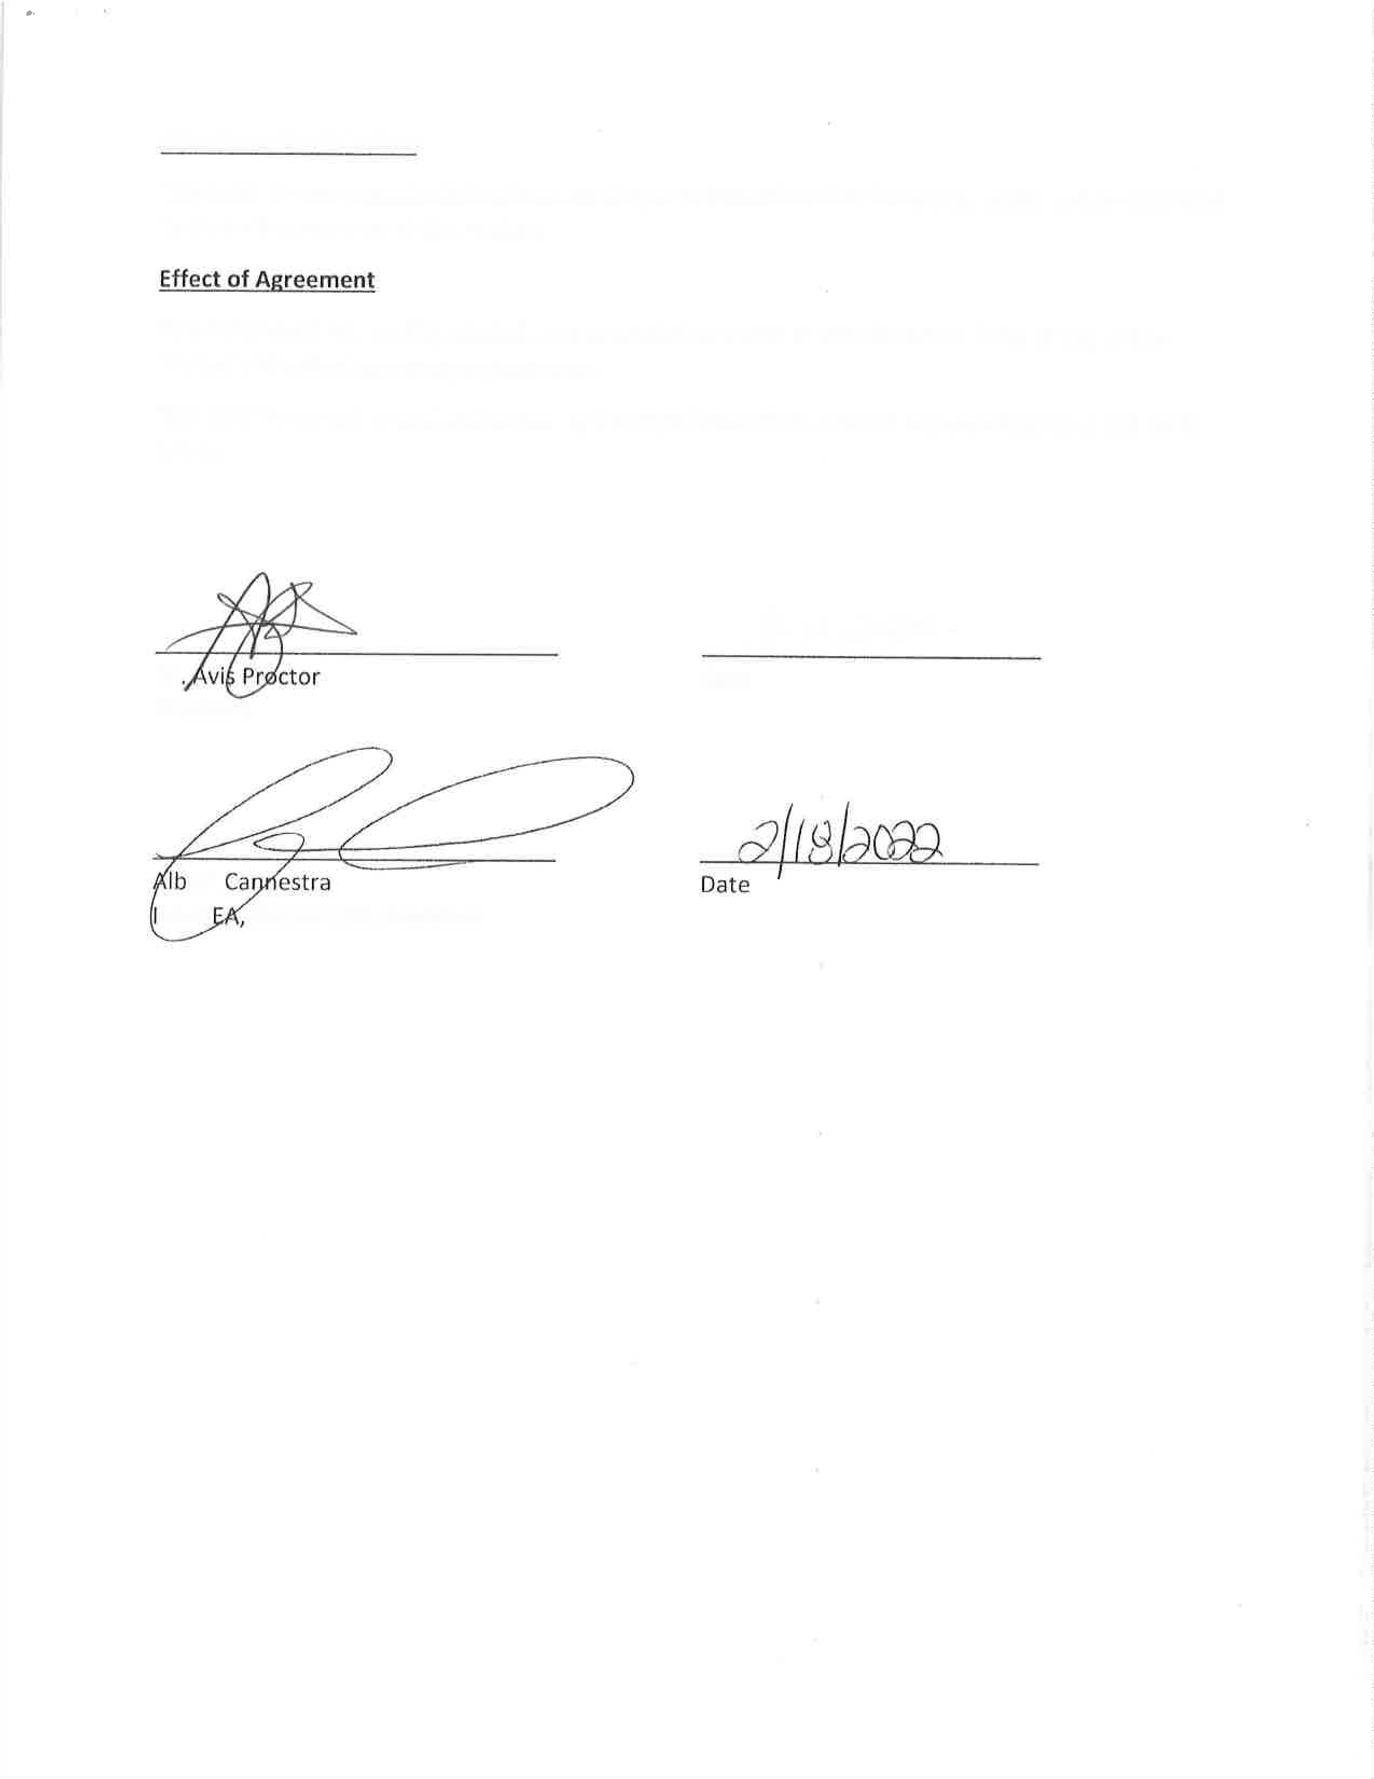
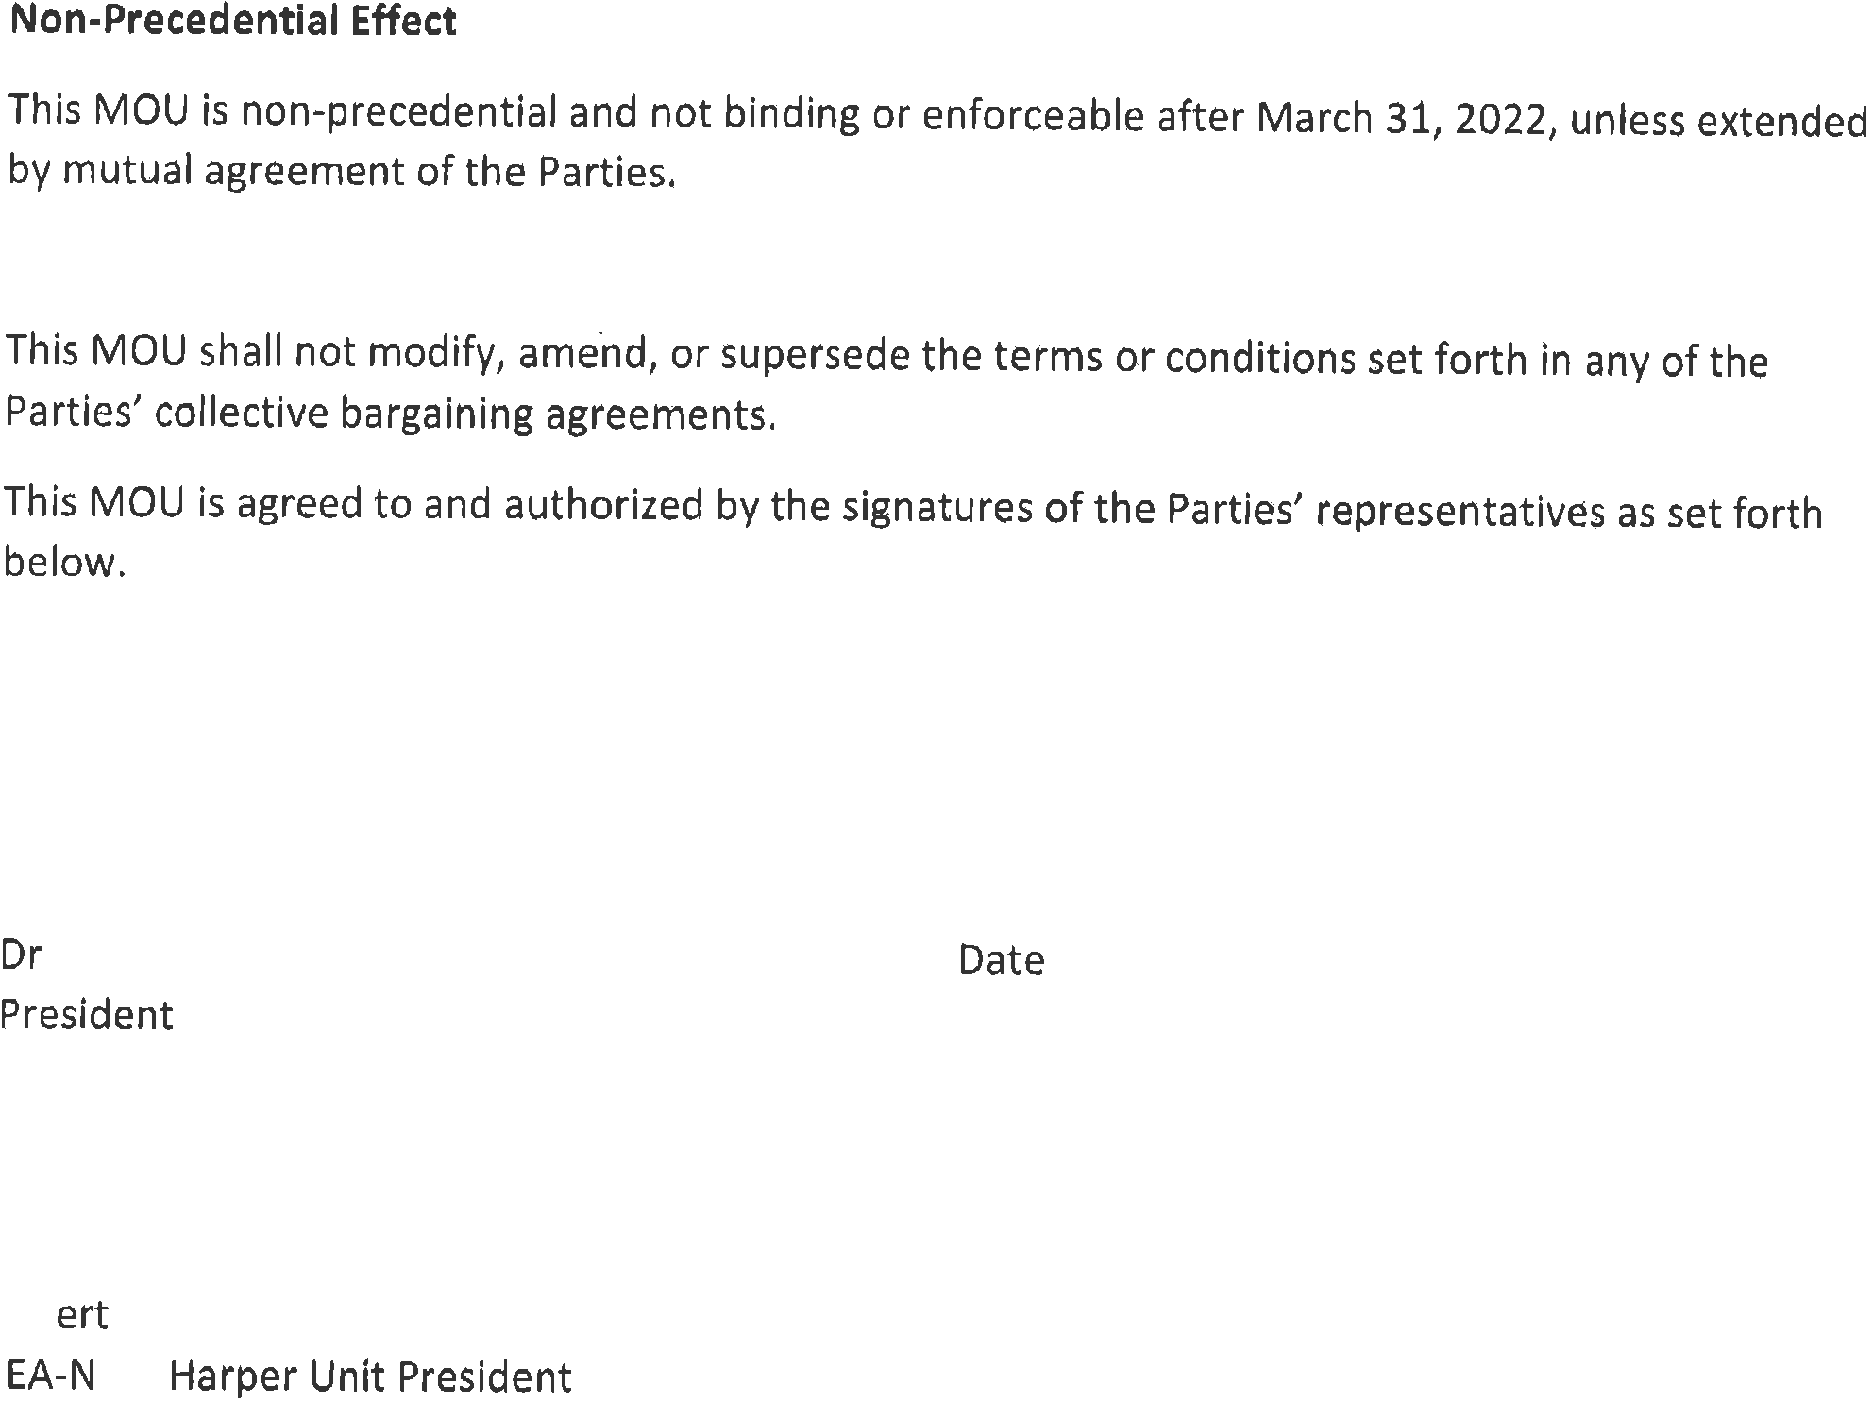



Memorandum of Agreement (MOA) Change to leave usage
March 1, 2023
This Memorandum of Agreement is entered into this 1st day of March 2023, between William Rainey Harper College (“College”) and Harper 512 Association, IEA-NEA (Union).
In mutual agreement, the College and Union have agreed to changes in the usage of personal, sick and vacation leave. Changes are as listed below and are effective January 1, 2023.

Article XIV. Other Leave With Pay Personal Leave
Current:
Regular full-time employees will be eligible for three (3) non-cumulative days of personal business leave to be used each contract year for special occasions when they cannot attend to personal business on their own time.
Employees wishing to be excused for Personal Business leave will not be allowed the leave during the new hire introductory period or during the last two (2) weeks of employment, or the day before or after a holiday, vacation, or sick day except in an emergency, which emergency shall be fully explained and/or documented as soon as possible.
Any of the three (3) Personal Business days which are unused each year shall be added to the employee's accumulated sick leave.
New:
Regular full-time employees will be eligible for three (3) non-cumulative days of personal business leave to be used each contract year for special occasions when they cannot attend to personal business on their own time.
Employees wishing to be excused for Personal Business leave will not be allowed the leave during the new hire introductory period or during the last two (2) weeks of employment, or the day before or after a holiday, vacation, or sick day except in an emergency, which emergency shall be fully explained and/or documented as soon as possible.

Any of the three (3) Personal Business days which are unused each year shall be added to the employee's accumulated sick leave.
Employees may use personal business leave in quarter hour (15 minute) increments.

Article XI Sick Leave
11.2 Current:
Sick leave cannot be used for any purpose other than personal illness, quarantine, or serious illness/medical emergency in the immediate family. Medical emergency would typically include an emergency hospital admission or critical care of an immediate family member or the serious illness of a young dependent child. These short-term situations are limited to five (5) working days. "Immediate family" shall be defined as: parents, spouse or domestic partner, children (or any child that the employee is acting in loco parentis), brother, sister, grandchildren, grandparents or parents-in-law.
Appointments with doctors or dentists should be scheduled on Saturdays or regular days off or during the first or last hour of the workday, if possible. An employee must make up all time lost from work as a result of medical appointments within the same workweek on a straight time basis.
New:
Sick leave cannot be used for any purpose other than personal or immediate family illness, quarantine, or medical emergency. "Immediate family" shall be defined as parents, spouse or domestic partner, children (or any child that the employee is acting in loco parentis), brother, sister, grandchildren, grandparents or parents-in-law.
Employees may use sick leave in quarter hour (15 minute) increments.
11.8 Current:
An employee arriving at work two (2) hours after his/her normal starting time or leaving work two (2) hours before his/her normal quitting time due to illness shall be charged for one-half (½) day of sick leave. One-half (½) day sick leave will not be allowed the day before or after a holiday or vacation.
New:
An employee arriving after their scheduled starting time or leaving work before their scheduled quitting time due to illness may use sick leave time (in quarter hour increments) to supplement the hours work for the shift. The hours may not exceed the scheduled shift.

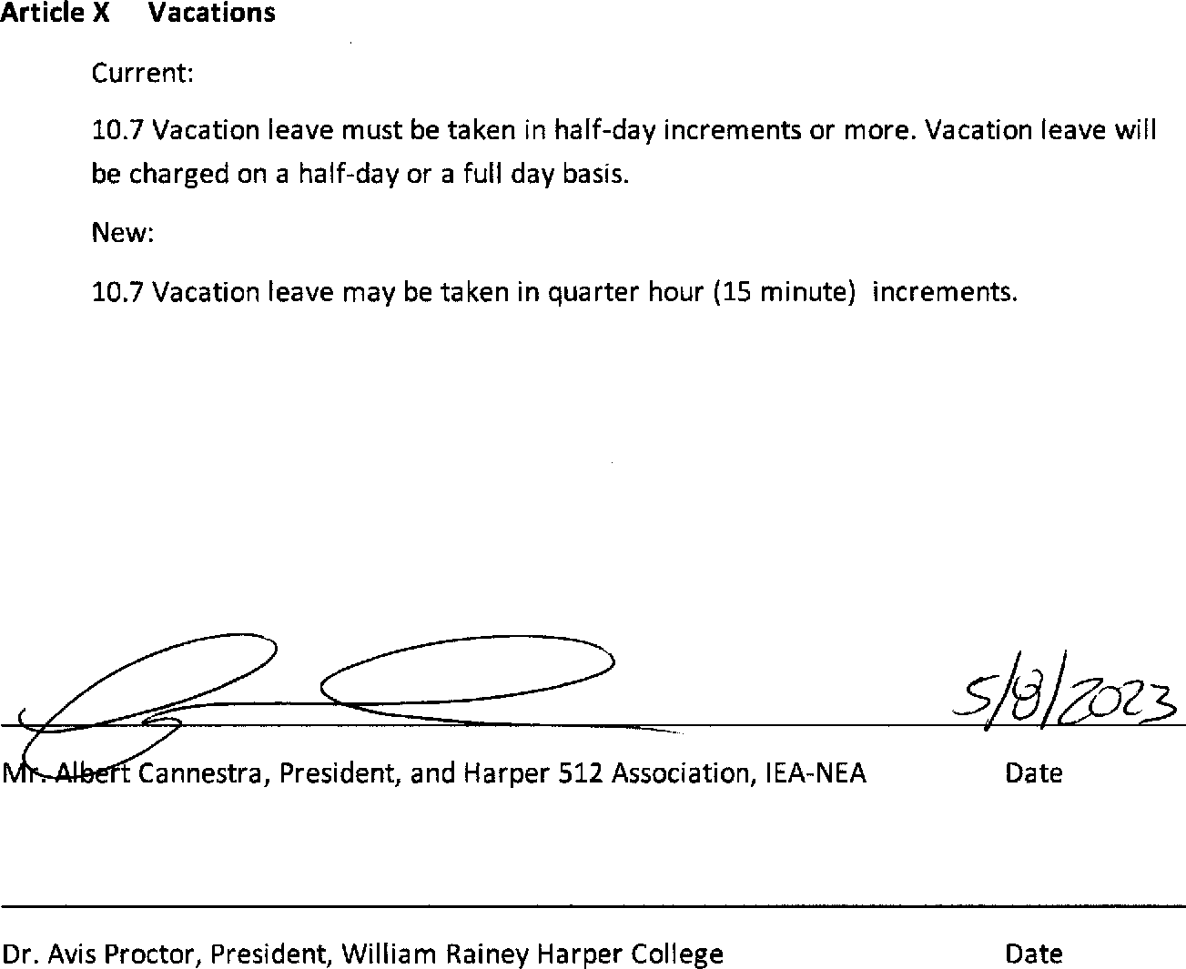
5/16/23
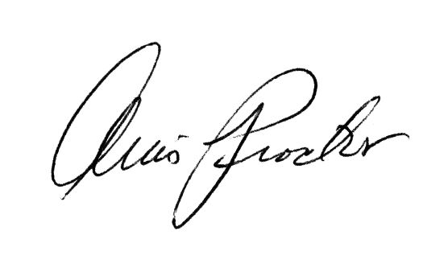
IEA -NEA
STARTING HOURLY WAGES 2021 - 2024

 |  | July - Dec | Jan - June | July - June
LEVEL TITLE | 2021-2022 | 2022-2023 | 2022-2023 | 2023-2024

SE1 | Custodians 1 & 2 | $15.17 | $15.40 | $17.63 | $18.16

$16.03 $18.27 $18.82
SE2 | Set-Up Crew | $15.79
 | Warehouse/Driver

SE3 | Painter | $16.75 | $17.00 | $19.26 | $19.84

SE4 | Groundskeeper | $16.75 | $17.00 | $20.26 | $20.87

$27.32 $27.73 $28.56
SE5 | Maintenance Mechanic | $26.92
 | Equipment Mechanic

SE6 | HVAC Mechanic | $30.96 | $31.42 | $42.00 | $43.26

SHIFT DIFFERENTIAL:
2nd & Swing Shifts | $0.40/hr.
3rd Shift | $0.95/hr.

$0.40/hr.
$0.95/hr.

$1.00/hr.
$2.50/hr.

$1.00/hr.
$2.50/hr.

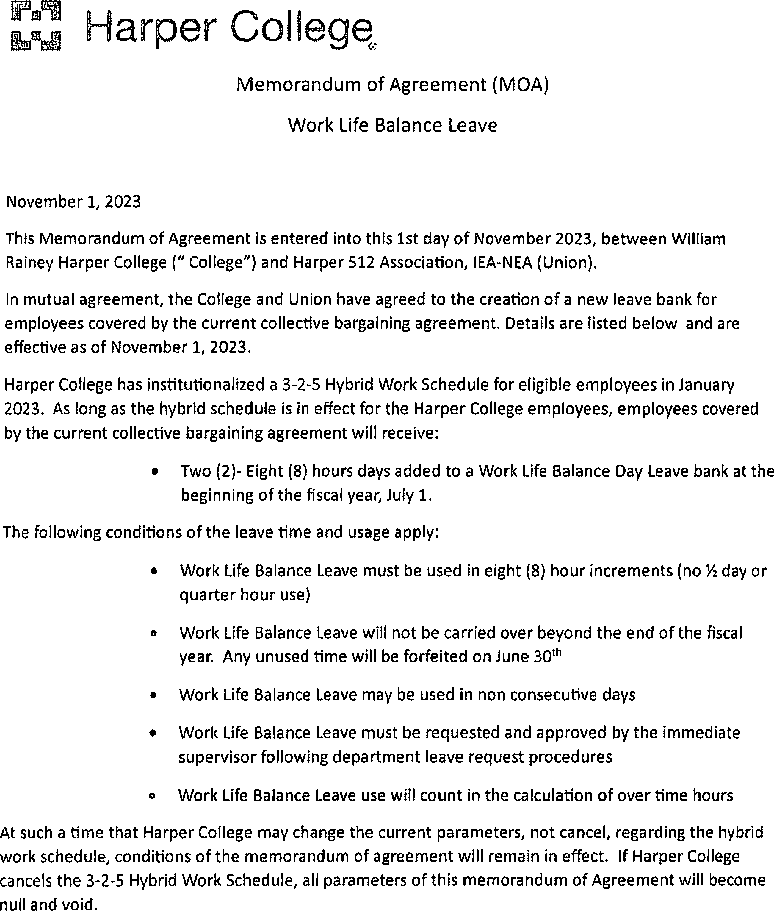

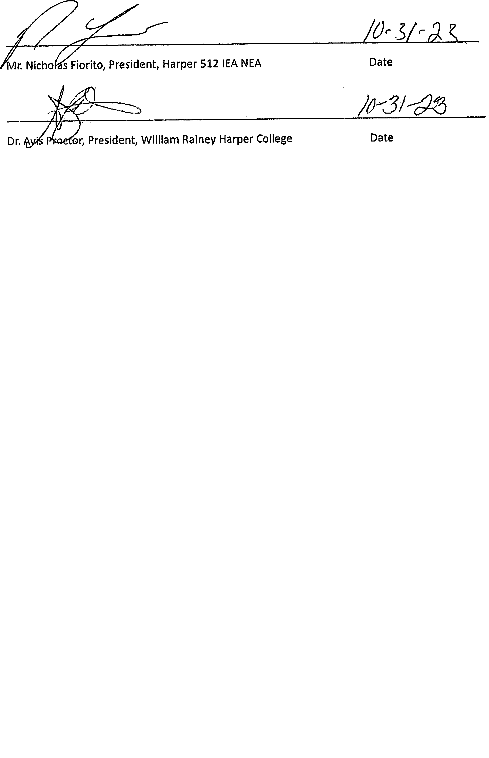

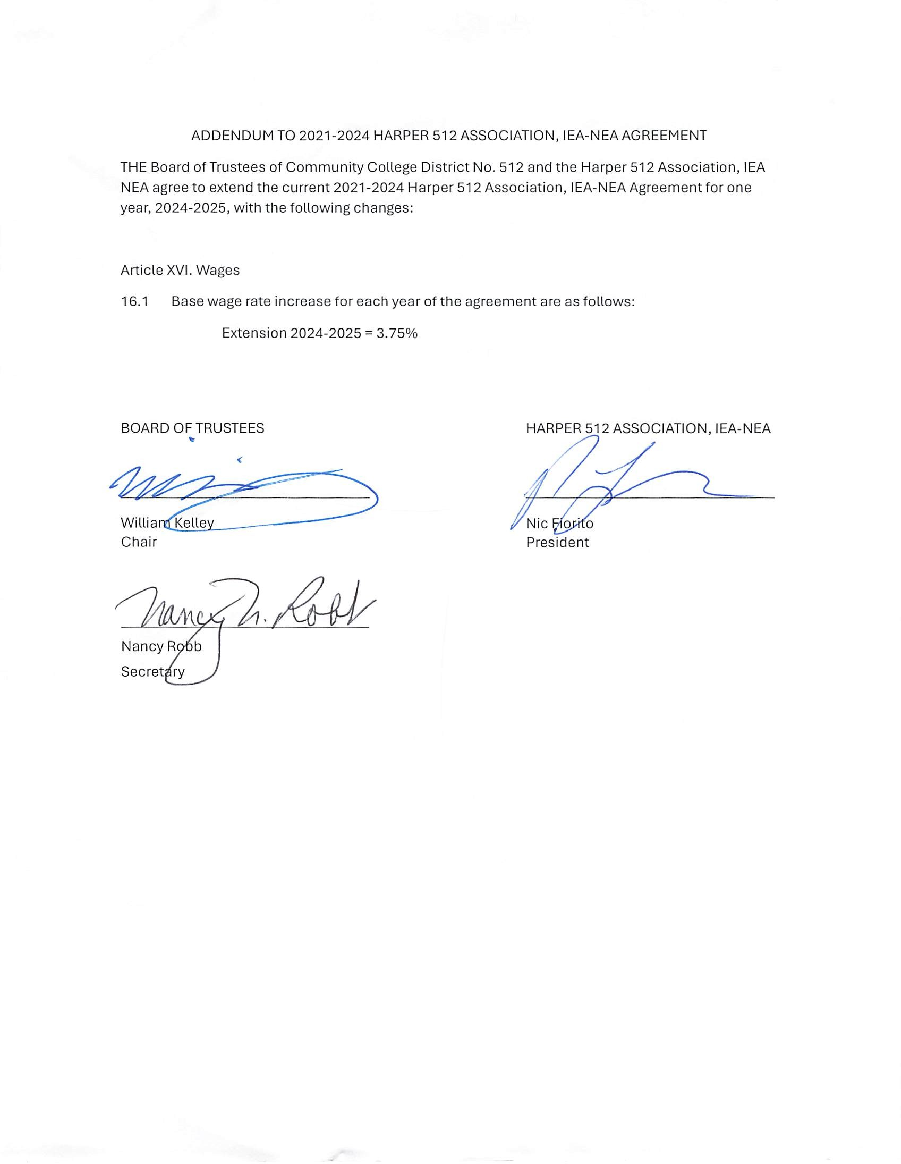

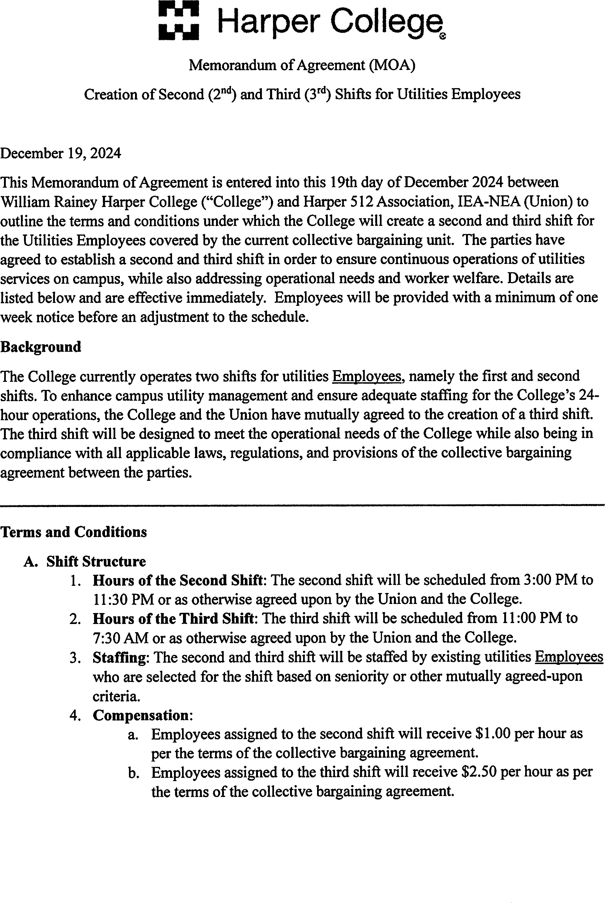

c. The pay rate for the second and third shift will be in accordance with Article 16.2 and 16.3 ofthe collective bargaining agreement.
- Scheduling and Assignment
The second and third shifts will follow the standard workweek as defined in the collective bargaining agreement for payroll processing. Employeesworking second and third shift Utilities may be scheduled Monday through Sunday for operations continuity. Overtime rules and rates will be applied as necessary, in accordance with the agreement.
- Health and Safety
  - Workplace Safety: The College will ensure that the second and third shifts are staffed with the appropriate tools, equipment, and safety measures to maintain a safe working environment.
  - Health and Wellness: The College will take into consideration the health and well-being ofEmployees working the second and third shifts, offering appropriate resources, such as access to first aid kits and break rooms, where necessary.
  - Support: Employees will contact their immediate supervisor ifthere·are any questions or need for additional support while working shifts.
- Training and Support
  - Training: Employees will receive proper training and orientation to ensure they are equipped with the necessary skills and information for their duties. Training will be provided at no cost to the Employee.
  - Support Services: The College will ensure that all departments and services that require utilities maintenance are fully supported during the second and third shifts to maintain smooth operations.
- Removal of On-Call
Effective February 1, 2025, on-call will be eliminated for Employees working in utilities and maintenance.
All other terms and conditions ofthe current collective bargaining agreement will apply.
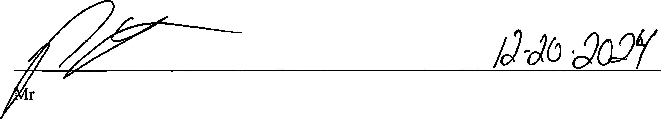
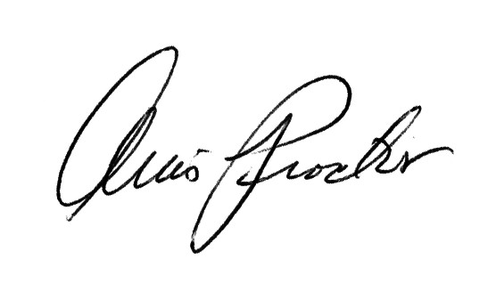
. Nicholas Fiorito, President, Harper 512 Association, IEA-NEA
Date
12/20/2024

Dr. Avis Proctor, President, William Rainey Harper College Date

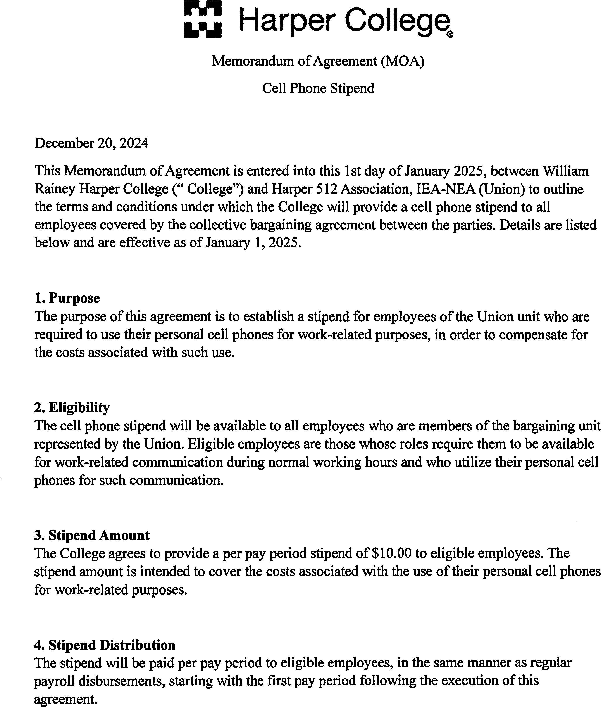

- Tax Implications
The stipend is considered taxable income and will be subject to all applicable federal, state, and local taxes. The College will withhold applicable taxes as required by law.

- Use of Stipend
The stipend is intended to reimburse employees for the work-related use of their personal cell phones. Employees are not required to submit detailed records of cell phone usage. However, employees must maintain their availability for work-related communications as required by their job description.

- Modifications or Termination
Either party may request to renegotiate the terms of this agreement during the term of the contract.

- Duration
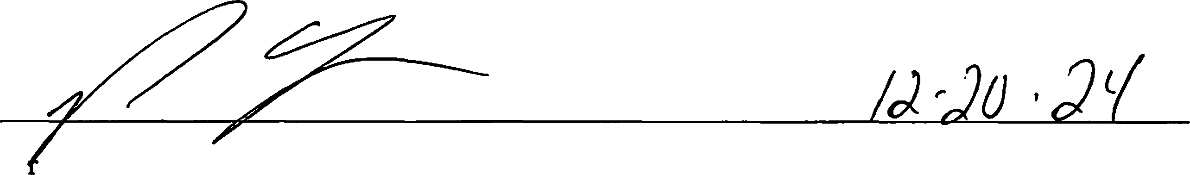
This agreement will be in effect for the duration of the current collective bargaining agreement unless modified or terminated by mutual agreement of the College and the Union.
M . Nicholas Fiorito, President, Harper 512 IEA NEA
Date

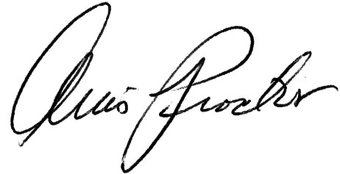
12/20/2024
Dr. Avis Proctor, President, William Rainey Harper College Date

