How to Submit an Event
Using the Harper College Events Calendar

The following user guide is for Harper College staff, students, faculty and community partners looking to list their events on the Harper College events calendar. Below you’ll find instructions on how to sign up for an account and submit an event. Let’s get started.
Get Started
First, you will need to sign up for an account. As an account holder you can make additions, changes, updates or a cancelation to your event. Click on the direct sign-up link here to create a new account.
Tip Be sure to use your Harper email address for your account.

Submit an Event
Once an account is established, submit your event by entering the listing into the submission form. Start with your primary information:

Primary Information
- Event Name
- Description (This can be pasted from a Word document)*
- Status (select Live, Canceled, Postponed or Sold Out)
- Schedule: Day/Date/Time (NOTE: See below for multiple event dates)
- Experience (select Hybrid, In-Person or Virtual event)
- Location: (Provide physical location/address if In-Person; include links, URL or stream codes for Virtual and Hybrid events here)
- Filter=Event Type: (select from the menu)
- Filter=Department: (select from the menu)

Be sure to have the information handy as you fill in the sections. You may go back to the event listing and update as needed.
*NOTE: If you are pasting copy into the form, make sure to remove any formatting (program works best with text only copy). This can be done by:
In Windows = copy the text into a Notepad, then copy and paste unformatted text into the calendar form.
On Mac = copy the text into TextEdit, then copy and paste unformatted text into the calendar form.
This will avoid uneven text and fonts appearing in your event copy. Be sure to review the copy when your event has gone live.

Tip Be sure to plan ahead to allow prospective attendees time to find out about your event.

Secondary Information
  - Event Website (link to website or registration form—TIP: copy and paste live link)
  - Hashtags (specific to your event—TIP: test it as an internet search)
  - Event photo image (TIP: drag and drop from your desktop, or photo library) Event
photo image size is 940x557 pixels.
  - Ticket pricing (include pricing. This should first be submitted to the box office and be live for ticket ordering)
  - Ticketing information (link to Harper box office recommended)
  - Multiple Dates or Date Ranges. Users can add as many dates as needed in one form. Just keep hitting “Include Above in Schedule” until all the dates are covered. You have features where you can update each confirmed date or delete, as needed. If an event reoccurs with consistency, you may select from the options provided in the “repeating” menu.

See example snippets below:
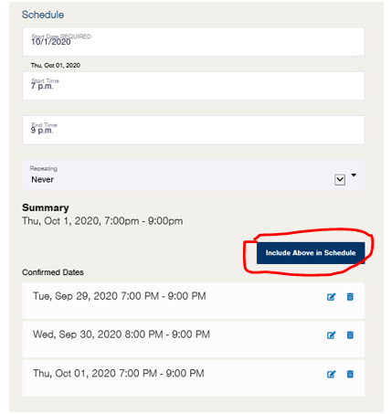 | 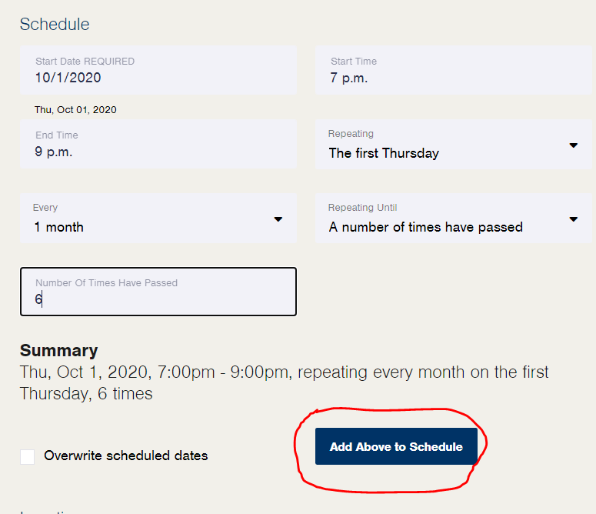

Tip Including filter information allows users to specify and find your event.

Filter Example:
For a Cultural Arts event, choose from the pull-down menu.
Event Type = Cultural Arts, then Department = Cultural and Performing Arts. (Note: For cultural arts events, this will allow the event to be shown on the Live@Harper events page.)
See filter snippets below:

Last step: Once the form is filled out with your event information, click Submit Event.

Each pending event is monitored and reviewed by Marketing Services. Any grammatical errors or submissions lacking primary information will be edited to ensure appropriate content for public viewing.
The event listings and descriptions on the calendar are used to promote a variety of events on social media, in newsletters and more. Be sure the information is clear, concise and accurate.
Await Approval
Once submitted, it may take up to 24 hours to see your listing on the calendar, or longer if it is a holiday/weekend. As a reminder, you may make changes at any time. Please check the calendar regularly.
Contact Us
Please contact Kevin Prchal with Marketing Services should you require help with your account or event listing. For additional support and resources on how to navigate the events calendar, visit the Localist Knowledge Base.

~ Revised 10/2020

