Rock & Roll
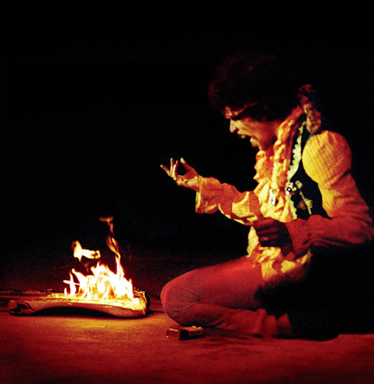
ENG102-1WL, CRN 61963
Instructor: Maggie McKinley
IAI C1 901R

LIT105-1WL, CRN 61964
Instructor: Kurt Hemmer
IAI H3 903

Total Credits: 6
This course examines the poetics of rock and roll lyrics, compares works of poetry to rock and roll lyrics with similar themes, explores the history of rock and roll and its impact on society and culture, and provides instruction in the conventions of academic writing and research.
Fulfills requirements for English 102 AND Fine Arts & Humanities.”

