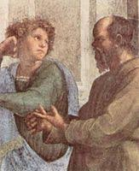
The Examined Life
This course examines an array of penetrating philosophical and literary works that confront the concept of living a meaningful life amidst the troubling events we encounter.

This class fulfills a Humanities requirement.
PHI105-2WL, CRN 63035
Instructor: John Garcia
IAI H4 900

ENG102-2WL, CRN 63034
Instructor: Kurt Hemmer
IAI C1 901R

Total Credits: 6

