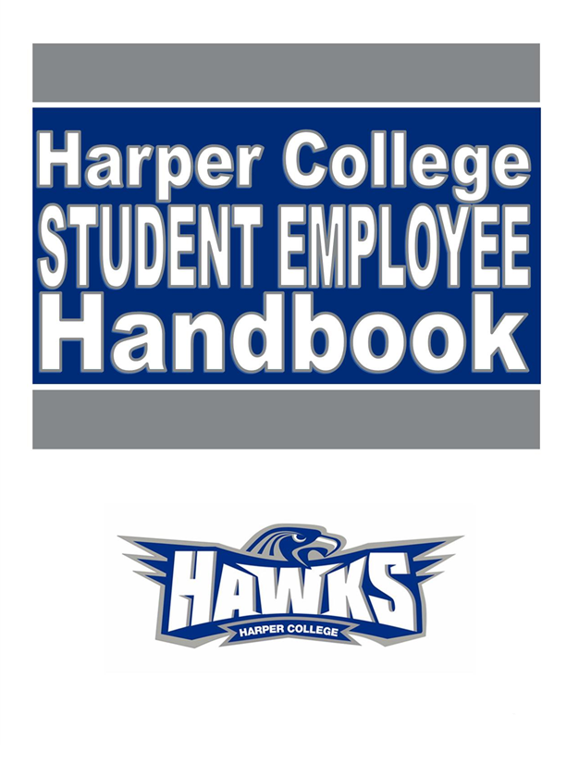

Contents
Introduction 3
Eligibility for Student Employment 4
Student Work Classifications 4
Maximum Hours 4
Applying for Student Worker On-Campus Jobs 5
The Interview 5
Criminal Background Checks 5
Pay Schedule/Time Sheet Entry 5
Student Employee Responsibilities 6
Attendance and Punctuality 7
Workplace Etiquette 7
Student Dress Code 7
Job Performance 8
Resignation 8
Termination 8
Frequently Asked Questions 9
Frequently Asked Questions – Continued 10
Sample Student Evaluation 11

Introduction

Harper College provides employment opportunities to students to enhance their educational experience, promote their involvement with the College, and enable it to function effectively and cost-efficiently. Research shows that on-campus student employment between 10 and 20 hours per week contributes to completing your college goals.

The purpose of the Handbook for Student Employees is to assist you with the procedures for acquiring a job on-campus. Guidelines for work etiquette, payroll, and job performance are outlined along with answers to frequently asked questions.
Students desiring to help meet their educational expenses through part-time employment are encouraged and assisted in locating employment opportunities through the Job Placement Resource Center (JPRC). However, ultimately, you are responsible for obtaining your own position on campus, and this handbook will help guide you through the experience.
Good luck and let us know in the Job Placement Resource Center (JPRC) if we can help!

Eligibility for Student Employment
To be eligible for on-campus jobs, you must meet the following:
- Be a current student enrolled in at least 6 credit hours in fall and/or spring semesters.
- For summer session, Regular Student Aides must be registered for summer (3 credits or more) or for at least 6 credit hours the following fall semester. Summer work for students on Federal Work Study may not be available. The supervisor will check prior to you being hired to determine if funds are available.

Student Work Classifications
On-campus jobs are classified in two categories: Federal Work Study (FWS) paid for by the government through FASFA and Regular Student Aide which is budgeted and paid for by the College Department.

All students must apply online at jobs.harpercollege.edu
To apply for a Federal Work Study job, students must be awarded and accept a Work Study grant through the Office of Student Financial Assistance. Work Study grants are based on financial need. The aid award designates the maximum amount of money you can earn through FWS. Federal Work Study students must meet Federal Satisfactory Academic Progress (SAP) standards. Your supervisor will submit paperwork to the Office of Student Financial Assistance who will verify your eligibility. Follow online application procedures and submit your application to the job(s) of interest.
Regular Student Aides follow online application procedures and submit your application to the job(s) of interest.
International Students may apply for any Regular Student Aide positions on campus. International students will process paperwork the same as non-international students, except for a few extra forms/steps to complete the new hire paperwork. International students will need to be ready to provide, at any time during the paperwork process, their Form I-94, I-20, and a short memo from the supervisor in the hiring department which includes the student’s job title, hourly pay rate, and the number of hours of work per week. Follow online application procedures and submit your application to the job(s) of interest.
Each job requires a separate application!

Maximum Hours
All students, including international students, can work a maximum of 20 hours per week when school is in session.

Students may work more than one job on campus, but the total amount of hours for all jobs combined may only be 20 hours per week maximum. Between semester break periods, when classes are not held, and during the week of Spring Break, Regular Student Aides can work 29 hours per week maximum. Federal Work study can only work 20 hours a week.

Applying for Student Worker On-Campus Jobs
- Search for open positions at jobs.harpercollege.edu
- Find a position you are interested in and click the title to open it up.
- Read over the job description to see if you meet the qualifications.
- Review the open positions and apply to all jobs in which you have an interest in by clicking Apply Now. You will need to fill out an application for each student worker job in which you are interested.
- Make sure that your application is filled out completely, is free of errors, and uses capitalization and punctuation correctly.
It is important to fill out your availability with the times(s) you are available to work each day. Do not put “open” as the employer will have no idea if you can work the hours they are looking to fill.
You may want to visit the hiring office on campus (with a copy of your application) to inquire about their opening and when they plan to interview candidates.

The Interview
Once your application has been chosen by an office, they will call you for an interview. Be sure to be prepared to answer questions about yourself and why you would be a good worker.
Here are some typical questions you should be prepared to answer:
Tell me about yourself?
Tell me about your customer service (computer, etc.) skills?
Why would you like to work in this department?

Come to the Job Placement Resource Center in I117 if you need help with your interviewing skills.

Criminal Background Checks
All students are required to pass a criminal background check before they are hired. When a background check has been ordered, an email will be sent to you with instructions concerning the background check.

Pay Schedule/Time Sheet Entry

Students will be paid every two weeks according to the College’s payroll schedule. The starting salary for January 2024 is $14.00/hour and will increase to $15.00/hour in January of 2025. It is up to the department to set your work schedule.

All student workers will fill out their online time sheet in Oracle Fusion. Instructions for filling out a time sheet will be given by your department when you are hired.

Be sure to:
- Keep an accurate record of hours worked.
- Adhere to time sheet deadlines set by your supervisor.

Student Employee Responsibilities
When you accept a student employee assignment, you AGREE TO:
- Adhere to Harper College’s Code of Student Conduct.
- Always maintain confidentiality. Some student employees will have access to confidential information. You will sign the “Employee Confidentiality Agreement” as part of your onboarding process
- Ask your supervisor when you have questions.
- Discuss workplace problems directly with your supervisor.
- Exercise professional etiquette. This includes dressing appropriately for the work setting, cleanliness, personal hygiene, manner of speech, and other proper conduct.
- Deliver excellent customer service.
- Conform to your supervisor’s rules regarding homework in the workplace. If homework is permissible in your office, only do homework when all your work tasks have been completed. When a work task arises, stop doing your homework.
- Abide by your supervisor’s regulations regarding computer and Internet usage.
- Follow your supervisor’s policy regarding personal telephone calls. If personal calls are permitted, they should be kept to a minimum.
- Avoid engaging in overly social behavior with fellow student employees or other students while at work.
- Follow safe working practices and observe safety rules. Employees safety is a responsibility shared by the College and every student employee.
- Promptly notify the supervisor of any job-related accident.

Attendance and Punctuality
- Report to work on time and be ready to work.
- Make requests for time off as early as possible. Projects, exams, and college-related activities may occasionally interfere with your work schedule. Most supervisors will make every effort to accommodate your request.
- Follow your supervisor’s procedures regarding notification when you will be absent because of illness or emergency.
- Repeated tardiness and excessive absences will be grounds for termination from the job.

Workplace Etiquette
Following these simple rules will make for a good working environment.

- Be sure to show up on time, every day you are scheduled to work.
- Make sure that you know the dress code for your department and follow it.
- Do not answer your cell phone or text during work hours.
- Do not check Instagram or any social media accounts.
- Do not have personal mail sent to you at Harper or use Harper’s address for non-Harper business.
- Be sure to work with enthusiasm and have a smile.

Student Dress Code
General guidelines regarding clothing NOT to wear in most on-campus positions are as follows:

- Flip-flops

- Cutoffs
- Inappropriate t-shirts or sweatshirts
- Ragged clothing
- Halter tops/tank tops
- Micro-miniskirts
- Revealing attire
- Bare midriff
- Low-rise pants
- Underwear as outerwear
- Hats should not be worn in the office except for religious reasons

A more department specific dress code may be required, depending on the department. Some departments allow you to dress more casually, depending on job duties, while other departments will require you to dress more professionally.

Job Performance
You are expected to perform the duties as required by your supervisor. Job duties will vary from position to position, but all student employees are expected to complete all job tasks completely, accurately, and in a timely manner. You should have a clear understanding of what is expected of you and ask questions when you do not understand. You should also have a copy of your job description.
Evaluations can be expected each semester or at least once each year. A sample evaluation is attached at the end of this handbook. Be sure to discuss your performance with your supervisors and ask for ways that you can improve.

Resignation
Providing your supervisor two weeks’ notice when you are going to end your employment is appropriate business etiquette.

Termination
Student employees may be terminated at any time.
The following problems account for most student employee terminations:
- Student employees should be familiar with the Code of Student Conduct. Failure to adhere to the Code of Student Conduct may result in termination of student employment.
- Unreported absences, excessive absences and/or tardiness as a rule will result in termination.
- Fraudulent reporting of hours worked constitutes gross misconduct and typically will result in termination of student employment.

Frequently Asked Questions


How do I find a job?
Go to the Harper College online employment site at jobs.harpercollege.edu You can search for Student Aide openings. Review the job description and apply to each job that you are interested in. You will need to fill out an application for each position.
How do I apply for a job?
Via the online employment site:
- Search in Find Jobs by Student Aide
- Click on any job for which you have an interest to review the position description
- If interested, hit the “Apply now” button to begin the application process
- Please contact the HR Recruitment Office at 847-925-6430 if you have any questions

How do I increase my chances of getting an interview?
After you have applied for a position online, you can go to that office/department on-campus and introduce yourself.
What offices are hiring?
Typically, the Health & Recreation Center, library, computer labs, the business office and department offices hire student aides. Check the employment website to see openings, but you can also ask any area if they need a student aide.
NOTE: the Harper Bookstore is run by the Follett Company. To work at the bookstore, you must apply online at http://www.follett.com/follett-CAREERS Click on careers.
The Harper Dining Services are run by Sodexo. To work at any of the cafes, catering, Starbucks, or Subway apply at http://www.sodexo.com/en/careers/work-for-sodexo.aspx
When do offices hire?
Most offices hire at the beginning of the semester, especially in August, September, and January. But there may be openings throughout the year.

Frequently Asked Questions – Continued

How do I know if I have or am eligible for Federal Work Study?
Federal Work Study is part of your financial aid, but you must ask for the money to be applied to your account. If you have submitted a FASFA form for financial aid, go to the One Stop in Building A first floor and ask them to check if you are eligible for Federal Work Study.
I have changed my class schedule. How do I update my online application?
Either withdraw your application and submit a new one or go to the office(s) you applied for and drop off your new availability.
I forgot my password for the online job site, how do I find it?
Use the Account Assistant on the jobs.harpercollege.edu to have the password reset sent to your email.
Do I have to fill out a new application for every job that I want to apply for?
Your profile (name, address, phone, email) will carry over to the applications. You must fill out the rest of the information for each job for which you apply.

Sample Student Evaluation

Name__________________________
Date___________________________

 | Superior | Above Standard | Meets Standard | Below Standard | Unsatis-factory | Comments
ADAPTABILITY: Ability to learn quickly; ability to adjust to change in job assignments, methods, personnel, or surroundings.

ATTENDANCE: Absenteeism; punctuality; remaining on the job.

COOPERATION: Willingness to take supervision; ability to get along with co-workers and others.

CREATIVITY: Talent for having new ideas, for finding new and better ways of doing things.

CUSTOMER SERVICE: Ability to use good judgment when dealing with customers. Degree of politeness and friendliness is shown to the customers.
DEPENDABILITY: The degree the employee can be relied upon to get the job done.

JOB KNOWLEDGE: Degree of familiarity with job procedure and essential equipment for satisfactory job performance.
QUALITY OF WORK: Consider accuracy; attention to detail and neatness of work, need to re-do work; orderliness of workplace.

REASONING: Ability to use good judgment to arrive at sound conclusions and the ability to take timely action.

INITIATIVE: Self-starter; finds work to do; self-motivated.

Overall Performance Evaluation: ________________________________________________________________________________________________________________________________________________________________________________________________________________________________________________________________________________________________________________________

________________________________ ______________________________
Employee Signature Supervisor Signature

