Class Resume Assignment: SOAR- Realize a Successful Landing

DUE DATE: _________________________

OBJECTIVE: To understand the components of a resume and how to create a resume that can be used for a class assignment, current or future job search, scholarship, and/or transfer application.

OUTCOMES: Students will:
- (Optional) search and identify a position of interest
- become familiar with the purpose and key components of a resume (See reverse for checklist)
- complete a resume based on instructor requirements

RESUME CREATION:
Using VMock: www.VMock.com/Harper
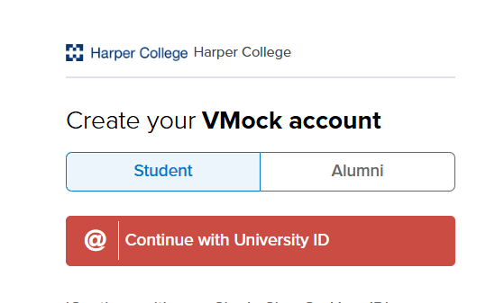
VMock Overview Video: https://tinyurl.com/3y3p9u37

- Step 1: Sign up
- Go to VMock.com/Harper
- Select “Student” and enter your Harper email address
- Create a profile

- Step 2: Resume Creation and Revision
  - Create a new resume from scratch OR upload a PDF of a current resume
- Complete revisions on resume based on all feedback and resubmit updated resume for new score (a maximum of 10 uploads to rescore your resume are allowed)
- (Recommended) Once all revisions are made, request feedback through “Network Feedback” in the VMock system or through a 1:1 appointment (Workforce Coordinators in the Job Placement Resource Center provide the feedback through VMock and through the 1:1 appointments)

- Step 3: Download
- If required, take a screenshot and print your resume score (s)
- Download final resume as a word document

- Step 4 (if applicable): Make Final Adjustments
  - Add specific information required for the assignment that fall outside of the resume checklist (see reverse):
- _____________________________________________
- _____________________________________________

- Step 5: Turn in resume
  - Student turns in resume assignment and optional screenshot of score

For additional resources and support connect with the Job Placement Resource Center

jprc@harpercollege.edu Building I I117
www.harpercollege.edu/jprc/student/resumes/index.php 847.925.6400

PURPOSE OF RESUME –> TO GET INTERVIEWS!
- Person whose qualifications most closely match those sought by the employer gets the interview.
- Use same skills/key words in resume as those sought by the employer and provide specific examples.

Key Items for Consideration
- Use blank Microsoft Word document (.doc) - no Google docs or Templates.
- One page only – unless significant related employment/experience (resume should be maximum of 2 pages).
- Use consistent indentation, capitalization, font style, spacing, and margins (1 inch max, ½ inch min).
- Use a standard font like Calibri or Arial, 11 point is best.
- No personal pronouns (I, me, you, he, she…).
- Use boldface for the most important information.
- No photos or personal information (e.g., such as date of birth or hobbies).

RESUME COMPONENTS
Name and Contact Information
- Should be at the top of your resume.
- Name is bolded and 12–14-point font, same type as the rest of your resume.
- Your City, State, Zip Code (optional), email, and phone number same font size as main body text (11 point).
- Email should be professional (e.g., NOT rockstar@gmail.com) and one you check daily.
Headline/Job Title and/or Summary Statement (optional)
- Should be specific to position or industry.
- Do not include headline/job title if you are unsure of position(s) employer has available.
- Click here to download the Summary Checklist.
Education
- List College, City, State, degree/certificate earned or current program of study and expected graduation date.
- Once enrolled in college credit courses, high school diploma or equivalency should not be included.
- Optional components: GPA if above 3.5, previous colleges attended listed with most recent first and include type of coursework taken or credential received, relevant coursework, accreditations/certifications, or licenses.
Skills
- Skills section should include relevant skills such as proficiency in certain computer programs, applications, or languages, and fluency in a language in addition to English.
Employment -- use “Experience” as section title if including relevant unpaid position(s)
- Start with most recent experience first and go backward in chronological order for positions held within the past 10-15 years.
- Include employer/organization name, location (City, State), job title and dates of employment.
- Give details. Employers want to know exactly what you did, how you used your skills, and what you accomplished.
- Use “bullet” point statements, starting with an action verb to show what you did, how you did it and the outcome.
- Check to make sure statements are in correct tense. Present tense if currently performing task, past tense if no longer performing task or in position.
Volunteer, Activities, Awards/Honors, Military, Professional Affiliations (Optional)
- Employers want examples of initiative, leadership, teamwork, and other job-related skills. Demonstrate this by including experience and involvement in activities and achievements.

***Note: If you need a two-page resume, it should be two separate sheets of paper. Do NOT staple, paper clip, or print back-to-back. Include your name, email address and page number on the second page.
***If your resume is two pages, the second page should fill more than just a quarter of the page.

Job Placement Resource Center | www.harpercollege.edu/jprc | jprc@harpercollege.edu | 847.925.6400 Dec-24

