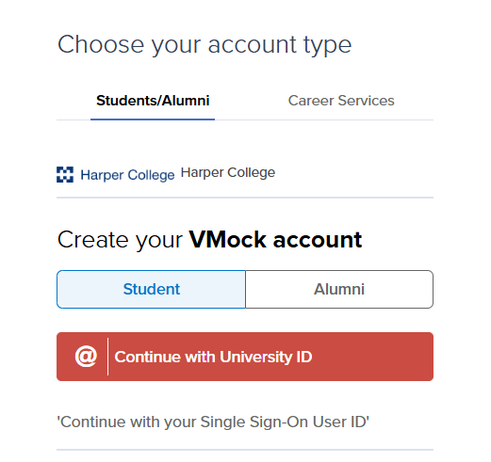
- Navigate to https://www.vmock.com/harper. Click on Student and Continue with University ID.
If you do not know your password, please call the Harper Help Desk at 847.925.6866.
- Enter your Harper student email address (use @mail.harpercollege.edu). You will have to authenticate your account either by text or through the authenticator application.
- Next, complete the profile section.
- Upload an existing resume (a) or create a new resume (b).
  - If you have a resume already, click on Upload Resume. VMock will score your resume and provide detailed feedback. You can read through the Scoring Overview and View Detailed Feedback to see suggestions for improvements. Go through each section to see what you did well and what needs improvement. To make suggested changes, click on SMART Edit. Choose a resume format to use and click Continue. Click through each section on the right side of the screen to view feedback/suggestions and make changes. Once you have made all the necessary updates, you can Rescore to see your new resume score. Please note, you can only rescore your resume a total of 10 times.
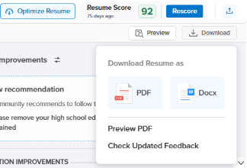
  - If you do not have a resume, click on Create New and choose the resume format you would like to use and click Continue. Complete each relevant section of the resume. Click on Add New Section/Subsection to add any other applicable fields. Click through the sections on the right side of the screen to view feedback/suggestions and make changes to each section. When finished, click Get Score to have VMock score your resume and provide feedback. Read through the Scoring Overview and View Detailed Feedback to see suggestions for improvements. Continue to make changes until you are satisfied with your resume. Please note, you can only rescore your resume a total of 10 times.
- To download a copy of your resume, click on the downward arrow on the right hand of the screen and choose either PDF or Docx (for a Word Document). Chose Docx if you want to make additional changes outside of the VMock system.
- You can also optimize your resume to the jobs you are applying for by clicking Optimize Resume. Please note, you can only optimize your resume 20 times.
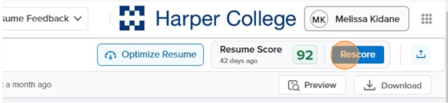



Paste the job description in the box and click Start Optimizing. View feedback and click Continue. Start making edits by clicking on Optimize with SMART Editor

*If you would like to receive feedback on your resume from a JPRC staff member, click on Request Feedback next to the Harper logo and then Ask for Network Feedback. Select the resume version you would like feedback on, click next, select Job Placement Resource Center as the reviewer, click next and fill in the fields for Targeted Job Title and Note for Review, then click next to complete the process. Your resume will then be reviewed by a staff member during regular business hours. Please allow up to 5 business days for review.

