Follow the instructions below to optimize your resume to jobs you are applying for or watch this short video: https://tinyurl.com/yfh7mfxb
- Navigate to https://www.vmock.com/harper and sign in to your VMock account.
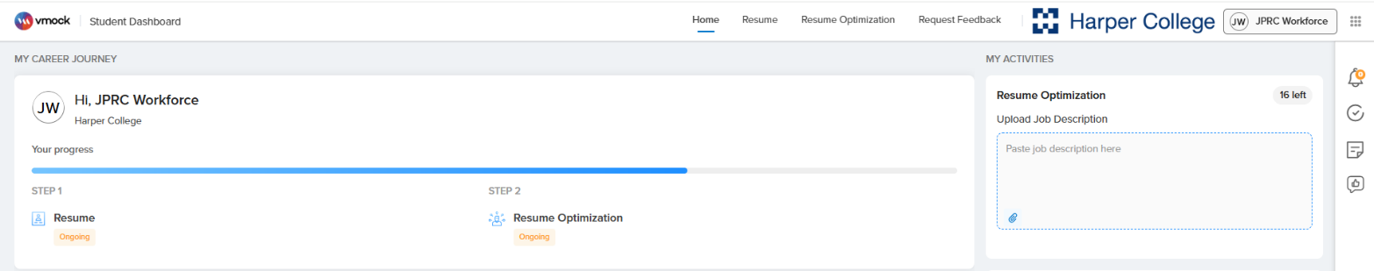
- At the top of the screen, you can either click on Resume Optimization or add a job description in the Resume Optimization box on the right, as shown in the image below.
- If you have clicked on Resume Optimization, click on Start Optimizing/New Optimization to upload or copy and paste a job description.
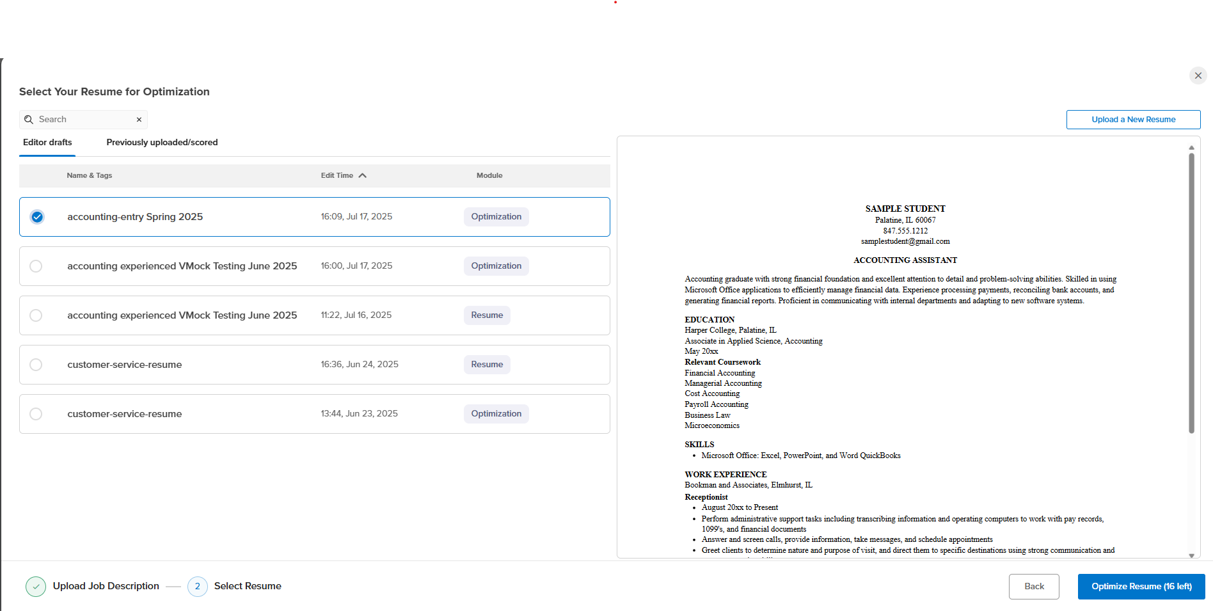
- Once the job description has been added, Click Next and then choose which resume you would like to optimize. If you do not have a resume in the system, you can Upload a New Resume from the top right, as shown in the image below.

- If you choose to upload a new resume, it must be in a PDF format. You will also need to choose a resume format you would like to use. Review all formatting and correct anything that did not convert correctly.
- Once you have selected a resume, click on Optimize Resume on the bottom right. Please note, you can only optimize your resume 20 times per year.
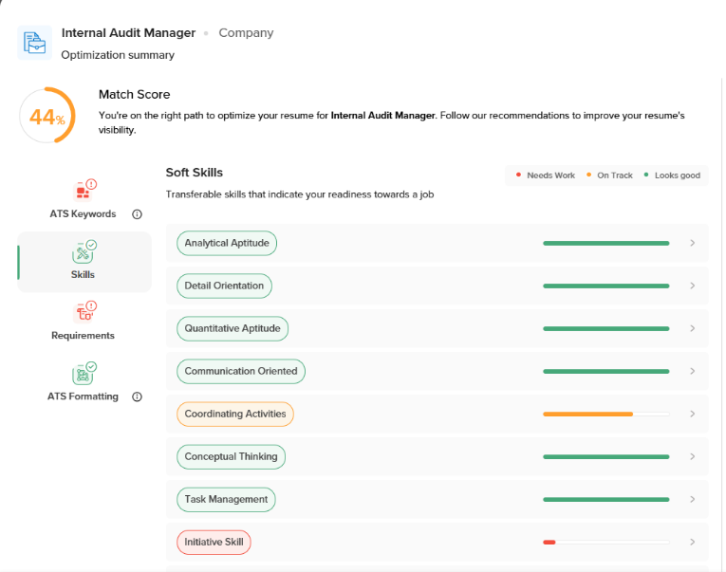
- VMock will then show you the Optimization Summary. Review all feedback provided, going through each category to view recommendations to improve your resume’s visibility.

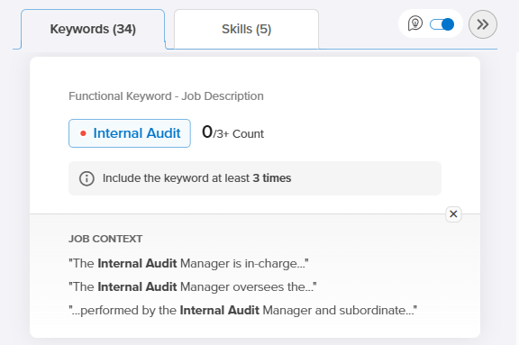
- To make improvements, click on Optimize with SMART Editor at the bottom of the screen. Hover over highlighted words to view feedback/suggestions and make any changes.
- Click through the Keywords and Skills section on the right to view suggestions you should consider incorporating into your resume.
- Once you have made all necessary edits, you can Re-evaluate your resume. Please note this will count towards your yearly optimization count.
- To download a copy of your resume, click on the download button on the right hand of the screen and choose either PDF or Docx (Word Document).
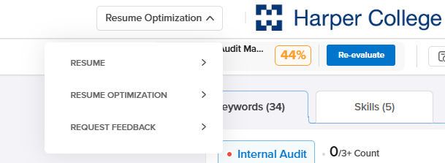
- You can also receive feedback on your resume from a JPRC staff member by clicking on Resume Optimization button on the top right of the screen and selecting Request Feedback. Resumes will be reviewed by a staff member during regular business hours.

