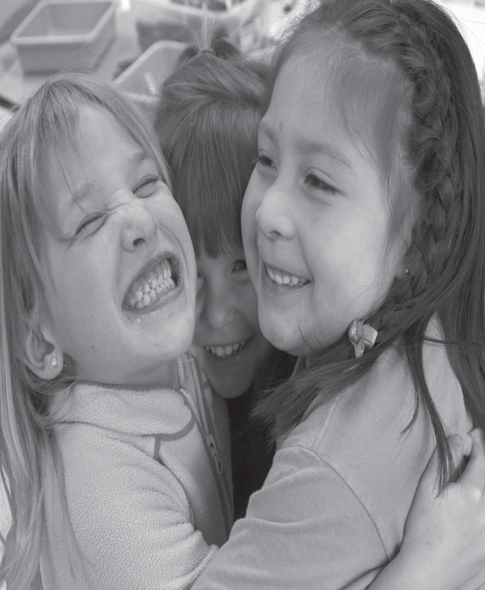
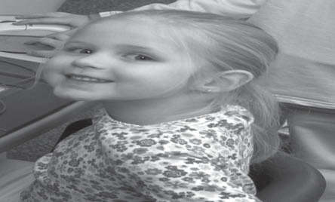
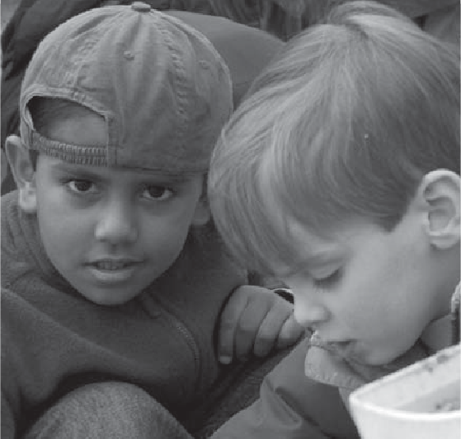
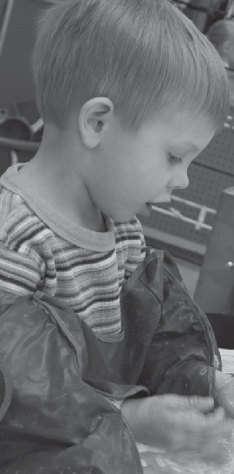
Handbook
Early Childhood Laboratory School
of Harper College
LEARNING AND ENRICHMENT FOR YOUNG CHILDREN
Dear Families,

Welcome to the Early Childhood Laboratory School at Harper College!

We are delighted that you have chosen our program and look forward to partnering with you during this exciting stage of your child's development.

The Early Childhood Laboratory School is part of Harper College's Early Childhood Education Program, which prepares future early childhood professionals through classroom instruction and supervised field experiences. The Laboratory School serves two important purposes: to provide a high-quality early learning environment for young children and to serve as a model teaching site for students preparing careers in early childhood education.

The Early Childhood Laboratory School is licensed by the Illinois Department of Children and Family Services (DCFS), accredited by the National Association for the Education of Young Children (NAEYC), and has earned the ExceleRate Illinois Gold Circle of Quality. These recognitions reflect our commitment to providing an exemplary early childhood program based on best practices in teaching and learning.

Our Preschool and Extended Preschool programs provide children with a safe, nurturing, and engaging environment where they can learn through active exploration, develop meaningful relationships, and build confidence as lifelong learners.

This handbook provides important information about our programs, policies, and procedures. Please read it carefully and keep it for future reference. If you have questions at any time, we encourage you to contact your child's teacher or the Director.

We look forward to working together to make your child's early school experiences positive, successful, and memorable.

Sincerely,

The Director and Staff
Early Childhood Laboratory School
Harper College

Preschool Program . . . . . . . . . . . . . . . . . . . . . . . . . . . . . . . . . . . . . . . . . . 3

Extended Preschool Program . . . . . . . . . . . . . . . . . . . . . . . . . . . . . . . . . .4

Program Philosophy . . . . . . . . . . . . . . . . . . . . . . . . . . . . . . . . . . . . . . . 5

Active Participatory Learning. . . . . . . . . . . . . . . . . . . . . . . . . . . .. . . . . . .6

Daily Activities . . . . . . . . . . . . . . . . . . . . . . . . . . . . . . . . . . . . . . . . . . . . 7

General Program Information . . . . . . . . . . . . . . . . . . . . . . . . . . . . . . . . 8

Policies and Procedures . . . . . . . . . . . . . . . . . . . . . . . . . . . . . . . . . . . . . . 14

Guidance and Discipline Policy . . . . . . . . . . . . . . . . . . . . . . . . . . . . . . 17

Grievance Procedure . . . . . . . . . . . . . . . . . . . . . . . . . . . . . . . . . . . . . . . 19

Early Childhood Lab School

Preschool

The Preschool program is open to the public. The children are registered
for set sessions that coincide with Harper’s academic calendar.

Harper College Palatine Campus
Business and Social Science Center, I123
1200 West Algonquin Road
Palatine, IL 60067
847.925.6262

Sessions: Monday/Wednesday/Friday 9 a.m.- 2 p.m.
Tuesday/Thursday 9 a.m.- 2 p.m.
Monday through Friday 9 a.m. – 2p.m.

Current Fees: Visit www.harpercollege.edu
OR call 847.925.6262.

Registration: $50 registration fee is assessed annually. New children are
accepted on a first-come, space-available basis. A $25 nonrefundable onetime
application fee is assessed for all new children. Enrollment and
medical forms must be completed. A copy of the child’s birth certificate is
required.

Early Childhood Lab School

Extended Preschool

The Extended Preschool program is open to the public year-round
from 7:30 a.m. to 4:30 p.m. (Summer hours may vary based on enrollment
needs.)

Harper College Palatine Campus
Business and Social Science Center, I121
1200 West Algonquin Road
Palatine, IL 60067
847.925.6262

Current Fees: Visit www.harpercollege.edu
OR call 847.925.6262.

Registration: $50 registration fee is assessed annually. New children
are accepted on a first-come, space-available basis. A $25 nonrefundable
one-time application fee is assessed for all new children. Enrollment and
medical forms must be completed. A copy of the child’s birth certificate
is required.

Early Childhood Lab School

Program Philosophy

The curriculum is based on the philosophy that young children learn
through active exploration in an environment which is rich in materials
and opportunities to converse, socialize, work, play and negotiate with
others. The High Scope curriculum is based on child development theory, research and proven instructional practices.

The classrooms are planned to encourage curiosity, exploration and
problem solving in an atmosphere of warmth, affection and respect for
each child. Teachers plan experiences based on children’s interests and
curriculum content areas with key developmental indicators (KDIs) for children.

Children may work individually or collaboratively and may choose
whether or not to participate in a group activity. Children are actively involved in
experiences which include foundations of math, science and technology, social studies,
creative art, language arts, music, movement and dramatic play.

All interrelated aspects of the child’s growth and development are
considered—intellectual, social, emotional, physical and creative.

Activities, experiences and teacher-child interactions are constantly being
planned, implemented, documented, and evaluated in terms of the following programs goals.

To provide an atmosphere which encourages within each child:

1. Development of a positive self-concept
2. Respect for the individuality and rights of others
3. Positive ways of interacting with peers and adults
4. Acceptance and expression of both positive and negative feelings
5. Growth of independence and self-sufficiency
6. Growth of creative thinking and problem solving
7. Cognitive growth and development
8. Emergent literacy development
9. Small and large muscle development

Early Childhood Lab School

Active Participatory Learning

Children develop school readiness skills through play-oriented, exploratory experiences that encourage them to investigate, make choices, solve problems, and actively participate in their learning. This philosophy is central to HighScope's approach to active participatory learning.:

- Materials – Program offers abundant supplies of diverse, age - appropriate materials. Materials appeal to all the senses and are open ended, that is, they lend themselves to being used in a variety of ways and help expand children’s experiences and stimulate their thought.

- Manipulation – Children handle, examine, combine, and transform materials and ideas. They make discoveries through direct hands-on and “minds-on” contact with these resources.

- Choice – Children choose materials and play partners, change and build on their play ideas, and plan activities according to their interest and needs.

- Child language and thought – Children describe what they are doing and understanding. They communicate verbally and nonverbally as they think about their actions and modify their thinking to take new learning into account.

- Adult scaffolding – scaffolding means teachers support and gently extend children’s current level of thinking and understanding. In this way, teachers help children gain knowledge and develop creative problem solving skills.

Early Childhood Lab School

Daily Activities

The classrooms learning environments are organized into interest centers and are designed to encourage
children’s learning through investigation, exploration and problem solving. High Scope daily routine organizes the day’s events. The daily routine provides children with a consistent and predictable schedule while remaining flexible enough to respond to children's interests, needs, and special events., although time periods are occasionally altered to accommodate children’s interest and there are exceptions for field trips, celebrations, or other special events.

Plan – Do – Review
Is devoted to the sequence: planning time, work time and recall time.

Planning Time
Meeting in a small group, each child decides what to do during work time-what area to play in, what materials to use, and who else will be involved – and shares this plan with a teacher and other children in the group.

Work Time
Work time is when children carry out their plans, alone and/or with others and then clean up.

Recall Time
At recall time, children meet with the same teacher and small group of children with whom they planned to share and discuss what they did and learned during work time

Large Group Time
Those times when the entire class does something together. The children meet to share ideas and experiences, sing songs, perform finger plays and discuss topics for the day (message board) or playing outside

Small Group Time
During these times, teachers introduce children to new materials, ideas, and activities, which the children can then continue to explore during work time. The activities may include following curriculum content areas: Mathematics; Language, Literacy and Communication; Science and Technology; Social Studies; Physical Development and Health; Social Emotional and Approaches to Learning. Children meet with the same teacher and set of classmates during the year. This arrangement provides continuity and security for children and also allows the teacher to develop a thorough knowledge of each child in this group over time.

Early Childhood Lab School

General Program Information

Eligibility
Children of Harper students, faculty, staff and children from the
community.

Ages
Three through age five. Children must be completely potty trained (day
and night; pull up diapers are not allowed). Enrolled children may
complete the semester in which they turn six. Children aged two may attend
if fully potty trained and enrollment not at capacity. (See Acceptance and Discharge.)

Teaching Staff
Lead teachers in both programs have degrees in Early Childhood
Education or related fields and experience teaching and supervising in the
field of early childhood education. Lead Teachers are also HighScope certified.
Teachers participate in ongoing professional development throughout the year to remain current in research-based practices, child development, health and safety, and curriculum implementation.

Teacher Assistants
Teacher assistants are either graduates of or are enrolled in an Early
Childhood Education program.

Student Teachers
Each semester students from the Early Childhood Education Program are
assigned to assist the teaching staff.

Children With Special Needs
Children with special needs are accepted on an individual basis when
reasonable accommodations can be made. Collaboration and consultation
among the Harper staff, parents and the special education district are
expected in order to fully meet the needs of children.

Dates in Session
The Preschool conforms to Harper’s calendar and not
the public school calendar. The College is in session for two 17-week
semesters. Two professional development days are scheduled during the fall semester and preschool program is closed for those days. A summer program is also offered. The Extended
Preschool program is closed for the following holidays: Labor Day, Thanksgiving
break (three days), winter break (two weeks), Martin Luther King’s birthday,
Lincoln’s birthday (February 12), Reading Day (Friday
before Easter), Memorial Day, Professional Development Days (two days), July 4 and summer break (one week)

Observations
An observation room with a one-way viewing glass and
sound system is adjacent to the preschool. Parents may observe at any
time. Call 847.925.6262 to make arrangements.

Orientation
An orientation program is held each fall for one day during
the week prior to the start of school. This is an informal visit to the
classroom by the child accompanied by one or both parents. Children and
parents are invited to acquaint themselves with the room and meet the
teachers. An open house that consists of a parent information night is also
held in the fall of each year.

Records
Each child enrolled is required to have on file: 1) registration
form; 2) copy of birth certificate; 3) enrollment history form; 4) current
medical form; 5) emergency information forms; 6) guidance and discipline
policy and other forms which may be required by the Illinois Department
of Children and Family Services.

Deposit
Preschool parents will be responsible for payment of a $100
nonrefundable deposit to guarantee their child’s place in the preschool
program. The $100 deposit will be applied to tuition. A $25
nonrefundable one-time application fee is assessed for all new children. Annual nonrefundable $50 registration fee required for all programs.

Outdoor Play
Children play outdoors every day unless weather is
extremely severe. Children should wear appropriate outer clothing daily.
Children too ill to be outside should not come to school. Outdoor play is an important part of our curriculum. Children are expected to participate in outdoor activities unless a physician provides written documentation indicating otherwise.

Field Trips and Resource Visitors
Off-campus field trips are not taken,
but on-campus sites of interest are occasionally visited. Children may walk
to such places as the security police office, television studio, health service
office and dental hygiene department. Resource people including firemen,
pilots and musicians visit the classroom. Parents are encouraged to share
their talents, occupations and hobbies with their child’s class.

Parent Involvement and Family Partnerships
The Early Childhood Laboratory School recognizes families as children’s first and most important teachers. Families are recognized as important partners in children’s learning and development, and we value their role in supporting each child’s growth, learning, and overall well-being. Open and ongoing communication and collaboration between families and teachers help create a strong connection between home and school and allow us to better understand and support each child’s individual needs, interests, and experiences.

Families are encouraged to participate in many aspects of our program, including daily communication with teachers, reviewing classroom newsletters and updates, attending parent-teacher conferences, participating in classroom activities and special events, and sharing information about their child’s interests, experiences, and development. Families may also contribute to the program by completing family questionnaires, participating in home observations, providing feedback through program evaluations, and serving in advisory or other collaborative opportunities.

Parents and families are encouraged to share their family traditions, occupations, hobbies, languages, cultures, and experiences with the children. These contributions help create an inclusive classroom community where every child and family feels welcomed, respected, valued, and represented.
The Early Childhood Laboratory School welcomes and appreciates family feedback and involvement. Through ongoing communication, collaboration, and shared decision-making, families and teachers work together to support children’s development and continuously improve the program to provide the best possible learning experience for all children.

Inclusion, Respect for Diversity, and Anti-Bias Practices
The Early Childhood Laboratory School is committed to providing an inclusive environment where all children and families are respected, valued, and supported. We recognize and celebrate the diversity of each child and family, including culture, language, abilities, family experiences, and traditions. Teachers promote acceptance, respect, and fairness by creating learning experiences that reflect and honor children’s identities while helping children appreciate and respect differences among others.

Conferences
Teacher Reflection Form is sent to parents at the end of the first semester, where the teachers list accomplished milestones, progress that has been observed and list the milestones that this child is working on. Parental conferences are scheduled in the spring. However,
conferences may be arranged at any time at the request of either the
teacher or parents.

Assessment
Our assessment practices focus on the whole child. We use the COR Advantage Assessment System, which is aligned with the Illinois Early Learning and Development Standards (IELDS), to assess children's learning and development across all developmental domains.

Each day, teachers document objective anecdotal observations of children's play, interactions, and learning experiences. These observations are used to document each child's progress, identify strengths and emerging skills, and plan meaningful learning experiences that support both individual children and the classroom as a whole.

Family Participation in the Assessment Process
Families are important partners in the assessment process because they know their child best. Information shared by families helps teachers gain a more complete understanding of each child's development, interests, and learning across different settings.

Families are encouraged to contribute to their child's assessment by:
Sharing observations from home about new skills, interests, behaviors, routines, or significant developmental milestones through conversations, emails, conferences, or written notes.
Participating in parent-teacher conferences and completing family questionnaires or screening forms, where they can discuss their child's development, strengths, interests, and any questions or concerns they may have.

Teachers consider information provided by families, along with classroom observations, when planning individualized learning experiences and supporting each child's continued growth and development.

Developmental Screenings
A developmental screening is completed for each newly enrolled child and shared with the family within 60 days of the child's start date. The Early Childhood Laboratory School uses the Ages & Stages Questionnaires® (ASQ), which are completed by the child's parent or guardian. The Director reviews and scores the questionnaire and discusses the results with the family.

The purpose of the screening is to identify each child's strengths, monitor developmental progress, and support collaboration between families and teachers in planning developmentally appropriate learning experiences.

Information provided by families on the Ages & Stages Questionnaire, along with ongoing classroom observations, contributes to each child's overall assessment.

The publisher of the Ages & Stages Questionnaires has established procedures for standardization, scoring, reliability, and validity. Information regarding these procedures is available upon request.

Confidentiality of Children’s Records
The Early Childhood Laboratory School respects and protects the privacy and confidentiality of all children and families. Information pertaining to a child’s admission, development, progress, health, assessment, or discharge shall be kept confidential and shared only with Early Childhood Laboratory School staff members who have a legitimate educational or professional need to access the information.
Confidential information will not be disclosed to individuals outside of the program unless the child’s parent or legal guardian provides written authorization, or disclosure is required by law. The program follows all applicable regulations regarding the confidentiality and secure maintenance of children’s records.
Teachers and staff recognize that families entrust the program with sensitive information and are committed to maintaining respectful, professional relationships while protecting each child’s dignity, privacy, and well-being.

Program Evaluations
The Early Childhood Laboratory School is committed to continuous program improvement and values the feedback of families as an essential part of this process. To help us maintain a high-quality learning environment, families are invited to complete anonymous program evaluations at least twice each year. The evaluation provides an opportunity to share feedback regarding the curriculum, teaching practices, communication, learning environment, health and safety, and overall program quality.
Families are encouraged to offer suggestions, identify areas for improvement, and recognize aspects of the program they value most. Evaluation results are reviewed by the Director and teaching staff and are used to guide program planning, professional development, and continuous quality improvement. We appreciate your partnership and thank you for helping us provide the highest quality early childhood education for all children and families.

Integrated Pest Management Program
IPM uses the most appropriate practice to achieve control of pests while avoiding adverse effects on people and the environment. Public Act 95-0058 requires written notification prior to the application of pesticides. Should parents wish to receive written notification prior to the specific application of pesticides they must register. To register to receive written notification 48 hours prior to pesticide applications, parents may submit their name and address by email to ibakalus@harpercollege.edu

If an emergency pesticide application exists to protect against an imminent threat to health or property, prior to the actual application, a good faith effort will be made to supply written notification to those on this registry.

Program Newsletters
Weekly program newsletters will be shared with all families to provide updates about classroom experiences, children’s learning, and upcoming events. Newsletters will include information about current classroom activities across all curriculum areas, such as mathematics, science, language and literacy, creative arts, social-emotional development, and physical development.
Families will also receive updates about special projects, classroom investigations, guest visitors, field trips, special events, and important program dates and reminders. Newsletters will include photographs of children’s experiences and learning activities to help families stay connected to their child’s day and understand the many ways children are learning and growing at the Early Childhood Laboratory School.

Payment of Fees
Fees are assessed per semester for both programs. Payments might be made weekly or in the installments. There are no refunds for sick days, holidays, vacations, emergency closings or staff development days. Fees may be made through the Harper College on-line tuition payment system.

Emergency Situations
The safety and well-being of children are our highest priorities. The Early Childhood Laboratory School maintains written emergency response procedures for a variety of situations, including medical emergencies, fire, severe weather, evacuation, shelter-in-place, and lockdown situations. Staff receive training on emergency procedures and participate in regular emergency drills throughout the year.
Parents are required to provide current emergency contact information, including home, work, and mobile telephone numbers, as well as the names and phone numbers of at least two authorized emergency contacts who may be contacted if a parent or guardian cannot be reached. Families are responsible for notifying the school promptly of any changes to this information.

In the event of a medical emergency or serious illness, staff will provide immediate first aid, contact emergency medical services (911) when necessary, and notify the child's parent or guardian as soon as possible. If a parent or guardian cannot be reached, the school will contact the individuals listed on the child's emergency contact form.

If an emergency requires evacuation, shelter-in-place, or lockdown, children will remain under the supervision of trained staff until the situation has been resolved or they are safely reunited with their authorized parent, guardian, or emergency contact. Families will be notified as soon as practical with information regarding the emergency and any instructions for child pick-up or reunification.

Laboratory Procedures
The Early Childhood Lab School of Harper College is the laboratory
component of the Early Childhood Education Program. As such, students
enrolled in some courses in the program are assigned to observe or
participate in the Lab School.

Research studies are occasionally conducted in the Lab School by professionals
in various fields. Such studies are carefully screened by the Lab School staff.
Parents will receive information as to the nature of any study to take place
and parental permission for their child’s participation will be requested.

Early Childhood Lab School

Policies and Procedures

School Closing
If the campus is closed due to inclement weather, announcements to
that effect will be made on the website www.harpercollege.edu or by calling
847.925.6000 after 6 a.m. The announcements are also sent as an automated
message when signed up for the Harper Emergency Alert system.

Families will also receive notifications through the Harper College Emergency Alert System, email, and other communication methods when available.

Drop-off and Pick-up
Preschool children may arrive no earlier than 10 minutes prior to their
designated arrival time and must be picked up promptly.

Parents may park cars briefly in the short-term parking spaces for the purpose of dropping off or
picking up children. All spaces are marked “Reserved for Child Drop Off”.

Children may not, under any circumstances, be dropped off outside the
building. Each child is to be accompanied to the classroom by a parent.
Younger siblings should not be left unattended in the car while the parent
is in the building.

No child will be released to anyone other than his/her own parent or
designated car pool driver without the written consent of the parent.

No child will be released at any time to a parent or designated individual
who is visibly impaired due to alcohol consumption, substance abuse,
prescription drugs or other substances. In the event a parent or designated
individual is impaired, the Lab School’s staff will telephone individuals on the
child’s information sheet to arrange for the child to be released in his or
her custody. The Lab School staff will immediately telephone the appropriate
law-enforcement officials.

Vehicle Idling Policy
To promote a healthy and safe environment for all children, families, staff, and visitors, the Early Childhood Laboratory School discourages vehicles from idling in the parking lot or designated drop-off and pick-up areas. Vehicle exhaust contributes to air pollution and can affect the health of young children, who are especially sensitive to poor air quality.
Families are asked to turn off their vehicle's engine when parked or waiting, unless idling is necessary during periods of extreme heat or extreme cold to maintain a safe interior or engine temperature. We appreciate your cooperation in helping us provide a healthier environment for everyone in our school community.

Dressing for School
Since creative art and outdoor activities are an integral part of the daily
curriculum, washable clothing should be worn by the child.

During cold, snowy weather, the child should dress for outdoor play with
a heavy jacket, hat, gloves and boots. All outer clothing should be marked
with the child’s name, and mittens should be fastened to sleeves. Children
are encouraged to dress and undress themselves. Parents can help by
teaching children to put on and remove outer clothing in proper sequence.

Health Policy
Each child is required to have a complete physical examination and be up-to-
date on all immunizations. Children who exhibit symptoms of illness or are unable to comfortably participate in classroom activities should remain at home until they meet the school's return-to-care guidelines without obvious symptoms (for example, a child who is unusually pale or flushed, acting
irritable, or is unusually tired or lethargic) or any child who exhibits
obvious symptoms (such as fever, vomiting or diarrhea) should be kept
home from the Lab School.

The Early Childhood Lab School uses the Health Service department on campus
as a consultant to advise the Lab School on children’s health and wellness issues.

Ill Children
Parents will be notified if their child becomes ill at the Lab School. Parents
should remove children from the Lab School after notification. Children
exhibiting signs of illness listed below should remain at home. The
following are indications of illness that will necessitate removal:

- Fever: Children who develop a fever while at the Center and children
with a fever of 100 will not be readmitted to the Center until their
temperature has been normal for 24 hours.
- Vomiting: Parents will be asked to remove children from the Center.
- Diarrhea: Parents will be asked to remove children from the Center.

Communication
No school sessions will be disrupted by communications directed to a
student or faculty member except in the case of an authorized family visit
or in the event of an emergency.
Emergency messages for children or staff should be directed to the Director of the Early Childhood Laboratory School, who will ensure that information is communicated promptly and appropriately.

Snack Sharing
Nutrition education is an important part of the program. Each preschool
child is required to provide a nutritious snack for his/her class for one week
each semester. This is both a learning and sharing experience for the
children as they discuss the various snacks provided. They explore smell,
taste, texture, color, shape, and where and how the food is grown or made.
Suggested foods include raw fruit or vegetables, dried fruit, cheeses, whole
grain crackers, or breads. Only prepackaged foods can be accepted.
Children cannot be served any home-prepared foods. A refrigerator, stove
and oven are available and the children help with snack preparation.

The Early Childhood Laboratory School is a nut-free environment.. This includes peanuts and
tree nuts. No whole grapes, raisins, popcorn, hard pretzels or chunks of raw
carrots will be served as they may be a choking hazard.
Sweets such as candy or cookies will not be accepted.

Separation
For some parents and children, separation is much more difficult than
for others. We support those for whom separation creates anxiety by
allowing a parent to stay in the classroom. While in the room, a parent is
asked to try to gradually become uninvolved with the child, encouraging
him or her to move away. When the child seems more at ease and has
learned to trust the teachers, and when the child and parent seem
comfortable separating, the parent is encouraged to leave.

Acceptance and Discharge
Every effort is made to support each child's successful participation in the program. If concerns arise regarding a child's development, behavior, or ability to participate safely, teachers and the Director will work collaboratively with the family to develop strategies and identify appropriate supports. When reasonable accommodations and available resources are no longer sufficient to meet the child's needs or ensure the safety and well-being of all children, alternative placement options may be discussed with the family. Any decision regarding disenrollment will occur only after careful consideration, collaboration with the family, and appropriate transition planning.

Change of Schedule
Four-week notice needed to change the child’s schedule.

Withdrawal
At least four-weeks notice of withdrawal is required. Parents are responsible
for payment for those two weeks.

Early Childhood Lab School

Guidance and Discipline Policy

Center Philosophy
The staff of the Early Childhood Laboratory School believes that each child is a unique individual with their own needs, feelings, interests, abilities, and learning styles. When children's needs are met, their feelings are acknowledged and respected, their interests are nurtured, and their abilities and learning styles are recognized and supported, the need for discipline is greatly reduced.

We are committed to providing a safe, caring, and inclusive learning environment that respects each child's developmental level while encouraging independence, self-regulation, problem-solving, and positive relationships with others. Through caring interactions and developmentally appropriate expectations, teachers help children develop the social and emotional skills needed to become confident and responsible members of the classroom community.

Positive Guidance and Discipline
Children are encouraged to express their needs, ideas, and feelings using words. Teachers support children in their interactions with peers by helping them communicate, negotiate, solve problems, cooperate, and express emotions in respectful and appropriate ways. Teachers acknowledge and accept children's feelings while guiding them toward safe, responsible, and socially appropriate behaviors.

Positive guidance strategies are individualized, developmentally appropriate, and designed to teach rather than punish. Teachers use redirection, modeling, encouragement, problem-solving, logical consequences, and conflict resolution to help children develop self-control and positive relationships.

When a child becomes overwhelmed or is unable to regain self-control independently, a teacher will remain with the child, provide comfort and reassurance, and help the child calm down before returning to classroom activities. The goal is to help children develop the skills needed to regulate their emotions and behavior while maintaining their dignity and sense of belonging.

The Early Childhood Laboratory School does not use corporal punishment or any form of physical punishment. Staff do not use humiliation, ridicule, threats, intimidation, shaming, or the withholding of food, rest, comfort, or participation in activities as forms of discipline.

Communication with Families Regarding Behavior
Teachers maintain ongoing communication with families regarding each child's social-emotional development and classroom experiences. If behavioral concerns arise, families will be informed promptly and respectfully. Teachers and families will work together to identify goals, develop consistent strategies, and support the child's success both at school and at home.

When appropriate, the program may recommend consultation with specialists or other community resources. Families will be involved in all discussions regarding additional supports and services.

Enrollment Decisions Related to Behavioral Concerns

The Early Childhood Laboratory School is committed to supporting every child's success within the program. A child's enrollment will be terminated because of behavioral concerns only after all reasonable efforts to support the child have been exhausted and it has been determined that continued enrollment is not in the child's best interest or the best interest of the program.

Before disenrollment is considered, teachers, administrators, and families will work collaboratively to identify concerns, implement appropriate interventions, monitor progress, and explore available supports and community resources. If disenrollment becomes necessary, staff will assist the family in planning for the child's transition and provide referrals to appropriate programs or agencies whenever possible.

Addressing Classroom Concerns

Families are encouraged to communicate openly with their child's teacher regarding any questions or concerns about their child's classroom experience. A conference may be scheduled at any time to discuss concerns, share observations, and develop a plan to support the child's growth and success.

The Director of the Early Childhood Laboratory School is also available to meet with families as needed. If concerns are not resolved through these discussions, families may request a conference with the Dean of the Business and Social Science Division.

Early Childhood Laboratory School of Harper College

Grievance Procedure

Thank you for choosing the Early Childhood Lab School. If you have questions or concerns at any time, please do not hesitate to speak to us. We want your child to enjoy his/her time with us.

Harper College
Early Childhood Lab School
Building I, Room I123
1200 West Algonquin Road
Palatine, Illinois 60067
847.925.6000

Preschool (ext. 6262)
Brygida Fudala and Claudine Voltolina
bfudala1@harpercollege.edu and cvoltoli@harpercollege.edu

Extended Preschool (ext. 6262)
Sandra Mendoza and Dragana Kulisic and Samantha Kennedy
ms38287@harpercollege.edu and kd36315@harpercollege.edu
ks36783@harpercollege.edu

Director (ext. 6262)
Irena Bakalus
ibakalus@harpercollege.edu

Division Dean (ext. 6311)

I/We
Parent(s) of
Hereby certify that I/we have received a copy of the Early Childhood Lab School Handbook.
Signature of Parent
Date
Signature of Parent
Date
Notes

Notes


Accredited by the National Academy of Early Childhood Programs

