WILLIAM RAINEY HARPER COLLEGE
BOARD OF TRUSTEES OF COMMUNITY COLLEGE DISTRICT #512 COUNTIES OF COOK, KANE, LAKE, AND McHENRY, STATE OF ILLINOIS
c Minutes of the Closed Session June 5, 2024

CALL TO ORDER

ROLL CALL

DISCUSSION

FORMAL ACTIONS

ADJOURNMENT
A closed session of the Board of Trustees of Community College District No. 512 was called to order by Chair William Kelley Wednesday, June 5, 2024 at 6:20 p.m. in the Wojcik Conference Center, 1200 W. Algonquin Road, Palatine, Illinois. The reason for the closed session was pursuant to OMA 2 (c) (8) security procedures.

Present: Student Trustee Lei, Members, Greg Dowell, Pat Stack, Diane Hill, Walt Mundt and Bill Kelley

Absent: Members Herb Johnson and Nancy Robb

Also attending: Riaz Yusuff, Tony Butler, Gloria Plaza, Jeff Julian, Rob Galick and Maria Coons

The Board reviewed and discussed Harper College's action related to the Gramm Leach Bliley Act.

The Act was passed in 1999 but new parameters have been added to ensure student financial information is properly protected and safeguarded. Most of this information is in the Financial Aid system.
Cybersecurity measures are in place and the Harper team reviewed items that have been addressed, suggested via a third-party review of our practices. This work continues to ensure integrity of our systems and security of our students' information.

There were no formal actions taken.

Member Dowell moved, Member Stack seconded, adjournment of the closed session at 6:20 p.m.
Upon roll call, the vote was as follows:
Ayes: Student Trustee Liman Lei, Members Pat Stack, Greg Dowell, Diane Hill, Walt Mundt and Bill Kelley

Nays: None.
Motion carried.



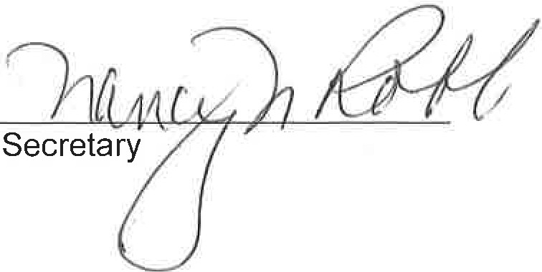
Chair

