To request an item, start by selecting Catalog above the search bar, typing in keywords or a title, and clicking Search.
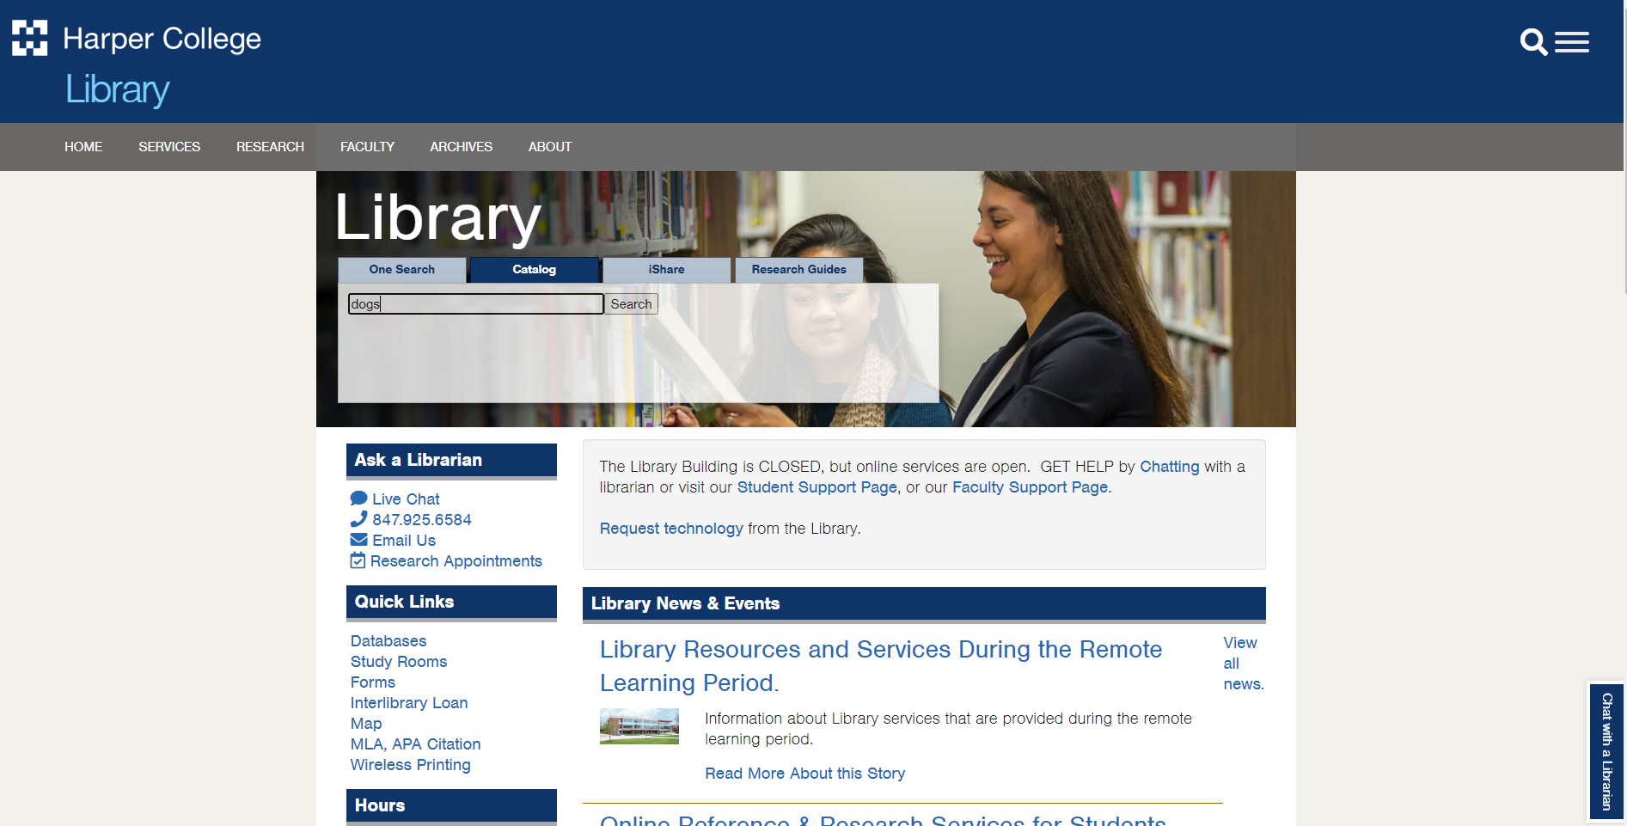

Once you have accessed the catalog, click Sign in (top right corner).
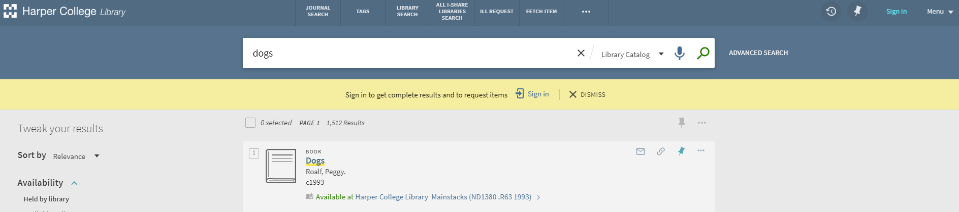
Click on Student and Employee Login. Login with your portal info.
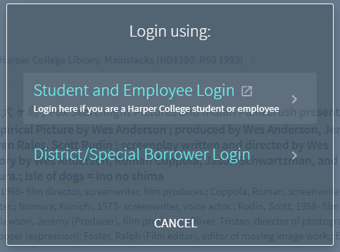

You will be taken back to your search results. Once you find an item you’re interested in, click on the item to open the record. Click on Request.
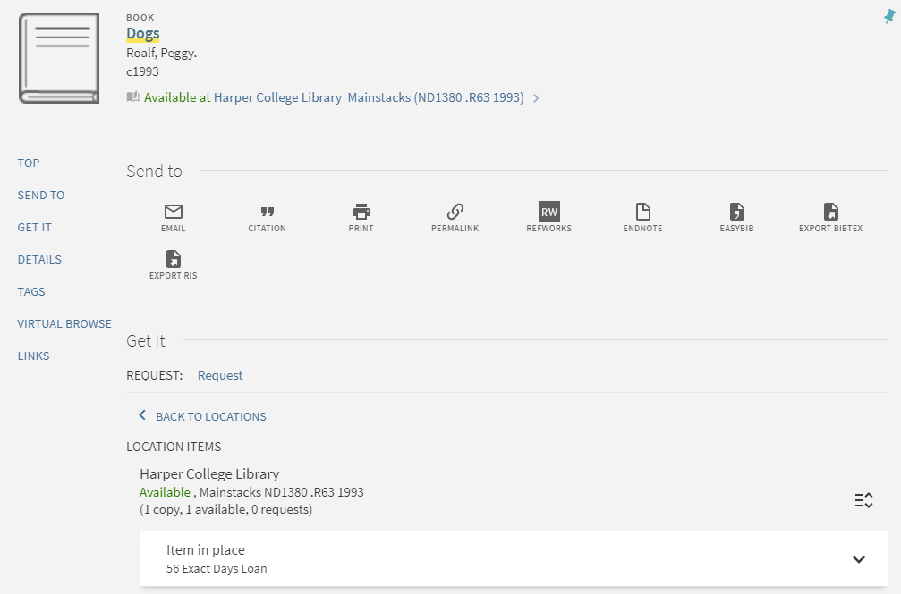

If there is a date you would no longer need the item by, you can select the date (this is optional). Click Send Request. Once it confirms your request, you’re all set! You will receive an email when your item is ready for curbside pickup.
