Chromebook Setup
  - Basic Chromebook Usage for Students


Table of Contents
Using your Chromebook 2
Initial Set up 2
Chromebook Quick Guide 8
Chromebook Touch Pad 8
Click 8
Right-click 8
Scroll 8
Keyboard Shortcuts 8
Take a Screenshot 8
Toggle Caps Lock 8
View all Keyboard Shortcuts 8
Sign in as Guest / Add another User 8
Signing out as a guest 9
Finding your Files 9
Accessing Office 365 on Chromebook 9
Updating your Chromebook 10
Installing Honorlock 10
Honorlock FAQ 10
Returning your Chromebook to the Library 11

Using your Chromebook
The purpose of this guide is to assist students with using their Harper Library provided Chromebook. If you have any questions about the information in this guide or any other technology related questions, please contact the Harper College Service Desk by phone 847.925.6866 or by email studentsd@harpercollege.edu.
Chromebooks can be picked up and returned at the Desk in the Library (Building F, Second Floor).
All the following must be true to complete the Loan Contract for a Chromebook:
- Student must be in good standing
  - No outstanding fees or overdue items
- Student must be enrolled in a Credit course
Harper College Library
847.925.6184
semesterloantech@hapercollege.edu

Initial Set up
Students will not be able to log in to the Chromebook with their Student email. A personal Google Account must be used to sign in. Signing in with a Harper email address will restrict access to important functions such as downloads, installations, and videos. If there is no personal Google Account, one can be created at step 7.
Please note the set up may vary based on the version the Chromebook is on.
- Plug in the provided charger into the Chromebook.
- Turn on the Chromebook by pressing the Power Button on the left side of the device.
- On the Welcome screen, click Get started (Figure 1).
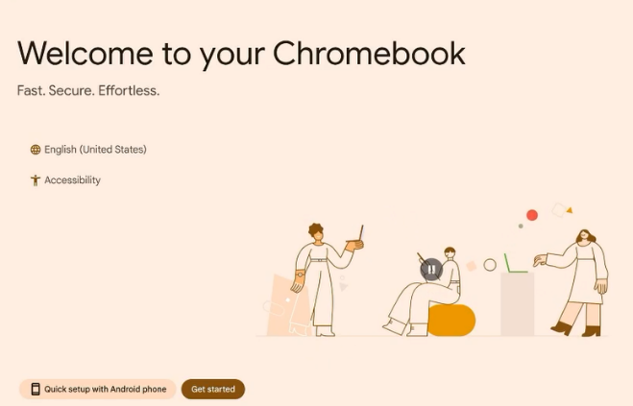
Figure 1: Welcome to your Chromebook

- Select a Wi-Fi network to connect to then click Next (Figure 2).
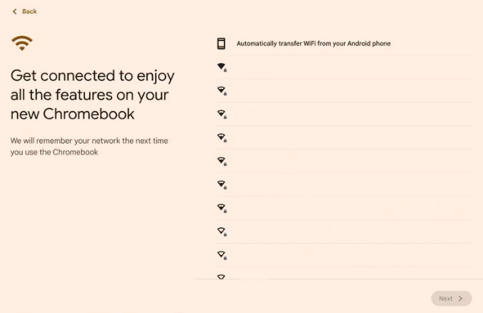
Figure 2: Connect to a Wi-Fi to get started
- Select For personal use then click Next (Figure 3).
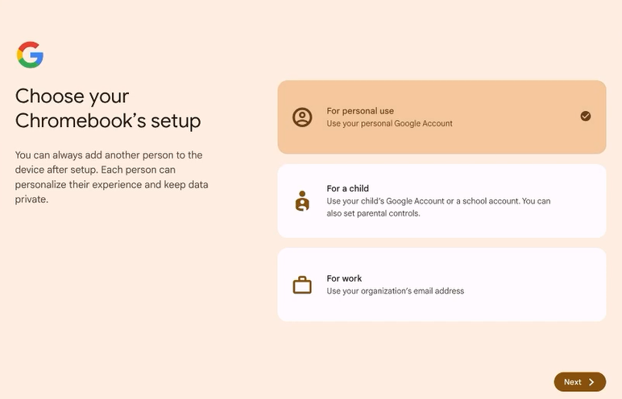
Figure 3: Continue using a personal Google Account
- Select Enter your Google Account and password then click Next (Figure 4).
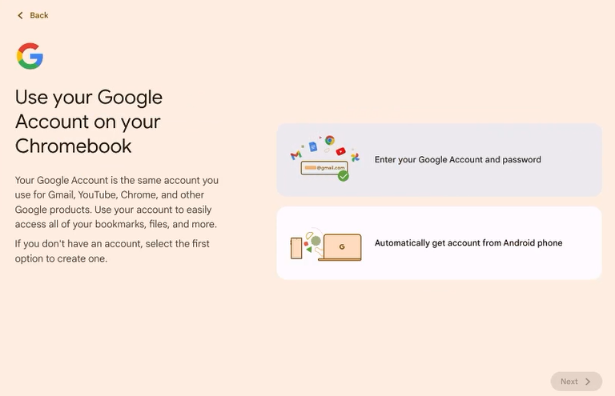
Figure 4: Sign in using your personal Google Account credentials

- Sign in using your personal Google Account credentials (Figure 5).
  - Click More options if you need to create a personal Google Account.
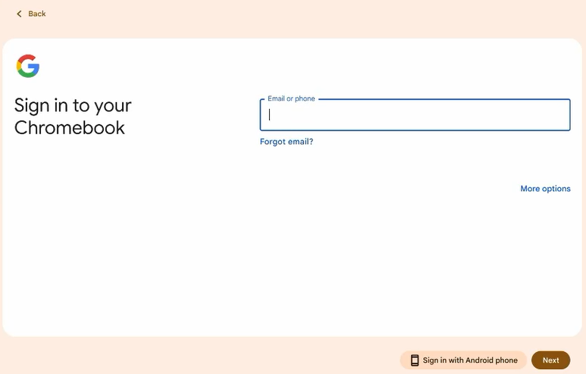
Figure 5: Enter your Google Account credentials
- Review the terms and data usage then click Accept and continue (Figure 6).
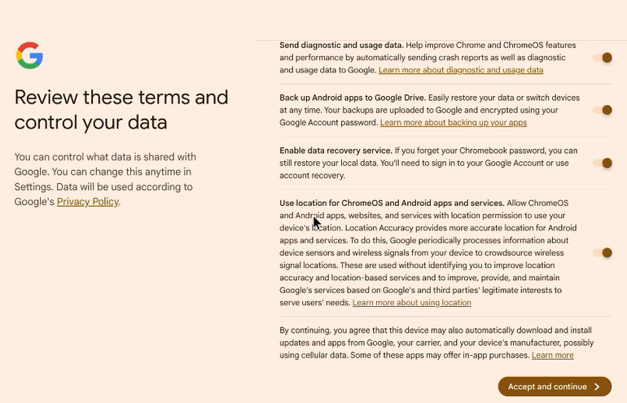
Figure 6: Configure the terms and data usage to your preference
- Review the Sync your Chromebook settings then click Accept and continue (Figure 7).
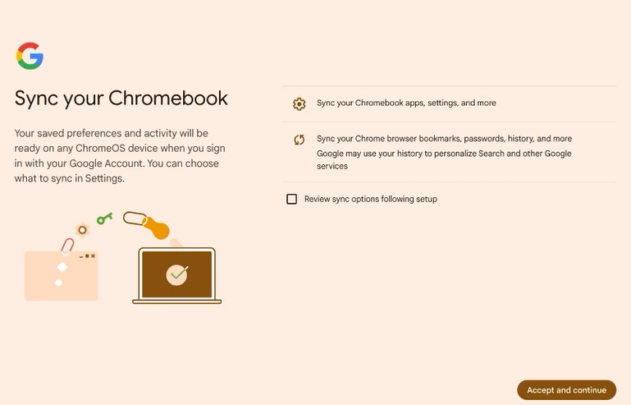
Figure 7: Sync your Chromebook when you sign in with your Google Account

- Select whether to use a password or to create a PIN to sign in to the Chromebook (Figure 8).
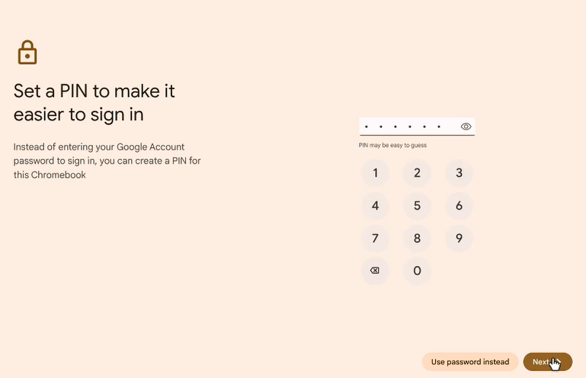
Figure 8: Create a PIN to sign in
- Select the Chromebook usage or click Skip (Figure 9).
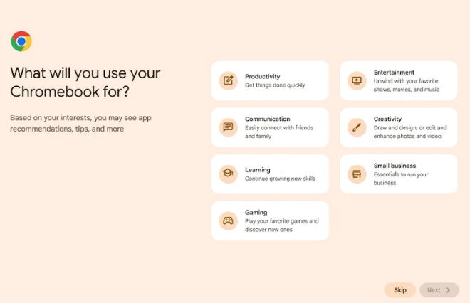
Figure 9: Select what the Chromebook will be used for or click skip
- Click No thanks (Figure 10).
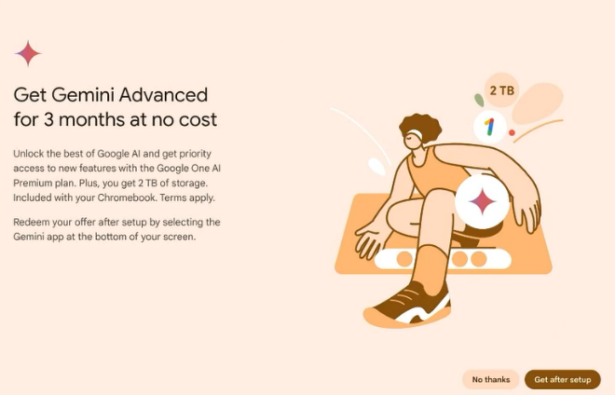
Figure 10: Skip the Google Gemini advertisement

- Adjust the features based on your preferences or click Skip (Figure 11).
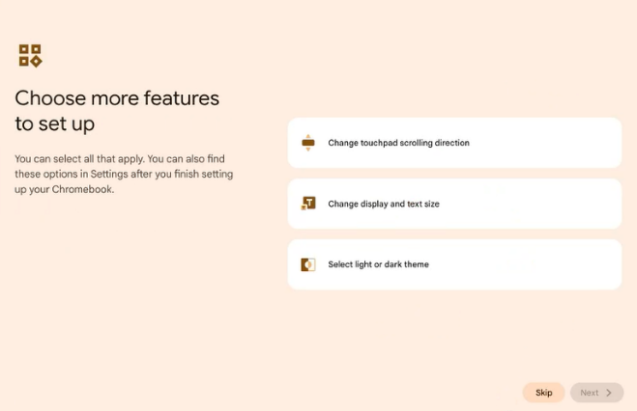
Figure 11: Adjust settings based on your preference
- Click Get started to complete the set up (Figure 12).
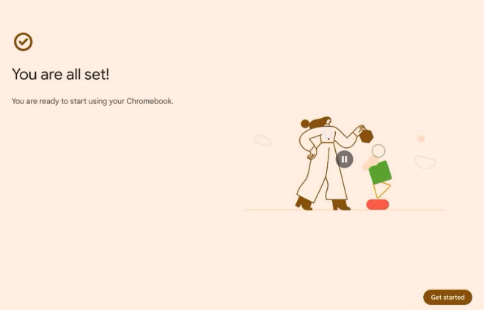
Figure 12: Finalize the set up by clicking Get started

Chromebook Quick Guide

Chromebook Touch Pad

Click
Press down on the lower half of the touchpad. Tap-to-click is enabled by default, where a quick tap on the touchpad allows a click.

Right-click
Click the touchpad with two fingers.

Scroll
Place two fingers on the touchpad and move them vertically or horizontally.

Keyboard Shortcuts

Take a Screenshot
Ctrl + Show Windows

Toggle Caps Lock
Alt + Search 

View all Keyboard Shortcuts
Ctrl + Search + S

Sign in as Guest / Add another User
- Click the Clock on the lower right.
- Click Power then Sign out (Figure 13).
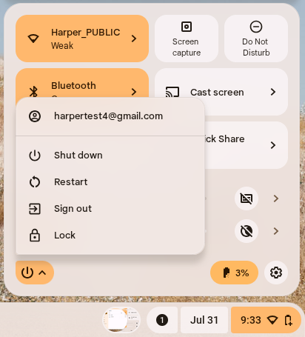
Figure 13: Chromebook power/sign out options
- On the lower left of the login screen, click  Browse as Guest
  - Guests do not have access to your personal apps or data.
  - Adding a Person will allow multiple users on the same device while using their own personalized settings.

Signing out as a guest
- On the lower right, click the Time.
- Click Exit guest.

Finding your Files
Chromebooks are made with the intention of saving files to the cloud. Files do not appear on the desktop. By default, everything you download will be saved in the Downloads folder. Files saved to Google Drive are backed up online automatically.
- Open Files 
- Click Downloads  to access downloaded content.
- Click Google Drive  to access cloud content.
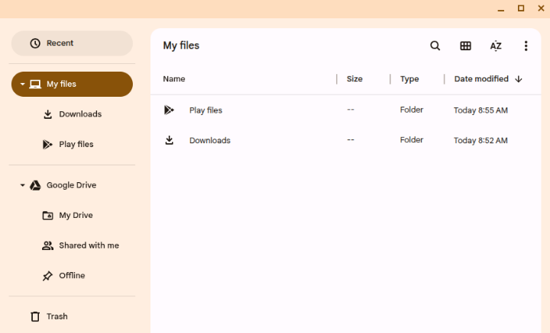
Figure 14: Files window

Accessing Office 365 on Chromebook
Chromebooks cannot install Office 365 applications. However, the web version is available to use.
- Open Google Chrome 
- Navigate to office.com
- Sign in using your Harper College email address.
  - Your email address is your username followed by @mail.harpercollege.edu
- Complete the multi-factor authentication to gain access to Office 365.
  - If you have not set up multi-factor authentication, visit the following for more information: harpercollege.edu/services/techsupport/setup-authentication.php

Updating your Chromebook
To ensure the latest features and security, updates should be performed on the Chromebook. To manually check for updates, follow the instructions below.
- Click the Clock on the lower right.
- Click Settings 
- Click About ChromeOS on the left menu.
- Click Check for updates.
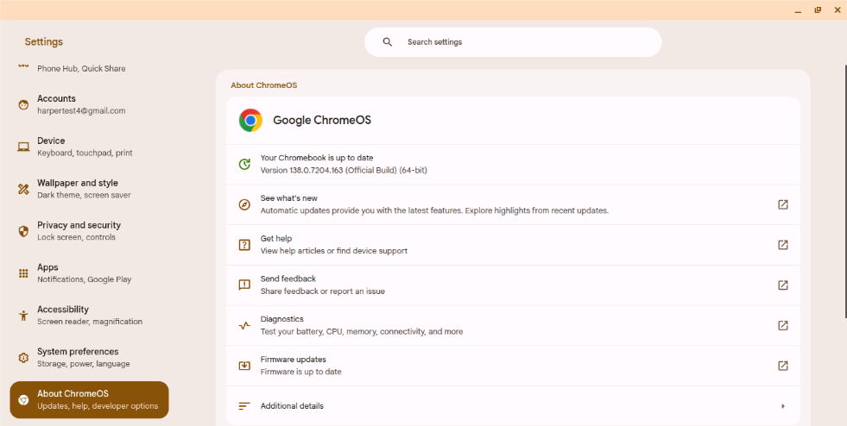
Figure 15: Settings – About ChromeOS

Installing Honorlock
Instructors may require the use of Honorlock for tests or quizzes. Follow the instructions below to set up Honorlock on a Chromebook (Figure 16).
- Open Google Chrome
- Navigate to app.honorlock.com/install/extension
- Agree to Honorlock’s Terms of Service
- Click Add Extension
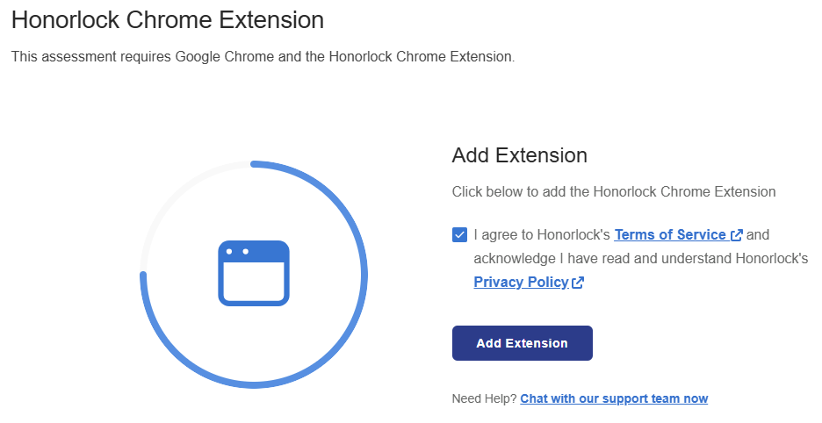
Figure 16: Honorlock extension installation page

Honorlock FAQ
If you have questions regarding Honorlock, visit harpercollege.edu/testing/honorlock.php

Returning your Chromebook to the Library
Before returning your Chromebook to the Library a Powerwash must be performed. This ensures that your personal Google Account, Apps, and settings will be removed from the Chromebook.
- Click the Clock on the lower right.
- Click Power then Sign out.
- At the login screen, press and hold Ctrl + Alt + Shift + R on the keyboard.
- Click Restart.
- In the following boxes, click Powerwash, then Continue.

