Harper Flex Classroom
Single and dual projector rooms

Table of Contents
Harper Digital Podium 1
Logging in to the Computer 1
Lectern Features 1
Height Adjustable 1
Single Projector Flex Room 2
Flex Room Control Touch Panel 2
Turning the System On 2
Camera Controls 3
Turning the Camera On 3
Input 3
Picture-in-Picture (PIP) 3
Sharing Outputs in Webex 4
Lectern PC 4
Doc Cam 4
HDMI 5
Blu-Ray Player 5
Flex Room Device Adjustments 6
Projector Blank 6
Speaker Volume 6
Device Controls 6
Turning the System Off 7
Dual Projector Flex Room 8
Flex Room Control Touch Panel 8
Turning the System On 8
System Tab 8
Sources Tab 9
Speakers 9
Share Tab 9
Audio Tab 10
Blu-Ray Tab 10
Join Webex 10
Document Camera 11
Opening and Positioning the Document Camera 11
Displaying a Document 11
Document Camera Controls 11
SMART Monitor (Annotation LCD) 12
SMART Ink General Usage 12
LCD Annotation Controls 12
USB Ports 12

Harper Digital Podium

Logging in to the Computer
- Press Ctrl + Alt + Del on the keyboard.
- Click OK at the Acceptable Use Policy screen.
- The screen will show the workstation ID (i.e., LAB\D114PDU) and a password field. No password is required to log in to the workstation. Press Enter to log in.
- Open Webex found on the desktop. If Webex is not there, click Search on the Taskbar and type Webex.
- Log in to Webex to start the meeting.

Lectern Features
The lectern technology at Harper College has been updated with changes resulting from an independent survey of faculty and students, an IT survey of faculty, and assistance from faculty on the design. This updated lectern is designed to improve instructor sightlines to see the students while ensuring the students can see the instructor without the podium blocking the projection screens, white boards, etc. The units are smaller, more portable, height adjustable, and ADA compliant.
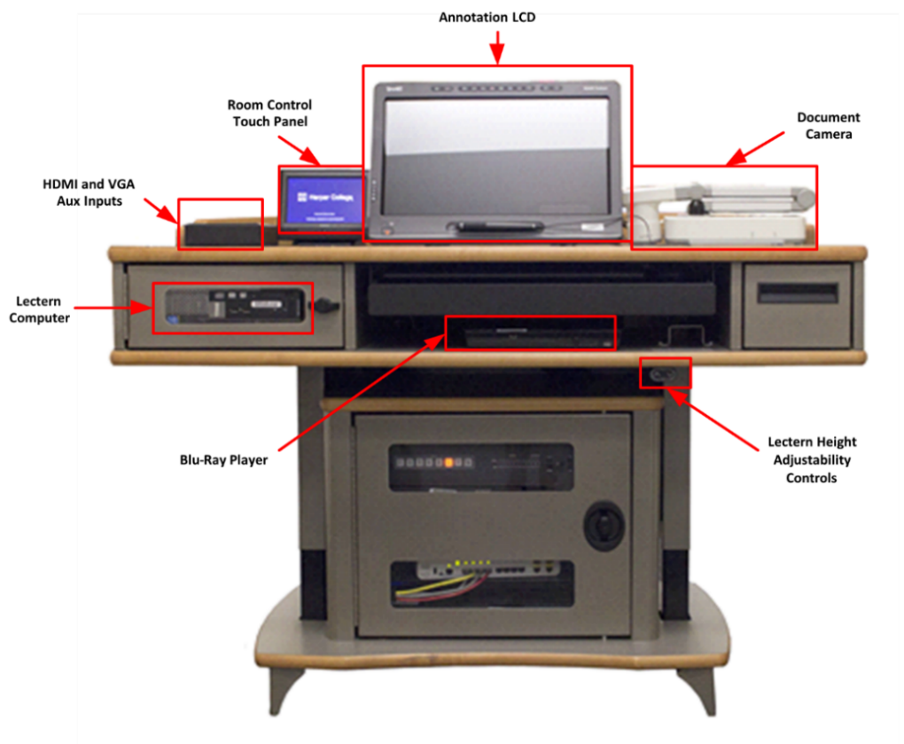
Figure 1: Lectern features from the perspective of the presenter

Height Adjustable
Adjust the height of the lectern by using the Up or Down arrows on the height adjustability control located below the podium surface towards the right. If unable to locate the controls, refer to Figure 1 above for the location.
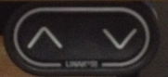
Figure 2: Height Adjustment buttons

Single Projector Flex Room

Flex Room Control Touch Panel

Turning the System On
- Move in front of the touch panel to wake the touch display.
- Tap Press to Begin to turn on the Flex Room system. The startup sequence may take up to a minute to complete.
- The following will appear when the startup is complete:
  - Outputs – Changes what is being displayed
  - Projector Blank & Room Controls – Hides the screen contents and displays additional options
  - Speaker Volume – Adjusts the speakers in the room
  - Camera Controls – Turns on and controls how the camera functions
  - Shut Down – Turns off the systems controlled by the touch panel
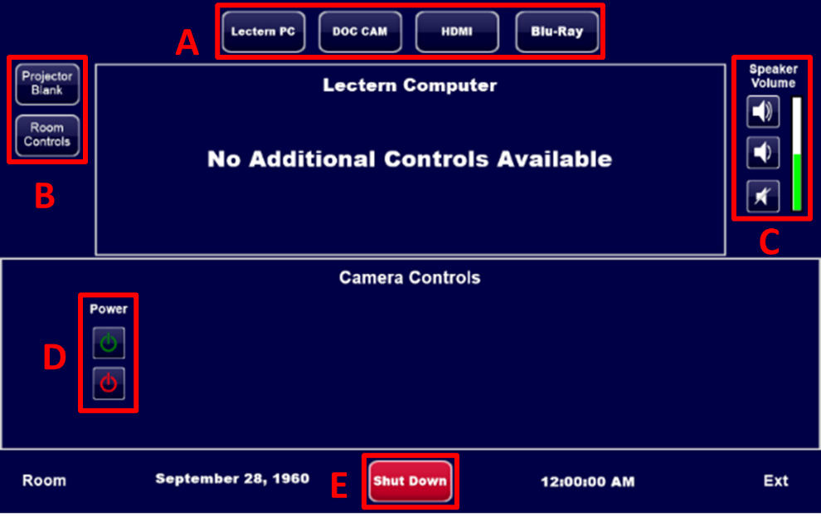
Figure 3: Initial startup layout

Camera Controls

Turning the Camera On
The Camera will be off by default. There will be no lights on the camera. Tap Power  under Camera Controls to turn on the camera and view additional controls. When in use, the camera will show a red light.
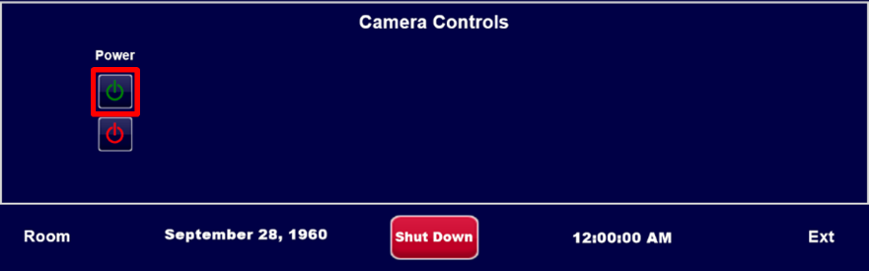
Figure 4: Camera - Power button

Input
Selecting either Camera or Sources will change the output displayed on the projector and in Webex.
- Sources refers to any of the Outputs (Lectern PC/Doc Cam/HDMI/Blu-Ray) on the top of the touch display.
- Tap Camera to return to the default camera output.
- To show Lectern PC in Webex, tap Camera and share the screen or application in Webex itself.
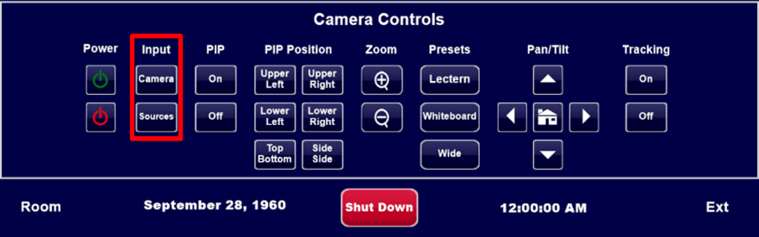
Figure 5: Camera Controls – Input

Picture-in-Picture (PIP)
Turning on PIP displays a smaller window of the Camera Control Input that is not selected in Webex.
PIP Position buttons will only be visible if PIP is On.
Use PIP Position, Zoom, Presets, Pan/Tilt, and Tracking to fine-tune the Camera Controls.
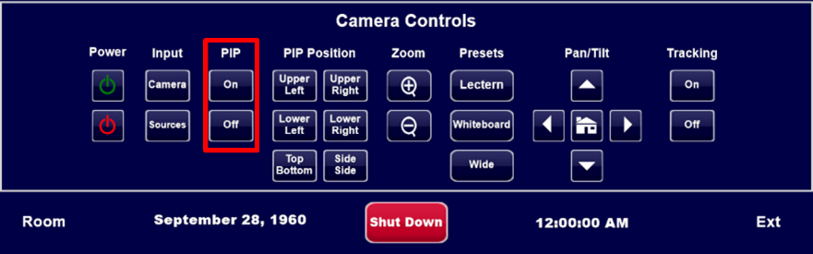
Figure 6: Camera Controls - Picture-in-Picture

Sharing Outputs in Webex

Lectern PC
- Tap Lectern PC on the top of the Control Panel to switch the projector display to the Lectern PC. By default, this will be selected upon startup.
- Tap Camera, under Input in Camera Controls.
- Share Screen or Application in Webex. Both the projector and Webex show the Lectern PC contents.
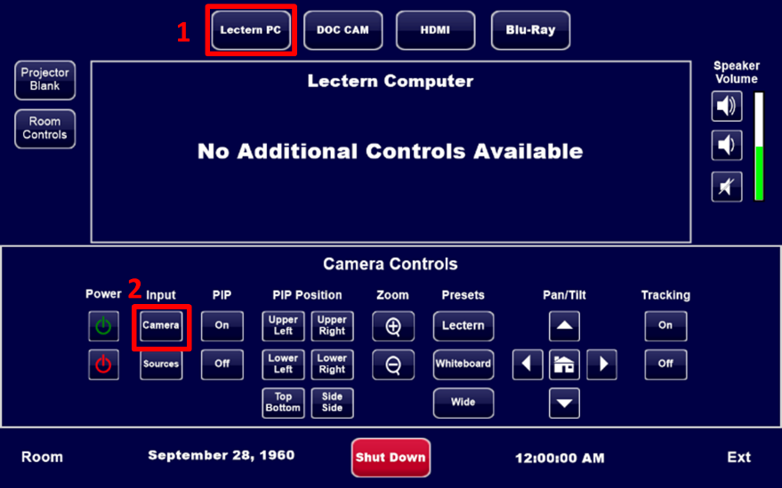
Figure 7: Lectern PC layout

Doc Cam
- Tap Doc Cam on the top of the Control Panel to switch the projector display to the Document Camera Controls can be accessed through either the touch panel or document camera.
- If using Webex, tap Sources under Input in Camera Controls to have the projector display and Webex show the Doc Cam screen.
- The Doc Cam can be controlled through either the touch panel or on the Doc Cam itself. Refer to Page 12 for additional Doc Cam instructions.
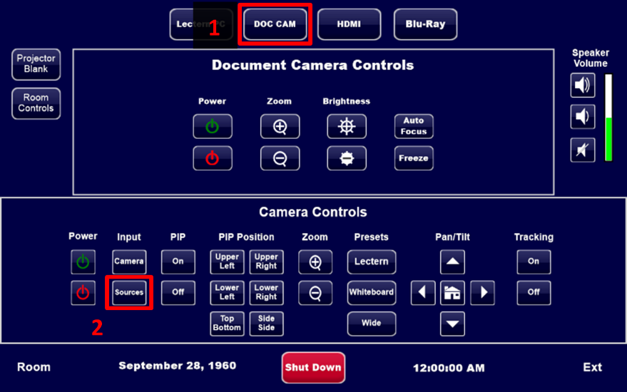
Figure 8: Document Camera layout

HDMI
- Tap HDMI on the top of the Control Panel to switch the projected source to the plugged in HDMI device.
- If using Webex, tap Sources, under Input in Camera Controls, to have the projector and Webex show the connected device’s screen.
- Tap Camera to switch the projector display and Webex back to the Flex Room camera.
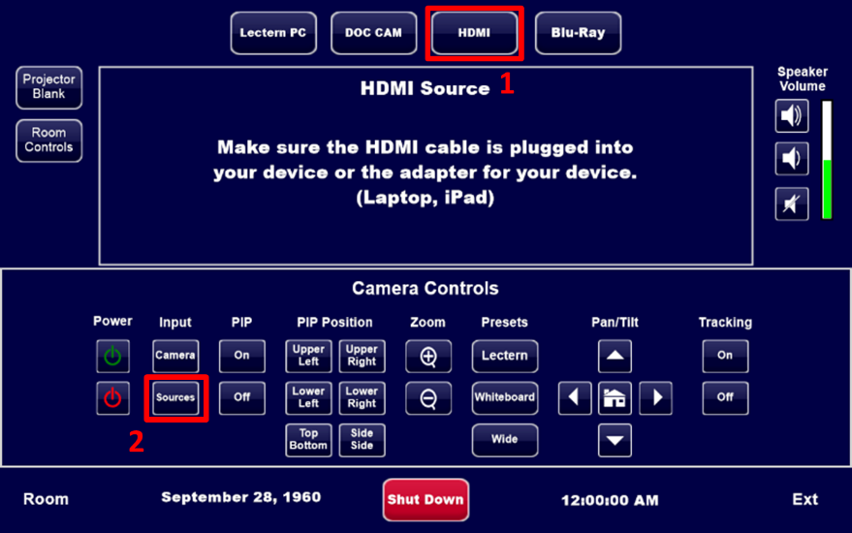
Figure 9: HDMI Source layout

Blu-Ray Player
- Tap Blu-Ray on the top of the Control Panel to switch the projected source to the Blu-Ray player.
- If using Webex, tap Sources, under Input in Camera Controls, to have the projector and Webex show the Blu-Ray player screen. Tap Camera to switch the projector display and Webex back to the Flex Room camera.
- Playback controls for the Blu-Ray player can be found below the Output options on the top.
Note: DVDs can also be played from the Blu-Ray player.
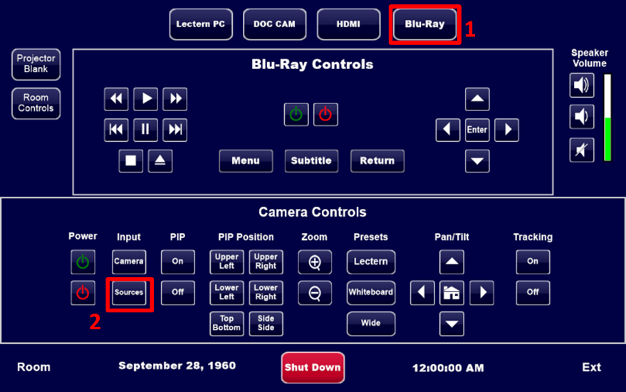
Figure 10: Blu-Ray source output

Flex Room Device Adjustments

Projector Blank
- Tap Projector Blank on the top left of the Control Panel to show a blank screen from the projector. The button will flash to indicate when the projector is blanked.
- Tap again to show the projector contents.
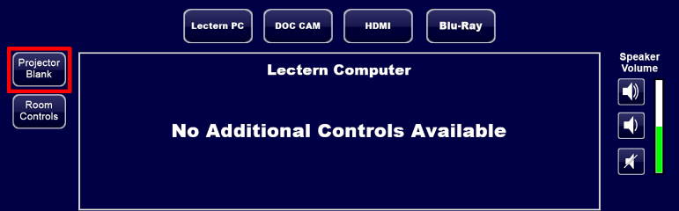
Figure 11: Home screen - Projector Blank

Speaker Volume
- Tap Volume Up/Down on the top right of the Control Panel to adjust the room speakers.
- Tap Mute to mute/unmute the room speakers. The button will flash when muted.
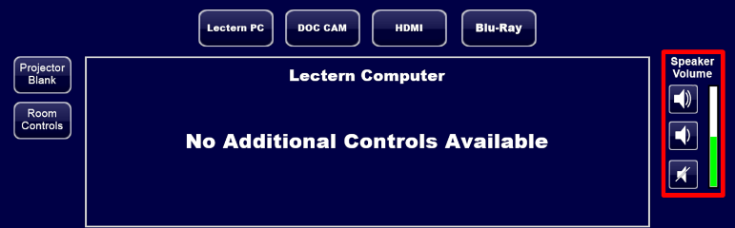
Figure 12: Home screen – Speaker Volume

Device Controls
Tap Room Controls to view additional controls for the Flex Room.
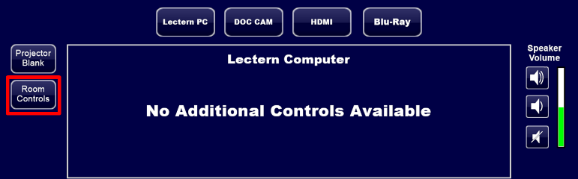
Figure 13: Home Screen - Room Controls

Volume Controls in Room Controls
Tap Volume Controls on the top to adjust various audio input and devices in the room.
- The color of the ceiling microphones will indicate the status: blue – active, red – muted.
- Tap Privacy to mute all microphones and speakers.
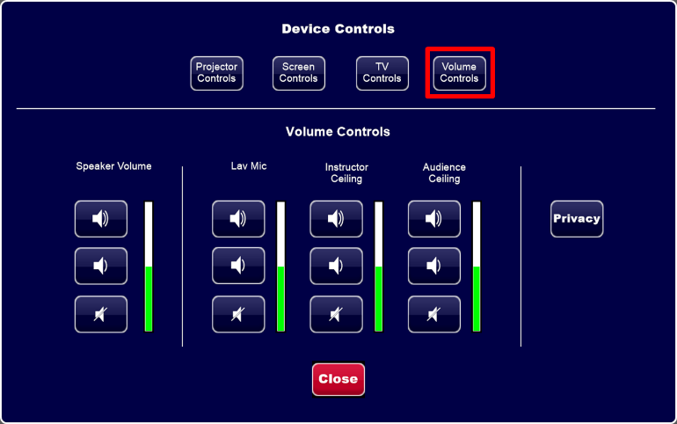
Figure 14: Device Controls – Volume Controls

Additional Device Controls in Room Controls
- Projector Controls – Turn the projector On/Off.
- Screen Controls – Adjust the height or retract the projector screen.
- TV Controls – Turn the Flex Room TV On/Off.

Turning the System Off
- Log out of the computer.
- Tap Shut Down on the bottom of the main screen.
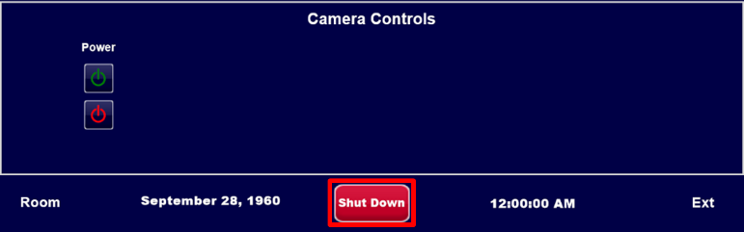
Figure 15: Main Screen - Shut Down
- Tap Yes to begin the Flex Room shutdown process.

Dual Projector Flex Room
Flex Rooms do not natively support Teams, Zoom, or Collaborate Ultra video calls. Connect a laptop in order to display non-Webex calls in the Flex Room.

Flex Room Control Touch Panel

Turning the System On
- Tap the room control touch display to turn on the Flex Room system.
- Tap the Room Control button to access the Flex Room controls (Figure 16).
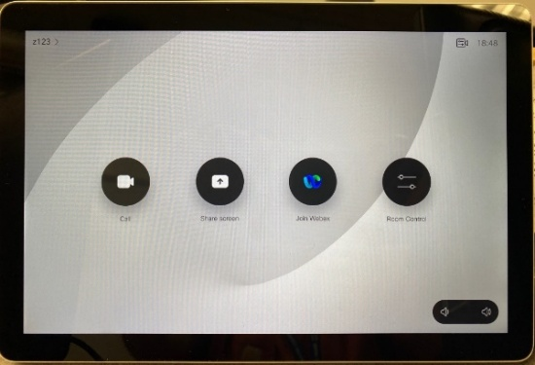
Figure 16: Home screen
- Under the System tab, tap the On button for System Power to gain access to the following:
- System
- Sources
- Share
- Audio
- Blu-Ray

System Tab
The System Power button is used to turn the Flex system on or off. When the Flex system power is turned on, the screens will lower, and the projectors will turn on and the System Power On and the Projector On buttons will change to blue.
Projector Left/Right – turns the projector on, off, or set to blank.
Screen Left/Right – raises or lowers the projector screen.
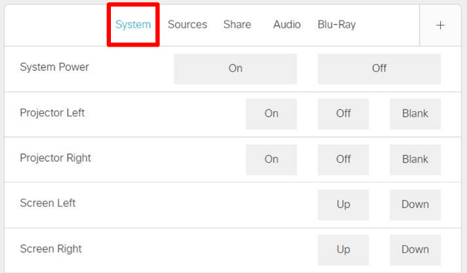
Figure 17: System tab

Sources Tab
Select one of the following sources to project on either left and/or right projector:
- Laptop – device connected via HDMI cable
- Doc Cam – refer to the Document Camera section located on Page 11 for instructions.
- PC – lectern PC
- Blu-Ray – DVD/Blu-Ray
- Codec – display the current Webex meeting. This is the same screen that is displayed in the back of the classroom on the Flex display.
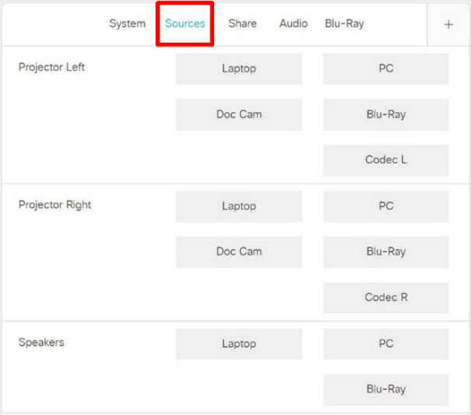

Speakers
Audio sources can be changed by selecting PC, Laptop, or Blu-Ray on the bottom of the Sources tab.

Share Tab
The Share tab is used to select which source is shown when sharing your screen in a Webex meeting. Laptop, PC, and Doc Cam outputs can be shared over Webex.
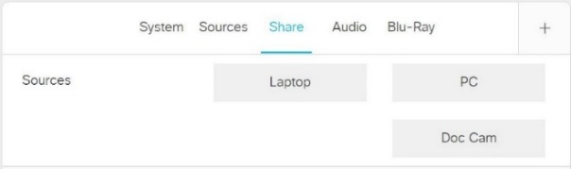
Figure 18: Share tab

Audio Tab
Adjust the Program Volume Value to control the source volume.
Microphones 1 and 2 control the volume output for the lavalier microphones.
By default, ceiling microphones are off. They will turn on when a Webex session is started.
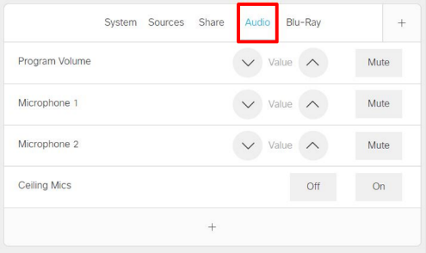
Figure 19: Audio tab

Blu-Ray Tab
The Blu-Ray player can play both DVDs and Blu-Ray discs.
- Tap Blu-Ray under the Sources tab for either projector or both.
- Playback controls for the Blu-Ray player can be found under the Blu-Ray tab.
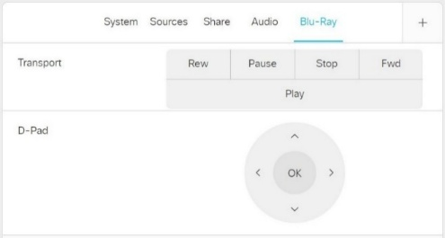
Figure 20: Blu-Ray tab

Join Webex
- Tap Join Webex on the home screen to open the search bar.
- Enter the meeting number or switch to the keyboard view to search for a Harper employee’s personal room, then tap Join.
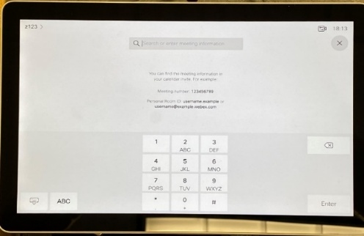
Figure 21: Switching to keyboard view
- To leave, tap Leave Meeting.

Document Camera

Opening and Positioning the Document Camera
- Raise the camera arm while holding the body of the camera with your other hand.
- Rotate the camera arm counterclockwise 90°.
- Position the camera head above the display area.
Note: Do not press the arm flat or fold it backwards; it may get damaged. The camera arm can only rotate within the 90° range.
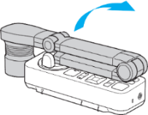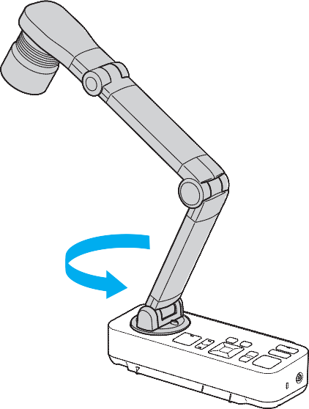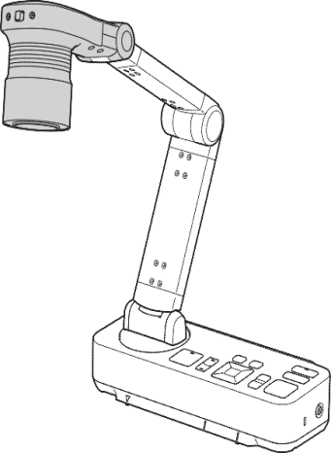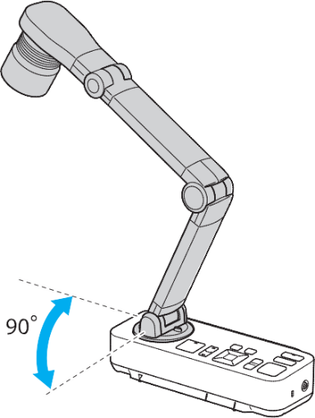
Figure 22: Document Camera positioning

Displaying a Document
- Place your document on the surface under the camera head.
- Align the center of your document with the  mark on the front of the document camera.
- 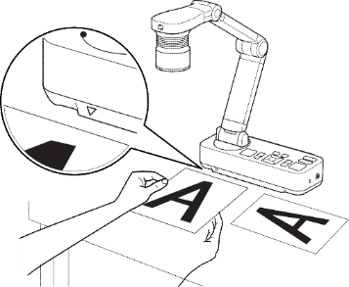
Figure 23: Correctly positioning a document
Note: If needed, press Focus on the document camera to auto-focus.

Document Camera Controls
- Zoom In 
- Zoom Out 
- Brighter
- Darker 
- Freeze/Unfreeze

SMART Monitor (Annotation LCD)

SMART Ink General Usage
Select the SMART Ink toolbar to view the following options:
- Pen color and line thickness
- Highlighter color
- Eraser options
- Clear Ink to remove all annotations
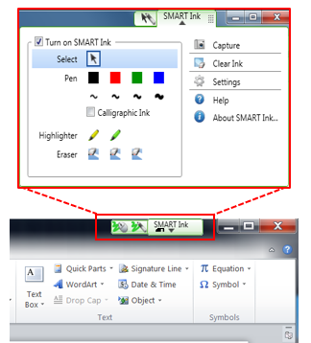
Figure 24: SMART Ink options

LCD Annotation Controls
On the top of the SMART Monitor are physical buttons for SMART Ink controls.
- Screen Capture Tool – Opens a dialog window to capture and save annotations made to the screen or within an application.
- Notebook – Opens the SMART Notebook for annotating.
- Keyboard – Opens an on-screen keyboard
- Eraser – Switches pen to erase mode
- Black, Red, Green, Blue – Switches pen color
- Left Click – Changes pen function to a left click
- Right Click – Changes next pen tap to a right click
- Help – Opens SMART monitor’s support window
- Alignment – Opens the pen calibration process
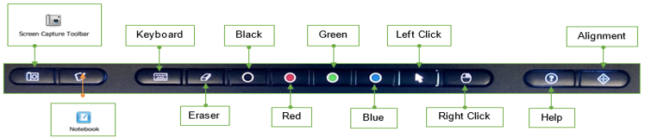
Figure 25: SMART physical buttons above the monitor

USB Ports
There are three (3) USB ports on the left of the SMART Monitor that you may use to connect USB devices.

