Adding Funds in Papercut

Required information:
- H-Number
- Quick Access to email (security code/MFA)
- Credit Card information

- Navigate to https://printportal.harpercollege.edu/ and login with your Harper Student Account.

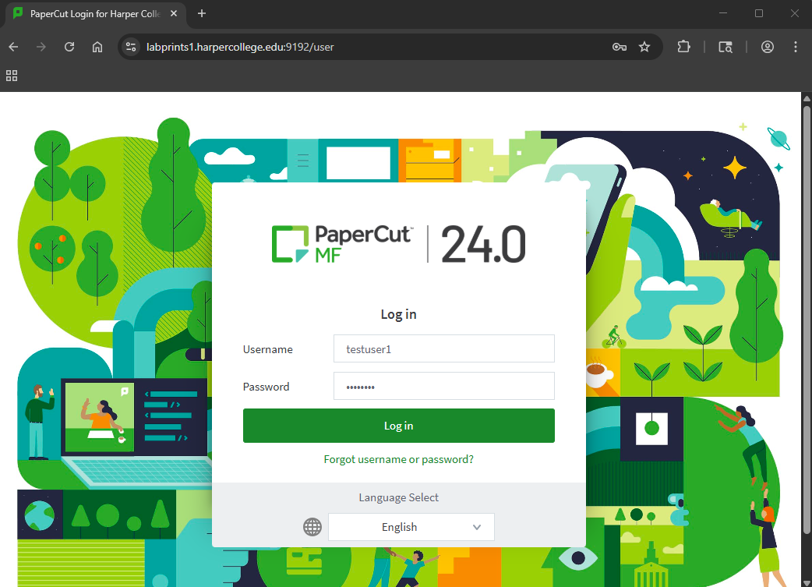
DO NOT include the email address (@mail.harpercollege.edu).

- Once logged into the portal, click on the “Add Credit” link.

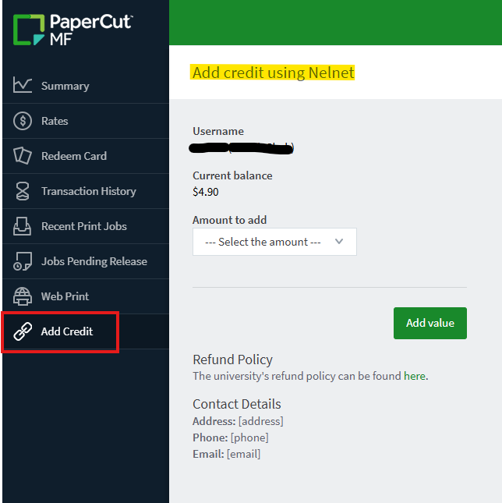

You should then see a page named “Add Credit using Nelnet”.

- Click on the “Amount to add” drop box and choose from the available amounts. PLEASE NOTE: As this time the maximum credit amount allowed is $5.00.

- Click on the “Add value” button. You will now be redirected to the Nelnet payment site.

- You will need to validate your account. Enter your email address and click “Send Code”.

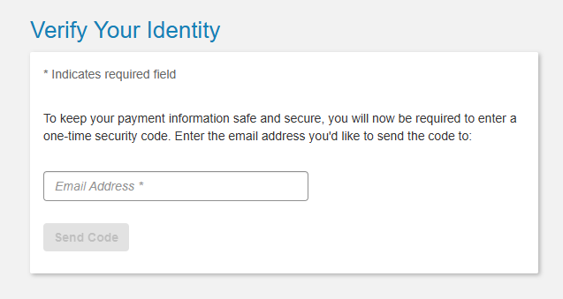

- Enter the Security Code received from your email and click on “Verify & Continue”
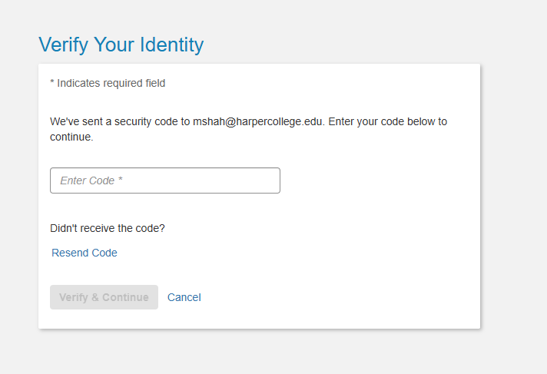

- At the “Make Payment Screen”, enter in the below information and then Click on “Next - Payment Method”
    - Amount in dollars not greater than $5.00 as displayed in drop down
    - Your First and Last Name
    - Your Harper ID number (H0xxxxxxx)
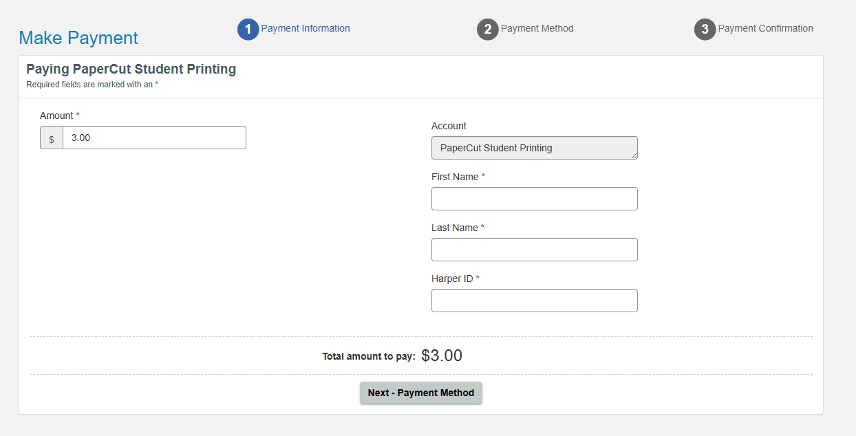

- Click on the “enter credit / debit information” link

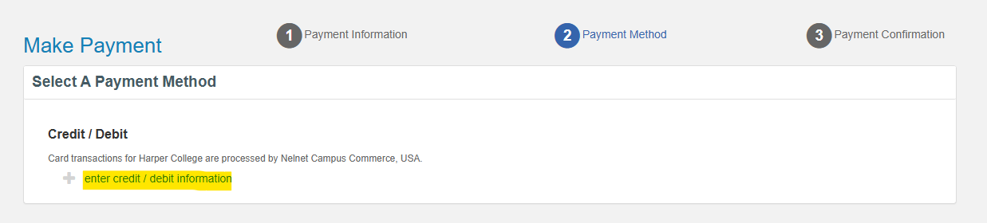

- Enter your Credit Card information, Billing Address, and Contact Information as required and then click on “Submit Payment for $x.00”. This should reflect the amount you want to add.

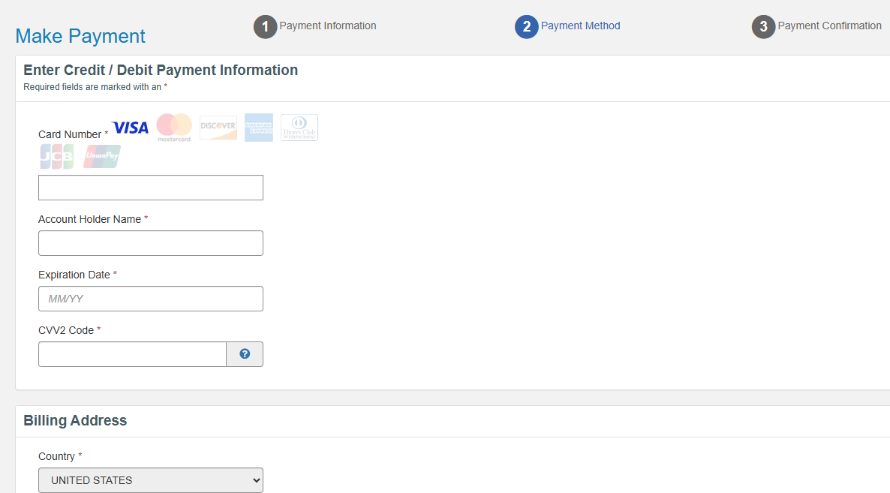
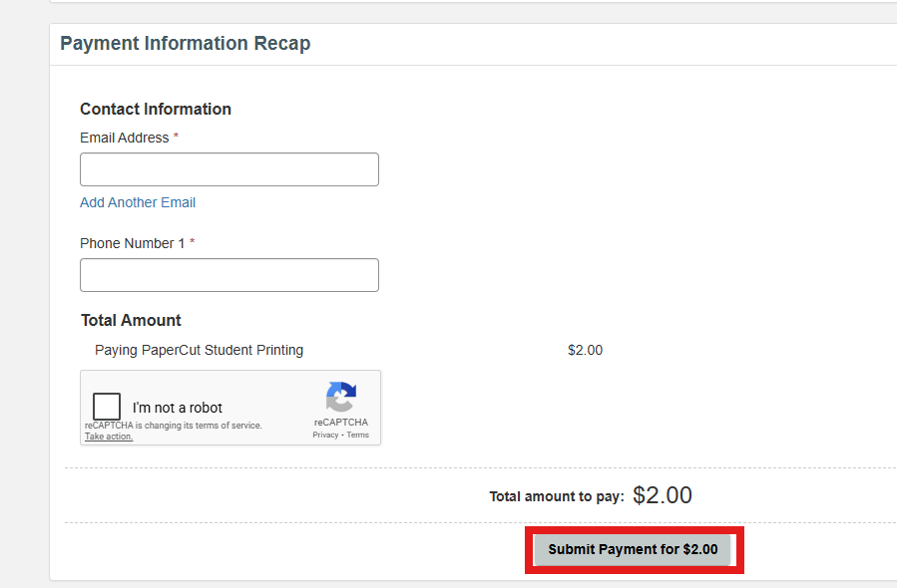

- After funds have been added, you will be redirected back to Papercut user portal

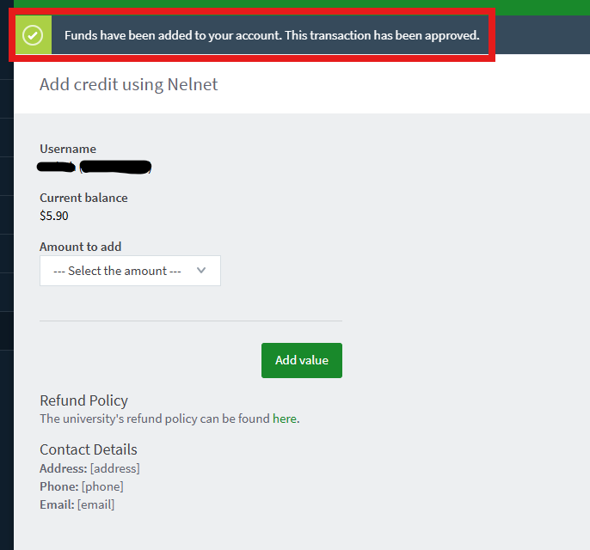

FAQS – Frequently Asked Questions
- How do I check my current Balance?
Navigate to https://printportal.harpercollege.edu/ and login with your Harper Student Account.

- When do the funds I add expire?
The funds do not expire but will be refunded at the end of the semester.

- How do I escalate an issue if I have a problem adding funds to my account?
Contact the Student Service Desk.

- What is the difference between my print allocation given at the beginning of the semester, and these funds?
The funds you add are real money and will be refunded at the end of the semester.
The Harper print allocation will expire at the end of the semester.

