

ALEKS Math Placement Test
Preview and Prep & Learning modules instructions
Before taking the ALEKS math placement test on campus, students must complete the ALEKS preview in their My Harper Student Portal.

Logging In:
- Go to the My Harper Student Portal: https://myharper.harpercollege.edu/facultystaff/Pages/default.aspx
- Log in using your Harper student username and password.

➢ Need assistance logging in?
If you need assistance, contact the Student Service Desk:
- Phone: 847-925-6866
- Email: studentsd@harpercollege.edu

Accessing ALEKS preview test online
Directions for students to access ALEKS preview test online:

- After logging into your student portal, select “VIEW ALL CARDS” on the right side of the screen.
You can also select the menu icon (three horizontal lines) at the top left of the screen and select “All Cards”.
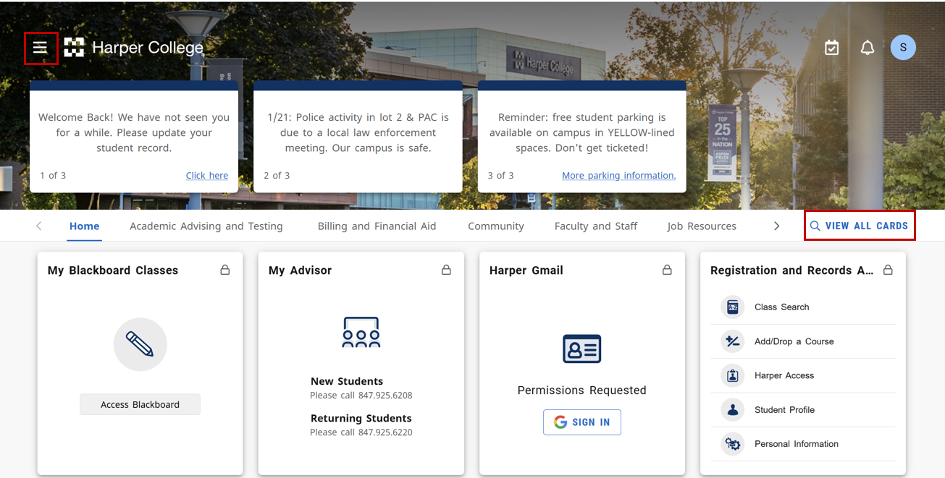

- Find the card labeled Testing Center Actions and select “ALEKS Placement Test”.
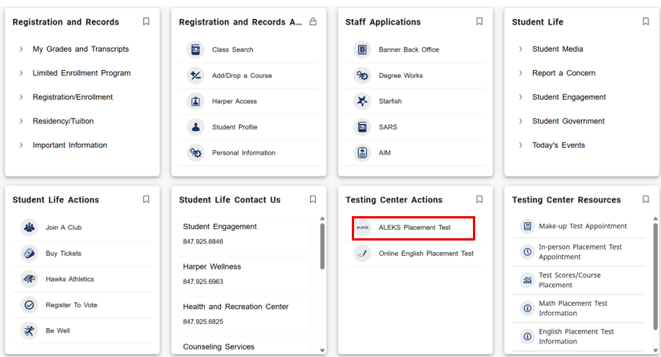
- Scroll to the bottom of the page and select “ALEKS LOGIN” next to ALEKS Math Placement Assessment Testing Login, located below the video and instructional text.
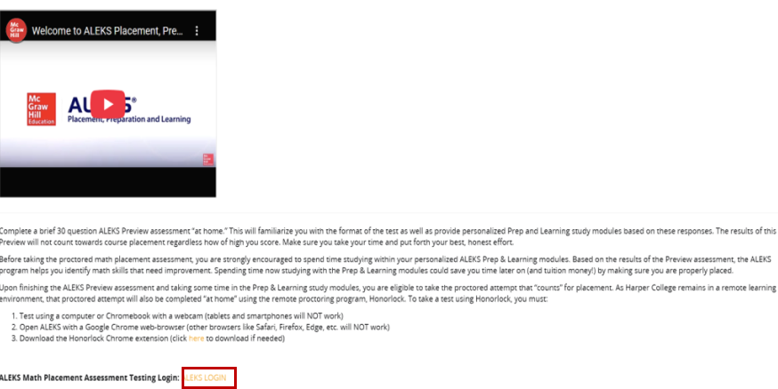
- Select the class. For example, for 2026, look for “Harper College Math Placement, Spring, Summer, Fall 2026 / Higher Education Math Placement” in the “Active Classes” section under “My Classes.”
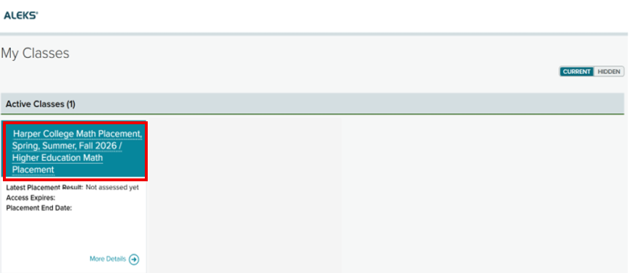
- To take the ALEKS preview test, which will appear as “Unproctored”, select the “GET STARTED” button in the Placement Assessment section on the left side of the page.
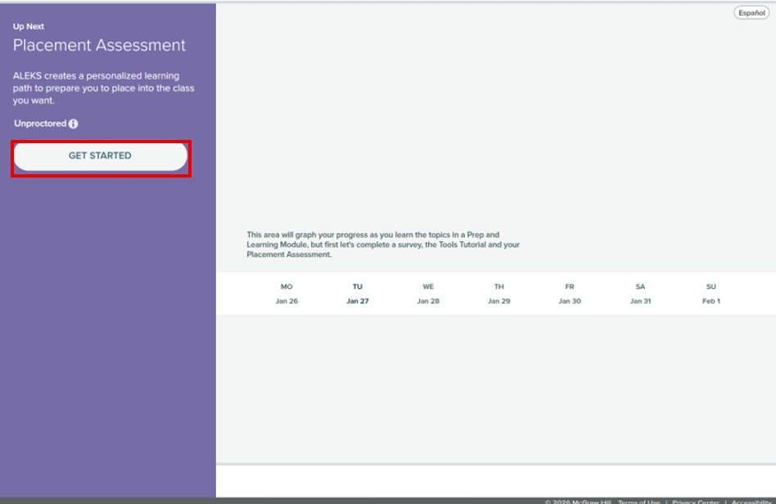
- After reviewing the placement assessment information, select the checkbox to confirm that you have read and understand the placement directions and honor code. Then select the “Get Started” button to begin the assessment.
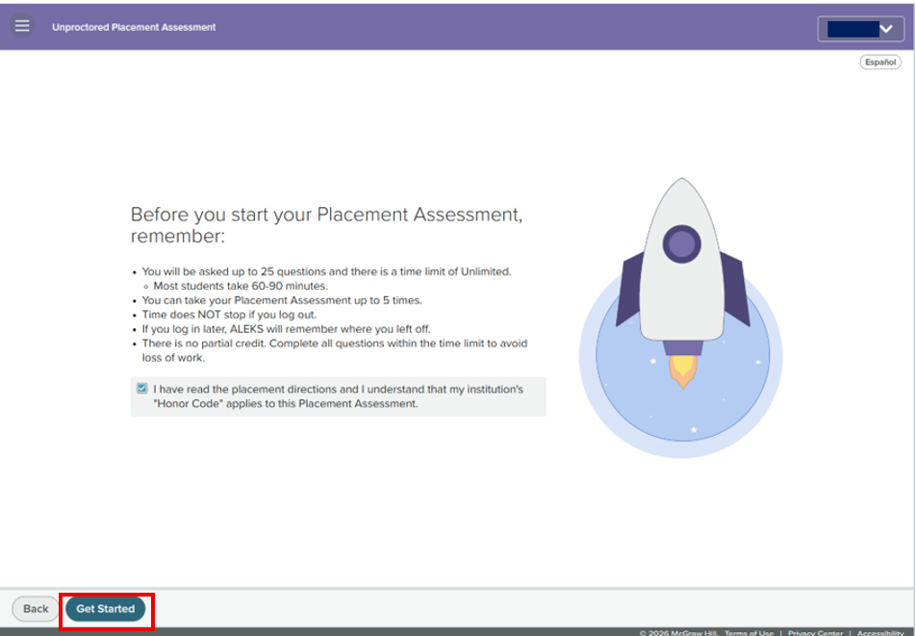

Accessing Prep & Learning Modules
Directions for students to access their Prep & Learning Modules

- Select the “Get Started” button to begin. After you complete the modules for the first time, the button text will change to “Continue My Path”. Use this button to return to your modules in the future.
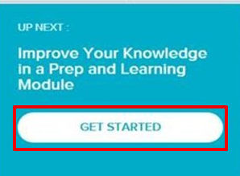
- You can check how much required study time you have left on the ALEKS homepage.
On the left side of the page, you may see information such as:
- Attempt: 3 of 5
This shows how many proctored retest attempts are available.
- A lock icon
This means the next attempt is not unlocked yet.
- Time Remaining in Learning Module (for example, 3 hours)
If an attempt is locked, it means you must complete the remaining required time in the Prep & Learning Module before you can take the next proctored assessment.
