

English Placement Test Instructions

Requirements:
- Desktop computer, laptop computer or Chromebook (tablets and smartphones will not work)
- Webcam
- Stable internet connection
- Google Chrome web browser: https://www.google.com/chrome

Additional Information: Honorlock Preparation
To learn more about Honorlock and online proctoring, go to the Honorlock Prep page:
https://prep.honorlock.com/ This page explains how Honorlock works and what will happen before and during a proctored exam.

Logging In:
- Clear your computer’s desktop of all software except for these instructions.
- Open the Chrome browser.
- Download the HonorLock Google Chrome extension:
https://app.honorlock.com/install/extension
- Go to https://myharper.harpercollege.edu/facultystaff/Pages/default.aspx and log into
your “My Harper Student Portal”.
- Follow the steps below.

➢ Need assistance logging in?
If you need assistance, contact the Student Service Desk:
- Phone: 847-925-6866
- Email: studentsd@harpercollege.edu

Accessing English Placement Test online
Directions for students to access English Placement Test online:
- After logging into your student portal, select “VIEW ALL CARDS” on the right side of the screen. You can also select the menu icon (three horizontal lines) at the top left of the screen and select “All Cards”.
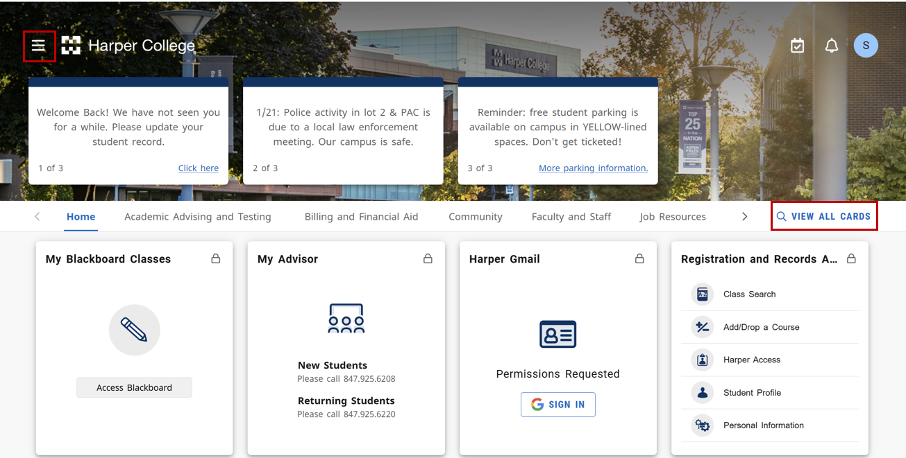
- Find the card labeled Testing Center Actions and select “Online English Placement Test”.
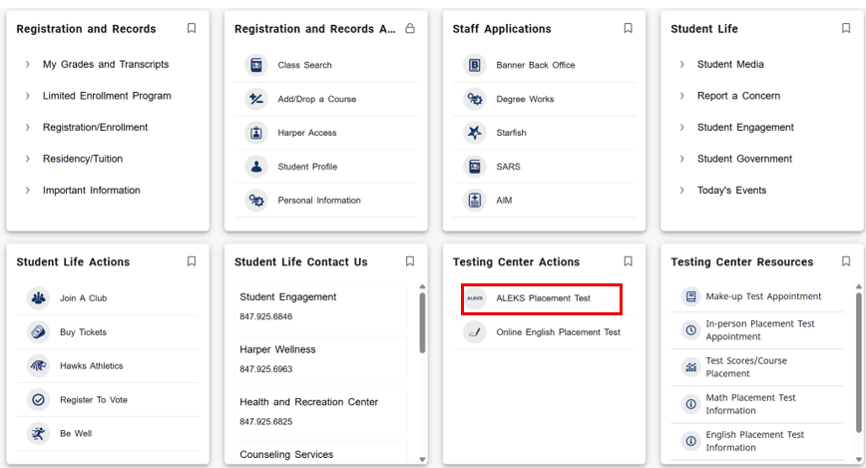
- Read all the directions on the next page carefully. When you are ready to proceed, open the following link: https://harper.blackboard.com/
- On the Blackboard login page, select the “Credit” button to continue.
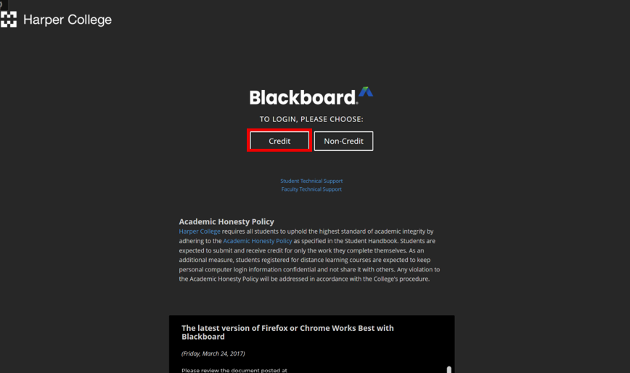
- In the left-hand navigation menu, select “Courses.” When the Courses page opens, go to the upper-right corner and select “Course Catalog.”
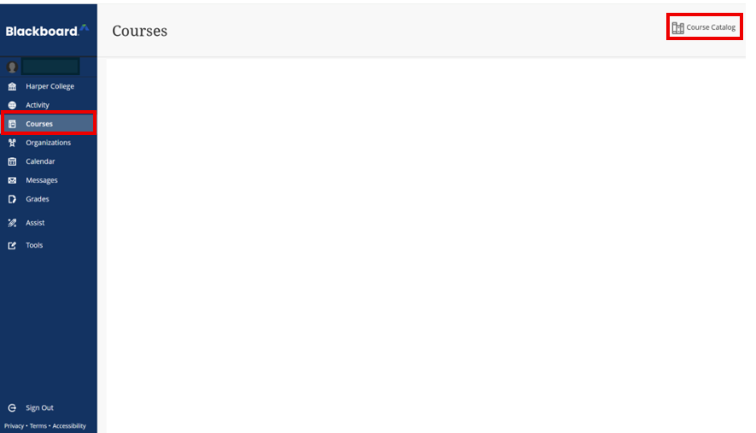

- In the Search Catalog section, type “placement” into the search box. Then select the “Go” button to run the search.
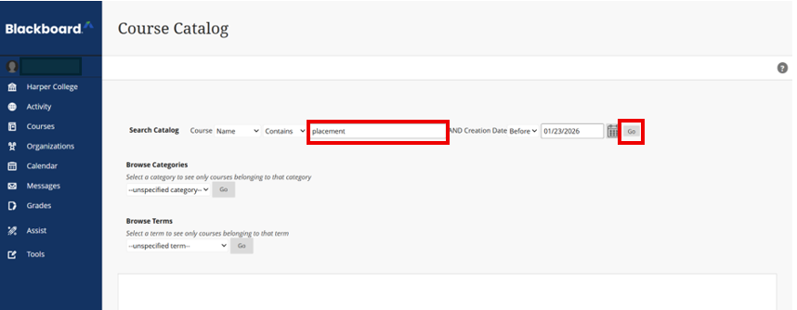
- In the search results, locate the course titled “Online English Placement Test.” Move your mouse to the right of the course title until an arrow icon appears. This arrow opens a menu—select ‘Enroll.’
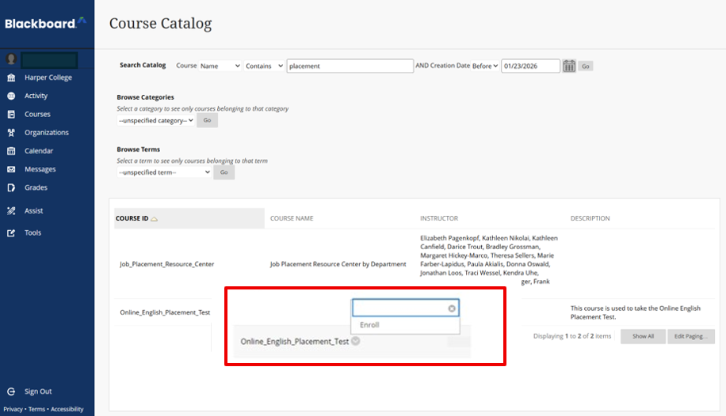
- On the next page, titled Self Enrollment, select “OK” to continue.
- After selecting “OK,” you will be taken to the course page. Read the instructions displayed on the screen. Then, in the left-hand menu, select “Launch ENGLISH TEST” to begin the assessment.

- On the next screen, select the link labeled “Click Here to Launch Your Honorlock Test” to open the Honorlock testing system.
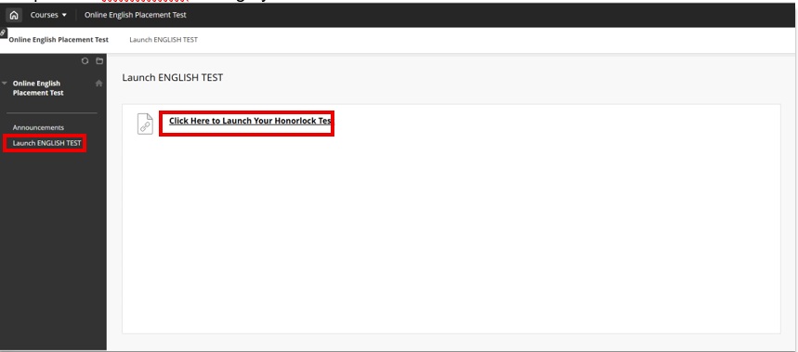
- On the Honorlock screen, review the information under Data Collection & Use. After checking the boxes to agree to data collection and Honorlock’s Terms of Service, select the “Continue to the System Check” button.
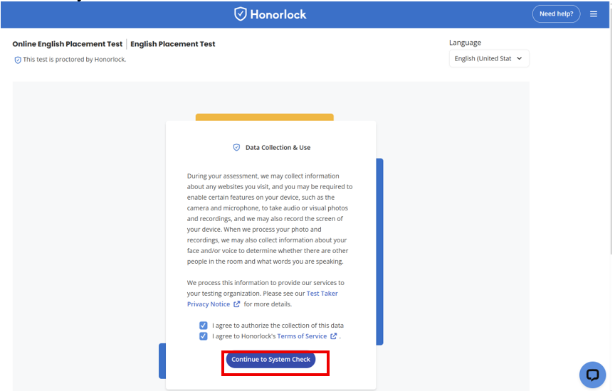
- Review the assessment guidelines on the screen, then select “Begin Authentication” to continue.
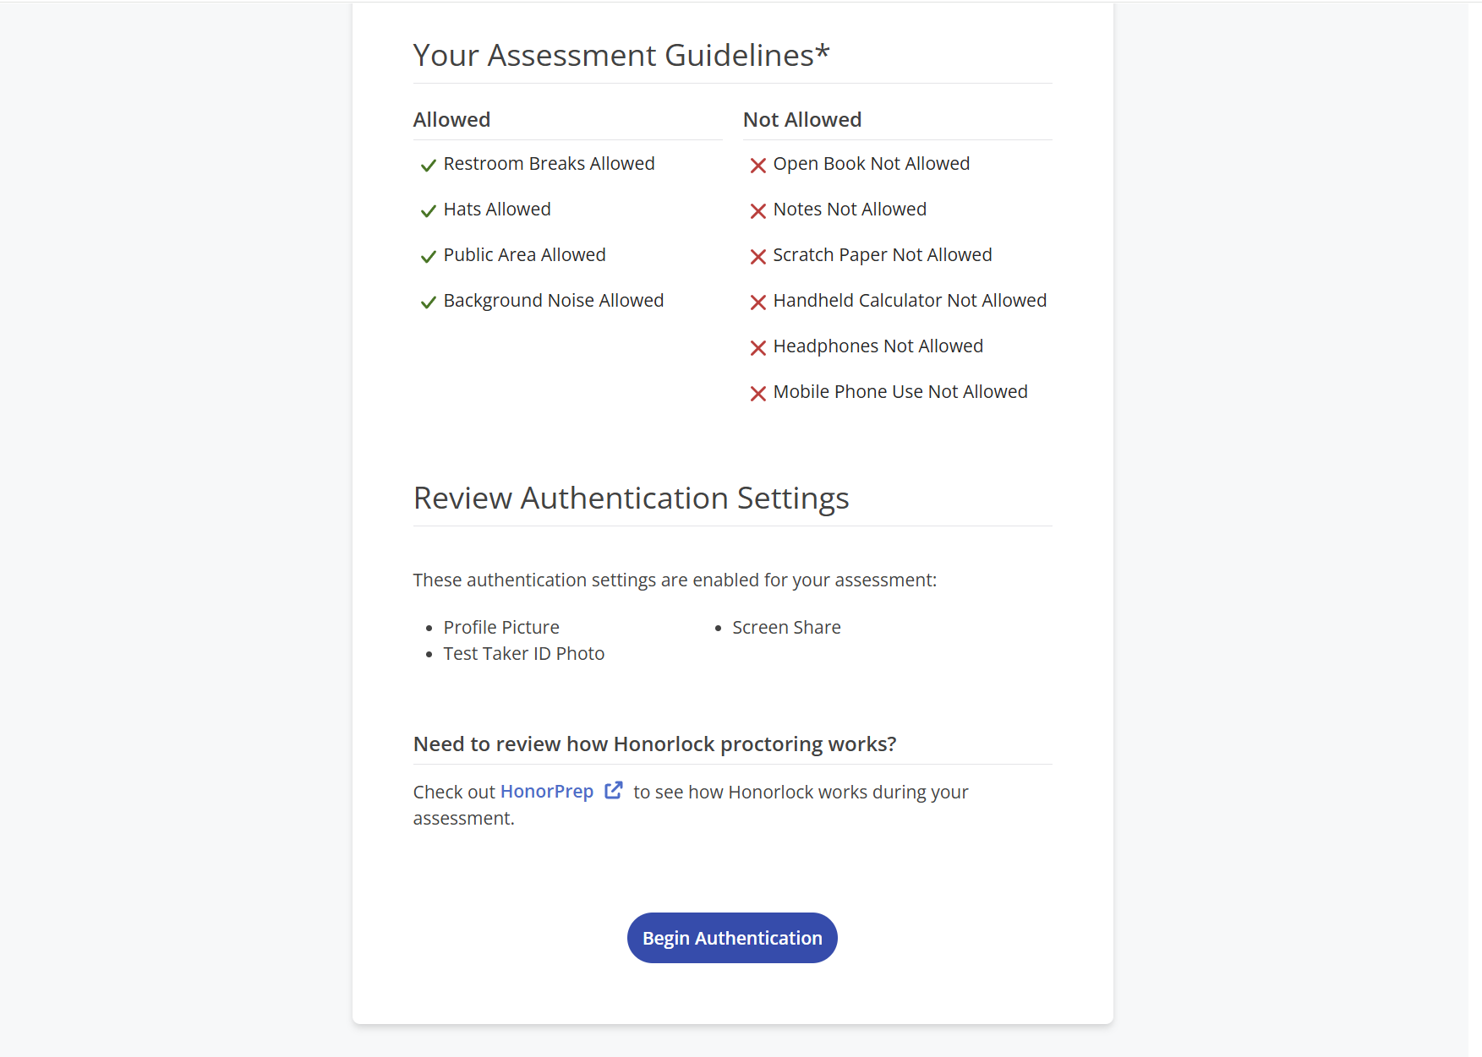
- A new Honorlock Proctoring window will open. If you do not see the window, you can also access it by selecting the Honorlock icon in your taskbar (the icon looks like a shield with a checkmark). In the Honorlock Proctoring window, complete the authentication process by taking a photo of your face, taking a photo of your ID, and performing a room scan of your testing environment.
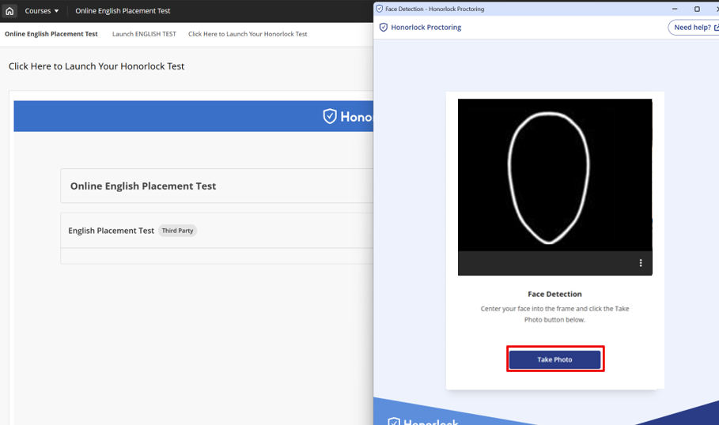
- Select the “Continue” button to begin sharing your screen.
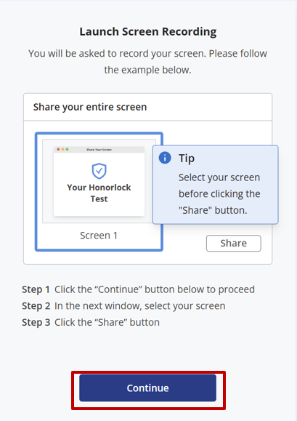
- The Share your entire screen window opens. Select “Entire screen” first. Then select the “Share” button to begin sharing your screen.
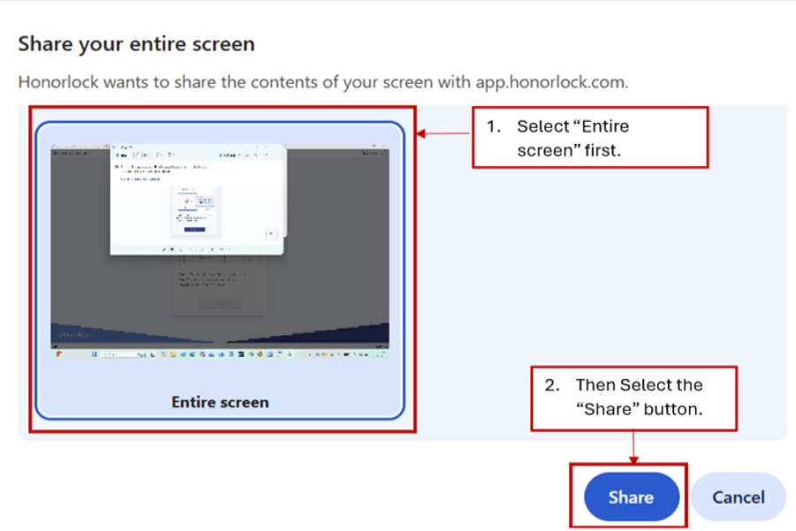
- On the “Accessing Your Assessment” screen, copy the link shown and open it in a new browser tab. Keep the Honorlock window open while you do this.
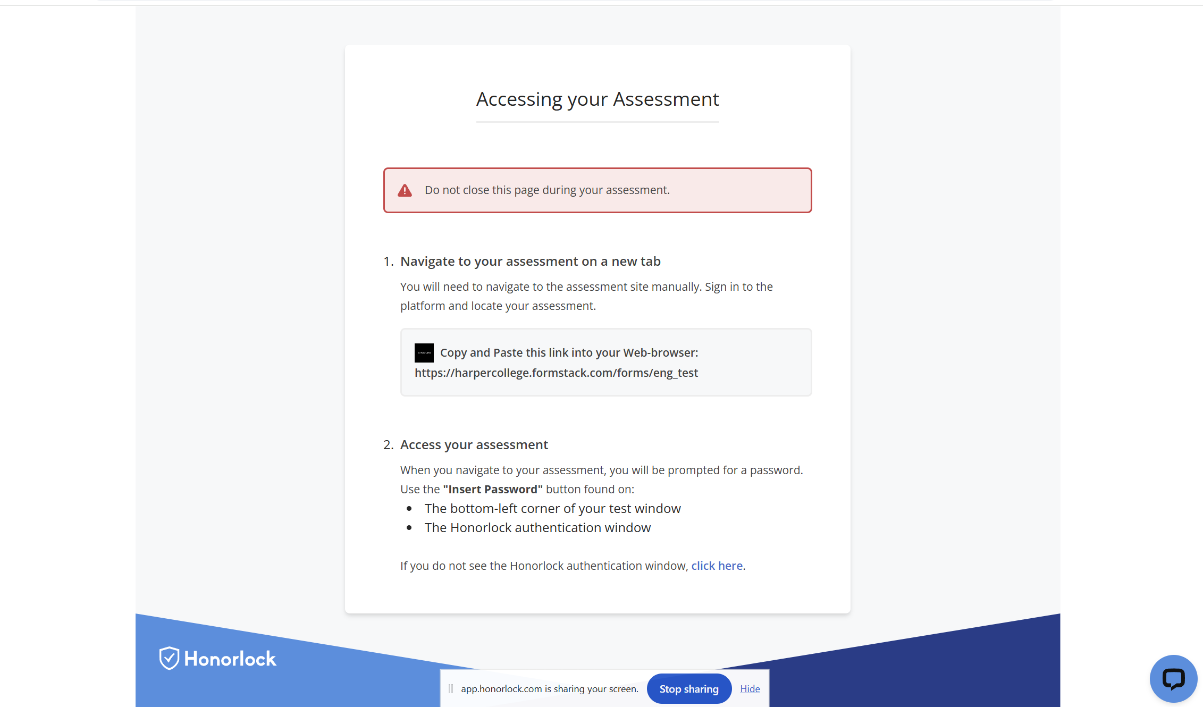
- When the assessment page prompts you for a password, return to the Honorlock window and select the “Insert Password” button.
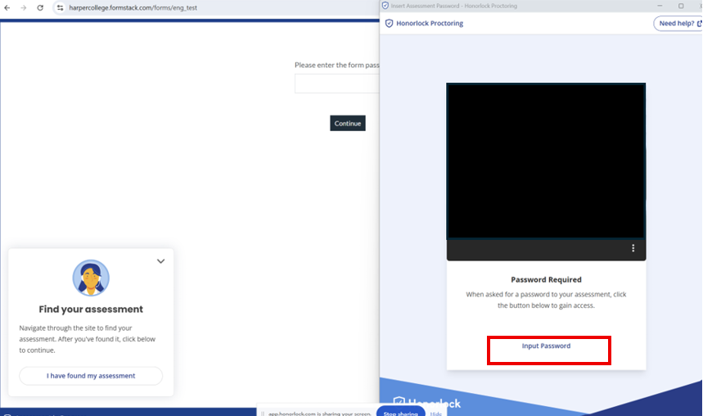

- The password will automatically fill into the password box on the assessment page. Select “Continue.”
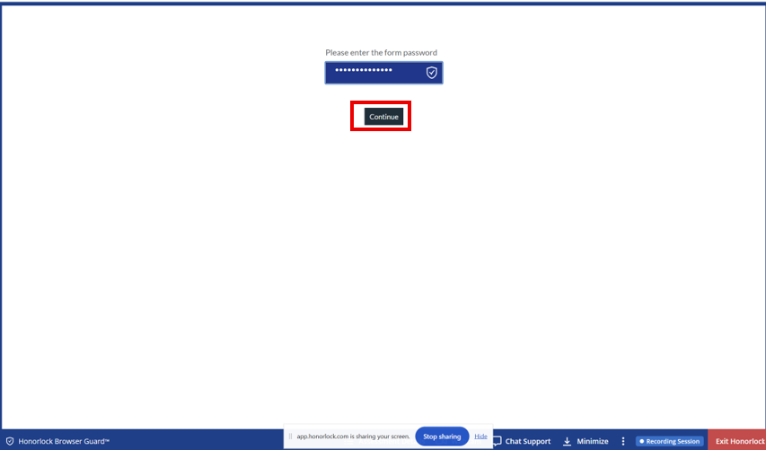
- After the password is accepted, enter the required personal information on the screen to begin your test.
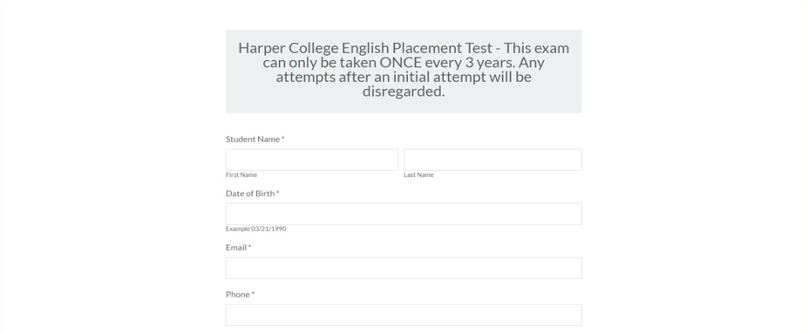
- After you submit the test, you can remove the Honorlock Google Chrome extension from your browser if you prefer. Go to your browser settings and select “Extensions.” Then select “Remove” for the Honorlock Chrome extension.

