

ALEKS Math Placement Test Instructions

Requirements:
- Desktop computer, laptop computer or Chromebook (tablets and smartphones will not work)
- Webcam
- Stable internet connection
- Google Chrome web browser: https://www.google.com/chrome

Additional Information: Honorlock Preparation
To learn more about Honorlock and online proctoring, go to the Honorlock Prep page:
https://prep.honorlock.com/ This page explains how Honorlock works and what will happen before and during a proctored exam.

Logging In:
- Clear your computer’s desktop of all software except for these instructions.
- Open the Chrome browser.
- Download the HonorLock Google Chrome extension:
https://app.honorlock.com/install/extension
- Go to https://myharper.harpercollege.edu/facultystaff/Pages/default.aspx and log into
your “My Harper Student Portal”.
- Follow the steps below.

➢ Need assistance logging in?
If you need assistance, contact the Student Service Desk:
- Phone: 847-925-6866
- Email: studentsd@harpercollege.edu

Accessing ALEKS Math Placement Test online
Directions for students to access Math Placement Test online:

- After logging into your student portal, select “VIEW ALL CARDS” on the right side of the screen. You can also select the menu icon (three horizontal lines) at the top left of the screen and select “All Cards”.
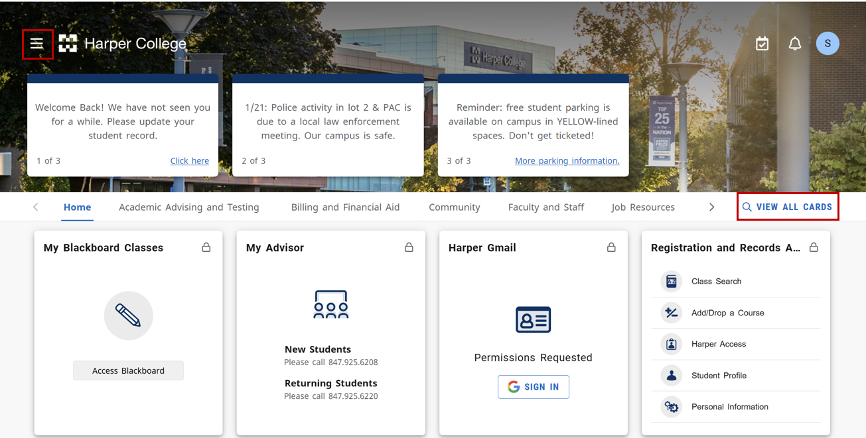
- Find the card labeled Testing Center Actions and select “ALEKS Placement Test”.
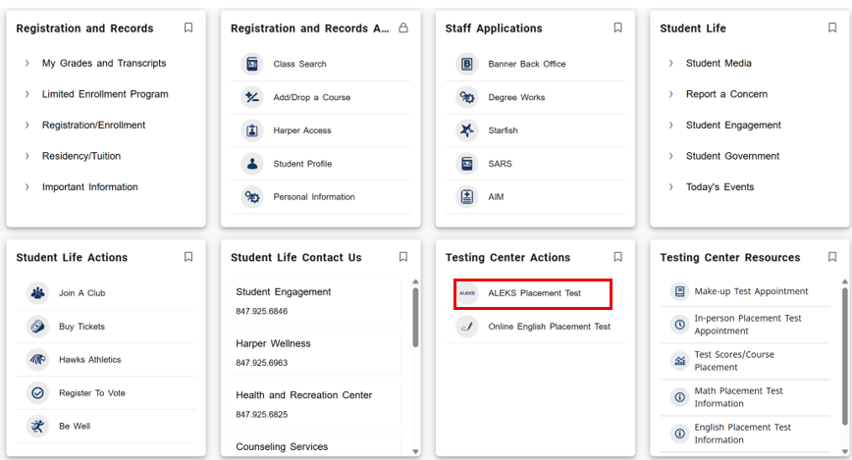
- Scroll to the bottom of the page and select “ALEKS LOGIN” next to ALEKS Math Placement Assessment Testing Login, located below the video and instructional text.
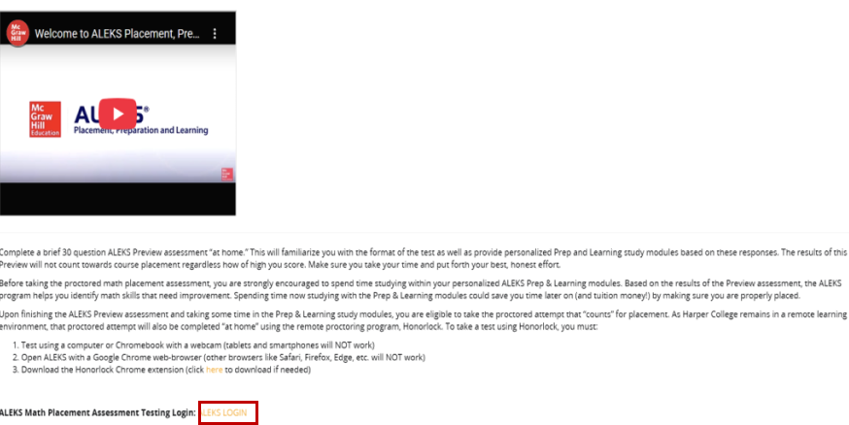
- Select the test. For example, for 2026, look for “Harper College Math Placement, Spring, Summer, Fall 2026 / Higher Education Math Placement” in the “Active Classes” section under “My Classes.”
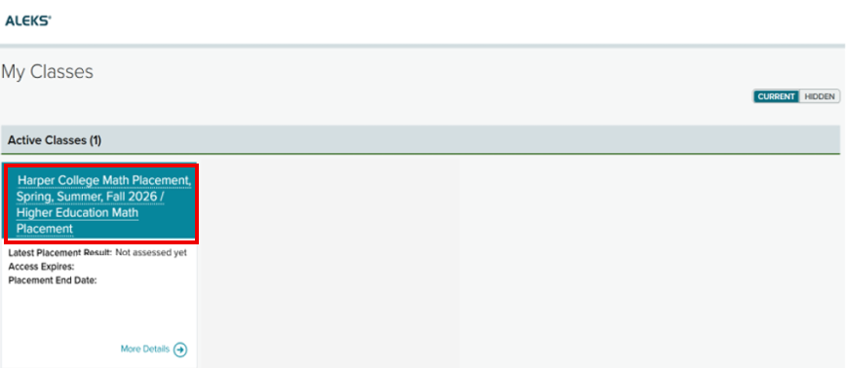
- If this is your first time logging into the ALEKS placement test, you will be directed to take an ALEKS Preview Assessment. This assessment will appear as “Unproctored”. Students must complete the ALEKS preview in their My Harper Student Portal before taking the ALEKS math placement test. The scores from the Preview Assessment do not count towards placement.
- To take a proctored ALEKS Placement test, select the “Start” button in the Placement Assessment section on the left side of the page.
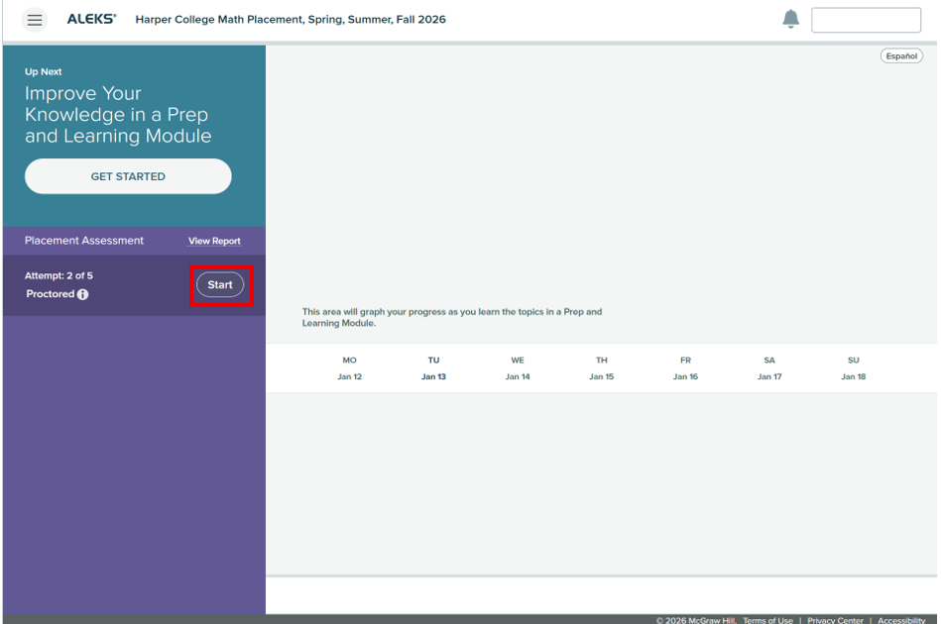
- After you agree to data collection and Honorlock’s Terms of Service, select the “Launch Proctoring” button.
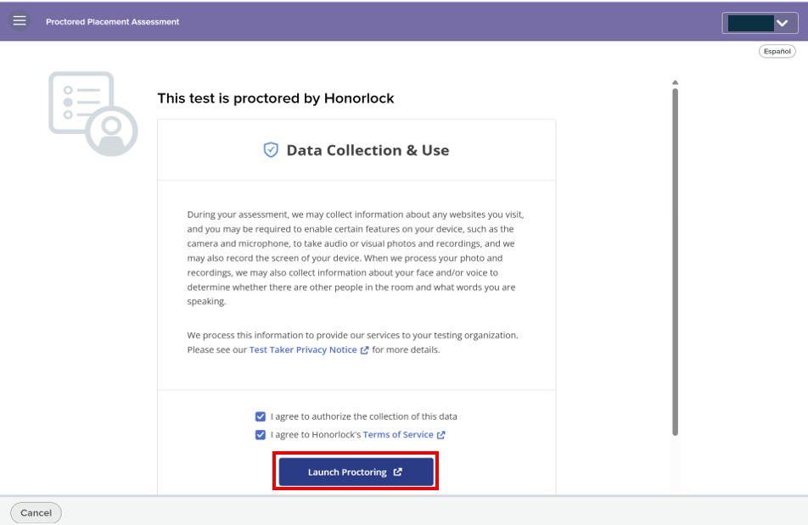
- Before starting the assessment, select all three checkboxes to confirm that you understand the requirements. Then select the “Continue” button.
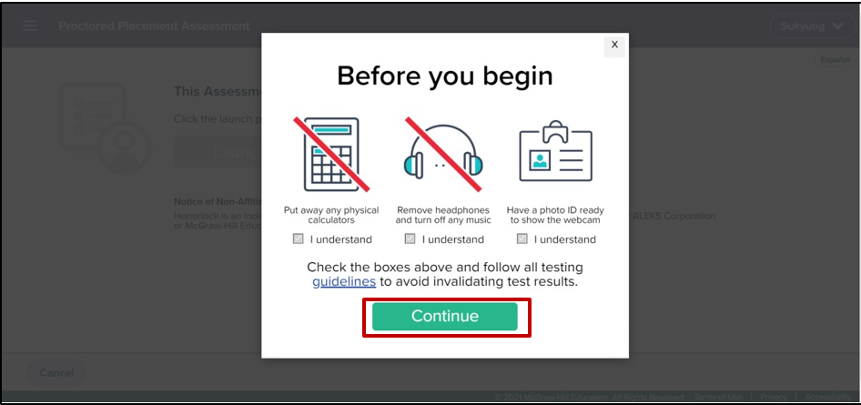
- Select “I understand” in the Privacy Details box.
- A new Honorlock Proctoring window will pop up. You can also access the Honorlock Proctoring window by selecting the Honorlock icon in the taskbar. The icon appears as a shield with a checkmark inside. In the Honorlock Proctoring window, complete the authentication process by taking a photo of your face, your ID and scanning the room that you are in.
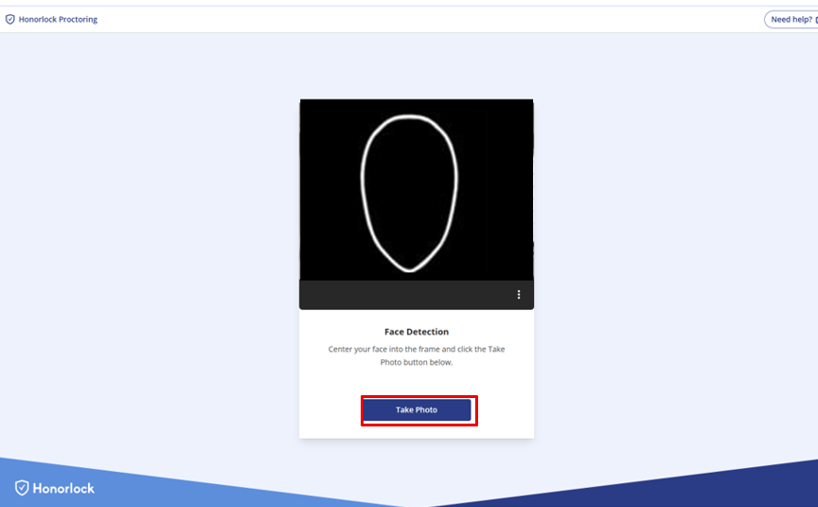
- Select the “Continue” button to begin sharing your screen. 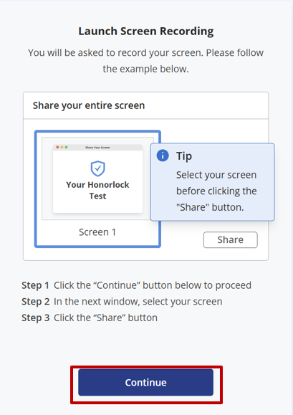
- The Share your entire screen window opens. Select “Entire screen” first. Then select the “Share” button to begin sharing your screen.
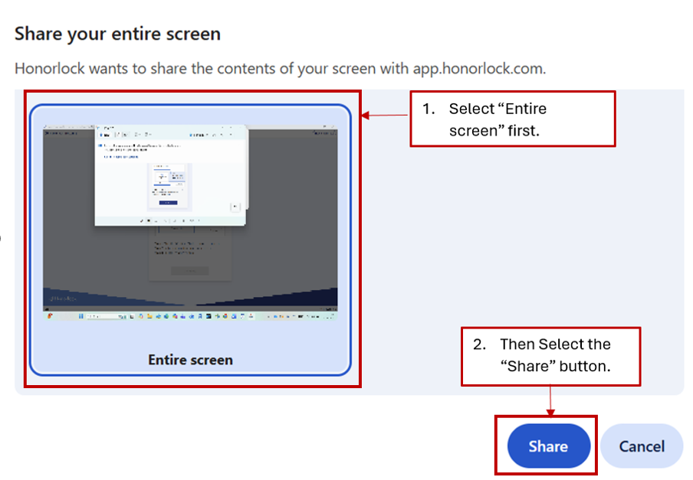
- In the “Good luck on your assessment” window, select the “Start Assessment” button to begin the test.
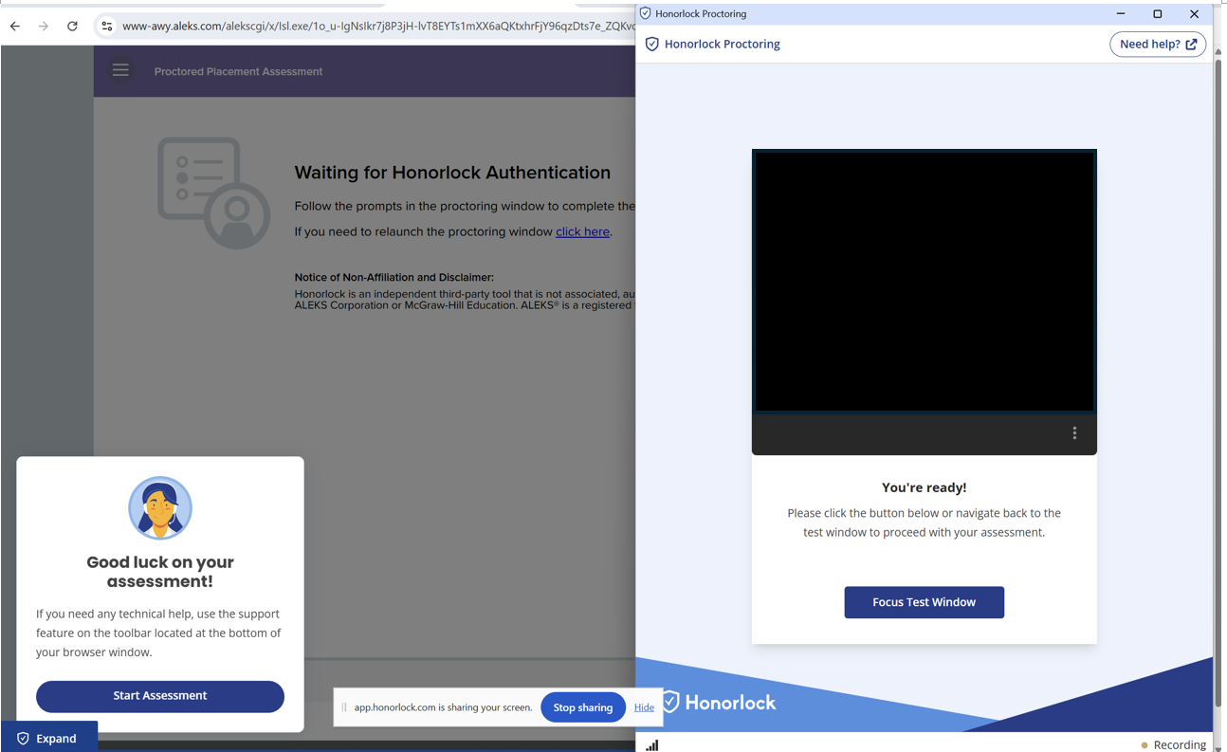
- After reviewing the placement assessment information, select the checkbox to confirm that you have read and understand the placement directions and honor code. Then select the “Get Started” button to begin the assessment.
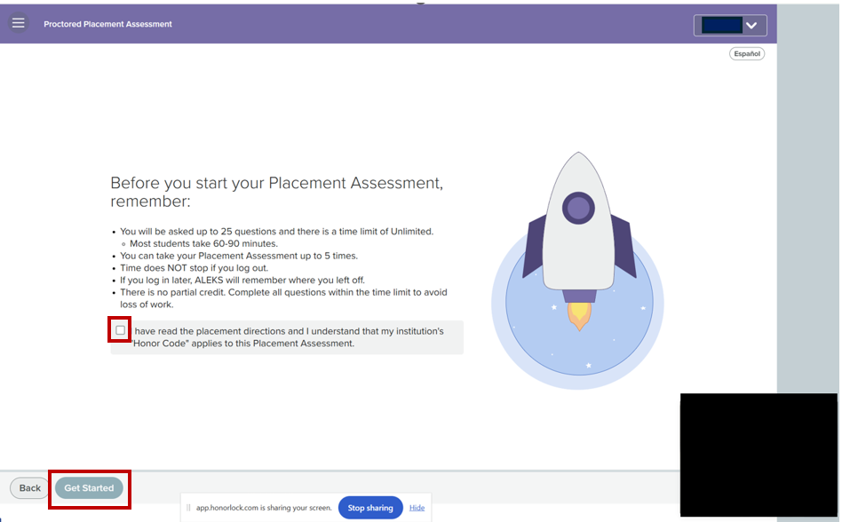
- After you submit the test, you can remove the Honorlock Google Chrome extension from your browser if you prefer. Go to your browser settings and select “Extensions.” Then select “Remove” for the Honorlock Chrome extension.

Accessing Prep & Learning Modules
Directions for students to access their Prep & Learning Modules
- Select the “Get Started” button to begin. After you complete the modules for the first time, the button text will change to “Continue My Path”. Use this button to return to your modules in the future.
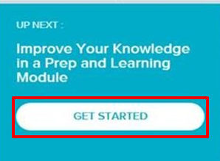
- You can check how much required study time you have left on the ALEKS homepage.
On the left side of the page, you may see information such as:
- Attempt: 3 of 5
This shows how many proctored retest attempts are available.
- A lock icon
This means the next attempt is not unlocked yet.
- Time Remaining in Learning Module (for example, 3 hours)
If an attempt is locked, it means you must complete the remaining required time in the Prep & Learning Module before you can take the next proctored assessment.
