Social Media Accessibility Standards
  - WCAG 2.2 Level AA-Aligned Authoring Guide
Last reviewed: August 24, 2026

Scope and conformance note
This guide applies to Harper College social media content published on Instagram, Facebook, and LinkedIn. It separates WCAG 2.2 Level A/AA requirements from additional accessibility best practices.
WCAG is a web-content standard, while Instagram, Facebook, and LinkedIn are third-party platforms whose interfaces and accessibility support can change. Use every accessibility feature the platform provides. If a platform cannot present required information accessibly, publish an equivalent accessible version on a Harper College web page and direct users to that version.

Pre-publish accessibility checklist
- Add meaningful alt text to every informative image and every image in a carousel.
- Put essential text from graphics in real post text or the caption instead of relying on text inside the image.
- Caption all spoken or narrated audio and review auto-generated captions for accuracy.
- Describe meaningful visual information in the audio track or provide an audio-described version when needed.
- Verify text contrast: at least 4.5:1 for normal text and 3:1 for large text.
- Do not use color alone to communicate meaning, and avoid flashing content that could trigger seizures.
- Use descriptive link context, readable hashtag capitalization, and restrained emoji use.
- For Stories or other temporary formats, make critical instructions and announcements available in a persistent accessible format too.

Universal requirements for all platforms

Images and text alternatives
- Required: Every informative image needs a text alternative that serves the same purpose. Write alt text for the image’s meaning in the context of the post, not merely its appearance. (WCAG 1.1.1)
- Required: If a carousel contains multiple informative images, provide a useful alternative for each image. (WCAG 1.1.1)
- Required: Do not rely on text embedded in an image when real text can provide the same information. If essential text must appear in a graphic, provide the complete equivalent in the post text or caption. (WCAG 1.4.5)
- Recommended: Keep alt text concise. Do not begin with “image of” or “photo of” unless that distinction matters. Do not copy a long block of visible text into alt text when the same text can be provided accessibly in the caption or post body.

Video, Reels, and audio
- Required: Provide accurate, synchronized captions for prerecorded speech and other meaningful audio. Review and correct automatic captions before publishing. (WCAG 1.2.2)
- Required: For live video, provide captions when the platform and production workflow support live captioning. (WCAG 1.2.4)
- Required: If important visual information is not communicated in the existing audio, provide audio description or integrate the visual information into the narration. (WCAG 1.2.5)
- Required: For prerecorded video-only content, provide an equivalent text or audio alternative. (WCAG 1.2.1)
- Recommended: Include meaningful non-speech audio in captions when it contributes to understanding, such as “[applause]” or “[alarm sounds]”.

Contrast, color, and motion
- Required: Text in graphics must have at least 4.5:1 contrast against its background. Large text must have at least 3:1 contrast. WCAG defines large text as at least 18 pt regular or 14 pt bold. (WCAG 1.4.3)
- Required: Meaningful graphical objects and visual states should have at least 3:1 contrast against adjacent colors when the criterion applies. (WCAG 1.4.11)
- Required: Do not use color as the only way to convey status, meaning, or instructions. Add text, shape, pattern, or another cue. (WCAG 1.4.1)
- Required: Do not publish content that flashes more than three times in one second unless it is below the WCAG flash thresholds. (WCAG 2.3.1)
- Recommended: Use large readable type, simple layouts, and sufficient spacing. Avoid dense text blocks in social graphics.

Links, hashtags, and emojis
- Required: Make the purpose of a link understandable from its wording and surrounding context. Prefer specific phrases such as “Register for the open house” over generic phrases such as “click here.” (WCAG 2.4.4)
- Recommended: When a platform requires a visible URL, keep it reasonably short and trustworthy. Do not rely on the URL itself to explain the destination.
- Recommended: Use PascalCase or camel case for multiword hashtags, for example #HarperCollege or #SummerAtHarper, to improve readability and screen-reader pronunciation.
- Recommended: Use emojis sparingly and place them where their spoken names will not interrupt essential information. There is no WCAG rule limiting a post to one emoji or one hashtag; the goal is readable, understandable content.
Platform menus change over time and can differ by device. The steps below use the labels shown in this guide’s screenshots. If a label has moved, locate the platform’s Alt Text, Accessibility, Captions, or Edit controls before publishing.

Instagram

Images and carousels
- Create a new post and select the image or images.
- Before sharing, open More Options or the current accessibility settings and locate Write Alt Text or Alt Text.
- Write context-specific alt text for every informative image. For a carousel, review each image individually.
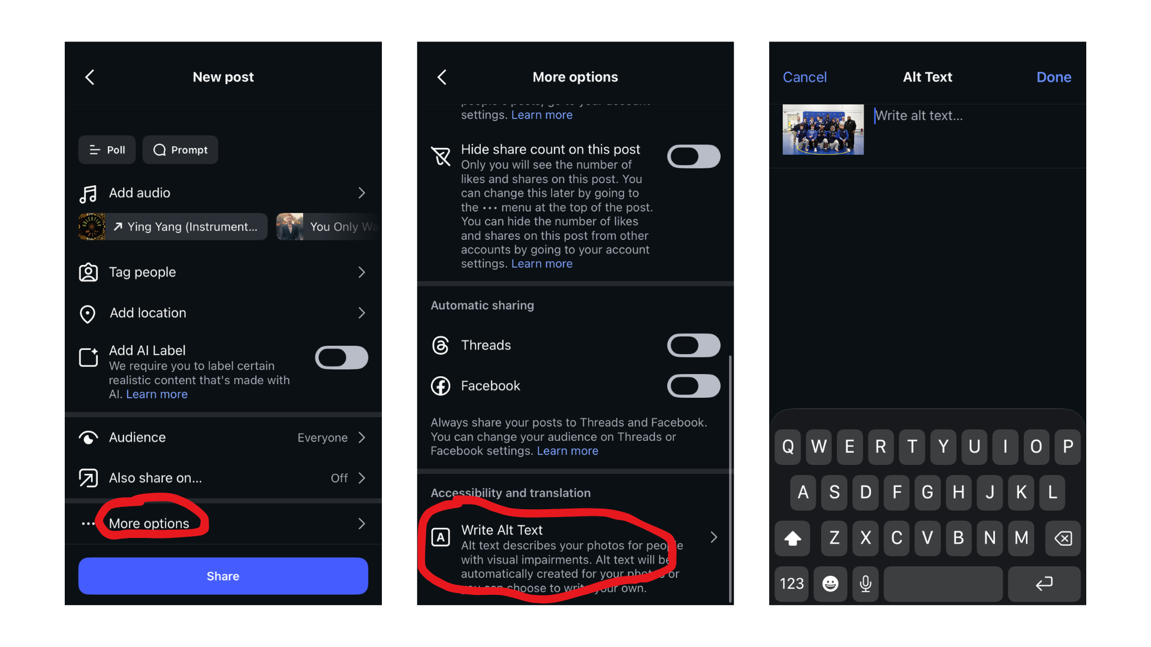
Figure 1. Instagram alt-text workflow shown in the original guide.

Images that contain text
- Avoid text-heavy flyers when the information can be published as real text in the caption.
- If a graphic includes essential words, repeat the complete information in the caption or post text. Use alt text to convey the image’s purpose and any visual information that is not already available in text.
- Keep text inside the image short, high contrast, and large enough to read on a phone.
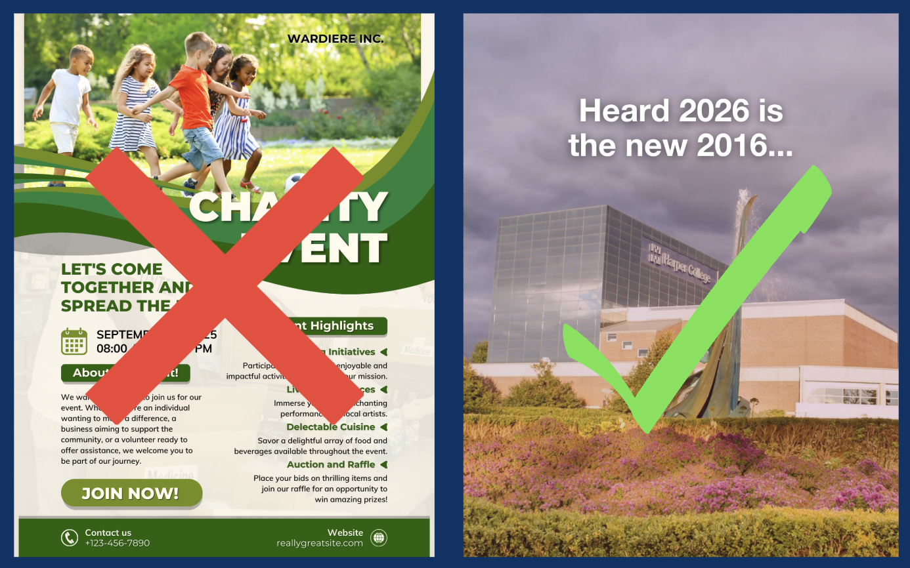
Figure 2. Prefer simple graphics and put detailed information in accessible post text.

Reels
- Caption speech and narration. Review captions for spelling, punctuation, timing, and speaker clarity.
- If the Reel contains important visuals that are not described in the audio, include that information in narration or publish an audio-described version.
- For image-and-music-only Reels, include an equivalent description in the caption and provide audio description when the visual sequence carries essential information.
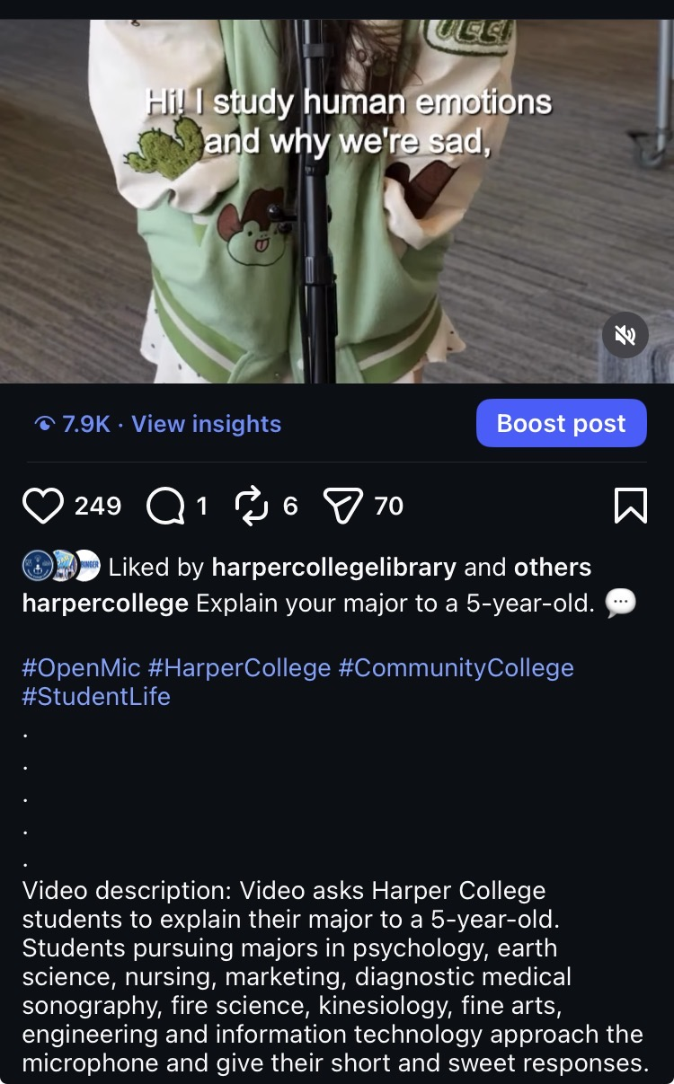
Figure 3. Example of captions plus a written description for supplemental context.

Stories
- Use the caption sticker or another captioning method for speech and narration.
- Use Instagram’s text/type tool for essential words so the information is not available only as pixels inside an image.
- Use strong contrast, large fonts, and simple layouts. Do not use color alone to convey meaning.
- When adding a link sticker, place clear descriptive text near it, such as “Register for orientation.”
- If a Story contains critical instructions, education, deadlines, or announcements, also publish the information in a persistent accessible feed post or Harper web page.
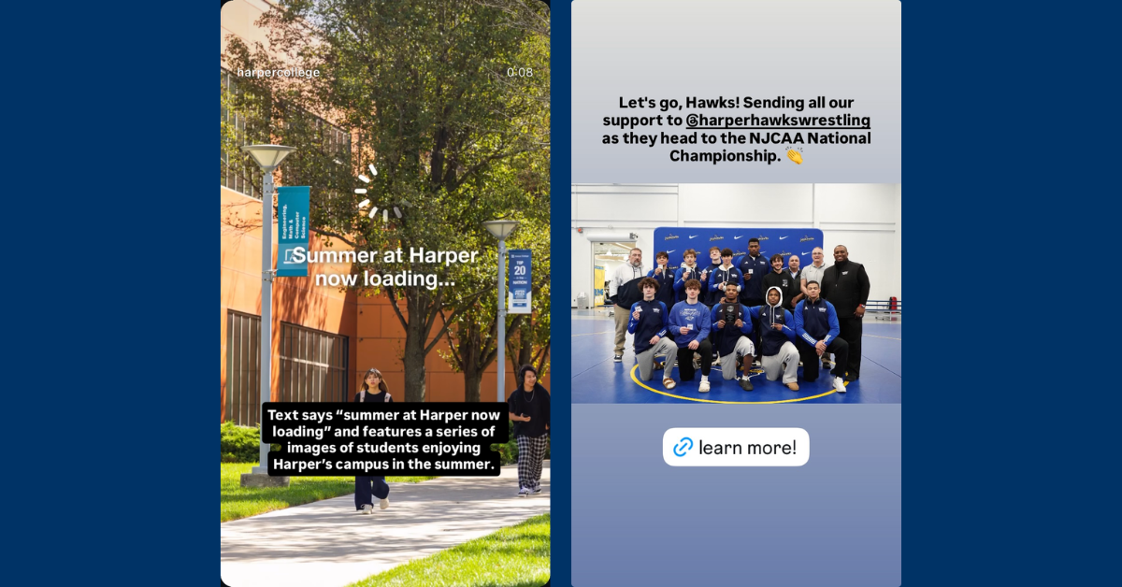
Figure 4. Example Stories that combine visuals with readable descriptive text.

Captions, hashtags, emojis, and links
- Keep sentences direct and avoid long strings of emojis. Screen readers announce emoji names, so repeated emojis can become disruptive.
- Capitalize each word in a multiword hashtag, for example #HarperCollege.
- Use descriptive wording before or with links so the destination is clear. Avoid making a long raw URL the main content a screen reader must announce.
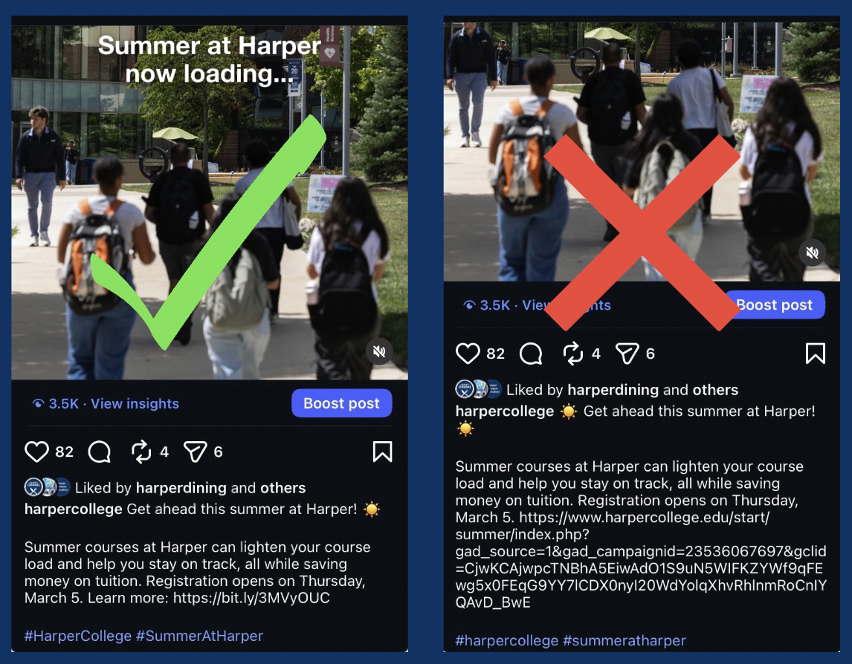
Figure 5. Keep post text readable and avoid long raw URLs when a clearer alternative is available.

Facebook

Photos and photo galleries
- Upload the photo or photos.
- Open Edit for each photo and locate Alternative Text or the current alt-text control.
- Choose custom alt text and write a description that explains the image’s purpose in the post. Review Facebook-generated descriptions rather than accepting them automatically.
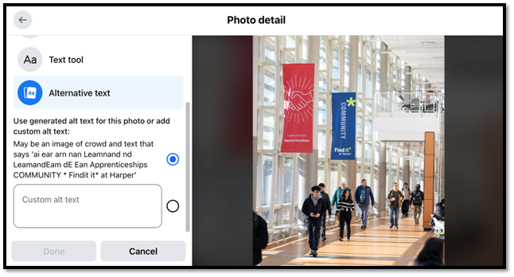
Figure 6. Facebook custom alt-text field.

Photos that contain text
- Avoid text-heavy flyers. Put the complete message in the post copy whenever possible.
- If a graphic contains essential words, provide the equivalent information in the post text. Use the alt text for the image’s purpose and relevant visual context rather than forcing a long flyer transcript into the alt field.
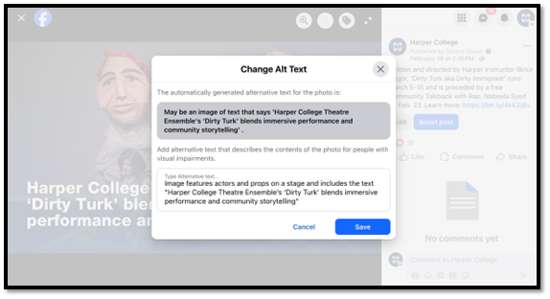
Figure 7. Replace generic automatic descriptions with useful custom alt text.

Video and Reels
- Caption all speech and narration and correct automatic captions before publishing.
- Describe important visual information in the audio track or provide an audio-described version when needed.
- For image-and-music-only video, provide an equivalent description in the post text and an audio alternative when the visual sequence is essential.

Emojis
- Use emojis sparingly and do not insert long runs of repeated emojis between essential words.
- Place decorative emojis after the key message when practical so the essential text is announced first.
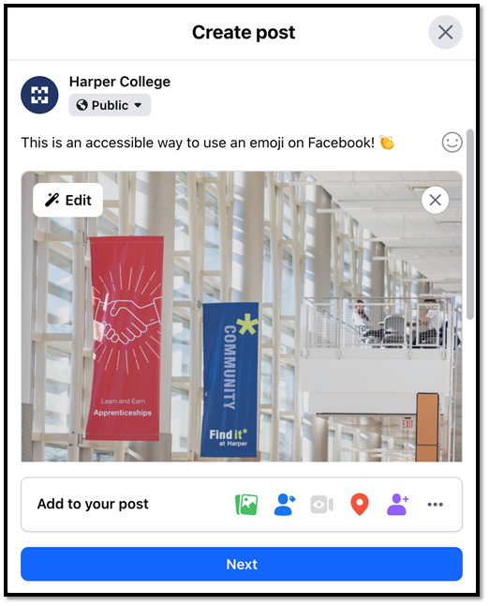
Figure 8. Example of a restrained emoji placed after the message.

Links
- State the destination or action in words, such as “Learn more about financial aid” or “Register for the event.”
- If the post must show a URL, keep it short enough to read comfortably. A shortener may reduce verbosity, but use a trustworthy destination and do not rely on the short URL itself to communicate purpose.
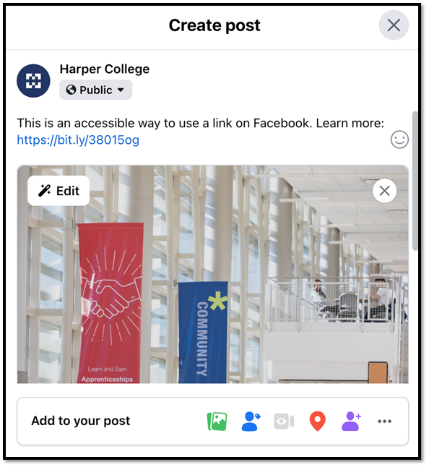
Figure 9. Link example with context before the URL.

Hashtags
- Use readable capitalization for multiword hashtags, for example #CamelCaseHashtag or #SummerAtHarper.
- Avoid long clusters of hashtags when they interfere with the main message.
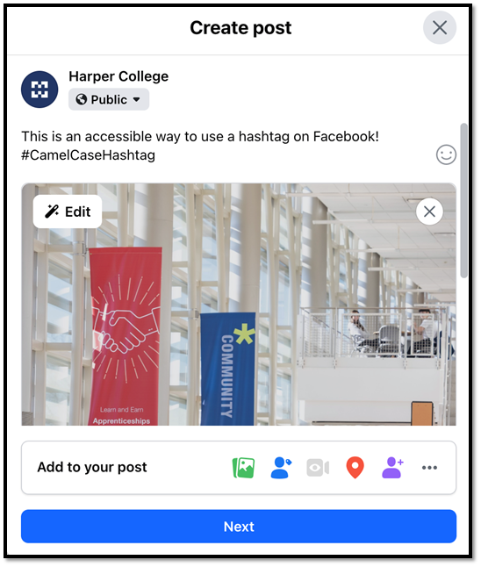
Figure 10. Readable capitalization improves hashtag interpretation.

Stories
- Use captions for speech and narration.
- Add essential descriptive text with Facebook’s text or caption tools rather than baking all information into an image.
- Use large fonts, strong contrast, and simple layouts.
- Repeat critical instructions, education, deadlines, and announcements in a persistent accessible post or Harper web page.
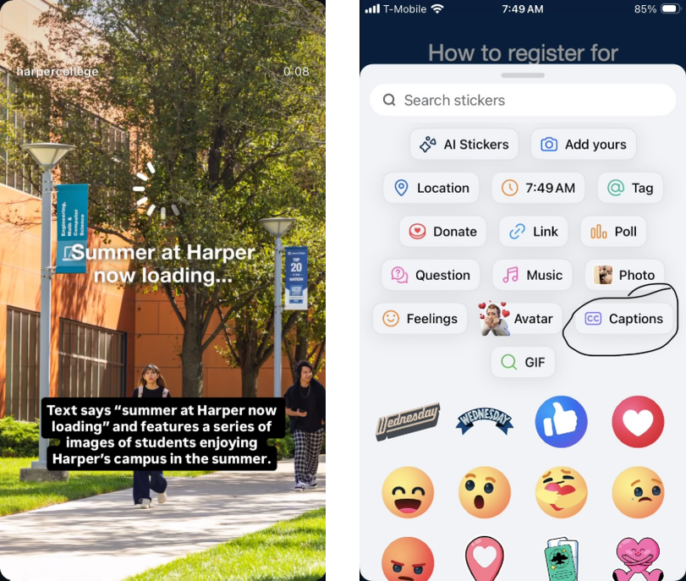
Figure 11. Facebook Story example and the Stories caption control.

LinkedIn

Photos and photo galleries
- Upload the photo or photos.
- Open Edit for each photo and locate Edit Alt Text or Alternative Text.
- Write custom alt text that communicates the image’s purpose. Do not rely on generic automatically generated text when it does not provide an equivalent description.
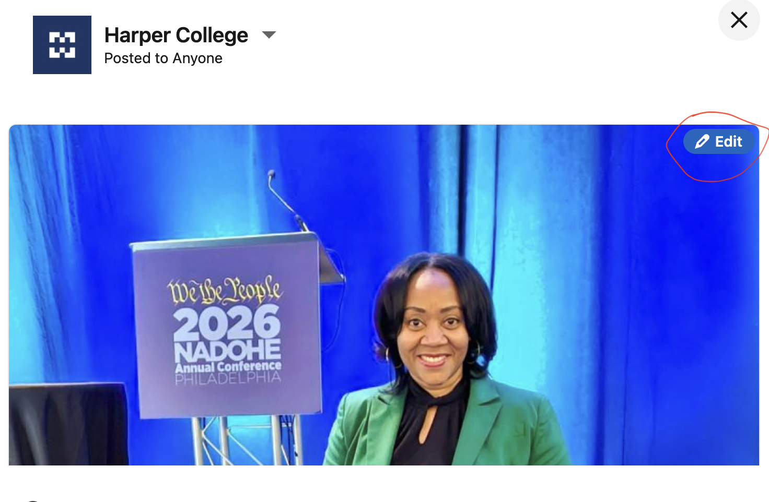
Figure 12. LinkedIn image editing control.
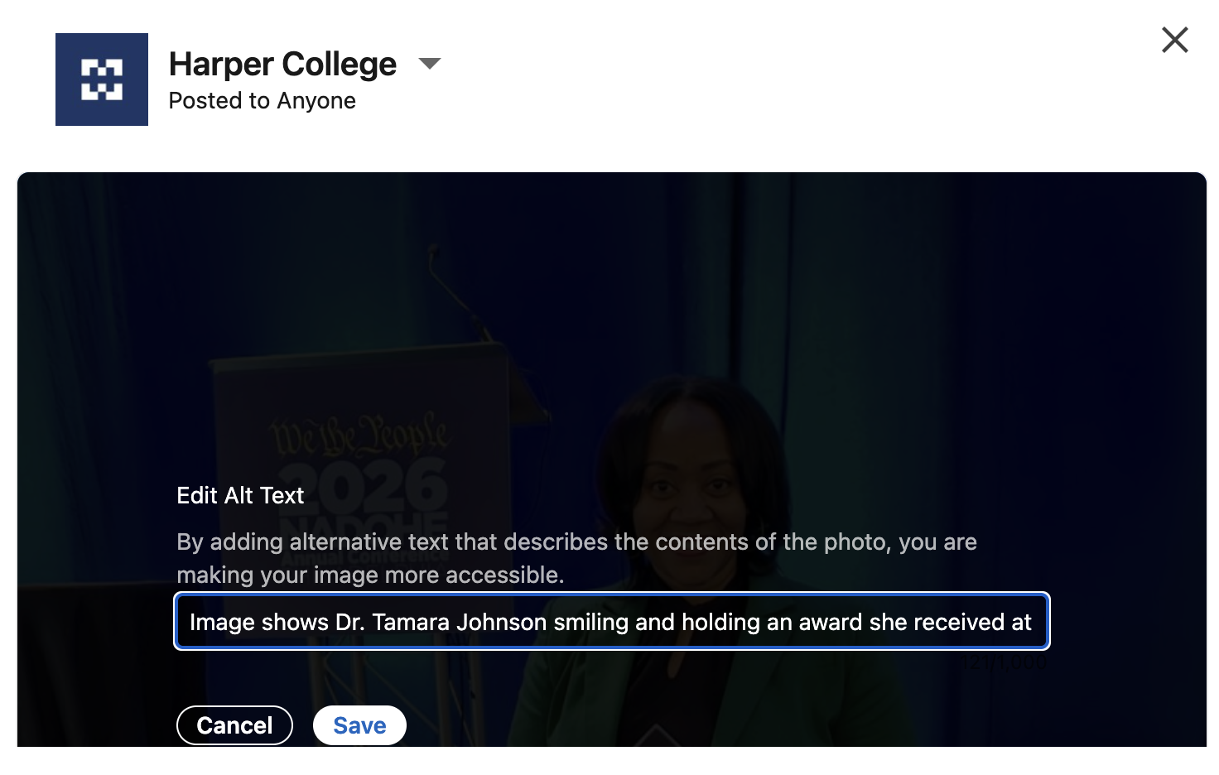
Figure 13. LinkedIn custom alt-text entry.

Photos that contain text
- Avoid text-heavy graphics when the same information can be written in the LinkedIn post.
- If essential text remains in an image, provide the complete equivalent in the post text. Keep alt text focused on the image’s purpose and visual context.
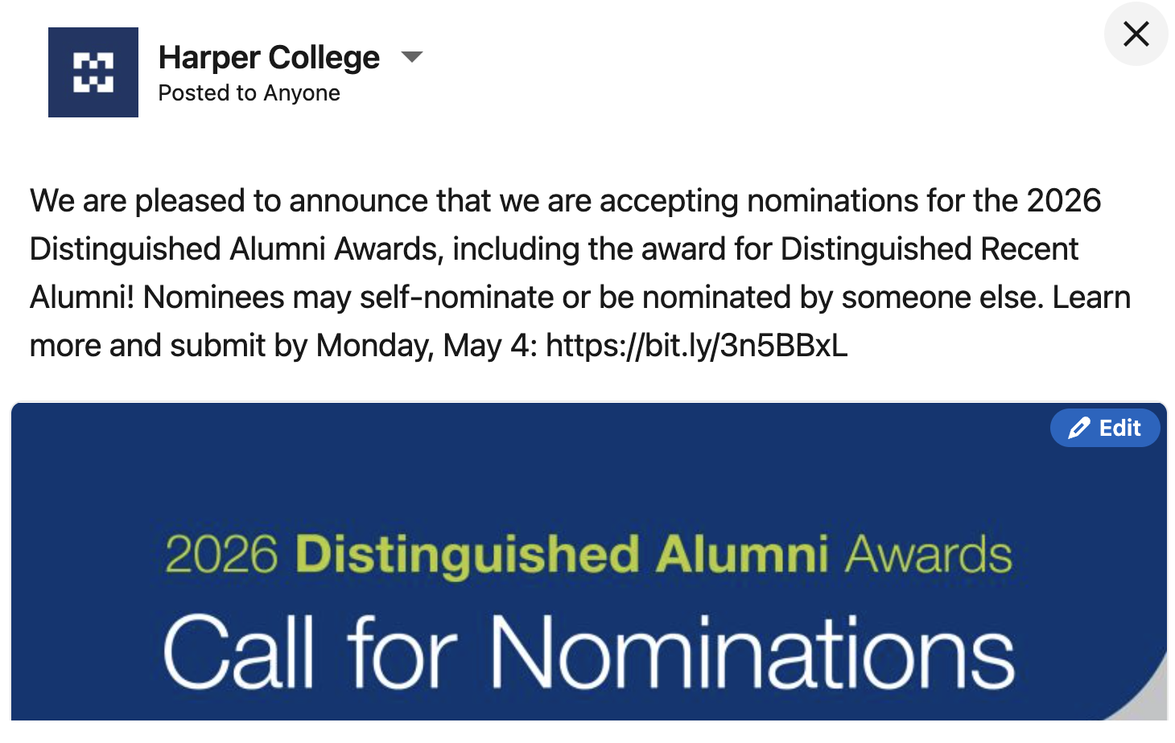
Figure 14. Put the essential message in real post text, not only inside the graphic.
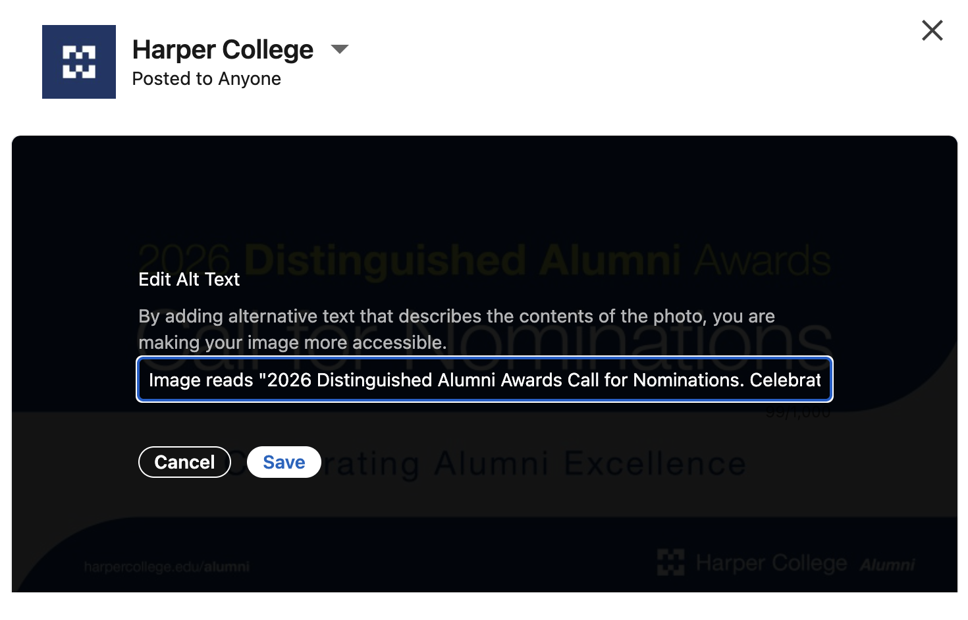
Figure 15. Custom alt text supplements, rather than replaces, accessible post text.

Video
- Caption all speech and narration and review automatic captions for accuracy.
- Integrate meaningful visual details into narration or provide an audio-described version when those details are necessary for understanding.
- For video-only content, provide an equivalent text or audio alternative.
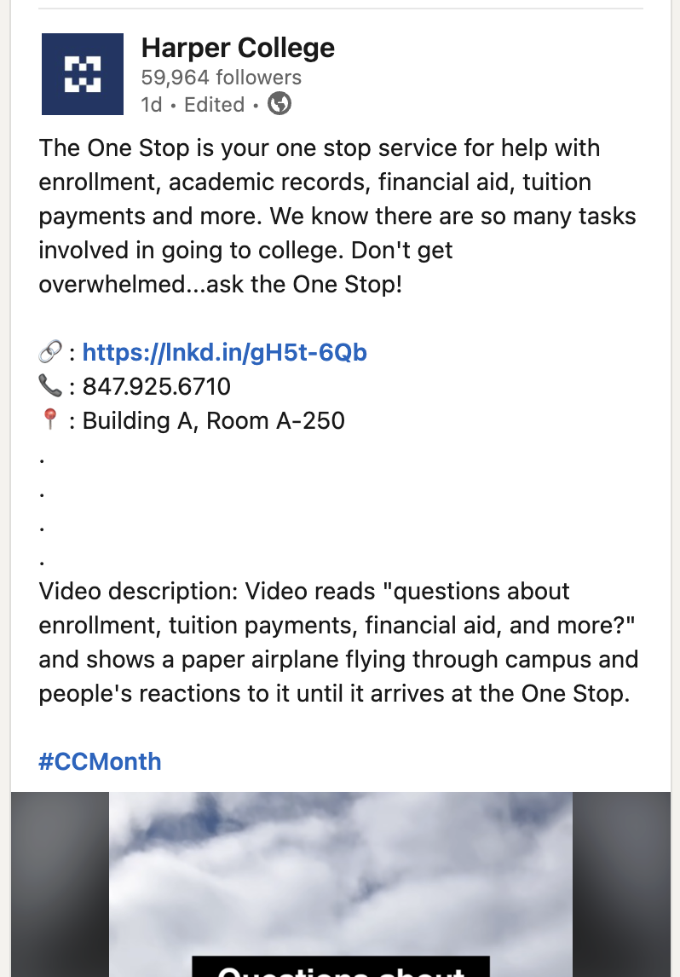
Figure 16. Written video description used as supplemental context in a LinkedIn post.

Captions, hashtags, emojis, and links
- Keep the main message before decorative emoji when practical, and avoid long strings of repeated emoji.
- Use readable capitalization for multiword hashtags, such as #HarperCollege.
- Use descriptive link context that tells readers where the link goes or what action it performs.

Writing examples

Alt text example
Weak: “Image of students.”
Better: “Three students walk through campus beneath blue Summer at Harper banners.”
If the photo is only decorative and the platform provides a true “mark as decorative” option, use that option. If the platform does not support decorative-image semantics, provide a brief text alternative rather than leaving an informative image unlabeled.

Text-in-image example
Graphic text: “Open House, October 17, 5-7 p.m., Building A.”
Post text: “Join us for the Open House on October 17 from 5-7 p.m. in Building A. Learn about programs, meet faculty, and tour campus.”
Alt text: “Open House promotional graphic with a photo of students outside Building A.”

Link example
Weak: “Click here.”
Better: “Register for the Open House.” Attach the platform link to that clear action when the platform supports linked text or a link control.

WCAG 2.2 criteria referenced in this guide
- 1.1.1 Non-text Content - text alternatives for meaningful non-text content.
- 1.2.1 Audio-only and Video-only (Prerecorded) - equivalent alternatives for prerecorded audio-only or video-only media.
- 1.2.2 Captions (Prerecorded) - captions for prerecorded synchronized media with audio.
- 1.2.4 Captions (Live) - captions for live synchronized media.
- 1.2.5 Audio Description (Prerecorded) - audio description for meaningful visual information in prerecorded synchronized media.
- 1.4.1 Use of Color - color is not the only visual means of conveying information.
- 1.4.3 Contrast (Minimum) - minimum text contrast requirements.
- 1.4.5 Images of Text - use real text instead of images of text when possible.
- 1.4.11 Non-text Contrast - contrast for meaningful graphical objects and interface components.
- 2.3.1 Three Flashes or Below Threshold - limits on flashing content.
- 2.4.4 Link Purpose (In Context) - link purpose is understandable from the link and its context.
Authoritative standard: W3C Web Content Accessibility Guidelines (WCAG) 2.2.
Implementation reference: How to Meet WCAG 2.2.

Final review before publishing
- Read the post in order without looking at the images. Confirm that the essential information still makes sense.
- Check every image and carousel item for useful alt text or a valid decorative treatment.
- Play every video with sound off and verify that captions communicate the audio content.
- Play every video without looking at the screen and verify that essential visual information is communicated by audio description or integrated narration.
- Check contrast and confirm that color is not the only cue.
- Review hashtags, emojis, and links for readability with a screen reader in mind.
- Confirm critical Story content is available in a persistent accessible format.

